

Functional Requirement Specification
CENTRAL KYC RECORD REGISTRY (CKYCRR 2.0)

Protean eGov Technologies Ltd


Version History

Version | Date | Prepared By | Reviewed By | Approved By | Details
V1.0 | 02/06/2025 | Rohit Mainkar, AM | Hardik JP, AVP | Ranjit Jadhav, VP | Functional Requirement Specifications
V1.1 | 06/06/2025 | Rohit Mainkar, AM | Hardik JP, AVP | Ranjit Jadhav, VP | Incorporation of feedback shared by CERSAI
V1.2 | 11/06/2025 | Rohit Mainkar, AM | Hardik JP, AVP | Ranjit Jadhav, VP | Incorporation of feedback shared by CERSAI
V1.3 | 16/06/2025 | Rohit Mainkar, AM | Hardik JP, AVP | Ranjit Jadhav, VP | Incorporation of feedback shared by CERSAI
V1.4 | 19/06/2025 | Rohit Mainkar, AM | Hardik JP, AVP | Ranjit Jadhav, VP | Incorporation of feedback shared by CERSAI
V1.5 | 25/06/2025 | Rohit Mainkar, AM | Hardik JP, AVP | Ranjit Jadhav, VP | Incorporation of feedback shared by CERSAI
V1.6 | 30/06/2025 | Hardik JP, AVP | Ranjit Jadhav, VP | Subhadip Saha, VP | Incorporation of feedback shared by CERSAI

Table of Contents
Table of Contents
Version History 2
Acronyms 6
1. Introduction 9
1.1. Project CKYCRR 2.0 10
1.2. Need for project 10
2. Scope 10
3. Functional Requirements 11
3.1. User Accessibility to CKCYRR modules 11
3.2. CKCYRR Website 14
Reporting Entity user – below modules are for Reporting Entity user type 15
3.3. Reporting Entity (RE) Registration 15
3.4. Resubmission of RE registration application 44
3.5. Password and DSC setup 53
3.6. Login 56
3.7. Forgot Password 59
3.8. Forgot user ID 63
3.9. Testbed Environment 66
3.10. IP whitelisting 70
3.11. Sub-user management 73
3.11.1. Create Region 76
3.11.2. Modify Region 81
3.11.3. De-activation of Region 85
3.11.4. Merger of Region 87
3.11.5. Create Branch 90
3.11.6. Modify Branch 94
3.11.7. De-activation of Branch 99
3.11.8. Merger of branch 101
3.11.9. Transfer of branch 104
3.11.10. Create Institutional Regional Admin User (IRA)/ Institutional User (IU) 106
3.11.11. Modify Institutional User (IU)/Institutional Regional Admin (IRA) User 113
3.11.12. Create Institutional Regional User (IRU) / Institutional Branch User (IBU) 121
3.11.13. Modify Institutional Regional user (IRU) / Institutional Branch User (IBU) 127
3.11.14. De-activation of User 136
3.11.15. Suspension of User 138
3.11.16. Revocation of Suspension of user 140
3.12. Update Profile 143
3.13. KYC Management 176
3.13.1. Search KYC Record 176
3.13.2. Download KYC Record 183
3.13.3. Create KYC Record – Individual 190
3.13.4. Create KYC Record – Legal Entity 219
3.13.5. Update KYC Record - Individual 244
3.13.6. Update KYC Record – Legal Entity 255
3.13.7. De-activate KYC record 265
3.13.8. Re-activate KYC record 271
3.13.9. Suspend KYC record 274
3.13.10. Revocation of Suspension 277
3.13.11. KYC logs 280
3.13.12. Client relationship 281
3.14. Billing Management System 284
3.14.1. Balance Ledger 285
3.14.2. TDS release request 301
3.14.3. Incentive 302
3.14.4. Proforma Invoice 306
3.14.5. eGST invoice 306
3.15. RE Merger/Amalgamation/Take Over/ Acquisition 310
3.16. RE de-activation (DIY) 313
3.17. Reporting Entity Administration 316
3.18. MIS Reports 318
CERSAI user – below modules are for CERSAI user type 319
3.19. Password and DSC setup 319
3.20. Login 319
3.21. Forgot Password 320
3.22. Forgot user ID 320
3.23. Sub-user management of CERSAI Users 320
Structure and mapped functionalities 320
3.23.1. Super Admin Creation 321
3.23.2. Create User 324
3.23.3. Modify User 333
3.23.4. De-activation of User 341
3.23.5. Suspension of User 343
3.23.6. Revocation of Suspension of user 345
3.24. Reporting Entity Registration / Modification Approval by CERSAI 349
3.25. Reporting Entity Update Profile Approval by CERSAI 354
3.26. Reporting Entity Merger Request Approval By CERSAI 357
3.27. Reporting Entity De-activation Request Approval by CERSAI (Request Initiated by RE) 360
3.28. Billing Management by CERSAI User 363
3.28.1. Balance Ledger 364
3.28.2. Incentive Claim Process 367
3.28.3. Refund Request Process 371
3.29. KYC Management by CERSAI 375
3.29.1. De-activate KYC record 375
3.29.2. Re-activate KYC record 378
3.29.3. Suspend KYC record 381
3.29.4. Revocation of Suspension 384
3.30. KYC Transactions Approval by CERSAI (Request Initiated by RE) 387
3.31. KYC transactions approval by CERSAI (Initiated by CERSAI) 390
3.32. RE Management 393
3.33. Reporting Entity De-activation/suspension Request Approval by CERSAI (Request Initiated by CERSAI) 404
3.34. Master Management by CERSAI 407
3.34.1. Dropdown masters 407
3.34.2. Geography masters 408
3.34.3. ISO code master 408
3.35. Content Management by CERSAI User 408
3.35.1. Homepage Content Management 409
3.35.2. Downloads Section Management 409
3.35.3. FAQ Management 409
3.35.4. SMS/Email Template Management 409
3.35.5. Invoice Template Management 409
3.35.6. Document Validation Settings 410
3.35.7. Charge Management 410
3.35.8. Form Validations (Sign-up, Registration, KYC) 410
3.36. MIS Reports 410
3.37. Client Access to CKYCRR 411
3.37.1. View KYC Details 412
3.37.2. Consent to Download KYC record 415
3.37.3. Raise Update Request 417
3.37.4. Raise ticket / complaint 420
3.37.5. Download CKYC card 420
3.38. Consent Mechanism 424
3.39. Beneficial Owners Registry 429
3.39.1. Existing Process 429
3.39.2. Proposed Process 429
3.40. Training Portal – RE user 431
3.41. Training Portal – CERSAI user 440
3.42. Training Portal – Publicly available content for clients 443
3.43. Customer Identification Procedure Confidence Level framework 443
3.44. Verifiable Credentials 446
3.44.1. Introduction 446
3.44.2. Objective: 446
3.44.3. Scope 446
3.44.4. System Overview 447
3.44.4.1. Key Stakeholders / Actors 447
3.44.4.2. Key Components 447
3.44.4.3. High-Level Components 447
3.44.4.4. CKYC Alias System: 447
3.44.5. User Journey 448
3.45. Annexure-I (SMS & Email Template) 449
3.46. Annexure-II (Proforma Invoice) 449
3.47. Annexure-III (Refund Voucher) 451
3.48. Annexure-IV (Proforma Invoice – Incentive) 452
3.49. Annexure-V (Tax Invoice- Incentive) 453
3.50. Annexure-VI (eGST Invoice) 454

Acronyms
Acronyms | Definition
AADHAR | Aadhaar (Unique Identification Authority of India)
ANNEXURE | Supplementary material added at the end of a document
API | Application Programming Interface
BCP | Business Continuity Plan
BIC | Bank Identification Code
CDSL | Central Depository Services (India) Limited
CERSAI | Central Registry of Securitisation Asset Reconstruction and Security Interest of India
CIN | Corporate Identification Number
CKYCRR | Central KYC Records Registry
CKYCRR | Central KYC Records Registry – Revised/Version 2.0
CRL | Credit Risk Level
CSV | Comma Separated Values
DC | Data Centre
DIY | Do It Yourself
DMS | Document Management System
DSC | Digital Signature Certificate
EKYC | Electronic Know Your Customer
EMI | Equated Monthly Instalment
FATCA | Foreign Account Tax Compliance Act
FIU | Financial Intelligence Unit
FRS | Functional Requirement Specification
FTP | File Transfer Protocol
FVU | File Validation Utility
FY | Financial Year
GST | Goods and Services Tax
GSTIN | Goods and Services Taxpayer Identification Number
H2H | Host-to-Host
HSM | Hardware Security Module
ID | Identity Document
IFSC | Indian Financial System Code
IP | Internet Protocol
IRDAI | Insurance Regulatory and Development Authority of India
ISO | International Organization for Standardization
IT | Information Technology
KRA | KYC Registration Agency
KYC | Know Your Customer
LAN | Local Area Network
LDAP | Lightweight Directory Access Protocol
LLP | Limited Liability Partnership
MIS | Management Information System
NBFC | Non-Banking Financial Company
NIC | National Informatics Centre
NPA | Non-Performing Asset
OCR | Optical Character Recognition
OTP | One-Time Password
OVD | Officially Valid Document
PAN | Permanent Account Number
PDF | Portable Document Format
PEP | Politically Exposed Person
PFRDA | Pension Fund Regulatory and Development Authority
PIN | Personal Identification Number
PKI | Public Key Infrastructure
PML | Prevention of Money Laundering
POA | Proof of Address
POI | Proof of Identity
QA | Quality Assurance
RBAC | Role-Based Access Control
RBI | Reserve Bank of India
RE | Reporting Entity (banking company, financial institution, intermediary or a person carrying on a designated business or profession under PML Act,2002)
SEBI | Securities and Exchange Board of India
SFTP | Secure File Transfer Protocol
SLA | Service Level Agreement
SMS | Short Message Service
STQC | Standardisation Testing and Quality Certification
TAN | Tax Deduction and Collection Account Number
TDS | Tax Deducted at Source
TIN | Taxpayer Identification Number
UAT | User Acceptance Testing
UI | User Interface
UIDAI | Unique Identification Authority of India
URL | Uniform Resource Locator
UTR | Unique Transaction Reference
XML | eXtensible Markup Language
ZIP | A compressed file format or code
DIY | Do It Yourself
IAU | Institutional Admin User
IU | Institutional User
IRA | Institutional Regional Admin
IRU | Institutional Regional User
IBU | Institutional Branch User

Acronyms of the images/ icons used in workflows

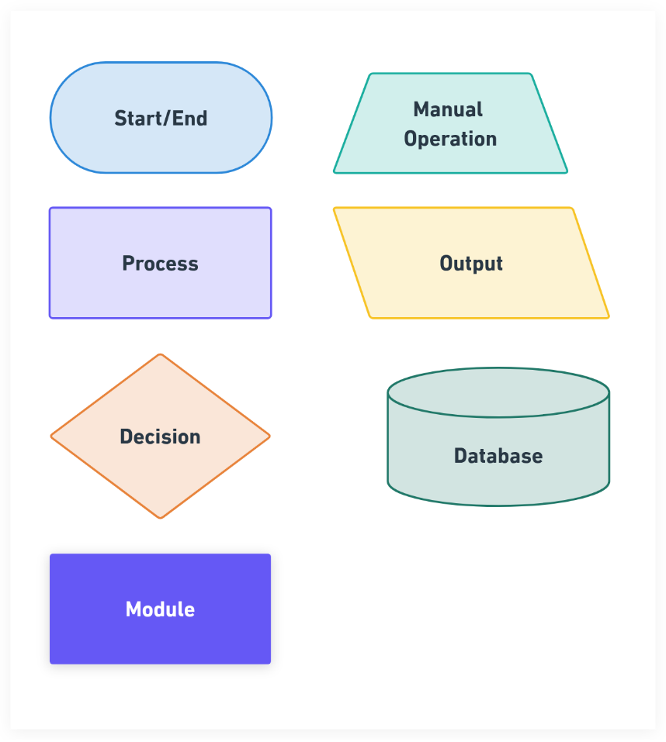

Introduction
Central KYC Records Registry (CKYCRR): The Central KYC Record Registry has been established under Rule 9A of The Prevention of Money Laundering (Maintenance of Records) Rules 2005. The Central KYC Records Registry started operating from 2016 and caters to Reporting Entities (REs) of all five major regulators of financial sector i.e. RBI, SEBI, IRDA,PFRDA & IFSCA.

Under the mandate of PML (Maintenance of Records) Rules 2005, more particularly Rule 9, the Reporting Entities have been mandated to file electronic copy of KYC records of the client to Central KYC Records Registry.

As on 15th April 2025, 8014 Reporting Entities had registered, and 101.57 crores KYC records had been uploaded. The number of downloaded records has also been increasing over the years with total downloads of 144.70 crores which signifies the benefit and ease this repository has provided to the REs and their clients.

Project CKYCRR 2.0
CERSAI maintains and operates the Central KYC Records Registry established under the provisions of PML Act, 2002 for the purpose of receiving, storing, safeguarding, and retrieving the electronic copies of KYC records obtained by the Reporting Entities (REs) from their clients in accordance with these rules.

The objective of setting up the CKYCRR was to have a Centralized Repository of KYC records of customers in the financial sector (across the Regulated Entities of all the Financial Sector Regulators viz RBI ,SEBI, IRDAI, PFRDA & IFSCA) with uniform KYC norms and inter-usability of KYC records across the financial sector to reduce the burden of producing KYC documents and getting those verified every time when the customer creates a new financial relationship with a financial entity.

Need for project
The existing Application is in operation since 2016. To meet evolving technological standards, security protocols, and user expectations to enhance the feature of CKYCRR, enhance operational efficiency, data security, and overall system performance, a new Application can bring fresh perspectives, leverage new technologies, and a tailored approach to meet the unique needs. A new application for CKYC Records Registry (CKYCRR 2.0) is required to:

  - Leverage the latest technologies to enhance scalability, flexibility, and security.
  - Implement a user-friendly and intuitive interface to improve user productivity and satisfaction.
  - Establish robust data management practices to ensure data integrity, reliability, and accessibility.
  - Integrate seamlessly with internal and external systems to streamline operations and adopt cutting-edge technologies.
  - Mitigate potential security risks by employing modern security protocols and practices

Scope
The scope of the CKYCRR 2.0 system primarily encompasses the following core modules. These modules form the foundation of the system, with other functionalities integrating into them. This document will provide a detailed elaboration on the below modules.
- Reporting Entity (RE) Registration
- KYC Management
- User Management
- Billing Management System
- Logs and Reports
- Administration

Functional Requirements
This section elaborates the detailed process flow of RE Registration module

User Accessibility to CKCYRR modules
CKYCRR system has the below modules/ functionalities accessible to different users of the CKYCRR system.
S.No. | User Type | Module | Sub-module
1 | Reporting Entity | Reporting entity registration | Sign-up & Registration
2 |  | Login
3 |  | Password and DSC setup
4 |  | Forgot Password
5 |  | Forgot User ID
6 |  | Testbed Environment / Activities
7 |  | Re-submission of reporting entity registration
8 |  | Update Profile | Update Entity Profile
9 |  |  | Update User Profile
10 |  | Sub-user management | Create region
11 |  |  | Modify Region
12 |  |  | De-activation of region
13 |  |  | Merger of region
14 |  |  | Create Branch
15 |  |  | Modify branch
16 |  |  | De-activation of branch
17 |  |  | Merger of branch
18 |  |  | Transfer of branch
19 |  |  | Create IRA/IU
20 |  |  | Modify IRA/IU
21 |  |  | Create IRU/IBU
22 |  |  | Modify IRU/IBU
23 |  |  | Deactivation of user
24 |  |  | Suspension of user
25 |  |  | Revocation of suspension of user
26 |  | Merger/ amalgamation/ take over/ acquisition of reporting entity
27 |  | De-activation of RE (DIY)
28 |  | Billing Management System | Balance Ledger
29 |  |  | Incentive
30 |  |  | Proforma invoice
31 |  |  | eGST invoice
32 |  | Reporting entity administration
33 |  | KYC management | Search KYC record
34 |  |  | Download KYC record
35 |  |  | Create KYC record – individual
36 |  |  | Create KYC record – legal entity
37 |  |  | Update KYC record - individual
38 |  |  | Update KYC record – legal entity
39 |  |  | De-activate KYC record
40 |  |  | Re-activate KYC record
41 |  |  | Suspend KYC record
42 |  |  | Revocation of suspension of KYC record
43 |  |  | KYC logs
44 |  |  | Client relationship
45 |  | Ticket management | Raise ticket
46 |  |  | Track ticket
47 |  |  | Assigned ticket
48 |  | MIS reports
49 |  | Beneficial Owner Registry
50 |  | Training portal
51 | CERSAI | Dashboard
52 |  | My Task | RE registration/ modification approval
53 |  |  | RE merger request approval
54 |  |  | RE de-activation request (initiated by RE)
55 |  |  | RE de-activation/ suspension request (initiated by CERSAI user)
56 |  |  | KYC transactions approval (initiated by RE)
57 |  |  | KYC transactions approval (initiated by CERSAI)
58 |  | KYC Management | De-activate KYC record
59 |  |  | Re-activate KYC record
60 |  |  | Suspend KYC record
61 |  |  | Revocation of suspension of KYC record
62 |  | Master management | Dropdown master
63 |  |  | Geography master
64 |  |  | ISO codes
65 |  | RE management
66 |  | Sub-user management | Super admin creation
67 |  |  | Create user
68 |  |  | Modify user
69 |  |  | De-activation of user
70 |  |  | Suspension of user
71 |  |  | Revocation of suspension of user
72 |  | Billing Management System | Balance ledger
73 |  |  | Incentive claim process
74 |  |  | Refund claim process
75 |  | Content Management System | Homepage content management
76 |  |  | Download section management
77 |  |  | FAQ management
78 |  |  | SMS/Email template management
79 |  |  | Invoice template management
80 |  |  | Document validation settings
81 |  |  | Charge management
82 |  |  | Form validations (sign-up, registration, KYC)
83 |  | MIS reports
84 |  | Ticket Management
85 |  | Analytics Dashboard
86 |  | Beneficial Owner Registry
87 | Client | Consent to download KYC record
88 |  | Raise update request
89 |  | Raise ticket
90 |  | Download CKYC card
91 | Annexure 1 | Client consent mechanism
92 | Annexure II | Consent based on face authentication
93 | Annexure III | CCL framework
94 | Annexure IV | ISO codes
95 | Annexure V | List of supporting document for merger
96 | Annexure VI | Proforma Invoice
97 | Annexure VII | Refund request (invoice raised by RE)
98 | Annexure VIII | Credit Note
99 | Annexure IX | Incentive claim invoice
100 | Annexure X | De-duplication logic

CKCYRR Website
CKYCRR website will be publicly available to reporting entity and citizens of India. Anyone can access the domain “https://www.ckycindia.in” from the system and mobile connected over internet. The website homepage will be GIGW compliant and mobile responsive.

The below components will be available on CKYCRR website
- Homepage – Providing information about CKYC, FAQ, action buttons (client access, RE registration, RE login), registration for online query resolution.
- Download – providing all downloadable material/ utility to help users of the CKYCRR website
- FAQ – Providing detailed FAQ to help users of the CKYCRR website on common queries
- Training – Publishing training material and training schedule
- Contact us / ticket management – providing contact details of the helpdesk team and accessibility to users to raise tickets
- Notifications – publishing notification to users of the CKYCRR website.
The CKYCRR website will be integrated with Content Management System to make real time changes to content displayed, publish notifications, manage FAQs, manage download material, etc. Also, the CKYCRR website will be mobile responsive for the below modules
- Website
- RE Sign-up
- RE – registration
- Client Access

Reporting Entity user – below modules are for Reporting Entity user type

Reporting Entity (RE) Registration
A Reporting Entity (RE) refers to a banking company, financial institution, intermediary, or any person engaged in a designated business or profession under the PML Act, 2002. The RE Registration process facilitates the onboarding of institutions on CKYCRR website while ensuring compliance with regulatory requirements. This process includes submitting institutional details, verifying key identifiers, and obtaining approval from CERSAI before gaining access to CKYCRR system. Registration on CKYCRR website enables reporting entities to efficiently manage customer KYC records and interact with the CKYCRR system for KYC-related activities. A robust approval mechanism ensures that only verified and legitimate reporting entities are granted access, preventing fraud and enhancing overall security.
RE Sign-up and Registration process
The RE registration process on CKYCRR website is divided into two stages: “Sign-up” and “Registration”. This section outlines the complete end-to-end process for reporting entity registration.
- Sign- up: Sign-up ensures initiation of RE registration by providing nodal officer details.
- Registration: Registration ensures the submission of required information and documents by the nodal officer of RE for CERSAI’s approval.

Below outlines process for sign-up:
Step 1: The nodal officer of the reporting entity will access domain / URL https://www.ckycindia.in from their respective systems connected over internet.
Step 2: Sign-up: The nodal officer of the reporting entity has to first click on “Register” button to initiate sign-up journey of reporting entity on the CKYCRR portal.
Step 3: The CKYCRR system takes the nodal officer of the reporting entity to the Sign-up page for RE registration.
Step 4: The nodal officer of the reporting entity is required to enter details as mentioned below to complete the sign-up process for their respective reporting entity.
Section | Field | Field Type | Field Size | M/O/CM | Validations
Nodal Officer Details | Citizenship | Char | 3 | M | Dropdown values as per configurations in CMS. Draft values will be configured.
 | CKYC number | Char | 14 | CM | 14 digits numeric value allowed. CKYC number will be verified from CKYCRR registry.  Mandatory if citizenship selected is Indian
 | Title | Char | 2 | M | Dropdown value  1. Mr.  2. Ms  3.Mrs.
 | First Name | Varchar | 33 | M | 1. Space allowed  2. A to Z and a to z will be allowed  3. Single apostrophe will be allowed  4. Dot(.) will be allowed  5. Auto-populated based on CKYC number provided if citizenship is Indian
 | Middle Name | Varchar | 33 | O | 1. Space allowed  2. A to Z and a to z will be allowed  3. Single apostrophe will be allowed  4. Auto-populated based on CKYC number provided if citizenship is Indian
 | Last Name | Varchar | 33 | O | 1. Space not allowed  2. A to Z and a to z will be allowed  3. Single apostrophe will be allowed  4. Auto-populated based on CKYC number provided if citizenship is Indian
 | Email | Varchar | 254 | M | 1. Alphanumeric value allowed  2. Following Special Characters will be allowed  `~@#$%.^&*()_+-=  3.Atleast one @ should be present.
 | Country Code | Char | 4 | M | 1.Default value selected will be India (+91).  2.Dropdown values as per ISO code (Annexure IV), which will be configurable
 | Mobile Number | Char | 15 | M | 1. Min 8 and maximum 15. In case of country code other than India, mobile number will accept numeric value of min 8 and maximum 15.  2.For India, 10 digit mobile number is allowed
Once the Nodal Officer of the reporting entity has entered the required mandatory details and clicks the “Validate” button. The system generates/ triggers 2 different One-Time Passwords (OTPs) to the registered mobile number and email address provided by the nodal officer of the reporting entity. The nodal officer of the reporting entity must enter both mobile OTP sent on their registered mobile number and email OTP sent on their registered email address and press the “Submit” button. The CKYCRR system will validate both the OTPs provided by the nodal officer of the reporting entity. Upon successful OTP verification, the system will trigger the password and a DSC setup link on registered email address of the nodal officer. If any of the email/ mobile OTP verification fails, the nodal officer will receive an error message “Invalid email/ mobile OTP” and the nodal officer must retry the OTP verification process. Sign-up process ends here and the nodal officer is now requested to check their mail box for email from CKYCRR system (email id – TBD@ckycindia.in)
Step 5: The nodal officer clicks on the link received in their mail box. Post clicking the link the system will redirect the nodal officer to the CKYCRR website to set up their password and class 3 Digital Signature Certificate (DSC) as per the “Password and DSC Setup Module” instructions. The nodal officer will receive an email confirmation on successful password and DSC setup along with registration link to continue registration journey of the reporting entity. In case password setup or DSC setup is unsuccessful, the nodal officer will have to repeat the password and DSC setup journey.
Step 6: The nodal officer of the Reporting Entity will click on the registration link received in their mailbox. The link will redirect the nodal officer to the CKYCRR website to complete the registration journey. Once the nodal officer is on CKYCRR website - login page, nodal officer will input his/her registered email address and password to access the registration form. Once the nodal officer provides email address and password and clicks on “Submit” button, the CKYCRR system will complete the required authentication. Based on authentication results, the below steps will be followed:
- Authentication- Valid → Email ID and Password match: The nodal officer will have to upload the DSC.
- Authentication- Invalid →Email ID and Password do not match: The CKYCRR system will display error message “Invalid Credentials. Please try again”.
Post valid authentication completed by the nodal officer of the reporting entity, CKCYRR system will check for DSC authenticity and mapping with email ID. Based on DSC authentication results, the below steps will be followed:
- Authentication- Valid → DSC is valid: The CKYCRR system will redirect the nodal officer to begin the entity registration journey.
- Authentication- Invalid →DSC is invalid: The CKYCRR system will display error message “Invalid DSC. Please try again”.
Step 7: Entity Profile: Upon the first successful login, the nodal officer will get the RE Registration screen where they must provide the following details of RE:
Section | Field | Field Type | Field Size | M/O/CM | Validations
Entity Details | Name of Institution | Varchar | 99 | M | 1. Space in between words is allowed  2. A to Z, a to z, 0 to 9 are allowed  3. Following special characters are allowed  `~!@#$%^&*()_.+-=
 | Regulator | Char | 2 | M | List of Regulators (dropdown selection)  1. RBI  2. PFRDA  3. SEBI  4. IRDAI  5. IFSCA  6. Government Agency
 | Institution Type | Char | 2 | CM | List of dropdown values  1.RBI  a. Foreign Exchange Business  b. Housing Finance Company  c. Full Fledged Money Changer  d.Non bank – PPI  e. Payment Bank  f. All India Financial Institutions  g. Payment System Operator  h. Non-Banking Financial Company  i. PSU Bank  j. Private Bank  k. Regional Rural Bank  l. Cooperative Bank  m. Foreign Bank  2.PFRDA  a. NPS Trust  b. POP  c. CRA  d. Custodian (Inactive)  e. Aggregators (Inactive)  3.SEBI  a. Depositary Participant  b. Portfolio Management Services  c. Trading Member  d. Investment Advisor  e. Mutual Fund  f. Venture Capital Funds  g. Alternative Investment Funds  h. Custodian  i. Clearing Member  j. Vault Manager (Inactive)  k. Real estate Investment trust (Inactive)  4.IRDA  a. Life Insurance  b. General Insurance  5.IFSCA  a. Payment Service Provider IFSCA_BKG  b. Finance Company IFSCA_BKG  c. IFSC Banking Units IFSCA_BKG  d. Bullion Trading/Clearing Members IFSCA_MCM  e. Fund Management Entity IFSCA_CMK  f. Investment Advisor IFSCA_CMK  g. Depositary Participant IFSCA_CMK  h. Clearing Member IFSCA_CMK  i. Broker Dealer IFSCA_CMK  j. Life Insurance IFSCA_INS  k. General Insurance IFSCA_INS  l. Custodian IFSC_CMK (inactive)  m. Vault manager IFSC_MCM (inactive)  6. Government Agency  a. Other  b. FIU-IND  List of dropdown values will be configurable
 | Constitution | Char | 2 | M | Dropdown with value:  A -Sole Proprietorship  B- Partnership Firm  C-HUF"  D- Private Limited Company  E - Public Limited Company  F - Society  G- Association of Persons (AOP) / Body of Individuals (BOI)  H- Trust  I- Liquidator  J - Limited Liability Partnership  K- Public Sector Banks  L-Central/State Government Department or Agency  M- Section 8 Companies (Companies Act, 2013)  N - Artificial Jurisdical Person  O- Others
 | Proprietor Name | Varchar | 50 | CM | 1.Alphanumeric values allowed.  2. Mandatory only where constitution type selected is ‘Sole Proprietorship’
 | Registration No. | Varchar | 50 | M | 1. As issued by regulator.  2.Alphanumeric values allowed  3.Special characters allowed
 | PAN | Char | 10 | M | "Format: AAAAA9999A (5 alphabets, 4 digits, 1 alphabet).  Checksum Logic:  Validate the first 5 characters as alphabets (A-Z).  Validate the next 4 characters as digits (0-9).  Validate the last character as an alphabet (A-Z)."  4th character of the PAN will be validated as per constitution type selected by the nodal officer.  “P” stands for Individual.  “F” stands for Firm.  “C” stands for Company.  “G” stands for Government.  “H” stands for HUF.  “L” stands for Local Authority.  “J” stands for Artificial juridical person.  “A” stands for AOP.  “B” stands for Body of individuals(BOI)  “E” stands for LLP  “T” stands for TRUST  Online verification of PAN from PAN issuing authority.
 | CIN | Char | 21 | CM | "Format: 21 Alphanumeric characters.  Example: L12345MH2020PLC987654  Breakdown:  First character: Alphabet indicating listing status (e.g., L for Listed).  Next 5 digits: Industry code.  Next 2 characters: State code.  Next 4 digits: Year of incorporation.  Next 3 characters: Entity type code (e.g., PLC for Public Limited Company).  Last 6 digits: Serial number.  Checksum Logic:  Validate against the structure above.  "  Mandatory only where constitution type selected is ‘Private Limited Company’, Public limited company’, ‘section 8 company’
 | LLPIN (Limited liability Partnership firm) | Varchar | 7 | CM | 7 digit alphanumeric.  Mandatory only where constitution type selected is “LLP”.
 | GSTIN | Char | 15 | CM | "Format: 15 Alphanumeric characters.  Example: 22ABCDE1234F1Z5  Breakdown:  First 2 digits: State code (numeric).  Next 10 characters: PAN of the taxpayer.  13th digit: Entity code (numeric).  14th digit: Default Z.  15th digit: Checksum character (alphanumeric).  Checksum Logic:  Validate the format structure.  "  Optional where regulator selected is IFSCA.  Online verification from document issuing authority.
 | RE Website | Varchar | 100 | O | 1. Space not allowed.
Documents | Regulator License/Certificate/Notification |  |  | M | Default file format: PDF/Jpg/Jpeg ( File size < 500kb)
 | PAN Card of the entity |  |  | M | Default file format: PDF/Jpg/Jpeg ( File size < 500kb)
 | Corporate Identification Number/ LLPIN(in case regulator issues multiple licenses to an entity) |  |  | M | Default file format: PDF/Jpg/Jpeg ( File size < 500kb)
 | Registration Certificate (In case of Co-operative Banks/societies) |  |  | M | Default file format: PDF/Jpg/Jpeg ( File size < 500kb)
 | Address proof |  |  | CM | Default file format: PDF/Jpg/Jpeg ( File size < 500kb)  Address proof to be provided where registered office address is different from the one mentioned in license registration certificate.
 | Others |  |  | O | Default file format: PDF/Jpg/Jpeg ( File size < 500kb)
Once the nodal officer fills in all required details and clicks the ‘Save & Next’ button, the system carries out de-deduplication check based on PAN provided by the nodal officer and online verification of PAN/CIN/GSTIN/LLPIN with respective issuing authority.
Deduplication Process: The PAN de-duplication check process is run by the CKYCRR system to ensure that duplicate REs are not registered on the CKYCRR system. The CKYCRR system checks for duplicate entries for REs based on the below parameters/ fields provided by the nodal officer in the entity details:
- For reporting entity registered as Sole Proprietorship– the CKYCRR system will check duplicates using PAN of the reporting entity, Name of the reporting Entity and regulator of reporting entity in the CKYCRR database.
- For reporting Entity registered as other than sole proprietorship – the CKYCRR system will check duplicate using PAN of the reporting entity and regulator of reporting entity in the CKYCRR database.
Based on de-duplication check process, the CKYCRR system will follow the below steps.
- Duplicate not found: The CKYCRR system will initiate online verification of PAN/GST/CIN/LLPIN from the issuing authority.
- Duplicate found: The CKYCRR system will display error message “RE with same PAN already registered”. The nodal officer must provide the correct PAN.
Post de-duplication of reporting entity record in the CKYCRR system, the system initiates online verification of the key identifiers listed below with the document issuing authority
- PAN (Permanent Account Number)
- CIN (Corporate Identification Number)/ LLPIN (Limited Liability Partnership Identification Number)
- GSTIN (Goods and Services Tax Identification Number)
Post successful verification of the above identifier from the issuing authority, the CKYCRR system will direct the nodal officer to “Address Details” section. If the verification of either one identifier fails, the CKCYRR system will display error message to provide the correct details. The nodal officer must update the provided details of identifier to proceed further for registration.
Step 08: Address Details: The ‘Address Details’ section, will have two addresses i.e. registered address and correspondence address. The nodal officer has to fill in both the addresses of the reporting entity. If the Registered Address of the reporting entity and Correspondence Address of the reporting entity are the same, the nodal officer can select a checkbox, and the CKYCRR system will auto-fill the Correspondence Address of the reporting entity fields based on information provided in registered address of the reporting entity. If the addresses are different, the nodal officer must manually enter the details for the Correspondence Address of the reporting entity. The nodal officer must provide the below details of the RE addresses
Section | Field | Field Type | Field Size | M/O/CM | Validations
Registered Address | Line 1 | Varchar | 60 | M | 1. Alphanumeric value allowed  2. Space between words is allowed  3. Following Special Characters will be allowed  `~@#$%^&*()_+-=
 | Line 2 | Varchar | 60 | O | 1. Alphanumeric value allowed  2. Space between words is allowed  3. Following Special Characters will be allowed  `~@#$%^&*()_+-=
 | Line 3 | Varchar | 60 | O | 1. Alphanumeric value allowed  2. Space between words is allowed  3. Following Special Characters will be allowed  `~@#$%^&*()_+-=
 | Country Code | Char | 4 | M | 1.Default value selected will be India (IN).  2. Dropdown values as per configurations in CMS. Draft values will be configured as per Annexure IV(ISO code).
 | State / UT | Char | 2 | M | 1.Dropdown will be provided and value will be as per State Master.  2. State master values as per configurations in CMS. Draft values will be configured as per motor vehicle Act.
 | District | Varchar | 4 | CM | 1.Value should be as per district Master  2. District master as per configurations in CMS. Draft values will be configured as per motor vehicle Act.
 | City/Town | Char | 60 | M | Alphanumeric values allowed
 | Pin Code | Char | 6 | CM | 1.Only numeric values allowed and should always be 6 digit.  2.Dropdown will be provided and Dropdown value will depend upon value selected in district field  3.Pincode will be configured as per India Post Master  4.Option to select “Others” will also be provided under Pincode field in case it is not there in the dropdown values.
 | Pin code (in case of others) | Char | 6 | CM | 1.Only numeric values allowed and should always be 6 digit numeric.  2. System to verify that once “others” is selected and combination of state, district & pincode entered by RE user matches with combination of state, district & pincode configured in the system, other options will not be allowed.
Correspondence  Address | Same as registered address | Char | 1 | M | Checkbox with possible values: Y/N
 | Line 1 | Varchar | 60 | M | 1. Alphanumeric value allowed  2. Space between words is allowed  3. Following Special Characters will be allowed  `~@#$%^&*()_+-=
 | Line 2 | Varchar | 60 | O | 1. Alphanumeric value allowed  2. Space between words is allowed  3. Following Special Characters will be allowed  `~@#$%^&*()_+-=
 | Line 3 | Varchar | 60 | O | 1. Alphanumeric value allowed  2. Space between words is allowed  3. Following Special Characters will be allowed  `~@#$%^&*()_+-=
 | Country Code | Char | 4 | M | 1.Default value selected will be India (IN).  2. Dropdown values as per configurations in CMS. Draft values will be configured as per Annexure IV (ISO code).
 | State / UT | Varchar | 2 | M | 1.Dropdown will be provided and value will be as per State Master.  2. State master as per configurations in CMS. Draft values will be configured as per motor vehicle Act.
 | District | Varchar | 4 | CM | 1.Value should be as per district Master  2. District master as per configurations in CMS. Draft values will be configured as per motor vehicle Act.
 | City/Town | Char | 60 | M | Alphanumeric values allowed
 | Pin Code | Char | 6 | CM | 1.Only numeric values allowed and should always be 6 digit.  2.Dropdown will be provided and Dropdown value will depend upon value selected in district field  3.Pincode will be configured as per India Post Master  4.Option to select “Others” will also be provided under Pincode field in case it is not there in the dropdown values.
 | Pin code (in case of others) | Char | 6 | CM | 1.Only numeric values allowed and should always be 6 digit numeric.  2.  System to verify that once “others” is selected and combination of state, district & pincode entered by RE user matches with combination of state, district & pincode configured in the system, other options will not be allowed.
For the reporting entities registered outside India but operating in India, the CKYCRR system will provide provision to enter free text values in State, District, city/town and pin code up to 50 characters (alphanumeric). Also, the free text will be provisioned only if country code selected is other than India. State, district, city/town and pin code fields will be optional for reporting entities registered outside India.
Once the nodal officer has filled in both the Registered Address of the RE and Correspondence Address of the RE, the nodal officer will click the ‘Save and Next’ button to proceed to the next “Head of Institution Details” section..
Step 9: Head of Institution Details: The nodal officer is navigated to the ‘Head of Institution’ tab, where the nodal officer must enter the following details of the head of institution.
Section | Field | Field Type | Field Size | M/O/CM | Validations
Details | Citizenship | Char | 3 | M | Dropdown values as per configurations in CMS. Draft values will be configured.
 | CKYC number | Char | 14 | CM | 14 digits numeric value allowed. CKYC number will be verified from CKYCRR registry.  Mandatory if citizenship selected is Indian
 | Title | Char | 2 | M | Dropdown value  1. Mr.  2. Ms  3.Mrs.
 | First Name | Varchar | 33 | M | 1. Space allowed  2. A to Z and a to z will be allowed  3. Single apostrophe will be allowed  4. Dot(.) is allowed  5. Auto-populated based on CKYC number provided if citizenship is Indian
 | Middle name | Varchar | 33 | O | 1. Space allowed  2. A to Z and a to z will be allowed  3. Single apostrophe will be allowed.  4. Auto-populated based on CKYC number provided if citizenship is Indian
 | Last name | Varchar | 33 | O | 1. Space not allowed  2. A to Z and a to z will be allowed.  3. Single apostrophe will be allowed  4. Auto-populated based on CKYC number provided if citizenship is Indian
 | Designation | Varchar | 100 | M | 1. Alphanumeric value allowed  2. Following Special Characters will be allowed  `~@#$%^&*()_+-=
 | email ID | Varchar | 255 | M | 1. Alphanumeric value allowed  2. Following Special Characters will be allowed  `~@#$%^&*.()_+-=  3.Atleast one @ should be present.
 | Gender | Char | 2 | M | Dropdown will be displayed and dropdown values will be  1.Male  2.Female  3. Transgender  Auto-populated based on CKYC number provided if citizenship is Indian
 | Country code | Char | 4 | M | 1.Default value selected will be India (+91).  2. Dropdown values as per Annexure IV (ISO code), will be configurable.
 | Mobile No | Char | 15 | M | 1. Min 8 and maximum 15. In case of country code other than India, mobile number will accept numeric value of min 8 and maximum 15.  2.For India, 10 digit mobile number is allowed
 | Landline number | Varchar | 15 | O | alphanumeric with special character (+) allowed
After filling in the mandatory details, the nodal officer must click the “Validate” button. The CKYCRR system will trigger 2 different OTPs to both the registered mobile number and email address of the head of institution. The nodal officer must enter the mobile OTP sent to registered mobile number of head of institution and email OTP sent to registered email address of the head of institution and click “Submit” button. The CKYCRR system will validate the OTPs entered by the nodal officer. Upon successful OTP validation, the CKYCRR system navigates the nodal officer to "Nodal Officer Details” section. If the OTP verification fails, the CKYCRR system will display error message “Incorrect email/ mobile OTP”. The nodal officer will have to re-enter the OTPs sent to provided email address and mobile number of the head of institution.
Step 10: Nodal Officer Details: The nodal officer of the reporting entity has to provide remaining details and associated documents in the CKYCRR system. The nodal officer is required to provide the below details
Section | Field | Field Type | Field Size | M/O/CM | Validations
Details | Citizenship | Auto-populate and non-editable | 3 | M | Dropdown values as per configurations in CMS. Draft values will be configured.
 | CKYC number | Auto-populate and non-editable | 14 | CM | 14 digits numeric value allowed. CKYC number will be verified from CKYCRR registry.  Mandatory if citizenship selected is Indian
 | Title | Auto-populate and non-editable | 2 | M | Dropdown value  1. Mr.  2. Ms  3.Mrs.
 | First Name | Auto-populate and non-editable | 33 | M | 1. Space allowed  2. A to Z and a to z will be allowed  3. Single apostrophe will be allowed  4. Dot (.) is allowed
 | Middle name | Auto-populate and non-editable | 33 | O | 1. Space allowed  2. A to Z and a to z will be allowed  3. Single apostrophe will be allowed
 | Last name | Auto-populate and non-editable | 33 | O | 1. Space not allowed  2. A to Z and a to z will be allowed  3. Single apostrophe will be allowed
 | Designation | Varchar | 100 | M | 1. Alphanumeric value allowed  2. Following Special Characters will be allowed  `~@#$%^&*()_+-=
 | email ID | Auto-populate and non-editable | 254 | M | 1. Alphanumeric value allowed  2. Following Special Characters will be allowed  `~@#$%^&*()._+-=  3.Atleast one @ should be present.
 | Country code | Auto-populate and non-editable | 4 | M | 1.Default value selected will be India (+91).  2. Dropdown values as per Annexure IV (ISO code), will be configurable.
 | Mobile No | Auto-populate and non-editable | 15 | M | 1. Min 8 and maximum 15. In case of country code other than India, mobile number will accept numeric value of min 8 and maximum 15.  2.For India, 10 digit mobile number is allowed
 | Proof of Identity | Char | 2 | M | Dropdown values will be displayed. The Nodal officer needs to select any one option from the below options  1. Aadhaar  2. Voter ID  3. Passport  4. Driving License  5. PAN card
 | Proof of identity number | Char | 50 | M | Validation to be kept as per option type selected in PoI.  System will verify the ID with document issuing authority, where facility is available and citizenship is Indian.
 | Date of Birth | Calendar | 8 | M | Date should be as per DDMMYYYY format
 | Gender | Char | 2 | M | Dropdown will be displayed and dropdown values will be  1.Male  2.Female  3. Transgender  Auto-populated based on CKYC number provided if citizenship is Indian
 | Employee Code | Char | 50 | 0 | Alphanumeric with special character + allowed
 | Office Address (same as entity registered address) | Checkbox | 1 | CM | Nodal officer can also select either RE registered address or Correspondence address
 | Landline number | Varchar | 15 | O | alphanumeric with special character + allowed
 | Date of board resolution for appointment of nodal officer | Calendar | 8 | M | Date should be as per DDMMYYYY format
Document | Board resolution |  |  | M | Default file format: PDF/Jpg/Jpeg ( File size < 500kb)
 | Certified copy of Proof of Identity Document of nodal officer |  |  | M | Default file format: PDF/Jpg/Jpeg ( File size < 500kb)
 | Certified copy of photo identity card of the Admin users issued by the institution (in case photo IDs are not issued by the institution to employees, a letter duly signed by the authorized signatory mentioning the same would be required along with the photographs of the admin users) |  |  | M | Default file format: PDF/Jpg/Jpeg ( File size < 500kb)
After filling in all the mandatory Nodal Officer details, the nodal officer clicks the ‘Save and Next’ button to proceed to the “Institutional admin user” details.
Step 11: Institutional admin user details: In the ‘Institutional admin user’ section, the nodal officer of the reporting entity must provide the required details for two institutional admin users
Section | Field | Field Type | Field Size | M/O/CM | Validations
Details | Citizenship | Char | 3 | M | Dropdown values as per configurations in CMS. Draft values will be configured.
 | CKYC number | Char | 14 | CM | 14 digits numeric value allowed. CKYC number will be verified from CKYCRR registry.  Mandatory if citizenship selected is Indian
 | Title | Char | 2 | M | Dropdown value  1. Mr.  2. Ms  3.Mrs.
 | First Name | Varchar | 33 | M | 1. Space allowed  2. A to Z and a to z will be allowed  3. Single apostrophe will be allowed  4. Dot (.) is allowed.  5. Auto-populated based on CKYC number provided if citizenship is Indian
 | Middle name | Varchar | 33 | O | 1. Space not allowed  2. A to Z and a to z will be allowed  3. Single apostrophe will be allowed  4. Auto-populated based on CKYC number provided if citizenship is Indian
 | Last name | Varchar | 33 | O | 1. Space not allowed  2. A to Z and a to z will be allowed  3. Single apostrophe will be allowed  4. Auto-populated based on CKYC number provided if citizenship is Indian
 | Designation | Varchar | 100 | M | 1. Alphanumeric value allowed  2. Following Special Characters will be allowed  `~@#$%^&*()_+-=
 | email ID | Varchar | 254 | M | 1. Alphanumeric value allowed  2. Following Special Characters will be allowed  `~@#$%^&*()._+-=  3.Atleast one @ should be present.
 | Country code | Char | 4 | M | 1.Default value selected will be India (+91).  2. Dropdown values as per Annexure IV (ISO code), will be configurable
 | Mobile No | Varchar | 15 | M | 1. Min 8 and maximum 15. In case of country code other than India, mobile number will accept numeric value of min 8 and maximum 15.  2.For India, 10 digit mobile number is allowed
 | Proof of Identity | Char | 2 | M | Dropdown values will be displayed. User needs to select any one option. List of OVD  1. Aadhaar  2. Voter ID  3. Passport  4. Driving License  5. PAN card
 | Proof of identity number | Char | 50 | M | Validation to be kept as per ID type selected in PoI.  System will verify the ID with document issuing authority, where facility is available and citizenship is Indian.
 | Date of Birth | Calendar | 8 | M | Date should be as per DDMMYYYY format
 | Gender | Char | 2 | M | Dropdown will be displayed and dropdown values will be  1.Male  2.Female  3. Transgender  Auto-populated based on CKYC number provided if citizenship is Indian
 | Employee code | Varchar | 20 | M | alphanumeric with special character + allowed
 | Office Address (same as entity registered address) | Checkbox | 1 | CM | Nodal officer can also select either RE registered address or Correspondence address.
 | Landline number | Varchar | 15 | O | alphanumeric with special character + allowed
 | Authorization letter details | Varchar | 20 | M | alphanumeric with special character + allowed
 | Date of authorization | Calendar | 8 | M | Date should be as per DDMMYYYY format
Document | Authorization letter by Competent Authority for Admin users (should be signed by the authorized signatory/director, etc.) |  |  | M | Default file format: PDF/Jpg/Jpeg ( File size < 500kb)
 | Certified copy of the proof of the identity of the Admin users |  |  | M | Default file format: PDF/Jpg/Jpeg ( File size < 500kb)  Configurable via CMS
 | Certified copy of photo identity card of the Admin users issued by the institution (in case photo IDs are not issued by the institution to employees, a letter duly signed by the authorized signatory mentioning the same would be required along with the photographs of the admin users) |  |  | M | Default file format: PDF/Jpg/Jpeg ( File size < 500kb)
Post filling in the Institutional admin user details, the nodal officer clicks the ‘Validate’ button. The CKYCRR system will trigger 2 different OTPs to both the registered mobile number and email address of the institutional admin users. The nodal officer must enter the mobile OTP sent to registered mobile number of institutional admin users and email OTP sent to registered email address of the institutional admin users and click “Submit” button. The CKYCRR system will validate the OTPs entered by the nodal officer. Upon successful OTP validation, the CKYCRR system navigates the nodal officer to "Preview” section. If the OTP verification fails, the CKYCRR system will display error message “Incorrect email/ mobile OTP”. The nodal officer will have to re-enter the OTPs sent to the email address and mobile number of the institutional admin users.
Step 12: Form Preview: The nodal officer is shown with a preview of the complete form filled by him/her, including thumbnails of the uploaded documents.
Nodal officer has two options on preview page:
- Edit – If nodal officer wishes to update any details provided, the nodal officer can click the ‘Edit’ button to navigate to specific section / tab to modify the details.
- Save and Next – If nodal officer feels all provided information and documents are valid then the nodal officer can click on the “Save and Next” button to proceed further in registration journey. Post clicking “Save and Next” button, the CKYCRR system will display a consolidated document of information provided and documents uploaded by the nodal officer of the reporting entity for preview and signing purposes. The document will only be available for viewing and download will not be allowed at this stage.
The CKYCRR system will display the below fields on the screen to the nodal officer to complete the registration journey
- Declaration* : The nodal officer of the reporting entity needs to provide the declaration before submitting the registration form for CERSAI’s approval.
- Place: The nodal officer of the reporting entity needs to enter the place of declaration.
- Date: The CKYCRR system will by default capture the current date before submitting the registration form for CERSAI’s approval.
*Declaration: I hereby declare that the details furnished above are true and correct to the best of my knowledge and belief and I undertake to inform you of any changes therein immediately on their occurrence. In case any of the above information is found to be false or untrue or misleading or misrepresenting I am aware that I may be held liable for same and the consequences thereof.
Step 13: Post providing declaration and filling details of Place and Date (auto-populated by the CKYCRR system) by the nodal officer of the reporting entity, the nodal officer needs to click “eSign” button to digitally sign the consolidated document before submitting the request to CERSAI for approval. In case the document is not signed by the nodal officer, the CKYCRR system will not allow the submission of the registration form.
Step 14: The CKYCRR system will accept the registration request of reporting entity submitted by the nodal officer, the application, and the signed document along with the CKYCRR system generated acknowledgement number will be available for download by nodal officer. The CKYCRR system will send notification to email addresses of the nodal officer and head of institution of the reporting entity regarding successful submission of registration application.
Step 15: The CKYCRR system will display the reporting entity request in CERSAI approvers’ my task for approval. The CERSAI approvers can view the details information and documents submitted by the nodal officer of the reporting entity. CERSAI approvers will have the following options
- Approve: The registration request of the reporting entity is approved in the CKYCRR system and the CKYCRR system triggers the approval notification to the email address and mobile number of the nodal officer and head of the institution of the reporting entity. The nodal officer and institutional admin user of the reporting entity will also receive the user ID, password setup link for testbed environment and the intimation of completing the testbed activities.
- Request for modification: The registration request of the reporting entity will be sent back to the nodal officer of the reporting entity along with the link of resubmission form over registered email address. The nodal officer of the reporting entity will have to complete the re-submission process and submit the request for CERSAI’s approval. The CKYCRR system will also trigger email and SMS notification to registered email address and mobile number of the head of institution and nodal officer on modification request and re-submission by the nodal officer.
- Reject: The registration request is rejected in the CKYCRR system and the CKYCRR system will trigger the email and SMS notification to the nodal officer and the head of institution with rejection remarks. In case, the nodal officer wishes to re-register the reporting entity, the nodal officer will have to follow sign-up and registration journey afresh.
Step 16: In case of approval of registration request: The nodal officer and institutional admin users of the reporting entity will follow password setup process (as per Password and DSC setup module), login process (as per login module) and testbed activities (as per testbed environment module) process to complete the required activities to get access to production environment.
Step 17: Upon successful completion of the testbed activities and auto approval by the CKYCRR system, the CKYCRR system will send the production environment User ID and password setup link to nodal officer and two institutional admin users.
Step 18: In case of modification required: The nodal officer of the reporting entity will have to follow re-submission of registration (as per re-submit of RE registration module) form journey to complete the registration process.
Functional Flow:
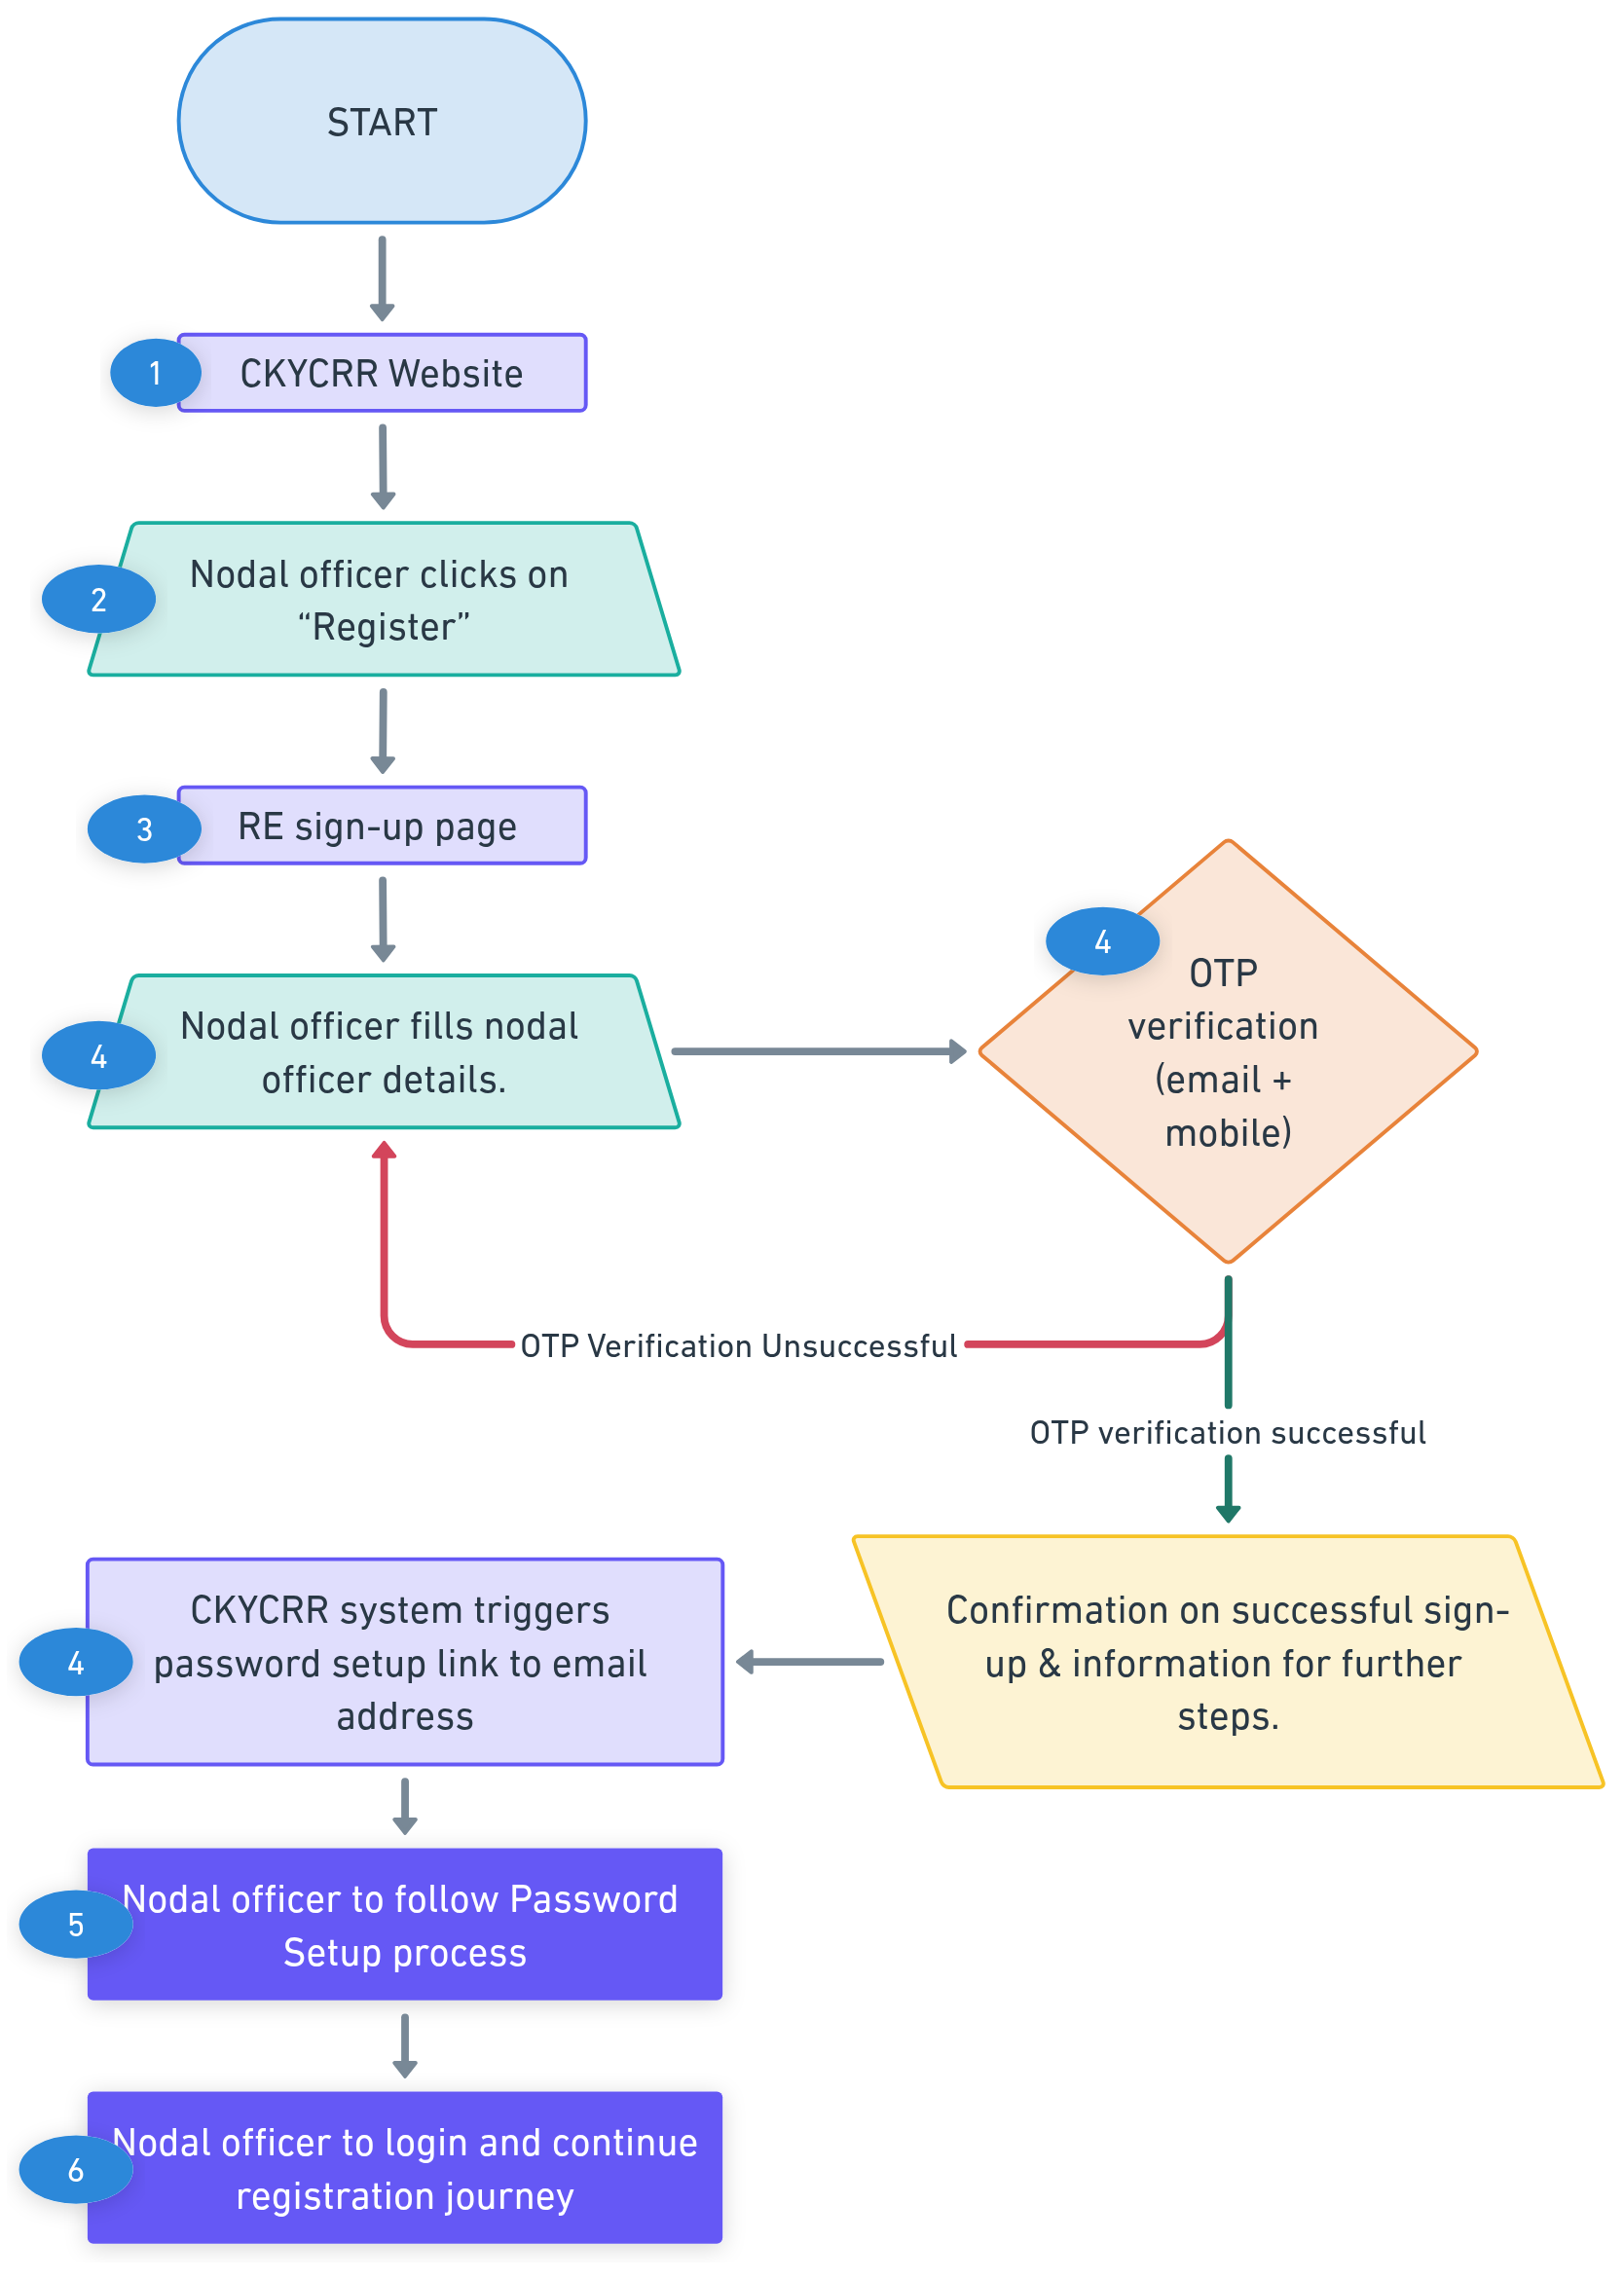
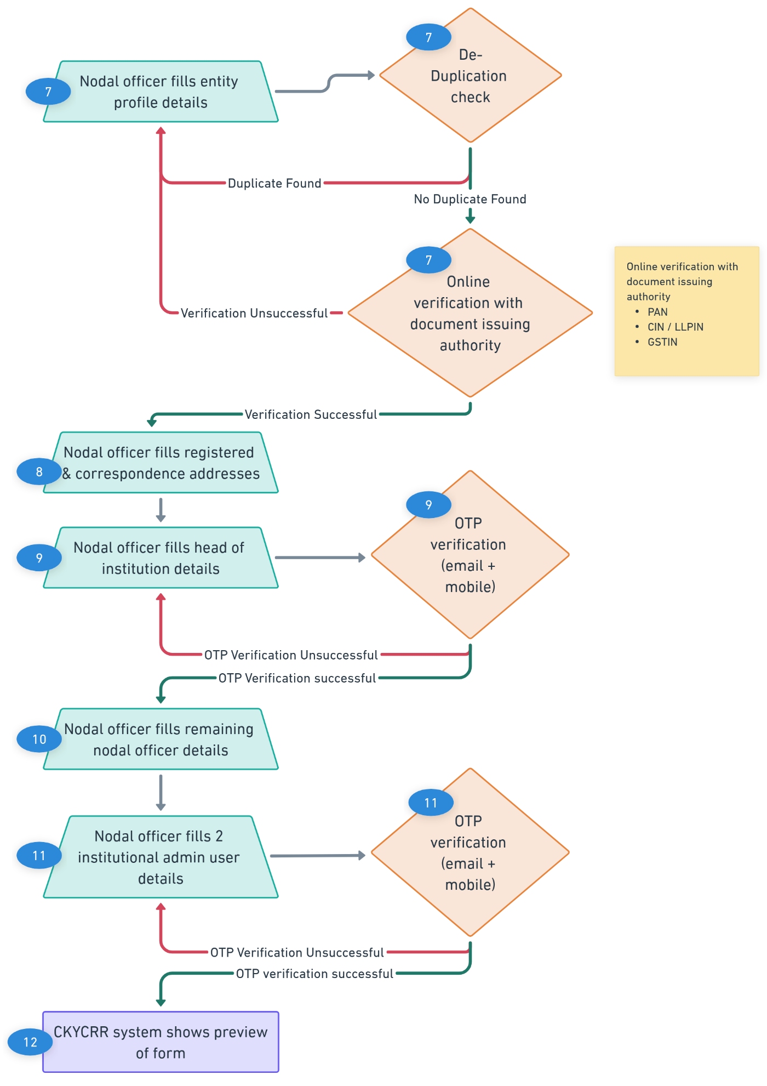
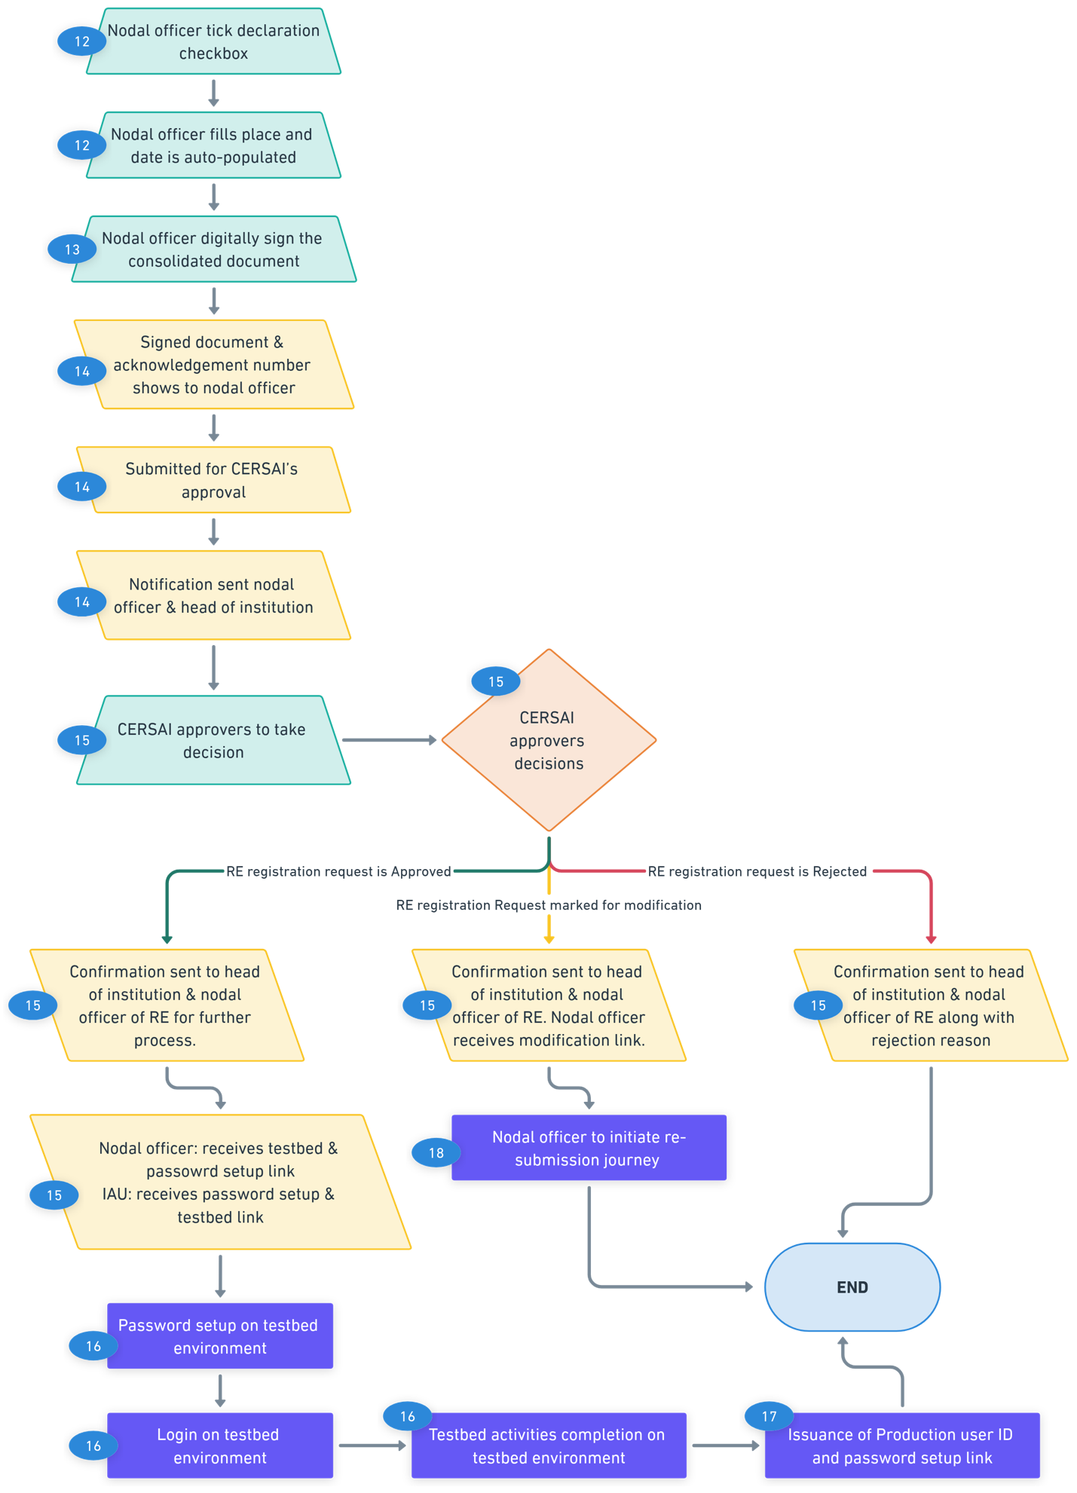
Points to remember:
- The CKYCRR system will check all fields validations in the registration form when nodal officer clicks save and next button. If the validation fails, the CKYCRR system will prompt error message to the nodal officer to update/ modify the respective fields.
- The nodal officer cannot proceed to the next step/ section without completing all mandatory fields in the current step/section. However, the nodal officer can navigate to the previous sections and make modifications to provided information and uploaded documents.
- The OTPs sent to the nodal officer, head of institution and institutional admin users to their registered mobile number and email addresses is valid for 10 minutes. The nodal officer of the reporting entity can request a resend of OTP as per below time intervals:
  - 30 seconds (1st attempt)
  - 60 seconds (2nd attempt)
  - 90 seconds (3rd attempt)
The CKYCRR system will send OTPs as per the above timeframes. Post 4 consecutive invalid OTP, the CKYCRR system will not send the OTP to particular email address or mobile number for 2 hours.
- If the registration request is not submitted within 30 days of sign-up by the nodal officer of the reporting entity, the CKYCRR system will automatically purge the draft data and the nodal officer details. Post purging of the data, the nodal officer of the reporting entity must reinitiate the sign-up and registration process. During the 30 days period CKYCRR system will send reminder emails to nodal officer email every 7 days.
- The password setup link sent by CKYCRR system to the nodal officer will be valid for 48 hours. Post 48 hours, the link will expire automatically and the CKYCRR system will re-trigger the password setup link to the nodal officer of the reporting entity. The CKYCRR system will trigger the link 14 times automatically, post that the purge policy will apply and sign-up information provided by the nodal officer will be purged in the CKYCRR system.
- Upon submission, the CKYCRR system generates an acknowledgment number and the same is shared with the nodal officer and head of institution along with the signed consolidated document of the registration form. The acknowledgement number can be used by the nodal officer to track the status of registration request submitted for the CERSAI approval. The nodal officer can track the status using option mentioned below
  - Register: The nodal officer can click on register button on the CKYCRR website and login using the registered email address, password and DSC. Post successful login, the CKYCRR system will show the status of registration request submitted for CERSAI’s approval along with the signed documents.
- The nodal officer must follow the password and DSC setup process and login process as per the processes defined in modules.
- Access to the CKYCRR system will only be granted after CERSAI approval and successful completion of testbed activities in the testbed environment by the nodal officer / the institutional admin users of the reporting entity.
- Once the registration application is submitted by the nodal officer of the reporting entity for CERSAI’s approval, no modifications will be allowed until action is being taken by the CERSAI official. CERSAI official can approve/ reject / send back for modification the registration application.
- The CKYCRR system will trigger notifications at the following key events
Key Event | User | Email | SMS | Post Login
Nodal Officer OTP Verification | Nodal Officer | Yes | Yes | No
Head of Institution OTP Verification | Head of Institution | Yes | Yes | No
Institutional admin user OTP Verification | Institutional admin user | Yes | Yes | No
Reminder to Resume Journey (if saved in draft) | Nodal Officer | Yes | No | No
Acknowledgment of Submission for Approval (with signed document) | Nodal Officer, Head of Institution | Yes | Yes | No
Approval / rejection/ request for modification by CERSAI | Nodal officer, Head of Institution | Yes | Yes | No
Completion of registration | Nodal officer, Head of Institution | Yes | Yes | No
Password setup link for testbed | Nodal officer, IAU | Yes | No | No
Password setup link for production | Nodal officer, IAU | Yes | No | No
Rejection by CERSAI | Nodal officer, Head of Institution | Yes | Yes | No

Resubmission of RE registration application
The nodal officer of the reporting entity must make the required modifications to the details submitted in registration form and document uploaded for CERSAI’s approval. This module enables the nodal user to make the necessary changes to previously submitted registration details and documents provided/ uploaded.

Below outlines the process of re-submission of registration details:
Step 1: CERSAI users ( either approver I or approver II) can request modifications in the registration request submitted by the nodal officer of the reporting entity.
Step 2: The CKYCRR system will trigger the email and SMS to the nodal officer and head of institution of the reporting entity with registration form modification link and the reason of the modification required provided by the CERSAI approver.
Step 3: The nodal officer of the reporting entity needs to click on the link received in the mail box to initiate the modification in the registration forms/ fields and document uploaded during last submission.
Step 4: The CKYCRR system will redirect the nodal officer of the reporting entity to the CKYCRR website and the earlier filled registration form will be displayed along with highlighted fields marked for modification.

Step 5: The nodal officer of the reporting entity can update/ modify the details under the following sections
- Entity profile and associated documents
  - The nodal officer can modify the fields and documents marked by CERSAI approver for the modification. All other fields and documents will be non-editable.
  - In case of any modification made to the name of the reporting entity, PAN of the reporting entity and regulator name, the CKYCRR system will run the de-duplication check process. The CKYCRR system checks for duplicate entries for REs based on the below parameters/ fields provided by the nodal officer:
    - For reporting entity registered as Sole Proprietorship– the CKYCRR system will check duplicates on PAN of the reporting entity, Name of the reporting Entity and regulator of reporting entity in the CKYCRR database.
    - For reporting Entity registered as others – the CKYCRR system will check duplicate on PAN of the reporting entity and regulator of reporting entity in the CKYCRR database.
Based on de-duplication check process, the CKYCRR system will follow the below steps based on duplication check result
    - Duplicate not found: The CKYCRR system will initiate online verification of updated key identifiers with document issuing authority.
    - Duplicate found: The CKYCRR system will display error message “Duplicate PAN in the CKYCRR system”. The nodal officer must provide the correct PAN.
  - In case, of any modifications made to the PAN, GSTIN, and CIN of the reporting entity, the CKYCRR system will do online verification of the identifiers with document issuing authority.
Post de-duplication check of reporting entity record in the CKYCRR system, the CKYCRR system initiates online verification of the updated key identifiers listed below with the document issuing authority
    - PAN (Permanent Account Number)
    - CIN (Corporate Identification Number)/ LLPIN (Limited liability Partnership Identification Number)
    - GSTIN (Goods and Services Tax Identification Number)
Post successful verification of the updated identifier from the document issuing authority, the CKYCRR system will navigate the nodal officer to “Address Details” section. If the verification of either one identifier fails, the CKYCRR system will display error message to provide the correct details. The nodal officer must update the details of identifier to proceed further for correction in registration form details.
If there are no changes requested for modification by the CERSAI approvers, the nodal officer of the entity can skip the entire entity profile section and above mentioned de-duplication check and online verification will not be done by the CKYCRR system.
- Registered and correspondence addresses and associated documents
  - The nodal officer can modify the fields and documents marked by CERSAI approver for the modification. All other fields and documents will be non-editable.
  - If there are no changes requested for modification by the CERSAI approvers, the nodal officer of the entity can skip the entire address section and can directly move to the next section.

- Head of institution details and associated documents
  - The nodal officer can modify the fields and documents marked by CERSAI approver for the modification. All other fields and documents will be non-editable.
  - In case of any modifications made to the email address and/or mobile number of the head of institution by the nodal officer, the CKYCRR system will trigger OTPs to new email address and/or mobile number registered. The nodal officer must enter the mobile OTP sent to registered mobile number of head of institution and/ or email OTP sent to registered email address of the head of institution and click “Submit” button. The CKYCRR system will validate the OTPs entered by the nodal officer. Upon successful OTP validation, the CKYCRR system moves to the next section. If the OTP verification fails, the CKYCRR system will display error message “Incorrect email/ mobile OTP”. The nodal officer will have to re-enter the OTPs sent to provided email address and/or mobile number of the head of institution.
  - If there are no changes requested for modification by the CERSAI approvers, the nodal officer of the entity can skip the entire head of institution details section and can directly move to the next section.
- Nodal officer details and associated documents
  - The nodal officer can modify the fields and documents marked by CERSAI approver for the modification. All other fields and documents will be non-editable.
  - In case of any modifications made to type of proof of identity type, the nodal officer of the reporting entity must provide the associate proof of identity number and document. The CKYCRR system will initiate the online verification with the document issuing authority of the provided proof of identity number. Post successful verification of the proof of identity number, the CKYCRR system will navigate the nodal officer to the next section. If the online verification fails, the CKYCRR system will display an error message “Invalid proof of identity number. Please try again”.
  - If there are no changes requested for modification by the CERSAI approvers, the nodal officer of the entity can skip the entire nodal officer details section and can directly move to the next section.
- Institutional admin user details and associated documents
  - The nodal officer can modify the fields and documents marked by CERSAI approver for the modification. All other fields and documents will be non-editable.
  - In case of any modifications made to the email address and/or mobile number of the institutional admin users by the nodal officer, the CKYCRR system will trigger OTPs to new email address and/or mobile number registered. The nodal officer must enter the mobile OTP sent to registered mobile number of institutional admin users and/ or email OTP sent to registered email address of the institutional admin users and click “Submit” button. The CKYCRR system will validate the OTPs entered by the nodal officer. Upon successful OTP validation, the CKYCRR system moves to the next section. If the OTP verification fails, the CKYCRR system will display error message “Incorrect email/ mobile OTP”. The nodal officer will have to re-enter the OTPs sent to provided email address and/or mobile number of the institutional admin users.
  - In case of any modifications made to type of proof of identity type, the nodal officer of the reporting entity must provide the associate proof of identity number and document. The CKYCRR system will initiate the online verification with the document issuing authority of the provided proof of identity number. Post successful verification of the proof of identity number, the CKYCRR system will navigate the nodal officer to the next section. If the online verification fails, the CKYCRR system will display an error message “Invalid proof of identity number. Please try again”.
  - If there are no changes requested for modification by the CERSAI approvers, the nodal officer of the entity can skip the entire institutional admin users details section and can directly move to the next section.
Step 6: Form Preview: The nodal officer is shown with a preview of the complete form filled by them, including thumbnails of the uploaded documents.
Nodal officer has two options on preview page:
- Edit – If nodal officer wishes to update any details provided by him/her, the nodal officer can click the ‘Edit’ button to navigate to specific section / tab to modify the details.
- Save and Next – If nodal officer feels all provided information and documents are valid then the nodal officer can click on the “Save and Next” button to proceed further in registration journey. Post clicking “Save and Next” button, the CKYCRR system will display a consolidated document of information provided and documents uploaded by the nodal officer of the reporting entity for preview and signing purposes. The document will only be available for viewing and download will not be allowed at this stage.
The CKYCRR system will display the below fields on the screen to the nodal officer to complete the registration journey
- Declaration* : The nodal officer of the reporting entity needs to provide the declaration before submitting the registration form for CERSAI’s approval.
- Place: The nodal officer of the reporting entity to needs to enter the place of declaration.
- Date: The CKYCRR system will auto-populate the current date and the nodal officer will not be allowed to modify it.
*Declaration: I hereby declare that the details furnished above are true and correct to the best of my knowledge and belief and I undertake to inform you of any changes therein immediately on their occurrence. In case any of the above information is found to be false or untrue or misleading or misrepresenting I am aware that I may be held liable for same and the consequences thereof.
Step 7: Post providing declaration and filling details of Place and Date (auto-populated by the CKYCRR system) by the nodal officer of the reporting entity, the nodal officer needs to click “eSign” button to digitally sign the consolidated document before submitting the request to CERSAI for approval. In case the document is not signed by the nodal officer, the system will not allow the submission of the registration form.
Step 8: The CKYCRR system will accept the registration request of reporting entity submitted by the nodal officer and the signed document along with the CKYCRR system acknowledgement number will be available for download. The CKYCRR system will also send the signed document to email addresses of the nodal officer and head of institution of the reporting entity.

Step 9: The CKYCRR system will display the reporting entity request in CERSAI approvers’ my task for approval. The CERSAI approvers can view the details of information and documents submitted by the nodal officer of the reporting entity. CERSAI approvers will have the following options
- Approve: The registration request of the reporting entity is approved in the CKYCRR system and the CKYCRR system triggers the approval notification to the email address and mobile number of nodal officer and head of the institution of the reporting entity. The nodal officer and institutional admin user of the reporting entity will also receive the user ID, password setup link for testbed environment.
- Request for modification: The registration request of the reporting entity will be sent back to the nodal officer of the reporting entity along with the link of resubmission form over registered email address. The nodal officer of the reporting entity will have to complete the re-submission process and submit the request for CERSAI’s approval. The CKYCRR system will also trigger email and SMS notification to registered email address of the nodal officer and head of institution on modification request.
- Reject: The registration request is rejected in the CKYCRR system and the CKYCRR system will trigger the email and SMS notification to the nodal officer and the head of institution with rejection remarks. In case, the nodal officer wishes to re-register the reporting entity, the nodal officer will have to follow sign-up and registration journey afresh.
Step 10: In case of approval of registration request: The nodal officer and institutional admin users of the reporting entity will follow password setup process (as per Password and DSC setup module), login process (as per login module) and testbed activities (as per testbed environment module) process to complete the required activities to get access to production environment.
Step 11: Upon successful completion of the testbed activities and auto approval by the CKYCRR system, the CKYCRR system will send the production URL alongwith FI code, User IDs, and password & DSC setup link for production environment.
Step 12: In case of modification required: The nodal officer of the reporting entity will have to follow re-submission of registration (as per re-submit of RE registration module) form journey to complete the registration process.
Functional Flow:
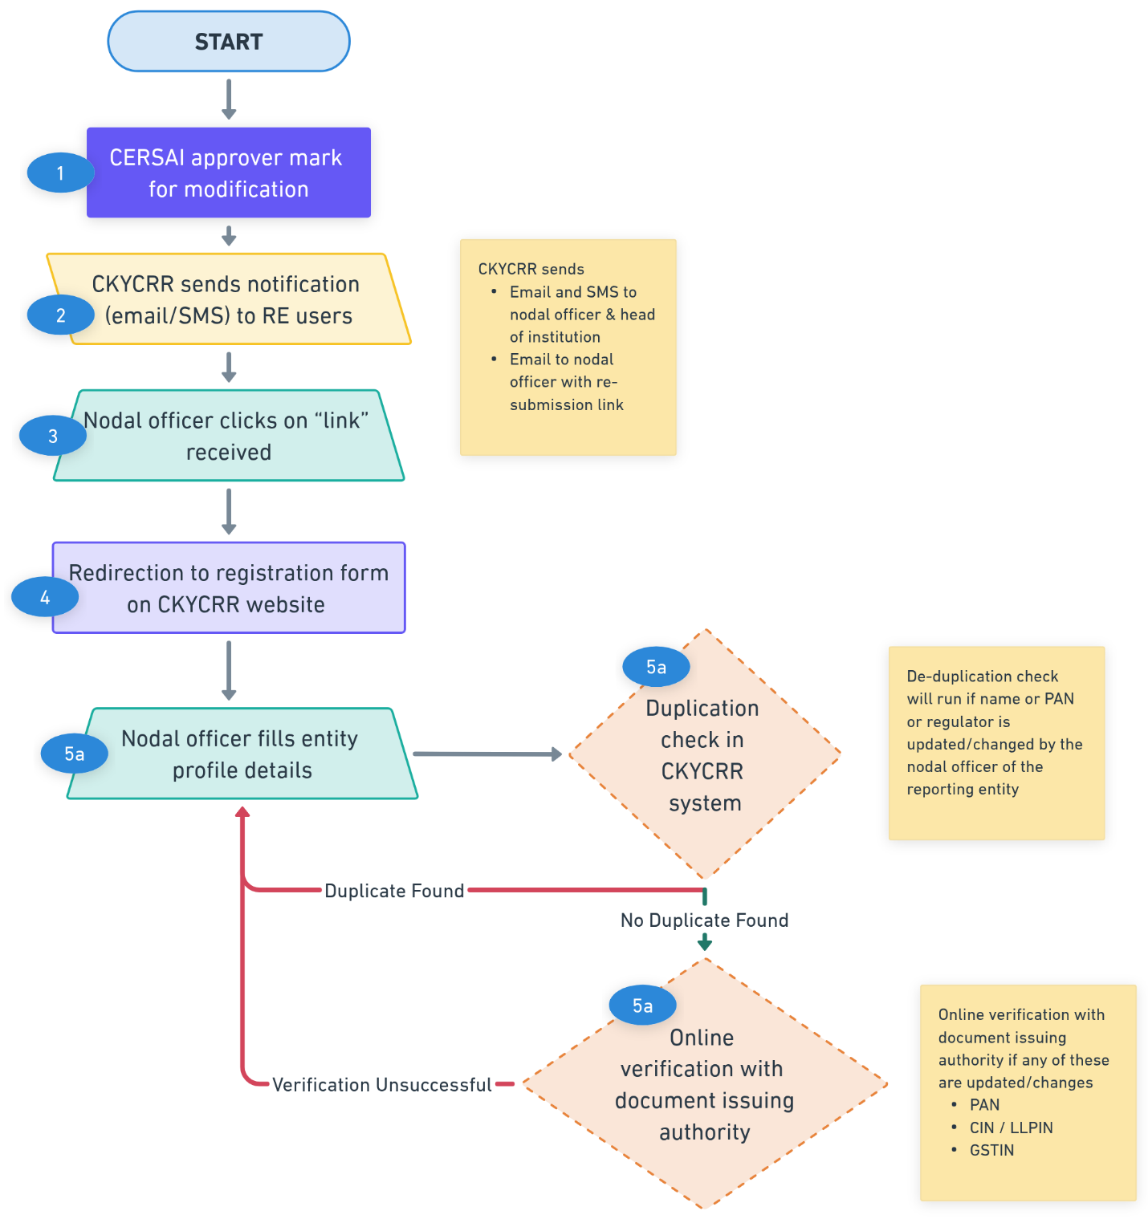
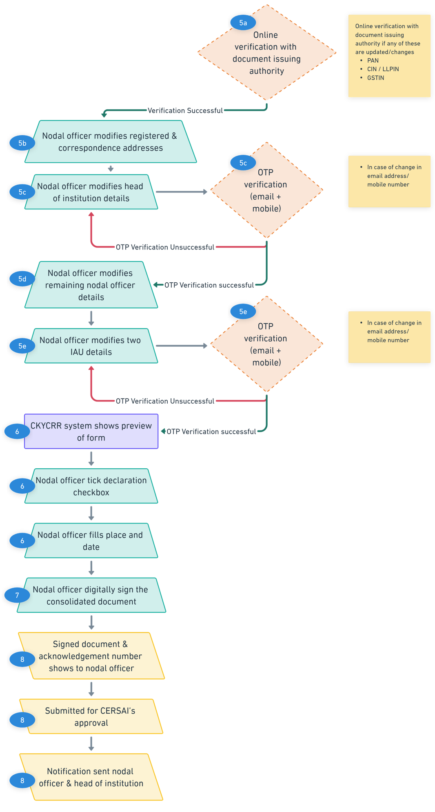
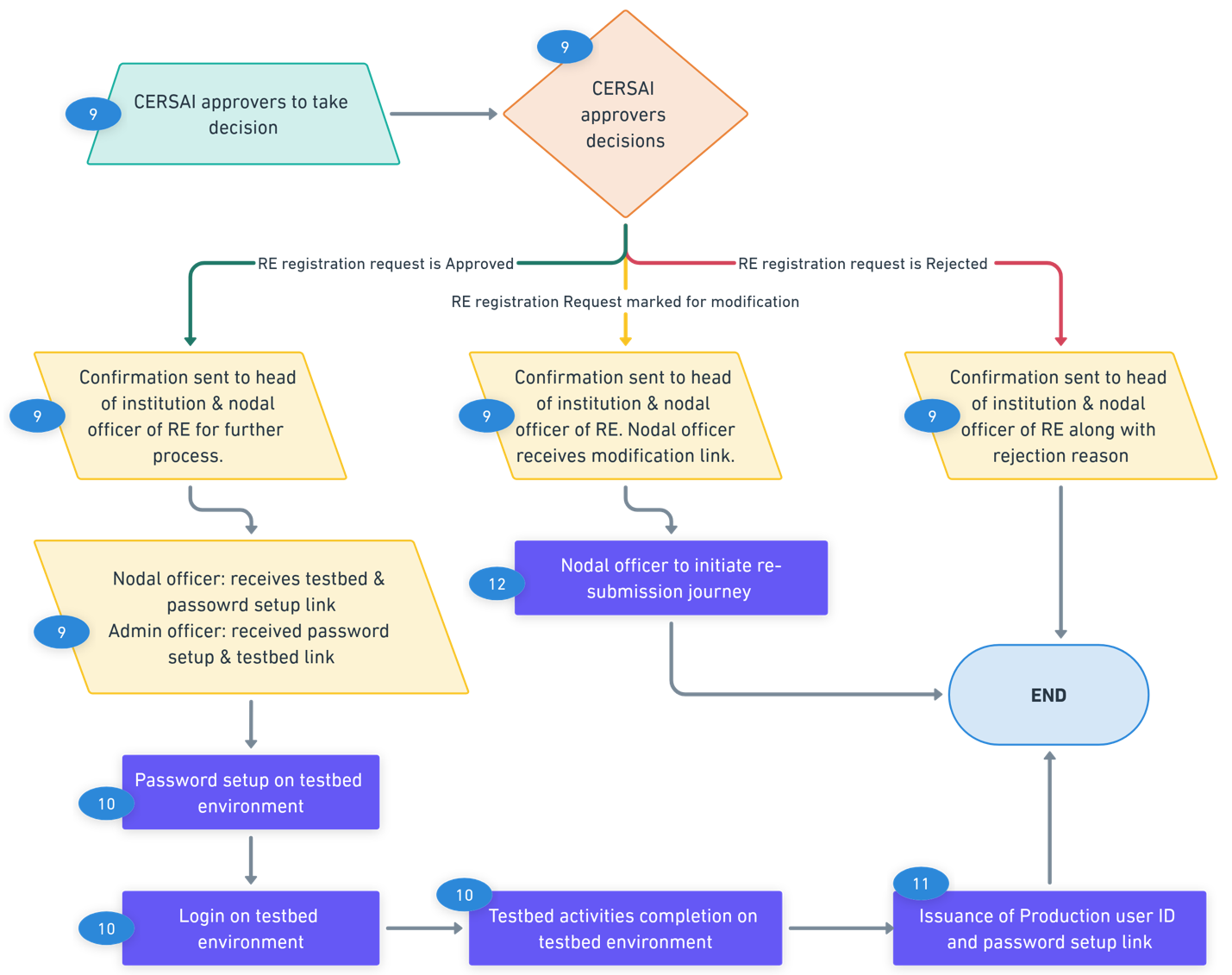

Points to remember:
- The CKYCRR system will auto-populate the details in the registration form. The nodal officer of the reporting entity is allowed to update only the fields marked for modification by the CERSAI approvers.
- The nodal officer cannot proceed to the next step without modifying all mandatory fields in the current section marked for modification by the CERSAI approvers. However, the nodal officer can navigate to the previous sections and make modifications to provided data.
- The OTPs sent to the user of the reporting entity to their registered mobile number and email addresses is valid for 10 minutes. The user of the reporting entity can request a resend of OTP as per below time intervals:
      - 30 seconds (1st attempt)
      - 60 seconds (2nd attempt)
      - 90 seconds (3rd attempt)
- The nodal officer of the reporting entity will receive periodic reminders to complete modifications and resubmit their registration requests for CERSAI’s approval.
- The acknowledgment number for the reporting entity registration request remains the same, however the document timestamp gets updated while signing the consolidated document.
- The registration request marked for modification by the CERSAI approver is marked as “Returned” status. The status “Returned” gets updated to “Pending” status in the CKYCRR system.
- Access to the CKYCRR system will only be granted after CERSAI approval and successful completion of testbed activities in the testbed environment.
- Once a registration request is submitted for CERSAI’s approval, the nodal officer cannot modify any details until CERSAI approvers take the necessary action.
- The CKYCRR system will trigger notifications at the following key events
Key Event | User | Email | SMS | Post Login
Modification information to nodal officer | Head of Institution, Nodal Officer | Yes | Yes | No
Head of Institution – email/ mobile OTP Verification | Head of Institution | Yes | Yes | No
Institutional admin user - email/ mobile OTP Verification | Institutional admin user | Yes | Yes | No
Reminder to re-submit the registration form | Nodal Officer | Yes | No | No
Acknowledgment of Submission for Approval (with signed document) | Nodal Officer, Head of Institution | Yes | Yes | No

Password and DSC setup
The Password and DSC Setup Module assists users of the reporting entity in setting up passwords for both the testbed and production environments in the CKYCRR system.
- Password Setup by the user of the reporting entity:
  - This enhances the CKYCRR system security and ensures role based access control.
  - Strengthens authentication measures to safeguard user accounts.
- Digital Signature Certificate (DSC) Authentication and mapping:
  - The CKYCRR system utilizes Class 3 DSC as a second layer of multi-factor authentication.
  - Each user of the reporting entity must map a valid Class 3 DSC to their User ID to access the CKYCRR system.

This section outlines the step-by-step process for setting up a password and mapping the Digital Signature Certificate (DSC) by the user of the reporting entity.

Step 1: The user of the reporting entity will receive an email with a password setup link on their registered email address. Email will have information about user Id issued by the CKYCRR system and environment.
Step 2: The user of the reporting entity needs to click the link received on the email address. The link will redirect the user of the reporting entity to the CKYCRR website.
Step 3: The CKYCRR system will trigger 2 different OTPs to both the registered mobile number and email address of the user of the reporting entity. Also, the CKYCRR system will display the masked email address and mobile number of the user. The user must enter the mobile OTP sent to registered mobile number and email OTP sent to registered email address and click “Submit” button. The CKYCRR system will validate the OTPs entered by the user of the reporting entity. Upon successful OTP validation, the CKYCRR system navigates the user of reporting entity to password setup and DSC screen. If the OTP verification fails, the CKYCRR system will display error message “Incorrect email/ mobile OTP”. The user will have to re-enter the OTPs sent to provided email address and mobile number.
Step 4: Post successful authentication of the OTPs, the user of the reporting entity needs to enter password and confirm password. The CKYCRR system will validate the password strength and match the password and confirm password entered by the user of the reporting entity. If the validation fails, the CKYCRR system will display error message “Please modify passwords and try again”. If the password match, the CKYCRR system moves to the next step.
Step 5: The user of the reporting entity will have to upload the class 3 DSC certificate. Post upload of DSC file in the CKYCRR system, the CKYCRR system will validate the DSC certificate as per the rules defined further in points to remember section.
- Authentication- Valid → Provided/ uploaded DSC file is valid: The CKYCRR system will display confirmation on successful password setup.
- Authentication- Invalid → Provided/ uploaded DSC file is invalid: The CKYCRR system will display error message “Invalid DSC file. Please try again”.
Step 6: The CKYCRR system displays confirmation of the successful password setup and sends notification on registered email address of the user of the entity along with the information pertaining to testbed or production environment login links. In case of first time password setup by the nodal officer of the reporting entity, the CKYCRR system will send the link of registration form of the reporting entity to complete the registration journey of the reporting entity.
Functional Flow:
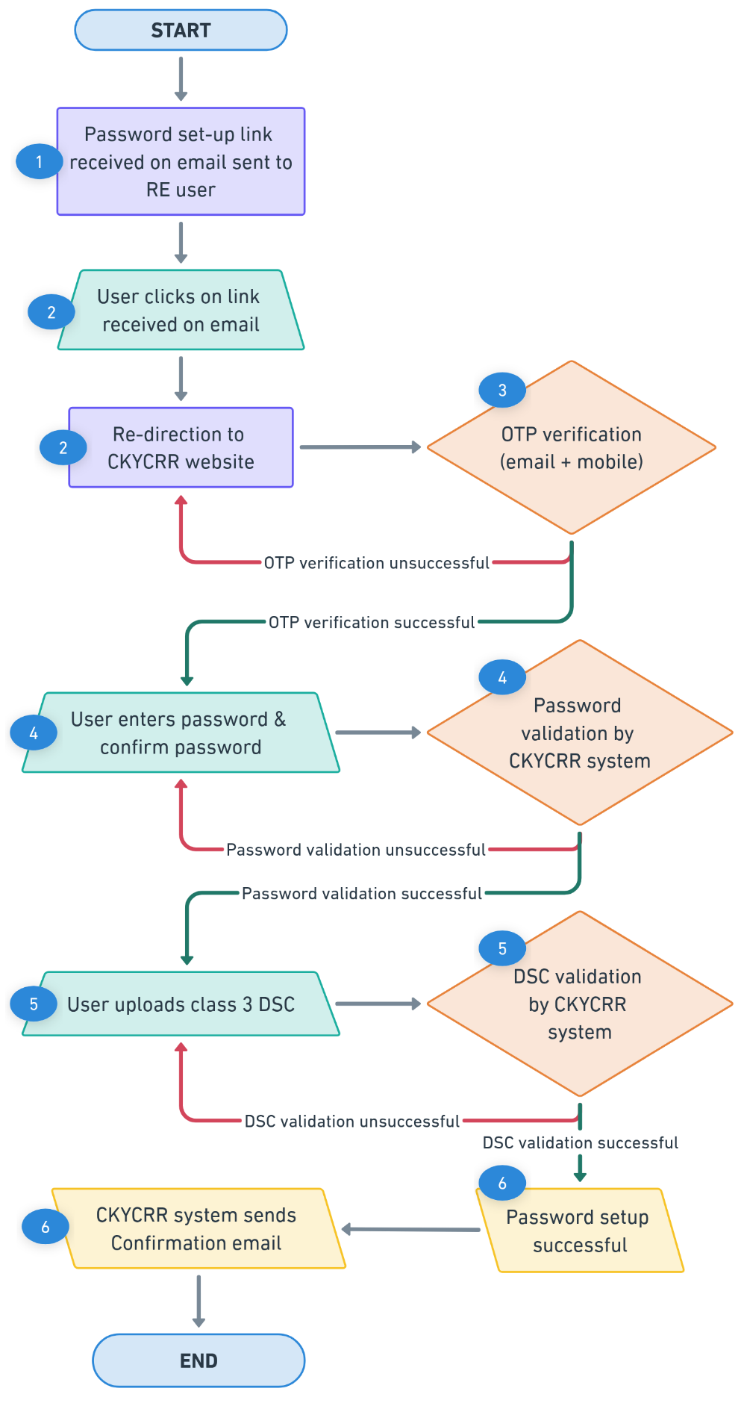
Points to Remember:
- Separate Passwords: The users of the reporting entity must set up separate passwords for the testbed and production environments.
- Email-Only communication: The CKYCRR system will send password setup link to the registered email address of the user of the reporting entity.
- DSC Utility Requirement: The user of the reporting entity must download and install the DSC utility from the CKYCRR website’s ‘Download’ section before or during the password setup process.
- The OTPs sent to the nodal officer, head of institution and institutional admin users to their registered mobile number and email addresses is valid for 10 minutes. The user of the reporting entity can request a resend of OTP as per below time intervals:
  - 30 seconds (1st attempt)
  - 60 seconds (2nd attempt)
  - 90 seconds (3rd attempt)
- The password entered/ provided by the user of the reporting entity must meet the following criteria in the CKYCRR system:
  - Minimum Length: 8-16 characters
  - At least one uppercase letter (A-Z)
  - At least one lowercase letter (a-z)
  - At least one numeric digit (0-9)
  - At least one special character (!@#$%^&*_-+=)
  - No spaces allowed
As the user of the reporting entity enters the password and confirm password, the CKYCRR system will dynamically validate each requirement in real-time. A green tick (✔) will appear next to each criterion once it is met. If a criterion is not fulfilled, a red cross (✖) will be displayed, indicating the requirement that needs to be incorporated. The user of the reporting entity cannot proceed until all password criteria are successfully met.
- The CKYCRR system will trigger notifications at the following key events
Key Event | User | Email | SMS | Post Login
User ID and environment information | User of RE | Yes | No | No
OTP Verification | User of RE | Yes | Yes | No
Confirmation on successful setup of the password | User of RE | Yes | No | No

Login
Login is the process of authenticating a user's identity before granting/permitting access to the CKYCRR system. It involves entering a User ID provided by the CKYCRR system and password set by the user, along with additional authentication methods of uploading the class 03 Digital Signature Certificates (DSC) mapped during password setup process for enhanced security. The login process is a critical security measure that ensures authorized access, data protection, and system integrity. It plays a key role in preventing security threats and maintaining user accountability.

Type of reporting entity users who can login to the CKYCRR system:
- Nodal officer
- Institutional admin users
- Institutional users
- Institutional Regional admin users
- Institutional Regional users
- Institutional Branch user

Below outlines process is for login:
Step 1: The user of the reporting entity will access domain / URL “https://www.ckycindia.in” from their respective systems connected over internet.
Step 2: Login: The user of the reporting entity has to first click on “Login” button to initiate login process to access the CKYCRR system.
Step 3: The CKYCRR system will navigate user of the reporting entity to login page where the CKYCRR system will prompt user of the reporting to enter their user ID issued by the CKYCRR system and password set by the user of the reporting entity.
Step 4: The CKYCRR system will validate the User ID and password entered by the user of the reporting entity. If the user ID and password entered do not match with the credentials in the CKYCRR system, the CKYCRR system will display error message “Invalid User ID / Password. Please try again”. If the entered user ID and password by the user of the reporting entity are valid, the CKYCRR system will prompt the user to upload the DSC mapped to user ID in the CKYCRR system.
Step 5: Post uploading of the DSC certificate by the user of the reporting entity, the CKYCRR system will validate the DSC uploaded with the user ID. The CKYCRR system will also authenticate the validity of the DSC certificate at the time of user login process. If the uploaded DSC by the user of the reporting entity fails the authentication process, the CKYCRR system will display the error message “Invalid DSC uploaded. Please try again”. Upon successful authentication of DSC, the CKYCRR system grants access to the user of the reporting entity and lands on the dashboard page.
Step 6: The CKYCRR system starts session management of the logged in user of the reporting entity and modules of the CKYCRR system are displayed in menu items are per the role based access control (RBAC).

Functional Flow:
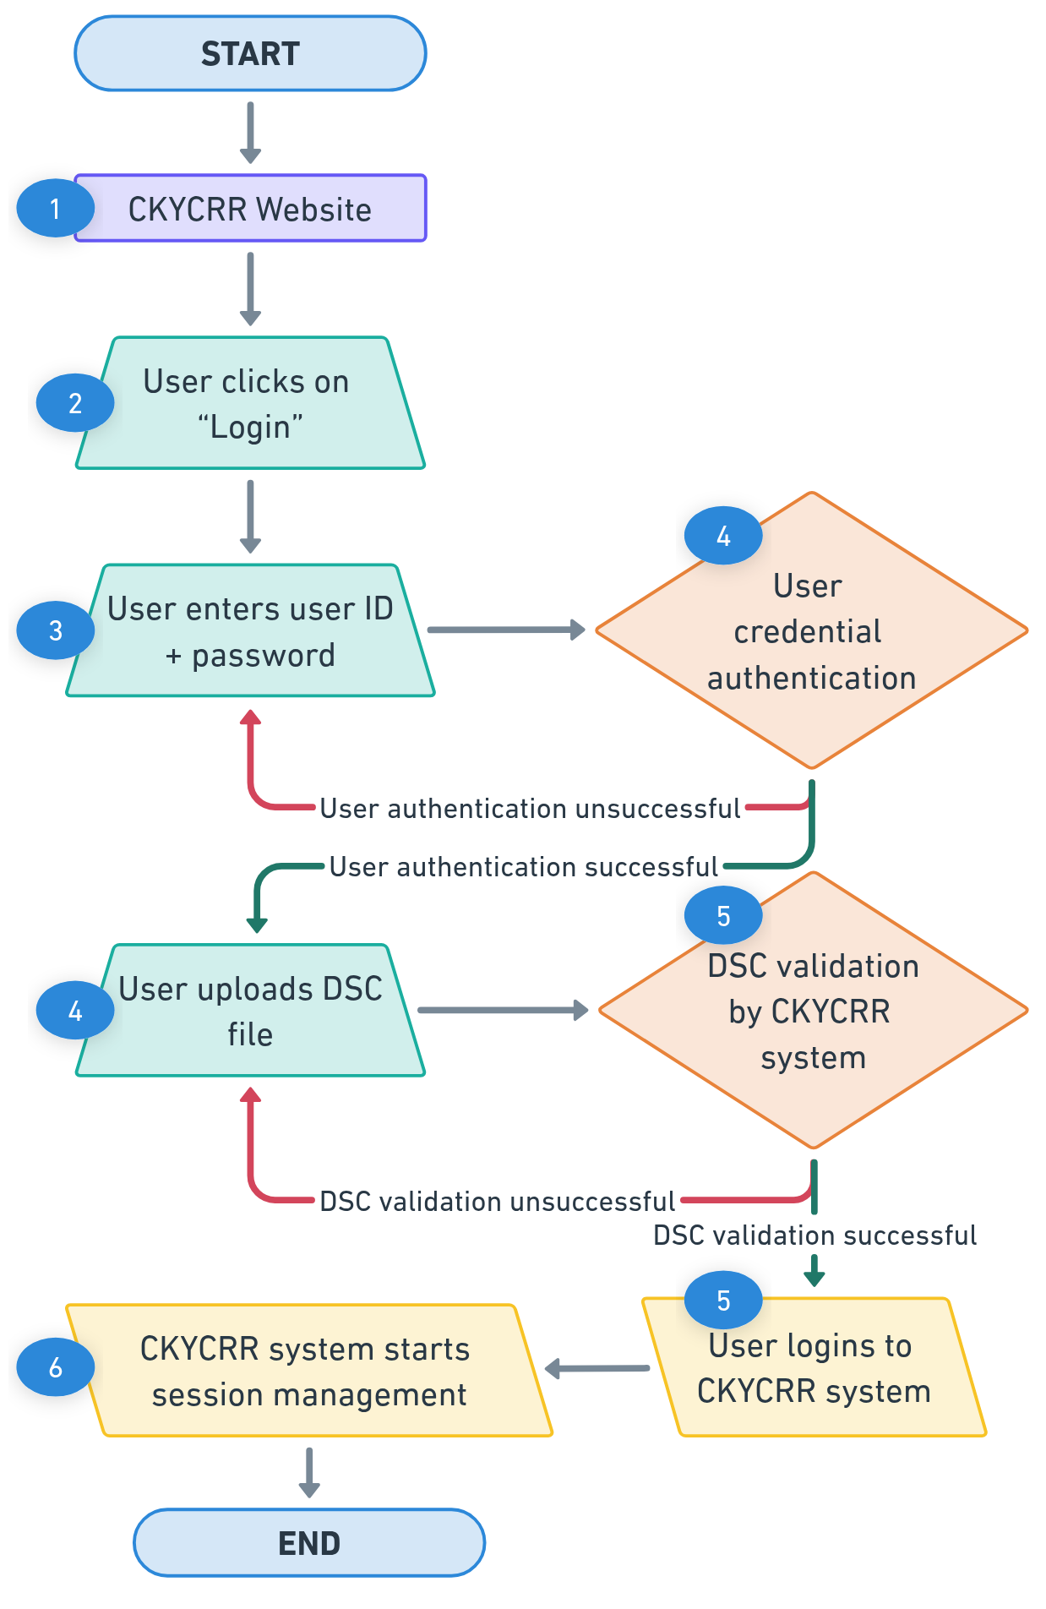

Points to remember:
- If the user fails to log in 4 consecutive times within a 5-minute timeframe, the CKYCRR system will lock their account temporarily for two hours. After this period, the CKYCRR system will automatically unlock the locked user account without requiring any manual intervention by the higher levels of the reporting entity or CERSAI admin users. However, if the users want an early unlocking of locked account, they can connect as per the below hierarchy.
RE User Level | Approval Level
Nodal Officer | CERSAI User
Institutional admin user | Nodal Officer
Institutional user | Institutional admin user
Institutional regional admin user | Institutional admin user
Institutional regional user | Institutional regional admin user
Institutional branch user | Institutional regional admin user

CERSAI User Level | Approval Level
Super admin | System Integrator
Admin users | Super Admin
Operational users | Admin user

- If the user of the reporting entity remains inactive for 10 minutes after logging in to the CKYCRR system, the CKYCRR system will automatically log them out for security reasons. Additionally, if the user of the reporting entity refreshes the browser page, the CKYCRR system will immediately terminate the session, requiring a fresh login.
- The CKYCRR system will trigger notifications at the following key events.
Key Event | User | Email | SMS | Post Login
Account Locking | User of the reporting entity | Yes | No | No

Forgot Password
The Forgot Password feature allows user of the reporting entity to reset their password if they are unable to log in to the CKYCRR system due to a forgotten or expired password. It involves verifying the user's identity through email address /mobile number, OTP verification of the email address/ mobile number, and DSC validation, followed by setting a new password.
Below outlines the process of forgot password journey:
Step 1: The user of the reporting entity will access domain / URL “https://www.ckycindia.in” from his/her respective system connected over internet.
Step 2: Login: The user of the reporting entity has to first click on “Login” button to navigate to forgot password option in the CKYCRR system.
Step 3: The user of the reporting entity needs to click on forgot password button to initiate the resetting of the password in the CKYCRR system.
Step 4: The CKYCRR system will prompt the user to enter the user ID issued by the CKYCRR system and click submit button. The CKYCRR system will check the availability of the user ID provided by the RE user in the CKYCRR system.
- Authentication- Valid → User ID exists: The CKYCRR system will trigger the email OTP and mobile OTP to their registered email address and mobile number.
- Authentication- Invalid →User ID does not exist: The CKCYRR system will display an error message “Invalid User ID. Please try again”.
Step 5: If the user ID exists, The CKYCRR system will trigger 2 different OTPs to both the registered mobile number and email address of the user. The RE user must enter the mobile OTP sent to registered mobile number and email OTP sent to registered email address and click “Submit” button. The CKYCRR system will validate the OTPs entered by the RE user. Upon successful OTP validation, the CKYCRR system navigates the RE user to password setup screen. If the OTP verification fails, the CKYCRR system will display error message “Incorrect email/ mobile OTP”. The RE user will have to re-enter the OTPs sent to provided email address and mobile number to continue password reset journey.
Step 6: Post successful authentication of the OTPs, the RE user of the reporting entity needs to enter password and confirm password. The CKYCRR system will validate the password strength and match the password and confirm password entered by the user of the reporting entity. If the validation fails, the CKYCRR system will display error message “Please modify passwords and try again”. If the password match, the CKYCRR system moves to the next step.
Step 7: The user of the reporting entity will have to upload the class 3 DSC certificate. Post upload of DSC file in the CKYCRR system, the CKYCRR system will validate the DSC certificate as per the rules defined further in points to remember section.
- Authentication- Valid → Provided/ uploaded DSC file is valid: The CKYCRR system will display confirmation on successful password setup.
- Authentication- Invalid → Provided/ uploaded DSC file is invalid: The CKYCRR system will display error message “Invalid DSC file. Please try again”.
Step 8: The CKYCRR system displays confirmation of the successful password setup and sends notification on registered email address of the user of the entity along with the information pertaining to testbed or production environment login links.
Step 9: The CKYCRR system will maintain audit of the password reset done by the user of the reporting entity and the new password will be effective immediately for login to the CKYCRR system.
Step 10: The user of the reporting entity can now login to the CKYCRR system with new password.

Functional Flow:

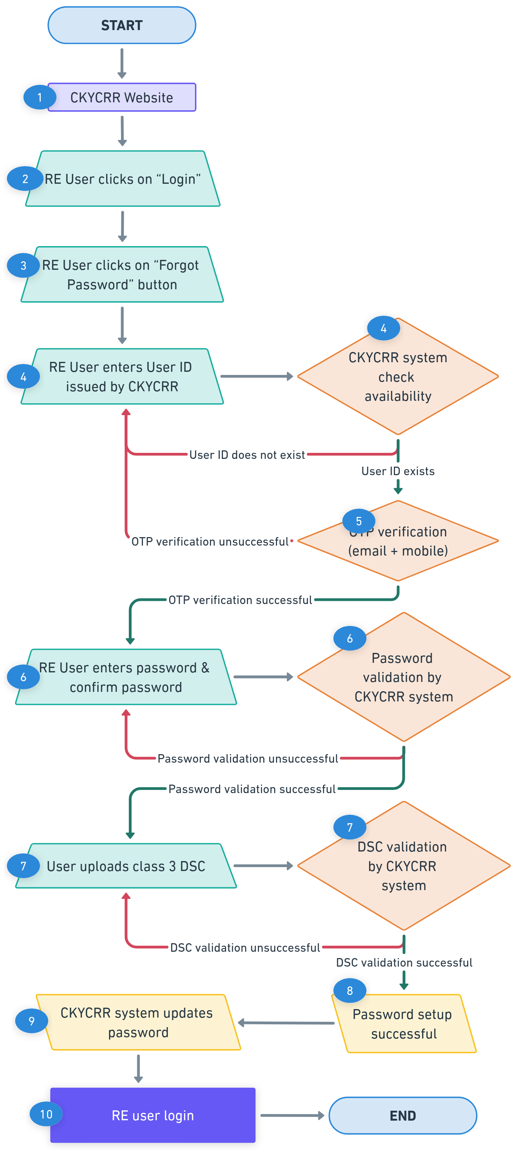
Points to remember:
- DSC Utility Requirement: The user of the reporting entity must download and install the DSC utility from the CKYCRR website’s ‘Download’ section before or during the password setup process.
- The OTPs sent to the user of the reporting entity to their registered mobile number and email addresses is valid for 10 minutes. The nodal officer of the reporting entity can request a resend of OTP as per below time intervals:
  - 30 seconds (1st attempt)
  - 60 seconds (2nd attempt)
  - 90 seconds (3rd attempt)
- The password entered/ provided by the user of the reporting entity must meet the following criteria in the CKYCRR system:
  - Minimum Length: 8-16 characters
  - At least one uppercase letter (A-Z)
  - At least one lowercase letter (a-z)
  - At least one numeric digit (0-9)
  - At least one special character (!@#$%^&*_-+=)
  - No spaces allowed
As the user of the reporting entity enters the password and confirm password, the CKYCRR system will dynamically validate each requirement in real-time. A green tick (✔) will appear next to each criterion once it is met. If a criterion is not fulfilled, a red cross (✖) will be displayed, indicating the requirement that needs to be incorporated. The user of the reporting entity cannot proceed until all password criteria are successfully met.
- The CKYCRR system will trigger notifications at the following key events
Key Event | User | Email | SMS | Post Login
OTP Verification | User of RE | Yes | Yes | No
Confirmation on successful resetting of the password | User of RE | Yes | No | No

Forgot user ID
The Forgot User ID feature allows user of the reporting entity to retrieve their registered User ID from the CKYCRR system if they have forgotten it. This ensures that user of the reporting entity can regain access to the CKYCRR system without contacting support/ helpdesk team, provided he/she verifies his/her identity through authentication mechanisms defined in the CKYCRR system.
Step 1: The user of the reporting entity will access domain / URL “https://www.ckycindia.in” or testbed environment from their respective systems connected over internet.
Step 2: Login: The user of the reporting entity has to first click on “Login” button to navigate to forgot user ID option in the CKYCRR system.
Step 3: The user of the reporting entity needs to click on forgot user ID button to retrieve user ID from the CKYCRR system.
Step 4: The CKYCRR system will prompt the user to enter the either email address or mobile number registered with the CKYCRR system and captcha and click submit button. The CKYCRR system will first validate the captcha entered by the user of the reporting entity and then check the availability of the provided email address and mobile number in the CKYCRR system.
- Authentication- Valid → Valid Captcha: The CKYCRR system will check the availability of email address/ mobile number entered by the user.
- Authentication- Invalid → Invalid Captcha: The CKYCRR system will display an error message “Invalid Captcha. Please try again”.
Post captcha validation, the CKYCRR system will check the availability of the provided email address/ mobile number. Below are the authentication possibilities:
- Email address/ mobile number exist → The CKYCRR system will send the mapped user ID to registered email address and mobile number.
- Email address/ mobile number does not exist → The CKYCRR system will display an error message “No user ID is associated with provided email/ mobile. Please try again”.
Step 5: The user of the reporting entity can check their registered email address and mobile number to get user ID issued to them by the CKYCRR system.
Step 6: The user of the reporting entity can login to the CKYCRR system using the User ID, password and authenticating DSC. In case the user has also forgotten the password, the user can follow the forgot password process instructions to reset the password.

Functional Flow:
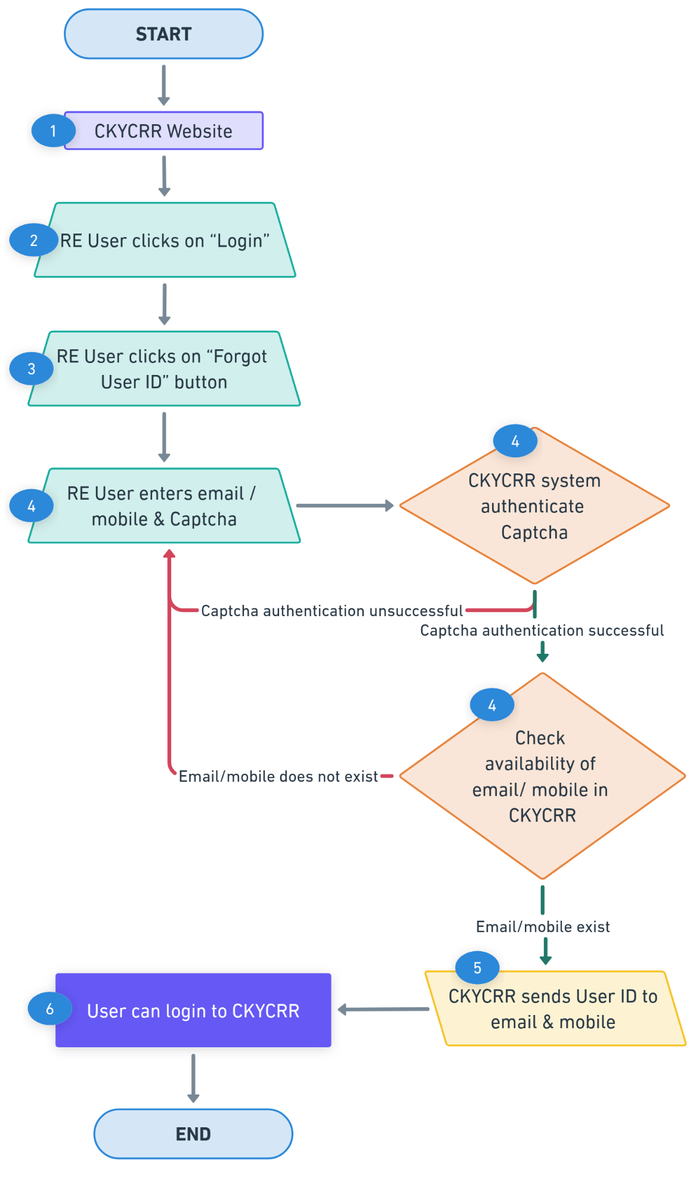
Points to remember:
- User of the reporting entity must use the correct environment to retrieve User ID from the CKYCRR system. User ID information will be sent basis environment used by user during forgot user ID process.
- Captcha verification is mandatory in the CKYCRR system to proceed to retrieve User ID.
- The CKYCRR system will trigger notifications at the following key events
Key Event | User | Email | SMS | Post Login
User ID information | User of the reporting entity | Yes | Yes | No

Testbed Environment
Testbed environment allow users of the reporting entity to familiarize themselves with CKYCRR system and practice modules before onboarding to production environment. Completion of these activities on testbed environment is mandatory to activate login credentials for the production environment.
Below outlines the process for completing test bed activities:
Step 1: CERSAI users (approver I & approver II) approves the registration request submitted by the nodal officer of the reporting entity.
Step 2: The CKYCRR system will trigger the notification to the users of the reporting entity with information of further steps. Information in notification will be as per below table:
Mode of notification | User Type (reporting entity) | Details to be sent by CKYCRR system
Email + SMS | Nodal officer | 1.Confirmation on successful approval of the registration request.  2. Testbed environment link along with user ID and password setup link.
Email | Institutional admin users | 1. Testbed environment link along with user ID and password setup link.
Email + SMS | Head of Institution | 1.Confirmation on successful approval of the registration request.
Step 3: Post password and DSC setup (as per password and DSC setup module), the user of the reporting entity will login to the testbed environment (as per login module).
Step 4: The CKYCRR system will ask the user of the reporting entity to select the mode of KYC transactions on dashboard page. The CKYCRR system will display the below options for selection
- Web Based KYC transaction (Single & Bulk)
  - Search
  - Download
  - Create/ Upload
  - Update
- API based KYC transaction
  - Search
  - Download
  - Create/ Upload
  - Update
- SFTP based KYC transaction
  - Search
  - Download
  - Create/ Upload
  - Update
The user of the reporting entity can select multiple options and submit the selection in the CKYCRR system. **The IP whitelisting process and SFTP based process will be defined in detail in SRS document.
Step 5: The users of the reporting entity need practice the below modules in the testbed environment.
Key Event | Sub-module | Mandatory/  Optional/CM | Remarks
Update Profile | Update company profile | O
 | Update user profile | O
IP whitelisting | IP registration  Public key mapping | CM | Mandatory where RE selected API and SFTP based KYC transaction
KYC Management | Web-based - Single  - Search  - Download  - Create/upload  - Update | CM | Mandatory where RE selected web based KYC transaction
 | Web-based - Bulk  - Search  - Download  - Create/upload  - Update | CM | Mandatory where RE selected web based -bulk KYC transaction
 | API based – transactions | CM | Mandatory where RE selected API based KYC transaction
 | SFTP – transactions | CM | Mandatory where RE selected SFTP based KYC transaction
Billing Management System | Balance top-up (offline/online)  Threshold amount setting  Minimum amount setting | M
 | Refund Initiation | M
 | Incentive Claim mechanism | M
 | Proforma invoice | M
 | eGST invoicing | M
Sub-user management | Region creation  Branch creation | M
 | User Creation | M
Administration | Approval of KYC record | M
 | Approval of User creation | M
 | Approval of refund/incentive request | M
*Note: All of the above activities will be carried out in maker-checker mode as per the user roles defined and processes defined for different modules.
Step 6: The CKYCRR system will track the completion status of the above modules. Post completion of the mandatory modules, the CKYCRR system will generate FI code and triggers the production environment link along with user ID and password setup link to the nodal officer and institutional admin users of the reporting entity.
Step 7: The nodal officer and institutional admin users of the reporting entity can setup the password and DSC on production environment (as per instructions in Password and DSC setup module) and login to production environment (as per instructions in login module) to carry out CKYCRR activities.
Functional Flow:
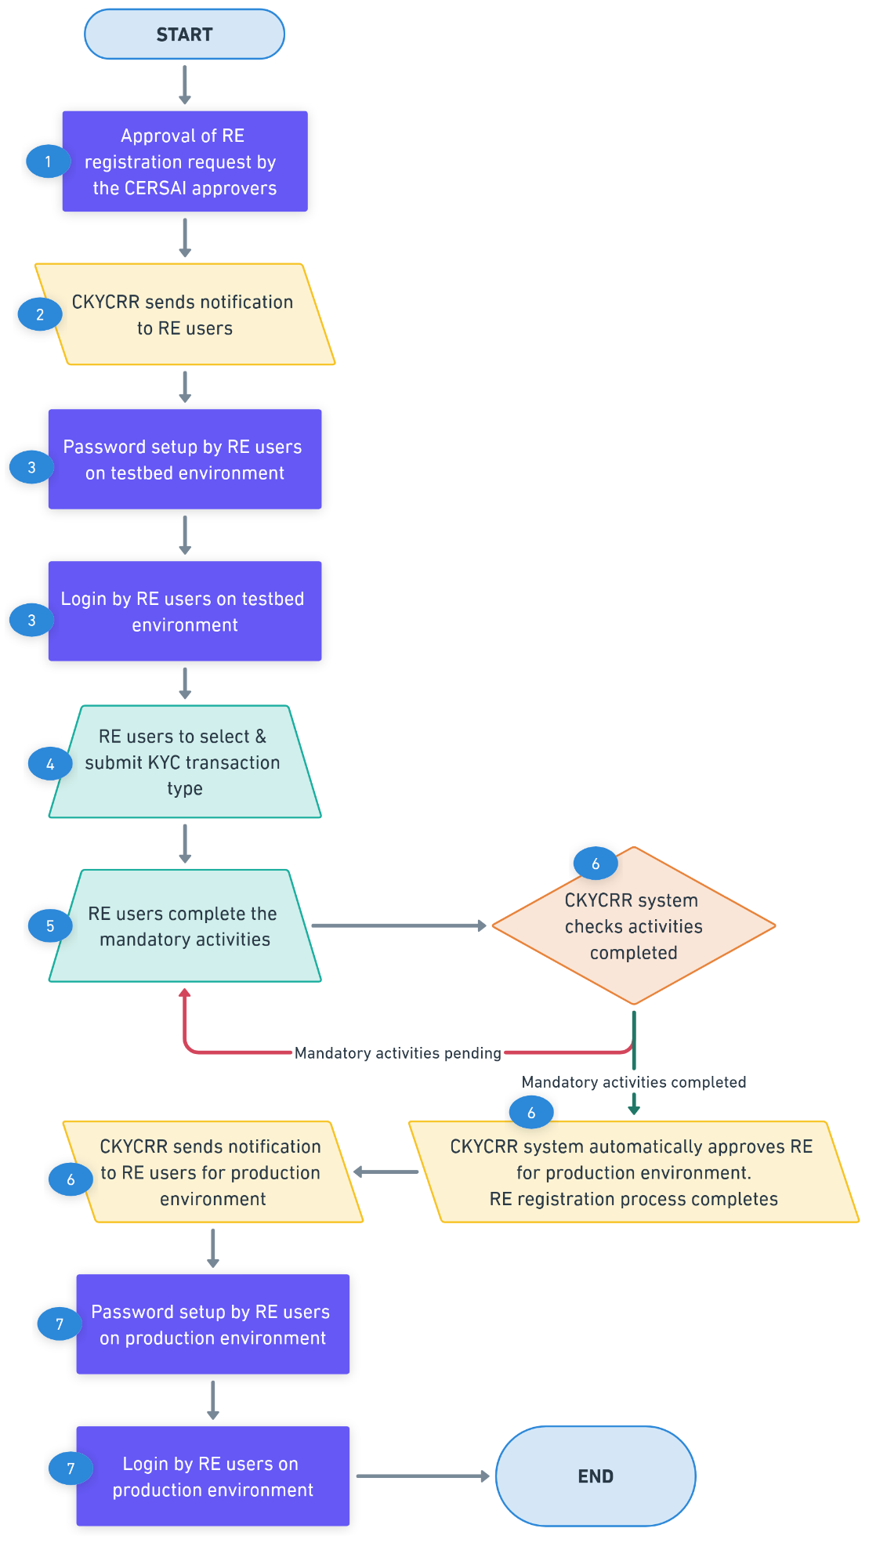

Points to remember:
- The CKYCRR issued testbed environment user IDs will have a predefined prefix to differentiate them from production environment User IDs. The testbed link/URL will be shared via email with RE users and however the testbed environment domain/URL will also be available on the CKYCRR website.
- Testbed User IDs issued to the user of the reporting entity will not have access to the production environment, and the status of the reporting entity will be marked as "In Process." The status of reporting entity will update post completion of the mandatory testbed activities by the users of the reporting entity and automatic approval by the CKYCRR system.
- Data generated from testbed activities in testbed environment will not be migrated to the production environment.
- Completion of testbed activities will be auto-approved in the CKYCRR system based on predefined criteria, with no manual intervention required by the CERSAI users or operations team. Upon approval, the CKYCRR system will send the production URL along with FI code, User IDs and password setup link for production environment.
- The DSC reading utility available under the CKYCRR website’s download will remain the same and will be operational in both testbed environment and production environment.
- IP registration is mandatory for reporting entities opting for API-based or SFTP based KYC management/ transactions. The Reporting entity must register their IP for the whitelisting process and complete the required tasks in testbed environment. Access to the production environment API will be restricted unless API-based KYC management has been successfully performed in the testbed environment by the users of the reporting entity.
- The CKYCRR system will trigger notifications at the following key events:
Key Event | User | Email | SMS | Post Login
Approval of registration and testbed environment information | Nodal officer, Institutional admin user, head of institution | Yes | Yes | No
Approval notification on completion of mandatory testbed activities | Nodal officer, Institutional admin user, head of institution | Yes | No | Yes
Production environment information and password setup links | Nodal officer, institutional admin user | Yes | Yes | No

IP whitelisting
To enable Reporting Entities (REs) to manage IP address whitelisting in CKYCRR 2.0 through a secure and auditable process involving maker-checker controls. This ensures that only verified IPs belonging to the RE are allowed system access.

Below outlines the process of IP whitelisting:
Step 1: The institutional admin user of the reporting entity will access domain / URL “https://www.ckycindia.in” or testbed environment from their respective systems connected over internet.

Step 2: The institutional admin user of the reporting entity will login to the CKYCRR system using the user ID issued, password and DSC (as per login module).

Step 3: The institutional admin user of the reporting entity will click on “IP whitelisting” button to navigate to “IP whitelisting” section.

Step 4: The institutional admin user of the reporting entity will provide the below details and submit the request to RE approver (IAU).
- Public Key (only one public key belonging to RE required)
- IP to be whitelisted (multiple IPs can be provided)

Step 5: The CKYCRR system will send the IP whitelisting request to IAU (approver) for approval. IAU will have the below actionable:
- Approve: On approval of the IP whitelisting, the CKYCRR system will initiate the process of verifying the ownership of IPs provided.
- Reject: the CKYCRR system will send email notification to the IAU (maker).

Step 6: On successful approval by the IAU, the CKYCRR system will initiate the verification of IP ownership. Basis verification carried out online, below are the possible outcome:
- IP belongs to RE: The CKYCRR system will whitelist the IPs.
- IP does not belong to RE: The CKYCRR system will send email notification to RE user (maker).
Step 7: the CKYCRR system will whitelist the IPs and notification will be sent to RE user (maker) if IP belongs to RE.

Functional Flow:
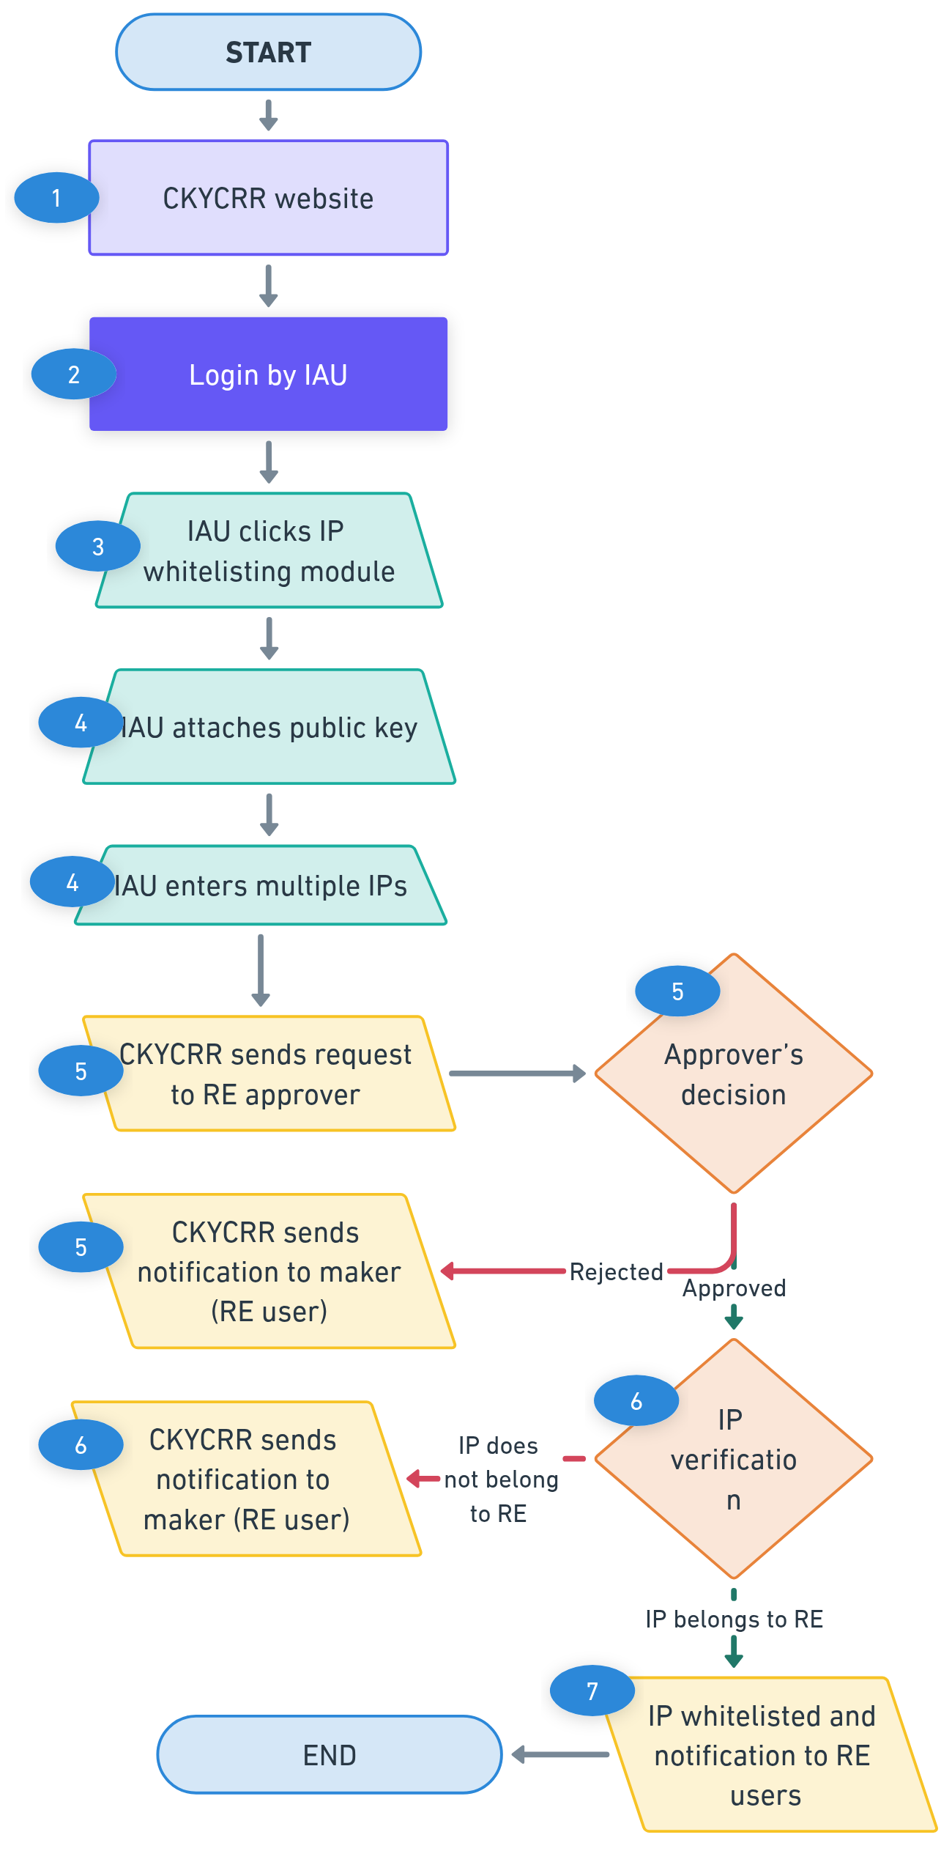
Points to remember:
- The IP whitelisting in production environment will only be enabled when RE has completed the IP whitelisting process in testbed environment and KYC transactions are completed for API based transactions and SFTP based transactions.
- The CKYCRR system will trigger notifications at the following key events
Key Event | User | Email | SMS | Post Login
Approval/ rejection notification to RE user (maker) | IAU | Yes | No | Yes
IP ownership status notification to RE user | IAU | Yes | No | Yes
IP whitelisted successfully in CKYCRR system | IAU | Yes | No | Yes

Sub-user management
At the time of reporting entity registration into the CKYCRR system, 3 user IDs will be issued (1- nodal officer, 2- institutional admin users). The institutional admin user will in turn be able to create sub-users looking at the operation of their entity as per the following structure.
Structure and mapped roles/ functionalities:
IA – Institutional Admin
IU – Institutional User
IRA – Institutional Regional Admin
IRU - Institutional Regional User
IBU - Institutional Branch User

Module | Sub-Module | NO | IAU | IU | IRA | IRU | IBU
Update Profile | Entity Profile | Y | Y | N | N | N | N
 | User Profile | Y | Y | Y | Y | Y | Y
Sub-user management | Create/modify region | N | Y | N | N | N | N
 | De-activate region | N | Y | N | N | N | N
 | Merge Regions | N | Y | N | N | N | N
 | Create/modify branch | N | Y | N | Y | N | N
 | De-activate branch | N | Y | N | Y | N | N
 | Merge Branches | N | Y | N | Y | N | N
 | Transfer branch | N | Y | N | N | N | N
 | Create/modify IU/IRA | N | Y | N | N | N | N
 | De-activate IU/IRA | N | Y | N | N | N | N
 | Suspend / revoke suspension of IU/IRA | N | Y | N | N | N | N
 | Create/modify IRU/IBU | N | Y | N | Y | N | N
 | De-activate IRU/IBU | N | Y | N | Y | N | N
 | Suspend / revoke suspension of IRU/IBU | N | Y | N | Y | N | N
Billing Management | Balance Ledger (view funds/ add funds/ set threshold amount/ set minimum amount) | Y | Y | N | N | N | N
 | Balance ledger (add bank account details) | Y | Y | N | N | N | N
 | Incentive request | Y | Y | N | N | N | N
 | Refund request | Y | Y | N | N | N | N
 | Access to proforma invoice | Y | Y | N | N | N | N
 | Access to eGST invoice | Y | Y | N | N | N | N
KYC management | Create/upload Individual KYC record (single / bulk) | N | Y | Y | Y | Y | Y
 | Update Individual KYC record (single / bulk) | N | Y | Y | Y | Y | Y
 | Search Individual KYC record (single / bulk) | N | Y | Y | Y | Y | Y
 | Download Individual KYC record (single / bulk) | N | Y | Y | Y | Y | Y
 | De-activate Individual KYC record | N | Y | N | N | N | N
 | Re-activate Individual KYC record | N | Y | N | N | N | N
 | Suspend/ revoke suspension of Individual KYC record | N | Y | N | N | N | N
 | Create/upload legal entity KYC record (single / bulk) | N | Y | Y | Y | Y | Y
 | Update legal entity KYC record (single / bulk) | N | Y | Y | Y | Y | Y
 | Search legal entity KYC record (single / bulk) | N | Y | Y | Y | Y | Y
 | Download legal entity KYC record (single / bulk) | N | Y | Y | Y | Y | Y
 | De-activate legal entity KYC record | N | Y | N | N | N | N
 | Re-activate legal entity KYC record | N | Y | N | N | N | N
 | Suspend/ revoke suspension of legal entity KYC record | N | Y | N | N | N | N
 | KYC logs - reconciliation of probable match | N | Y | Y | Y | Y | Y
 | KYC logs – Approval of bulk files uploaded | N | Y | N | Y | N | N
 | KYC logs – approval of KYC record creation | N | Y | N | Y | N | N
 | Response of bulk files uploaded | N | Y | Y | Y | Y | Y
 | Client relationship | N | Y | Y | Y | Y | Y
MIS reports | Access to MIS reports | Y | Y | Y | Y | Y | Y
Merger/amalgamation / take over/ acquisition | Raise Merger/amalgamation / take over/ acquisition request | Y | Y | N | N | N | N
De-activation of RE | Raise De-activation of RE request | Y | Y | N | N | N | N
Ticket management | Raise ticket | Y | Y | Y | Y | Y | Y
 | Track ticket | Y | Y | Y | Y | Y | Y
 | Assigned ticket | Y | Y | Y | N | N | N

Sub-user management module has below functionalities:
Functionality | Description | Allowed Actions | Managed By
Create/Modify Region | Manage operational regions under the RE. | - Create new region  - Modify region details  - De-activate region  - Merge two or more regions | Institutional admin user
Create/Modify Branch | Manage branches within assigned regions. | - Create new branch  - Modify branch details  - Link branch to a region  - Transfer branch to another region  - De-activate branch  - Merge two or more branch | Institutional regional admin  Institutional Admin User  Institutional regional admin, if within same region/ Institutional admin user if branches are in different regions
Create/Modify Users | Manage user roles and permissions. | - Create users - IU, IRA  - Modify user (IU,IRA) details & roles  - Suspend, or deactivate users | Institutional admin user
 |  | - Create users IRU, IBU  - Modify user details & roles  - Suspend, or deactivate users | Institutional regional admin

Create Region
Institutional admin user will create region by providing region name and region code.
Below outline the process of creating region:
Step 1: The institutional admin user of the reporting entity will access domain / URL “https://www.ckycindia.in” from their respective systems connected over internet.

Step 2: The institutional admin user of the reporting entity will login to the CKYCRR system using the user ID issued, password and DSC (as per login module).

Step 3: The institutional admin user of the reporting entity will click on “Sub-user management” button to navigate to “Create/ modify region” section.
Step 4: The CKYCRR system displays a list of already created regions. The institutional admin user can search any specific region by region name or region code. Also, the CKYCRR system allows institutional admin user to sort the displayed records in ascending and descending order.
Step 5: The institutional admin user can click “Create New” button to create a new region.
Step 6: The CKYCRR system will navigate the institutional admin user to the new screen and the following details to be provided
Section | Field | Field Type | Field Size | M/O/CM | Validations
Region Details | Region Name | Varchar | 50 | M | Alphanumeric values allowed
 | Region code | Varchar | 20 | M | Alphanumeric values allowed
Address details | Line 1 | Varchar | 60 | M | 1. Alphanumeric value allowed  2. Space between words is allowed  3. Following Special Characters will be allowed  `~@#$%^&*()_+-=
 | Line 2 | Varchar | 60 | O | 1. Alphanumeric value allowed  2. Space between words is allowed  3. Following Special Characters will be allowed  `~@#$%^&*()_+-=
 | Line 3 | Varchar | 60 | O | 1. Alphanumeric value allowed  2. Space between words is allowed  3. Following Special Characters will be allowed  `~@#$%^&*()_+-=
 | Country Code | Char | 4 | M | 1.Default value selected will be India (IN).  2. Dropdown values as per configurations in CMS. Draft values will be configured as per Annexure III (ISO code).
 | State / UT | Char | 2 | M | 1.Dropdown will be provided and value will be as per State Master.  2. State master values as per configurations in CMS. Draft values will be configured as per motor vehicle Act.
 | District | Varchar | 4 | CM | 1.Value should be as per district Master  2. District master as per configurations in CMS. Draft values will be configured as per motor vehicle Act.
 | City/Town | Char | 60 | M | Alphanumeric values allowed
 | Pin Code | Char | 6 | CM | 1.Only numeric values allowed and should always be 6 digit.  2.Dropdown will be provided and Dropdown value will depend upon value selected in district field  3.Pin code will be configured as per India Post Master  4.Option to select “Others” will also be provided under Pin code field in case it is not there in the dropdown values.
 | Pin code (in case of others) | Char | 6 | CM | 1.Only numeric values allowed and should always be 6 digit numeric.  2.System to verify that once others is selected and combination of state, district,, and Pin code entered by RE user matches with combination of state, district, and Pin code configured in the system, others option should not be allowed.
Note:- For the reporting entities registered outside India but operating in India, the CKYCRR system will provide provision to enter free text values in State, District, city/town and pin code up to 50 characters (alphanumeric). Also, the free text will be provisioned only if country code selected is other than India. State, district, city/town and pin code fields will be optional for reporting entities registered outside India.

Step 7: The CKYCRR system will check de-duplication of region based on region code and region name provided by the IAU. Based on de-duplication result, the below outcomes are possible
- Duplicate found: The CKYCRR system will display error message “This Region already exists. Please enter unique region details”.
- Duplicate not found: The CKYCRR system will submit the request to checker (institutional co-admin user) for approval.
Step 8: The CKYCRR system will send the request to institutional co-admin user for the approval. The CKYCRR system will display the approval request to institutional co-admin user in administration tab for further actions (Approve/ reject)
Step 9: If the region creation request is approved by the institutional co-admin user, the CKYCRR system will save the new region under reporting entity and status “Approved” will be maintained in the CKYCRR system. If the region creation is rejected by the institutional co-admin user, the CKYCRR system will mark status of region as “Rejected” and region will not be created.
Step 10: For approved region: the institutional admin user can create the institutional regional admin users and institutional regional admin user can create institutional regional user.

Functional Flow:
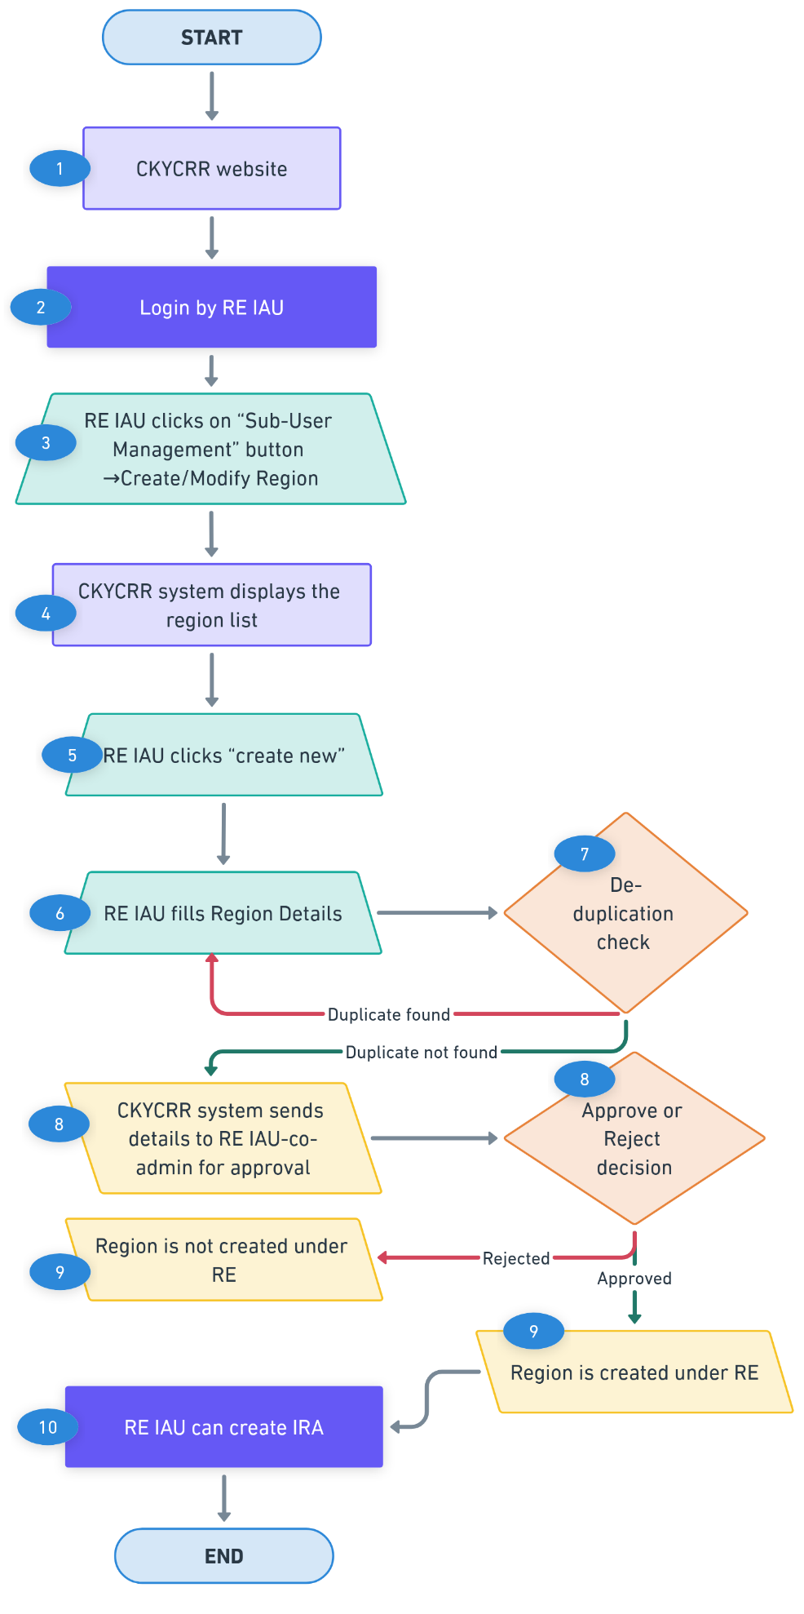

Modify Region
Institutional admin user can modify approved regions in the CKYCRR system.
Below outline the process of modifying a region:
Step 1: The institutional admin user of the reporting entity will access domain / URL “https://www.ckycindia.in” from their respective systems connected over internet.

Step 2: The institutional admin user of the reporting entity will login to the CKYCRR system using the user ID issued, password and DSC (as per login module).

Step 3: The institutional admin user of the reporting entity will click on “Sub-user management” button to navigate to “Create/ modify Region” section.
Step 4: The CKYCRR system displays a list of already created regions. The institutional admin user can search any specific region by region name or region code. Also, the CKYCRR system allows institutional admin user to sort the displayed records in ascending and descending order.
Step 5: The institutional admin user can click “Modify” button against an already approved region displayed.
Step 6: The CKYCRR system will navigate the institutional admin user to the new screen and the following details to be auto-populated
Section | Field | Field Type | Field Size | M/O/CM | Validations | Editable
Region Details | Region Name | Varchar | 50 | M | Alphanumeric values allowed | Y
 | Region code | Varchar | 20 | M | Alphanumeric values allowed | N
Address details | Line 1 | Varchar | 60 | M | 1. Alphanumeric value allowed  2. Space between words is allowed  3. Following Special Characters will be allowed  `~@#$%^&*()_+-= | Y
 | Line 2 | Varchar | 60 | O | 1. Alphanumeric value allowed  2. Space between words is allowed  3. Following Special Characters will be allowed  `~@#$%^&*()_+-= | Y
 | Line 3 | Varchar | 60 | O | 1. Alphanumeric value allowed  2. Space between words is allowed  3. Following Special Characters will be allowed  `~@#$%^&*()_+-= | Y
 | Country Code | Char | 4 | M | 1.Default value selected will be India (IN).  2. Dropdown values as per configurations in CMS. Draft values will be configured as per Annexure III (ISO code). | Y
 | State / UT | Char | 2 | M | 1.Dropdown will be provided and value will be as per State Master.  2. State master values as per configurations in CMS. Draft values will be configured as per motor vehicle Act. | Y
 | District | Varchar | 4 | CM | 1.Value should be as per district Master  2. District master as per configurations in CMS. Draft values will be configured as per motor vehicle Act. | Y
 | City/Town | Char | 60 | M | Alphanumeric values allowed | Y
 | Pin Code | Char | 6 | CM | 1.Only numeric values allowed and should always be 6 digit.  2.Dropdown will be provided and Dropdown value will depend upon value selected in district field  3.Pin code will be configured as per India Post Master  4.Option to select “Others” will also be provided under Pin code field in case it is not there in the dropdown values. | Y
 | Pin code (in case of others) | Char | 6 | CM | 1.Only numeric values allowed and should always be 6 digit numeric.  2.System to verify that once others is selected and combination of state, district and Pin code entered by RE user matches with combination of state, district and Pin code configured in the system, others option should not be allowed. | Y
Step 7: The institutional admin user will submit the modification request to institutional co-admin user for the approval. The CKYCRR system will display the modification approval request to institutional co-admin user in administration tab for further actions (Approve/ reject).
Step 8: If the region modification request is approved by the institutional co-admin user, the CKYCRR system will update the region details under reporting entity and status “Approved” will be maintained in the CKYCRR system. If the region modification is rejected by the institutional co-admin user, the CKYCRR system will mark status of region as “Rejected” and region details will not be updated.
Functional Flow:
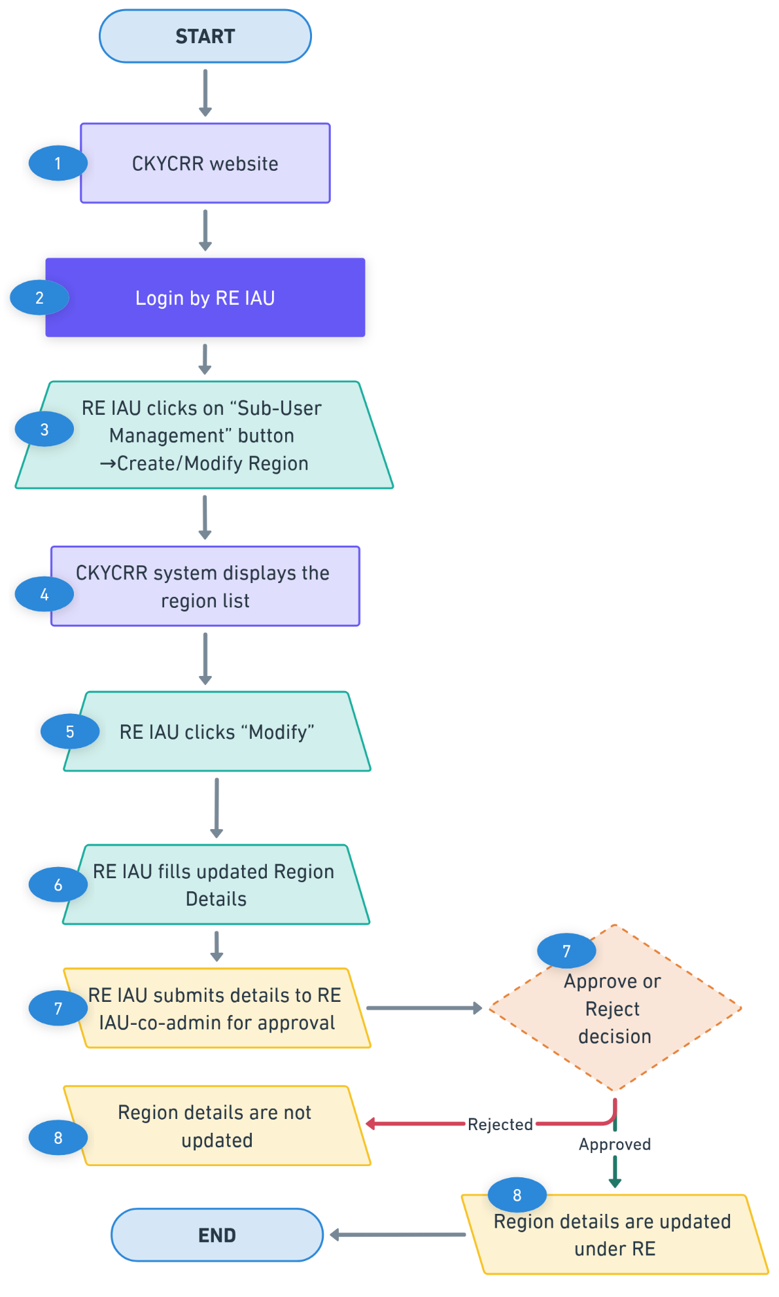

De-activation of Region
The CKYCRR system provisions de-activation of region by institutional admin users of the reporting entity

Below outlines the process of de-activating region:

Step 1: The institutional admin user of the reporting entity will access domain / URL “https://www.ckycindia.in” from their respective systems connected over internet.

Step 2: The institutional admin user of the reporting entity will login to the CKYCRR system using the user ID issued, password and DSC (as per login module).

Step 3: The institutional admin user of the reporting entity will click on “Sub-user management” button to navigate to “Create/ modify Region” section.
Step 4: The CKYCRR system displays a list of already created regions. The institutional admin user can search any specific region by region name or region code. Also, the CKYCRR system allows institutional admin user to sort the displayed records in ascending and descending order.
Step 5: The institutional admin user can click “De-activate” button against an already approved region displayed and add remarks. The CKYCRR system will show pop-up message displaying number of associated branches and users which will be de-activated along with de-activation of region.
Step 6: The CKYCRR system will prompt institutional admin user to confirm the de-activation of region. Once the de-activation is confirmed by the institutional admin user, the de-activation request will be submitted to institutional co-admin user for approval.
Step 7: The CKYCRR system will display the de-activation request to institutional co-admin user for further actions. The institutional co-admin user will have the below actionable
- Approve: The CKYCRR system will show pop-up message displaying number of associated branches and users which will be de-activated along with de-activation of region. On successful approval by institutional co-admin user, the CKYCRR system will mark the region de-activated under RE.
- Reject: The CKYCRR system will send the notification to institutional admin user (maker) and the region will not be de-activated.
Step 8: On successful approval, the CKYCRR system will mark the region as de-activated and associated branches and users of that region and its branches will also be de-activated for RE.
Functional flow:
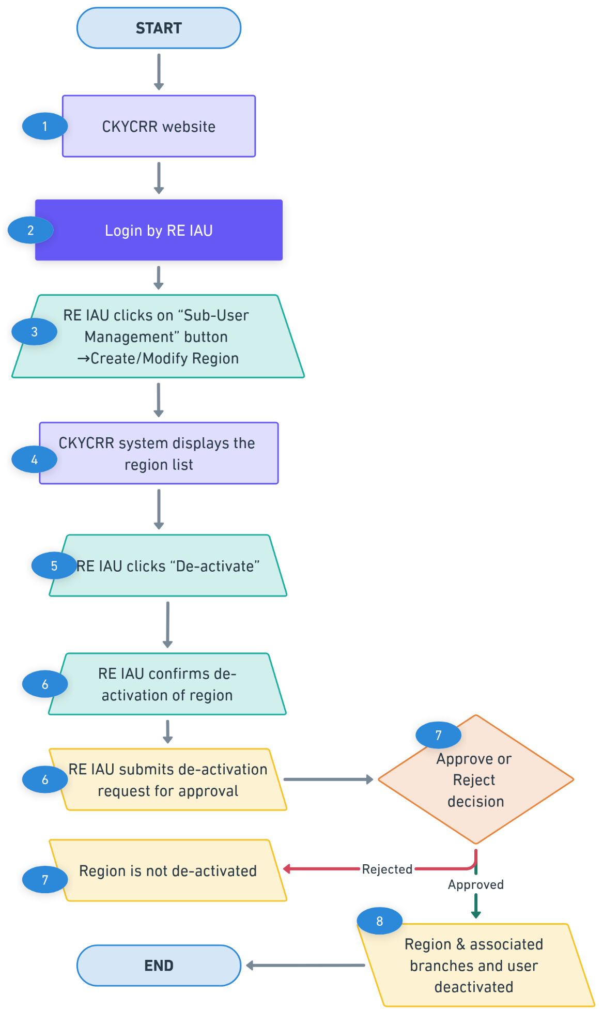

Merger of Region
The CKYCRR system provisions merger of region by institutional admin users of the reporting entity

Below outlines the process of merging regions:

Step 1: The institutional admin user of the reporting entity will access domain / URL “https://www.ckycindia.in” from their respective systems connected over internet.

Step 2: The institutional admin user of the reporting entity will login to the CKYCRR system using the user ID issued, password and DSC (as per login module).

Step 3: The institutional admin user of the reporting entity will click on “Sub-user management” button to navigate to “Create/ modify Region” section.
Step 4: The CKYCRR system displays a list of already created regions. The institutional admin user can search any specific region by region name or region code. Also, the CKYCRR system allows institutional admin user to sort the displayed records in ascending and descending order. In order to assist the user, forward / context search will be enabled in the dropdown list.
Step 5: The institutional admin user can click “Merge” button against an already approved region displayed, this selected region will be retained.
Step 6: The institutional admin user will select the single/multiple region code to be merged from dropdown value. Once the merged region code(s) are selected by the institutional admin user, the merger of region request can be submitted to institutional co-admin user for approval.
Step 7: The CKYCRR system will display the merger of region request to institutional co-admin user for further actions. The institutional co-admin user will have the below actionable
- Approve: On successful approval by institutional co-admin user, the CKYCRR system will merge the regions. The merged regions will be marked de-activated in the CKYCRR system and associated branches of merged region will be mapped to retained region. Users of merged region will be de-activated whereas users of associated branches of merged regions will continue to remain active.
- Reject: The CKYCRR system will send the notification to institutional admin user (maker) and the region will not be merged.

Step 8: On successful approval, the CKYCRR system will merge the regions. The merged regions will be marked de-activated in the CKYCRR system and associated branches of merged region will be mapped to retained/ surviving region. Users of merged region be de-activated whereas users of associated branches of merged regions will continue to remain active.
Functional flow:
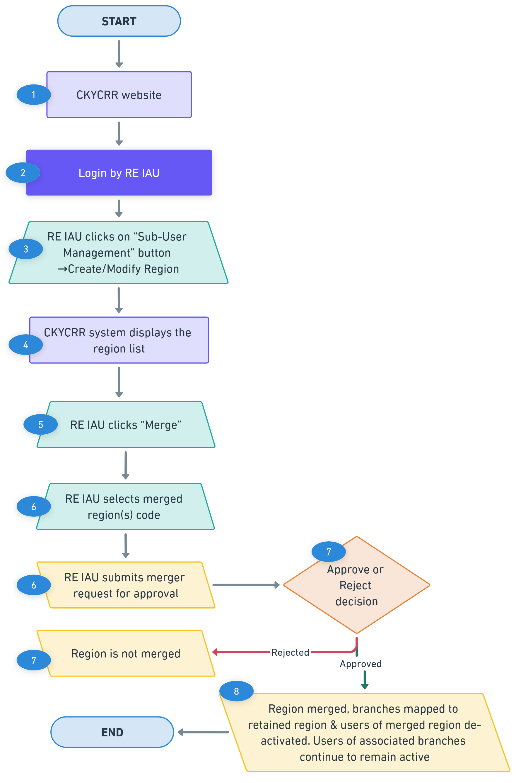

Create Branch
Institutional regional admin user will create branch by providing branch details.
Below outline the process of creating branch:
Step 1: The institutional regional user of the reporting entity will access domain / URL “https://www.ckycindia.in” from their respective systems connected over internet.

Step 2: The institutional regional user of the reporting entity will login to the CKYCRR system using the user ID issued, password and DSC (as per login module).

Step 3: The institutional regional user of the reporting entity will click on “Sub-user management” button to navigate to “Create/ modify Branch” section.
Step 4: The CKYCRR system displays a list of already created branches. The institutional regional admin user can search any specific branch by branch name and branch code. Also, the CKYCRR system allows institutional regional admin user to sort the displayed records in ascending and descending order.
Step 5: The institutional regional admin user can click “Create New” button to create a new branch.
Step 6: The CKYCRR system will navigate the institutional regional admin user to the new screen and the following details to be provided
Section | Field | Field Type | Field Size | M/O/CM | Validations
Branch Details | Branch Name | Varchar | 50 | M | Alphanumeric values allowed
 | Branch code | Varchar | 20 | M | Alphanumeric values allowed
Address details | Line 1 | Varchar | 60 | M | 1. Alphanumeric value allowed  2. Space between words is allowed  3. Following Special Characters will be allowed  `~@#$%^&*()_+-=
 | Line 2 | Varchar | 60 | O | 1. Alphanumeric value allowed  2. Space between words is allowed  3. Following Special Characters will be allowed  `~@#$%^&*()_+-=
 | Line 3 | Varchar | 60 | O | 1. Alphanumeric value allowed  2. Space between words is allowed  3. Following Special Characters will be allowed  `~@#$%^&*()_+-=
 | Country Code | Char | 4 | M | 1.Default value selected will be India (IN).  2. Dropdown values as per configurations in CMS. Draft values will be configured as per Annexure III (ISO code).
 | State / UT | Char | 2 | M | 1.Dropdown will be provided and value will be as per State Master.  2. State master values as per configurations in CMS. Draft values will be configured as per motor vehicle Act.
 | District | Varchar | 4 | CM | 1.Value should be as per district Master  2. District master as per configurations in CMS. Draft values will be configured as per motor vehicle Act.
 | City/Town | Char | 60 | M | Alphanumeric values allowed
 | Pin Code | Char | 6 | CM | 1.Only numeric values allowed and should always be 6 digit.  2.Dropdown will be provided and Dropdown value will depend upon value selected in district field  3.Pin code will be configured as per India Post Master  4.Option to select “Others” will also be provided under Pin code field in case it is not there in the dropdown values.
 | Pin code (in case of others) | Char | 6 | CM | 1.Only numeric values allowed and should always be 6 digit numeric.  2.System to verify that once others is selected and combination of state, district and Pin code entered by RE user matches with combination of state, district and Pin code configured in the system, others option should not be allowed.
Step 7: The CKYCRR system will check de-duplication of branch based on branch code and branch name provided by the IRA. Based on de-duplication result, the below outcomes are possible
- Duplicate found: The CKYCRR system will display error message “This Branch already exists. Please enter unique branch details”.
- Duplicate not found: The CKYCRR system will submit the request to checker (institutional regional co-admin user) for approval.
Step 8: The CKYCRR system will send the request to institutional regional co-admin user for the approval. The CKYCRR system will display the approval request to institutional regional co-admin user in administration tab for further actions (Approve/ reject)
Step 9: If the branch creation request is approved by the institutional regional co-admin user, the CKYCRR system will save the new branch under reporting entity and status “Approved” will be maintained in the CKYCRR system. If the branch creation is rejected by the institutional regional co-admin user, the CKYCRR system will mark status of branch as “Rejected” and the branch will not be created.
Step 10: For approved branch: the institutional regional admin user can create the institutional branch users.
Functional Flow:
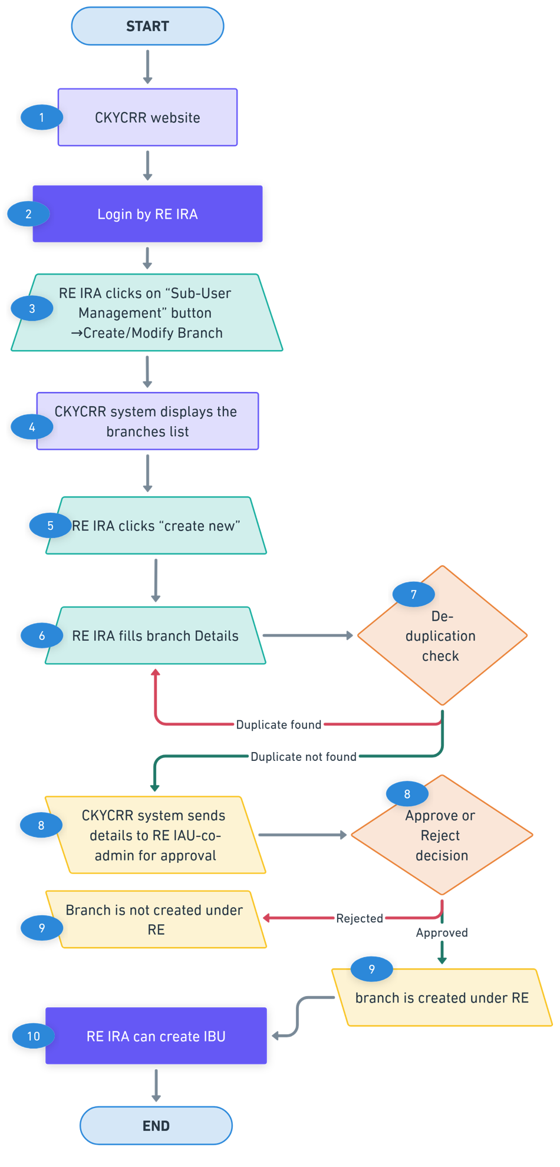

Modify Branch
Institutional regional admin user can modify approved branches in the CKYCRR system.
Below outline the process of modifying a branch:
Step 1: The institutional regional admin user of the reporting entity will access domain / URL “https://www.ckycindia.in” from their respective systems connected over internet.

Step 2: The institutional regional admin user of the reporting entity will login to the CKYCRR system using the user ID issued, password and DSC (as per login module).

Step 3: The institutional regional admin user of the reporting entity will click on “Sub-user management” button to navigate to “Create/ modify Branch” section.
Step 4: The CKYCRR system displays a list of already created branches. The institutional regional admin user can search any specific branch by branch name or branch code. Also, the CKYCRR system allows institutional regional admin user to sort the displayed records in ascending and descending order.
Step 5: The institutional regional admin user can click “Modify” button against an already approved branch displayed.
Step 6: The CKYCRR system will navigate the institutional regional admin user to the new screen and the following details to be auto-populated
Section | Field | Field Type | Field Size | M/O/CM | Validations | Editable
Branch Details | Branch Name | Varchar | 50 | M | Alphanumeric values allowed | Y
 | Branch code | Varchar | 20 | M | Alphanumeric values allowed | N
Address details | Line 1 | Varchar | 60 | M | 1. Alphanumeric value allowed  2. Space between words is allowed  3. Following Special Characters will be allowed  `~@#$%^&*()_+-= | Y
 | Line 2 | Varchar | 60 | O | 1. Alphanumeric value allowed  2. Space between words is allowed  3. Following Special Characters will be allowed  `~@#$%^&*()_+-= | Y
 | Line 3 | Varchar | 60 | O | 1. Alphanumeric value allowed  2. Space between words is allowed  3. Following Special Characters will be allowed  `~@#$%^&*()_+-= | Y
 | Country Code | Char | 4 | M | 1.Default value selected will be India (IN).  2. Dropdown values as per configurations in CMS. Draft values will be configured as per Annexure III (ISO code). | Y
 | State / UT | Char | 2 | M | 1.Dropdown will be provided and value will be as per State Master.  2. State master values as per configurations in CMS. Draft values will be configured as per motor vehicle Act. | Y
 | District | Varchar | 4 | CM | 1.Value should be as per district Master  2. District master as per configurations in CMS. Draft values will be configured as per motor vehicle Act. | Y
 | City/Town | Char | 60 | M | Alphanumeric values allowed | Y
 | Pin Code | Char | 6 | CM | 1.Only numeric values allowed and should always be 6 digit.  2.Dropdown will be provided and Dropdown value will depend upon value selected in district field  3.Pin code will be configured as per India Post Master  4.Option to select “Others” will also be provided under Pin code field in case it is not there in the dropdown values.
 | Pin code (in case of others) | Char | 6 | CM | 1.Only numeric values allowed and should always be 6 digit numeric.  2.System to verify that once others is selected and combination of state, district and Pin code entered by RE user matches with combination of state, district and Pin code configured in the system, others option should not be allowed. | Y
Step 7: The institutional regional admin user will submit the modification request to institutional regional co-admin user for the approval. The CKYCRR system will display the modification approval request to institutional regional co-admin user in administration tab for further actions (Approve/ reject).
Step 8: If the branch modification request is approved by the institutional regional co-admin user, the CKYCRR system will update the branch details under reporting entity and status “Approved” will be maintained in the CKYCRR system. If the branch modification is rejected by the institutional regional co-admin user, the CKYCRR system will mark status of branch as “Rejected” and latest approved details of branch will be kept in the CKYCRR system.
Functional Flow:
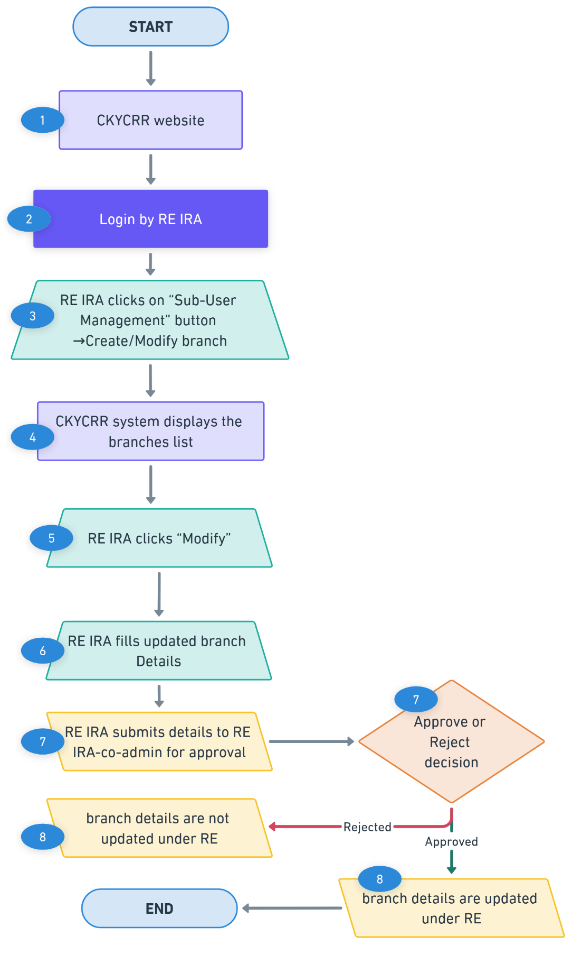

De-activation of Branch
The CKYCRR system provisions de-activation of branch by institutional regional admin users of the reporting entity.

Below outlines the process of de-activating branch:

Step 1: The institutional regional admin user of the reporting entity will access domain / URL “https://www.ckycindia.in” from their respective systems connected over internet.

Step 2: The institutional regional admin user of the reporting entity will login to the CKYCRR system using the user ID issued, password and DSC (as per login module).

Step 3: The institutional regional admin user of the reporting entity will click on “Sub-user management” button to navigate to “Create/ modify branch” section.
Step 4: The CKYCRR system displays a list of already created branches. The institutional regional admin user can search any specific branch by branch name or branch code. Also, the CKYCRR system allows institutional regional admin user to sort the displayed records in ascending and descending order. In order to assist the user, forward / context search will be enabled in the dropdown list.
Step 5: The institutional regional admin user can click “De-activate” button against an already approved branch displayed and add remarks.
Step 6: The CKYCRR system will prompt institutional regional admin user to confirm the de-activation of branch. Once the de-activation is confirmed by the institutional regional admin user, the de-activation request will be submitted to institutional regional co-admin user for approval.
Step 7: The CKYCRR system will display the de-activation request to institutional regional co-admin user for further actions. The institutional regional co-admin user will have the below actionable
- Approve: On successful approval by institutional regional co-admin user, the CKYCRR system will mark the branch de-activated under RE.
- Reject: The CKYCRR system will send the notification to institutional regional admin user (maker) and branch will not be de-activated.
Step 8: On successful approval, the CKYCRR system will mark the branch as de-activated and associated users will also be de-activated for RE.
Functional flow:
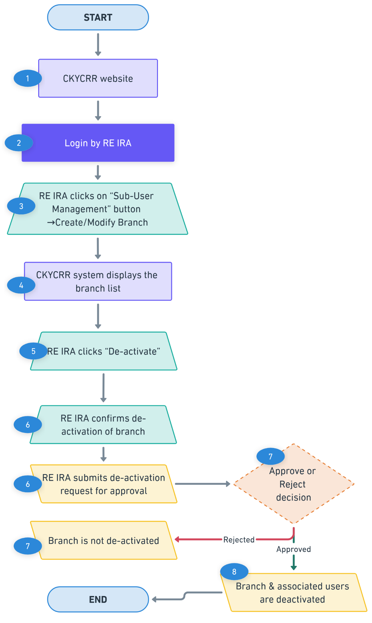

Merger of branch
The CKYCRR system provisions merger of branches by institutional admin users and institutional regional admin users of the reporting entity

Merger of branch rights
Merger of branch | Permitted to
Merger of branch within Region | Institutional regional admin user (IRA)
Merger of branch across regions | Institutional admin user (IAU)

Below outlines the process of merging branches:

Step 1: The IAU/IRA of the reporting entity will access domain / URL “https://www.ckycindia.in” from their respective systems connected over internet.

Step 2: The IAU/IRA of the reporting entity will login to the CKYCRR system using the user ID issued, password and DSC (as per login module).

Step 3: The IAU/IRA of the reporting entity will click on “Sub-user management” button to navigate to “Create/ modify Branch” section.
Step 4: The CKYCRR system displays a list of already created branches. The IAU/IRA can search any specific branch by branch name or branch code. Also, the CKYCRR system allows IAU/IRA to sort the displayed records in ascending and descending order. In order to assist the user, forward / context search will be enabled in the dropdown list.
Step 5: The IAU/IRA can click “Merge” button against an already approved branch displayed, this selected branch will be retained.
Step 6: The IAU/IRA will select the single/multiple branch code from dropdown value to be merged. Once the merged branch code(s) are selected by the IAU/IRA, the merger of branch request can be submitted to institutional co-admin user/ institutional regional co-admin user for approval.
The CKYCRR system will display the dropdown values as per below matrix:
- For IAU: the CKYCRR system will display all the branch codes alongwith branch name for selection in dropdown value.
- For IRA user: the CKYCRR system will display all the branch codes alongwith branch name of particular region for selection in dropdown values.
Step 7: The CKYCRR system will display the merger of branch request to institutional co-admin user/ institutional regional co-admin user for further actions. The institutional co-admin user/ institutional regional co-admin user will have the below actionable
- Approve: On successful approval by institutional co-admin user/ institutional regional co-admin user, the CKYCRR system will merge the branches. The merged branches will be marked de-activated in the CKYCRR system and associated branch users of merged branches will be de-activated.
- Reject: The CKYCRR system will send the notification to IAU/IRA (maker) and the branch will not be merged.
Step 8: On successful approval, the CKYCRR system will merge the branches. The merged branches will be marked de-activated in the CKYCRR system and associated branch users of merged branches will be de-activated
Functional flow:
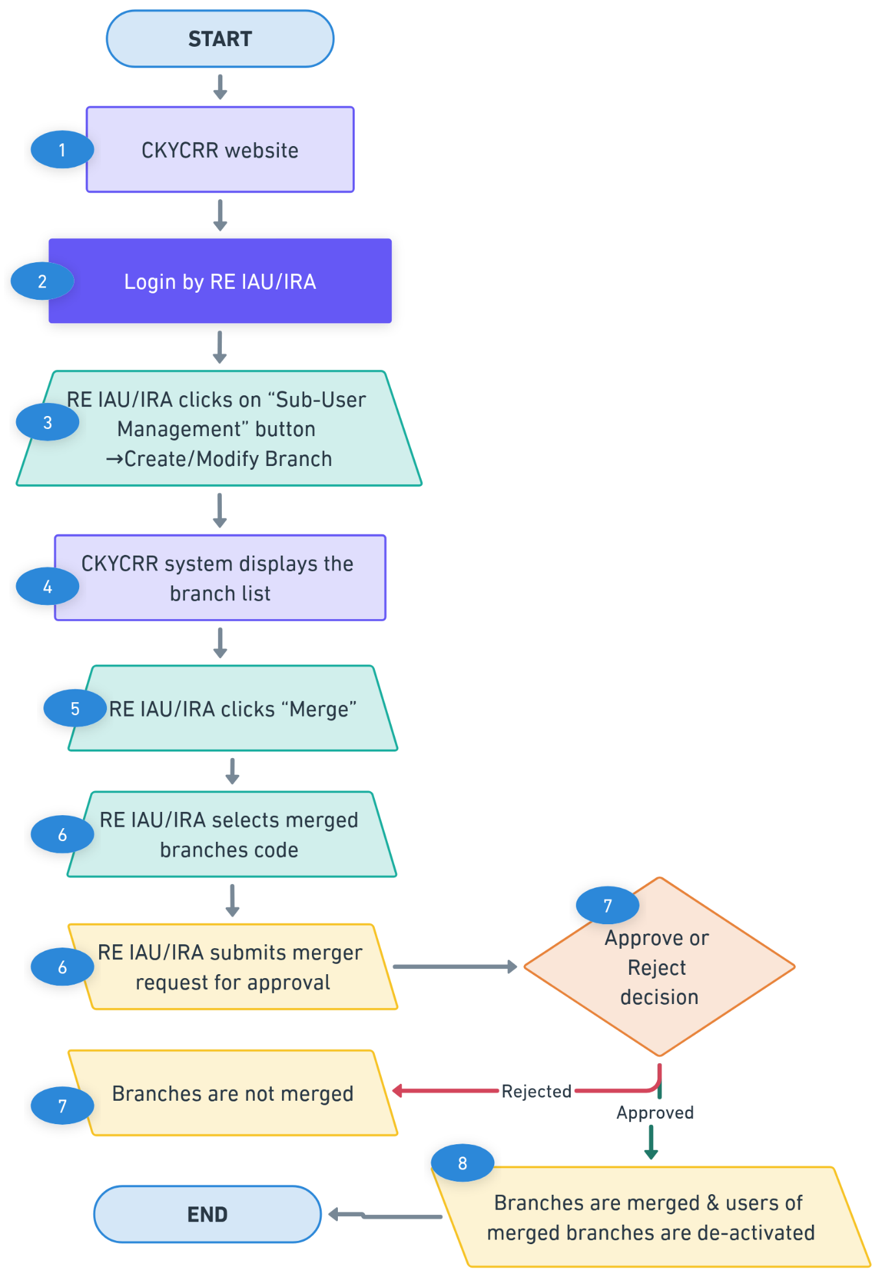

Transfer of branch
The CKYCRR system provisions transfer of branch by institutional admin users of the reporting entity from one region to another region.

Below outlines the process of transferring branch:-

Step 1: The IAU of the reporting entity will access domain / URL “https://www.ckycindia.in” from their respective systems connected over internet.

Step 2: The IAU of the reporting entity will login to the CKYCRR system using the user ID issued, password and DSC (as per login module).

Step 3: The IAU of the reporting entity will click on “Sub-user management” button to navigate to “Create/ modify Branch” section.
Step 4: The CKYCRR system displays a list of already created branches. The IAU can search any specific branch by branch name or branch code. Also, the CKYCRR system allows IAU to sort the displayed records in ascending and descending order. In order to assist the user, forward / context search will be enabled in the dropdown list.
Step 5: The IAU can click “Transfer” button against an already approved branch displayed.
Step 6: The IAU will select the region from dropdown value where branch has to be transferred. Post selection of new region, the transfer of branch request can be submitted to institutional co-admin user for approval.
Step 7: The CKYCRR system will display the transfer of branch request to institutional co-admin user for further actions. The institutional co-admin user will have the below actionable
- Approve: On successful approval by institutional co-admin user, the CKYCRR system will transfer the branch to new region. The associated users of the transferred branch will not be de-activated.
- Reject: The CKYCRR system will send the notification to IAU (maker) and the branch will not be transferred.

Step 8: On successful approval, the CKYCRR system will transfer the branch to new region. The associated users of the transferred branch will not be de-activated.

Functional flow:
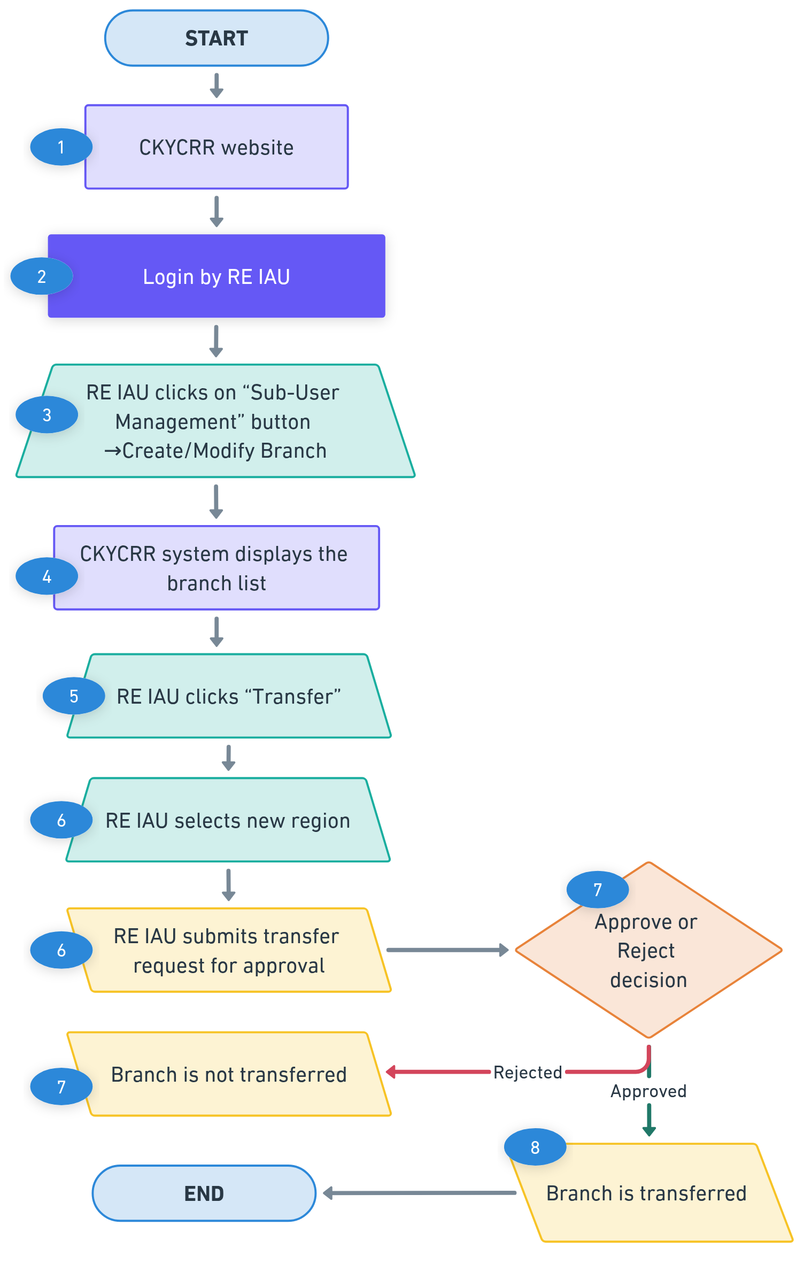

Create Institutional Regional Admin User (IRA)/ Institutional User (IU)
Institutional admin user will create institutional regional admin users/ institutional users by providing required details and mapping level.
Below outline the process of creating institutional regional admin users/ institutional users:
Step 1: The institutional admin user of the reporting entity will access domain / URL “https://www.ckycindia.in” from their respective systems connected over internet.

Step 2: The institutional admin user of the reporting entity will login to the CKYCRR system using the user ID issued, password and DSC (as per login module).

Step 3: The institutional admin user of the reporting entity will click on “Sub-user management” button to navigate to “Create/ modify User” section.
Step 4: The CKYCRR system displays a list of already created institutional regional admin users/ Institutional User . The institutional admin user can search any specific user by user name, user ID and email address of the user. Also, the CKYCRR system allows institutional admin user to sort the displayed records in ascending and descending order.
Step 5: The institutional admin user can click “Create New” button to create a new institutional regional admin/ institutional user.
Step 6: The CKYCRR system will navigate the institutional admin user to the new screen and the following details to be provided
Section | Field | Field Type | Field Size | M/O/CM | Validations
Role | Role Assigned | Char | 2 | M | Dropdown values (auto-populated)  a. Institutional User  b. Institutional regional admin user
 | Region | Char | 3 | CM | Dropdown values as per approved regions. Applicable only if Institutional Regional admin user selected in role assigned
Details | Citizenship | Char | 3 | M | Dropdown values as per configurations in CMS. Draft values will be configured.
 | CKYC number | Char | 14 | CM | 14 digits numeric value allowed. CKYC number will be verified from CKYCRR registry.  Mandatory if citizenship selected is Indian
 | Title | Char | 2 | M | Dropdown value  1. Mr.  2. Ms  3.Mrs.
 | First Name | Varchar | 33 | M | 1. Space allowed  2. A to Z and a to z will be allowed  3. Single apostrophe will be allowed  4. Dot (.) is allowed.  5. Auto-populated based on CKYCRR number (if provided)
 | Middle name | Varchar | 33 | O | 1. Space not allowed  2. A to Z and a to z will be allowed  3. Single apostrophe will be allowed  4. Auto-populated based on CKYCRR number (if provided)
 | Last name | Varchar | 33 | O | 1. Space not allowed  2. A to Z and a to z will be allowed  3. Single apostrophe will be allowed  4. Auto-populated based on CKYCRR number (if provided)
 | Designation | Varchar | 100 | M | 1. Alphanumeric value allowed  2. Following Special Characters will be allowed  `~@#$%^&*()_+-=
 | email ID | Varchar | 254 | M | 1. Alphanumeric value allowed  2. Following Special Characters will be allowed  `~@#$%^&*()._+-=  3.Atleast one @ should be present.
 | Country code | Char | 4 | M | 1.Default value selected will be India (+91).  2. Dropdown values as per Annexure III (ISO code), will be configurable
 | Mobile No | Varchar | 15 | M | 1. Min 8 and maximum 15. In case of country code other than India, mobile number will accept numeric value of min 8 and maximum 15.  2.For India, 10 digit mobile number is allowed
 | Proof of Identity | Char | 2 | M | Dropdown values will be displayed. User needs to select any one option. List of documents  1. Aadhaar  2. Voter ID  3. Passport  4. Driving License  5. PAN card
 | Proof of identity number | Char | 50 | M | Validation to be kept as per ID type selected in PoI.
 | Date of Birth | Calendar | 8 | M | Date should be as per DDMMYYYY format
 | Gender | Char | 2 | M | Dropdown will be displayed and dropdown values will be  1.Male  2.Female  3. Transgender  4. Auto-populated based on CKYCRR number (if provided)
 | Employee code | Varchar | 20 | M | alphanumeric with special character + allowed
Address details | Line 1 | Varchar | 60 | M | 1. Alphanumeric value allowed  2. Space between words is allowed  3. Following Special Characters will be allowed  `~@#$%^&*()_+-=  4. Auto-populate from region details and non-editable for IRA.  5. For IU, the IAU will have option to select from entity registered address or correspondence address. Based on selection, the details will be auto-populated
 | Line 2 | Varchar | 60 | O | 1. Alphanumeric value allowed  2. Space between words is allowed  3. Following Special Characters will be allowed  `~@#$%^&*()_+-=  4. Auto-populate from region details and non-editable for IRA.  5. For IU, the IAU will have option to select from entity registered address or correspondence address. Based on selection, the details will be auto-populated
 | Line 3 | Varchar | 60 | O | 1. Alphanumeric value allowed  2. Space between words is allowed  3. Following Special Characters will be allowed  `~@#$%^&*()_+-=  4. Auto-populate from region details and non-editable for IRA.  5. For IU, the IAU will have option to select from entity registered address or correspondence address. Based on selection, the details will be auto-populated
 | Country Code | Char | 4 | M | 1.Default value selected will be India (IN).  2. Dropdown values as per configurations in CMS. Draft values will be configured as per Annexure III (ISO code).  3. Auto-populate from region details and non-editable for IRA.  4. For IU, the IAU will have option to select from entity registered address or correspondence address. Based on selection, the details will be auto-populated
 | State / UT | Char | 2 | M | 1.Dropdown will be provided and value will be as per State Master.  2. State master values as per configurations in CMS. Draft values will be configured as per motor vehicle Act.  3. Auto-populate from region details and non-editable for IRA.  4. For IU, the IAU will have option to select from entity registered address or correspondence address. Based on selection, the details will be auto-populated
 | District | Varchar | 4 | CM | 1.Value should be as per district Master  2. District master as per configurations in CMS. Draft values will be configured as per motor vehicle Act.  3. Auto-populate from region details and non-editable for IRA.  4. For IU, the IAU will have option to select from entity registered address or correspondence address. Based on selection, the details will be auto-populated
 | City/Town | Char | 60 | M | 1.Alphanumeric values allowed  2. Auto-populate from region details and non-editable for IRA.  3. For IU, the IAU will have option to select from entity registered address or correspondence address. Based on selection, the details will be auto-populated
 | Pin Code | Char | 6 | CM | 1.Only numeric values allowed and should always be 6 digit.  2.Dropdown will be provided and Dropdown value will depend upon value selected in district field  3.Pin code will be configured as per India Post Master  4.Option to select “Others” will also be provided under Pin code field in case it is not there in the dropdown values.  5. Auto-populate from region details and non-editable for IRA.  6. For IU, the IAU will have option to select from entity registered address or correspondence address. Based on selection, the details will be auto-populated
 | Pin code (in case of others) | Char | 6 | CM | 1.Only numeric values allowed and should always be 6 digit numeric.  2.System to verify that once others is selected and combination of state, district and Pin code entered by RE user matches with combination of state, district and Pin code configured in the system, others option should not be allowed.  3. Auto-populate from region details and non-editable for IRA.  4. For IU, the IAU will have option to select from entity registered address or correspondence address. Based on selection, the details will be auto-populated
After filling in the mandatory details, the IAU must click the “Validate” button. The CKYCRR system will trigger 2 different OTPs to both the registered mobile number and email address of the IRA/IU. The IAU must enter the mobile OTP sent to registered mobile number of IRA/IU and email OTP sent to registered email address of the IRA/IU and click “Submit” button. The CKYCRR system will validate the OTPs entered by the IAU. Upon successful OTP validation, the CKYCRR system submit the request for approval. If the OTP verification fails, the CKYCRR system will display error message “Incorrect email/ mobile OTP”. The IAU will have to re-enter the OTPs sent to provided email address and mobile number of the IRA/IU.
Step 7: The institutional admin user will submit the request to institutional co-admin user for the approval. The CKYCRR system will display the approval request to institutional co-admin user in administration tab for further actions (Approve/ reject).
Step 8: If the user creation request is approved by the institutional co-admin user, the CKYCRR system will save the new user under reporting entity and status “Approved” will be maintained in the CKYCRR system. If the user creation is rejected by the institutional co-admin user, the CKYCRR system will mark status of user as “Rejected” and user will not be created.
Step 9: For approved Institutional User / institutional regional admin users: the CKYCRR system will send the user ID along with password setup link to registered email address of the Institutional User / institutional regional admin users.
Step 10: Institutional User/ Institutional regional admin users can login to the CKYCRR system using the login credentials and DSC mapped.
Functional Flow:
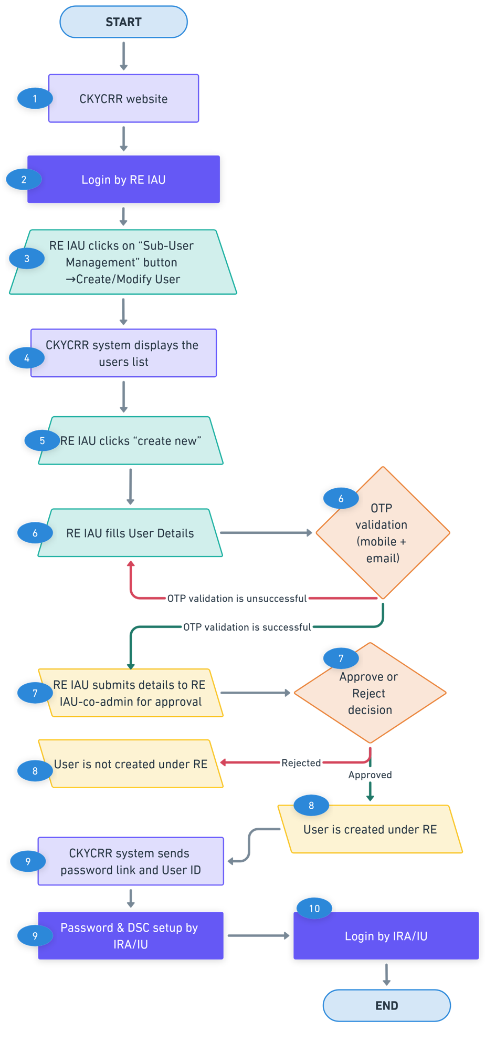

Modify Institutional User (IU)/Institutional Regional Admin (IRA) User
Institutional admin user will modify institutional user/ institutional regional admin user by modifying required details and mapping level.
Below outline the process of modifying institutional regional admin users/ institutional regional user:
Step 1: The institutional admin user of the reporting entity will access domain / URL “https://www.ckycindia.in” from their respective systems connected over internet.

Step 2: The institutional admin user of the reporting entity will login to the CKYCRR system using the user ID issued, password and DSC (as per login module).

Step 3: The institutional admin user of the reporting entity will click on “Sub-user management” button to navigate to “Create/ modify User” section.
Step 4: The CKYCRR system displays a list of already created institutional user/ institutional regional admin users. The institutional admin user can search any specific user by user name, user ID and email address of the user. Also, the CKYCRR system allows institutional admin user to sort the displayed records in ascending and descending order.
Step 5: The institutional admin user can click “Modify” button against the user to modify an institutional user/ institutional regional admin user.
Step 6: The CKYCRR system will navigate the institutional admin user to the new screen and the following details to be auto-populated
Section | Field | Field Type | Field Size | M/O/CM | Validations | Editable
Role | Role Assigned | Char | 2 | M | Dropdown values (auto-populated)  a. Institutional User  b. Institutional regional admin user | Y
 | Region | Char | 3 | CM | Dropdown values as per approved regions. Applicable only if Institutional Regional admin user selected in role assigned | Y
Details | Citizenship | Char | 3 | M | Dropdown values as per configurations in CMS. Draft values will be configured. | N
 | CKYC number | Char | 14 | CM | 14 digits numeric value allowed. CKYC number will be verified from CKYCRR registry.  Mandatory if citizenship selected is Indian | N
 | Title | Char | 2 | M | Dropdown value  1. Mr.  2. Ms  3.Mrs. | N
 | First Name | Varchar | 33 | M | 1. Space allowed  2. A to Z and a to z will be allowed  3. Single apostrophe will be allowed  4. Dot (.) is allowed.  5. Auto-populated based on CKYCRR number (if provided) | N
 | Middle name | Varchar | 33 | O | 1. Space not allowed  2. A to Z and a to z will be allowed  3. Single apostrophe will be allowed  4. Auto-populated based on CKYCRR number (if provided) | N
 | Last name | Varchar | 33 | O | 1. Space not allowed  2. A to Z and a to z will be allowed  3. Single apostrophe will be allowed  4. Auto-populated based on CKYCRR number (if provided) | N
 | Designation | Varchar | 100 | M | 1. Alphanumeric value allowed  2. Following Special Characters will be allowed  `~@#$%^&*()_+-= | Y
 | email ID | Varchar | 254 | M | 1. Alphanumeric value allowed  2. Following Special Characters will be allowed  `~@#$%^&*()._+-=  3.Atleast one @ should be present. | Y
 | Country code | Char | 4 | M | 1.Default value selected will be India (+91).  2. Dropdown values as per Annexure III (ISO code), will be configurable | N
 | Mobile No | Varchar | 15 | M | 1. Min 8 and maximum 15. In case of country code other than India, mobile number will accept numeric value of min 8 and maximum 15.  2.For India, 10 digit mobile number is allowed | Y
 | Proof of Identity | Char | 2 | M | Dropdown values will be displayed. User needs to select any one option. List of documents  1. Aadhaar  2. Voter ID  3. Passport  4. Driving License  5. PAN card | Y
 | Proof of identity number | Char | 50 | M | Validation to be kept as per ID type selected in PoI. | Y
 | Date of Birth | Calendar | 8 | M | Date should be as per DDMMYYYY format | N
 | Gender | Char | 2 | M | Dropdown will be displayed and dropdown values will be  1.Male  2.Female  3. Transgender  4. Auto-populated based on CKYCRR number (if provided) | N
 | Employee code | Varchar | 20 | M | alphanumeric with special character + allowed | Y
Address details | Line 1 | Varchar | 60 | M | 1. Alphanumeric value allowed  2. Space between words is allowed  3. Following Special Characters will be allowed  `~@#$%^&*()_+-=  4. Auto-populate from region details and non-editable for IRA.  5. For IU, the IAU will have option to select from entity registered address or correspondence address. Based on selection, the details will be auto-populated | N
 | Line 2 | Varchar | 60 | O | 1. Alphanumeric value allowed  2. Space between words is allowed  3. Following Special Characters will be allowed  `~@#$%^&*()_+-=  4. Auto-populate from region details and non-editable for IRA.  5. For IU, the IAU will have option to select from entity registered address or correspondence address. Based on selection, the details will be auto-populated | N
 | Line 3 | Varchar | 60 | O | 1. Alphanumeric value allowed  2. Space between words is allowed  3. Following Special Characters will be allowed  `~@#$%^&*()_+-=  4. Auto-populate from region details and non-editable for IRA.  5. For IU, the IAU will have option to select from entity registered address or correspondence address. Based on selection, the details will be auto-populated | N
 | Country Code | Char | 4 | M | 1.Default value selected will be India (IN).  2. Dropdown values as per configurations in CMS. Draft values will be configured as per Annexure III (ISO code).  3. Auto-populate from region details and non-editable for IRA.  4. For IU, the IAU will have option to select from entity registered address or correspondence address. Based on selection, the details will be auto-populated | N
 | State / UT | Char | 2 | M | 1.Dropdown will be provided and value will be as per State Master.  2. State master values as per configurations in CMS. Draft values will be configured as per motor vehicle Act.  3. Auto-populate from region details and non-editable for IRA.  4. For IU, the IAU will have option to select from entity registered address or correspondence address. Based on selection, the details will be auto-populated | N
 | District | Varchar | 4 | CM | 1.Value should be as per district Master  2. District master as per configurations in CMS. Draft values will be configured as per motor vehicle Act.  3. Auto-populate from region details and non-editable for IRA.  4. For IU, the IAU will have option to select from entity registered address or correspondence address. Based on selection, the details will be auto-populated | N
 | City/Town | Char | 60 | M | 1.Alphanumeric values allowed  2. Auto-populate from region details and non-editable for IRA.  3. For IU, the IAU will have option to select from entity registered address or correspondence address. Based on selection, the details will be auto-populated | N
 | Pin Code | Char | 6 | CM | 1.Only numeric values allowed and should always be 6 digit.  2.Dropdown will be provided and Dropdown value will depend upon value selected in district field  3.Pin code will be configured as per India Post Master  4.Option to select “Others” will also be provided under Pin code field in case it is not there in the dropdown values.  5. Auto-populate from region details and non-editable for IRA.  6. For IU, the IAU will have option to select from entity registered address or correspondence address. Based on selection, the details will be auto-populated | N
 | Pin code (in case of others) | Char | 6 | CM | 1.Only numeric values allowed and should always be 6 digit numeric.  2.System to verify that once others is selected and combination of state, district and Pin code entered by RE user matches with combination of state, district and Pin code configured in the system, others option should not be allowed.  3. Auto-populate from region details and non-editable for IRA.  4. For IU, the IAU will have option to select from entity registered address or correspondence address. Based on selection, the details will be auto-populated | N

In case of modifications made to mobile number or email address of the IU/IRA, the IAU must click the “Validate” button. The CKYCRR system will trigger OTPs to both the registered mobile number and email address of the IRA/IU. The IAU must enter the mobile OTP sent to registered mobile number of IRA/IU and email OTP sent to registered email address of the IRA/IU and click “Submit” button. The CKYCRR system will validate the OTPs entered by the IAU. Upon successful OTP validation, the CKYCRR system submit the request for approval. If the OTP verification fails, the CKYCRR system will display error message “Incorrect email/ mobile OTP”. The IAU will have to re-enter the OTPs sent to provided email address and mobile number of the IRA/IU.
Step 7: The institutional admin user will submit the modification request to institutional co-admin user for the approval. The CKYCRR system will display the approval request to institutional co-admin user in administration tab for further actions (Approve/ reject)
Step 8: If the user modification request is approved by the institutional co-admin user, the CKYCRR system will save the updated user details under reporting entity and status “Approved” will be maintained in the CKYCRR system. If the user modification is rejected by the institutional co-admin user, the CKYCRR system will mark status as “Rejected”and modifications will not be approved.
Step 9: For approved institutional user/ institutional regional admin users: The CKYCRR system will send the email notification to user.
Step 10: Institutional user/ Institutional regional admin users can login to the CKYCRR system using the login credentials and DSC mapped.
Functional Flow:
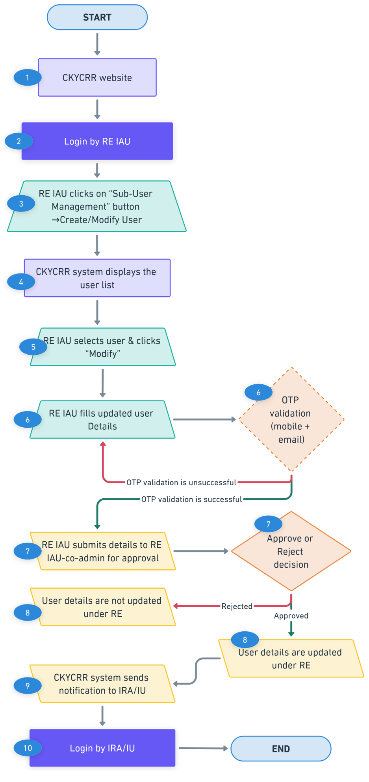

Create Institutional Regional User (IRU) / Institutional Branch User (IBU)
Institutional regional admin user will create institutional regional user / institutional branch users by providing required details and mapping level.
Below outline the process of creation of institutional regional user / institutional branch users:
Step 1: The institutional regional admin user of the reporting entity will access domain / URL “https://www.ckycindia.in” from their respective systems connected over internet.

Step 2: The institutional regional admin user of the reporting entity will login to the CKYCRR system using the user ID issued, password and DSC (as per login module).

Step 3: The institutional regional admin user of the reporting entity will click on “Sub-user management” button to navigate to “Create/ modify User” section.
Step 4: The CKYCRR system displays a list of already created institutional regional user / institutional branch user. The institutional regional admin user can search any specific user by user name, user ID and email address of the user. Also, the CKYCRR system allows institutional regional admin user to sort the displayed records in ascending and descending order.
Step 5: The institutional regional admin user can click “Create New” button to create a new institutional regional user / institutional branch users.
Step 6: The CKYCRR system will navigate the institutional regional admin user to the new screen and the following details to be provided
Section | Field | Field Type | Field Size | M/O/CM | Validations
Role | Region | Auto-populated and non-editable | 2 | M | Auto-populated and non-editable
 | Role Assigned | Char | 2 | M | Dropdown values  a. Institutional regional user  b. Institutional branch user
 | Branch | Char | 3 | CM | 1. Dropdown values as per approved branches.  2. Applicable only if institutional branch user selected in role assigned
Details | Citizenship | Char | 3 | M | Dropdown values as per configurations in CMS. Draft values will be configured.
 | CKYC number | Char | 14 | CM | 14 digits numeric value allowed. CKYC number will be verified from CKYCRR registry.  Mandatory if citizenship selected is Indian
 | Title | Char | 2 | M | Dropdown value  1. Mr.  2. Ms  3.Mrs.
 | First Name | Varchar | 33 | M | 1. Space allowed  2. A to Z and a to z will be allowed  3. Single apostrophe will be allowed  4. Dot (.) is allowed.  5. Auto-populated based on CKYCRR number (if provided)
 | Middle name | Varchar | 33 | O | 1. Space not allowed  2. A to Z and a to z will be allowed  3. Single apostrophe will be allowed  4. Auto-populated based on CKYCRR number (if provided)
 | Last name | Varchar | 33 | O | 1. Space not allowed  2. A to Z and a to z will be allowed  3. Single apostrophe will be allowed  4. Auto-populated based on CKYCRR number (if provided)
 | Designation | Varchar | 100 | M | 1. Alphanumeric value allowed  2. Following Special Characters will be allowed  `~@#$%^&*()_+-=
 | email ID | Varchar | 254 | M | 1. Alphanumeric value allowed  2. Following Special Characters will be allowed  `~@#$%^&*()._+-=  3.Atleast one @ should be present.
 | Country code | Char | 4 | M | 1.Default value selected will be India (+91).  2. Dropdown values as per Annexure III (ISO code), will be configurable
 | Mobile No | Varchar | 15 | M | 1. Min 8 and maximum 15. In case of country code other than India, mobile number will accept numeric value of min 8 and maximum 15.  2.For India, 10 digit mobile number is allowed
 | Proof of Identity | Char | 2 | M | Dropdown values will be displayed. User needs to select any one option. List of documents  1. Aadhaar  2. Voter ID  3. Passport  4. Driving License  5. PAN card
 | Proof of identity number | Char | 50 | M | Validation to be kept as per ID type selected in PoI.
 | Date of Birth | Calendar | 8 | M | Date should be as per DDMMYYYY format
 | Gender | Char | 2 | M | Dropdown will be displayed and dropdown values will be  1.Male  2.Female  3. Transgender  4. Auto-populated based on CKYCRR number (if provided)
 | Employee code | Varchar | 20 | M | alphanumeric with special character + allowed
Address details | Line 1 | Varchar | 60 | M | 1. Alphanumeric value allowed  2. Space between words is allowed  3. Following Special Characters will be allowed  `~@#$%^&*()_+-=  4. Auto-populate from region details for IRU or from branch details for IBU and non-editable.
 | Line 2 | Varchar | 60 | O | 1. Alphanumeric value allowed  2. Space between words is allowed  3. Following Special Characters will be allowed  `~@#$%^&*()_+-=  4. Auto-populate from region details for IRU or from branch details for IBU and non-editable.
 | Line 3 | Varchar | 60 | O | 1. Alphanumeric value allowed  2. Space between words is allowed  3. Following Special Characters will be allowed  `~@#$%^&*()_+-=  4. Auto-populate from region details for IRU or from branch details for IBU and non-editable.
 | Country Code | Char | 4 | M | 1.Default value selected will be India (IN).  2. Dropdown values as per configurations in CMS. Draft values will be configured as per Annexure III (ISO code).  3. Auto-populate from region details for IRU or from branch details for IBU and non-editable.
 | State / UT | Char | 2 | M | 1.Dropdown will be provided and value will be as per State Master.  2. State master values as per configurations in CMS. Draft values will be configured as per motor vehicle Act.  3. Auto-populate from region details for IRU or from branch details for IBU and non-editable.
 | District | Varchar | 4 | CM | 1.Value should be as per district Master  2. District master as per configurations in CMS. Draft values will be configured as per motor vehicle Act.  3. Auto-populate from region details for IRU or from branch details for IBU and non-editable.
 | City/Town | Char | 60 | M | 1.Alphanumeric values allowed  2. Auto-populate from region details for IRU or from branch details for IBU and non-editable.
 | Pin Code | Char | 6 | CM | 1.Only numeric values allowed and should always be 6 digit.  2.Dropdown will be provided and Dropdown value will depend upon value selected in district field  3.Pin code will be configured as per India Post Master  4.Option to select “Others” will also be provided under Pin code field in case it is not there in the dropdown values.  5. Auto-populate from region details for IRU or from branch details for IBU and non-editable.
 | Pin code (in case of others) | Char | 6 | CM | 1.Only numeric values allowed and should always be 6 digit numeric.  2.System to verify that once others is selected and combination of state, district and Pin code entered by RE user matches with combination of state, district and Pin code configured in the system, others option should not be allowed.  3. Auto-populate from region details for IRU or from branch details for IBU and non-editable.
After filling in the mandatory details, the IRA must click the “Validate” button. The CKYCRR system will trigger 2 different OTPs to both the registered mobile number and email address of the IRU/IBU. The IRA must enter the mobile OTP sent to registered mobile number of IRU/IBU and email OTP sent to registered email address of the IRU/IBU and click “Submit” button. The CKYCRR system will validate the OTPs entered by the IRA. Upon successful OTP validation, the CKYCRR system submit the request for approval. If the OTP verification fails, the CKYCRR system will display error message “Incorrect email/ mobile OTP”. The IRA will have to re-enter the OTPs sent to provided email address and mobile number of the IRU/IBU.
Step 7: The institutional regional admin user will submit the request to institutional regional co-admin user for the approval. The CKYCRR system will display the approval request to institutional regional co-admin user in administration tab for further actions (Approve/ reject)
Step 8: If the user creation request is approved by the institutional regional co-admin user, the CKYCRR system will save the new user under reporting entity and status “Approved” will be maintained in the CKYCRR system. If the user creation is rejected by the institutional regional co-admin user, the CKYCRR system will mark status of user as “Rejected”.
Step 9: For approved institutional regional user / institutional branch users: the CKYCRR system will send the user ID along with password setup link to registered email address of the institutional regional user / institutional branch users.
Step 10: Institutional regional user / institutional branch users can login to the CKYCRR system using the login credentials and DSC mapped.
Functional Flow:
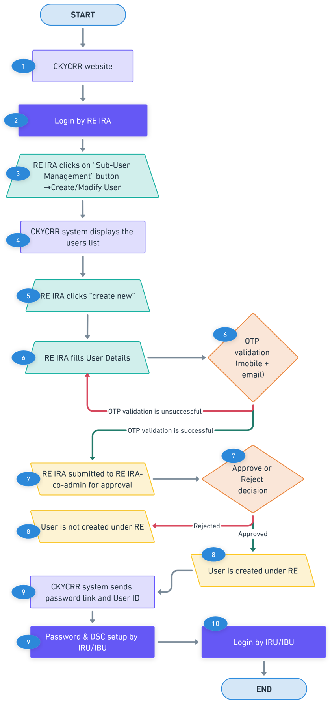

Modify Institutional Regional user (IRU) / Institutional Branch User (IBU)
Institutional regional admin user will modify institutional branch users/ institutional regional users by providing required details and mapping level.
Below outline the process of modification of institutional regional user / institutional branch users:
Step 1: The institutional regional admin user of the reporting entity will access domain / URL “https://www.ckycindia.in” from their respective systems connected over internet.

Step 2: The institutional regional admin user of the reporting entity will login to the CKYCRR system using the user ID issued, password and DSC (as per login module).

Step 3: The institutional regional admin user of the reporting entity will click on “Sub-user management” button to navigate to “Create/ modify User” section.
Step 4: The CKYCRR system displays a list of already created institutional regional user / institutional branch user. The institutional regional admin user can search any specific user by user name, user ID and email address of the user. Also, the CKYCRR system allows institutional regional admin user to sort the displayed records in ascending and descending order.
Step 5: The institutional regional admin user shall select the user record and can click “Modify” button to modify existing institutional regional user / institutional branch users.
Step 6: The CKYCRR system will navigate the institutional regional admin user to the new screen and the following details to be auto-populated
Section | Field | Field Type | Field Size | M/O/CM | Validations | Editable
Role | Region | Auto-populated and non-editable | 2 | M | Auto-populated and non-editable | N
 | Role Assigned | Char | 2 | M | Dropdown values  a. Institutional regional user  b. Institutional branch user | Y
 | Branch | Char | 3 | CM | 1. Dropdown values as per approved branches.  2. Applicable only if institutional branch user selected in role assigned | Y
Details | Citizenship | Char | 3 | M | Dropdown values as per configurations in CMS. Draft values will be configured | N
 | CKYC number | Char | 14 | CM | 14 digits numeric value allowed. CKYC number will be verified from CKYCRR registry.  Mandatory if citizenship selected is Indian | N
 | Title | Char | 2 | M | Dropdown value  1. Mr.  2. Ms  3.Mrs. | N
 | First Name | Varchar | 33 | M | 1. Space allowed  2. A to Z and a to z will be allowed  3. Single apostrophe will be allowed  4. Dot (.) is allowed.  5. Auto-populated based on CKYCRR number (if provided) | N
 | Middle name | Varchar | 33 | O | 1. Space not allowed  2. A to Z and a to z will be allowed  3. Single apostrophe will be allowed  4. Auto-populated based on CKYCRR number (if provided) | N
 | Last name | Varchar | 33 | O | 1. Space not allowed  2. A to Z and a to z will be allowed  3. Single apostrophe will be allowed  4. Auto-populated based on CKYCRR number (if provided) | N
 | Designation | Varchar | 100 | M | 1. Alphanumeric value allowed  2. Following Special Characters will be allowed  `~@#$%^&*()_+-= | Y
 | email ID | Varchar | 254 | M | 1. Alphanumeric value allowed  2. Following Special Characters will be allowed  `~@#$%^&*()._+-=  3.Atleast one @ should be present. | Y
 | Country code | Char | 4 | M | 1.Default value selected will be India (+91).  2. Dropdown values as per Annexure III (ISO code), will be configurable | N
 | Mobile No | Varchar | 15 | M | 1. Min 8 and maximum 15. In case of country code other than India, mobile number will accept numeric value of min 8 and maximum 15.  2.For India, 10 digit mobile number is allowed | Y
 | Proof of Identity | Char | 2 | M | Dropdown values will be displayed. User needs to select any one option. List of documents  1. Aadhaar  2. Voter ID  3. Passport  4. Driving License  5. PAN card | Y
 | Proof of identity number | Char | 50 | M | Validation to be kept as per ID type selected in PoI. | Y
 | Date of Birth | Calendar | 8 | M | Date should be as per DDMMYYYY format | N
 | Gender | Char | 2 | M | Dropdown will be displayed and dropdown values will be  1.Male  2.Female  3. Transgender  4. Auto-populated based on CKYCRR number (if provided) | N
 | Employee code | Varchar | 20 | M | alphanumeric with special character + allowed | Y
Address details | Line 1 | Varchar | 60 | M | 1. Alphanumeric value allowed  2. Space between words is allowed  3. Following Special Characters will be allowed  `~@#$%^&*()_+-=  4. Auto-populate from region details for IRU or from branch details for IBU and non-editable. | N
 | Line 2 | Varchar | 60 | O | 1. Alphanumeric value allowed  2. Space between words is allowed  3. Following Special Characters will be allowed  `~@#$%^&*()_+-=  4. Auto-populate from region details for IRU or from branch details for IBU and non-editable. | N
 | Line 3 | Varchar | 60 | O | 1. Alphanumeric value allowed  2. Space between words is allowed  3. Following Special Characters will be allowed  `~@#$%^&*()_+-=  4. Auto-populate from region details for IRU or from branch details for IBU and non-editable. | N
 | Country Code | Char | 4 | M | 1.Default value selected will be India (IN).  2. Dropdown values as per configurations in CMS. Draft values will be configured as per Annexure III (ISO code).  3. Auto-populate from region details for IRU or from branch details for IBU and non-editable. | N
 | State / UT | Char | 2 | M | 1.Dropdown will be provided and value will be as per State Master.  2. State master values as per configurations in CMS. Draft values will be configured as per motor vehicle Act.  3. Auto-populate from region details for IRU or from branch details for IBU and non-editable. | N
 | District | Varchar | 4 | CM | 1.Value should be as per district Master  2. District master as per configurations in CMS. Draft values will be configured as per motor vehicle Act.  3. Auto-populate from region details for IRU or from branch details for IBU and non-editable. | N
 | City/Town | Char | 60 | M | 1.Alphanumeric values allowed  2. Auto-populate from region details for IRU or from branch details for IBU and non-editable. | N
 | Pin Code | Char | 6 | CM | 1.Only numeric values allowed and should always be 6 digit.  2.Dropdown will be provided and Dropdown value will depend upon value selected in district field  3.Pin code will be configured as per India Post Master  4.Option to select “Others” will also be provided under Pin code field in case it is not there in the dropdown values.  5. Auto-populate from region details for IRU or from branch details for IBU and non-editable. | N
 | Pin code (in case of others) | Char | 6 | CM | 1.Only numeric values allowed and should always be 6 digit numeric.  2.System to verify that once others is selected and combination of state, district and Pin code entered by RE user matches with combination of state, district and Pin code configured in the system, others option should not be allowed.  3. Auto-populate from region details for IRU or from branch details for IBU and non-editable. | N
In case of modifications made to mobile number or email address of the IRU/IBU, the IRA must click the “Validate” button. The CKYCRR system will trigger OTPs to both the registered mobile number and email address of the IRU/IBU. The IRA must enter the mobile OTP sent to registered mobile number of IRU/IBU and email OTP sent to registered email address of the IRU/IBU and click “Submit” button. The CKYCRR system will validate the OTPs entered by the IRA. Upon successful OTP validation, the CKYCRR system submit the request for approval. If the OTP verification fails, the CKYCRR system will display error message “Incorrect email/ mobile OTP”. The IRA will have to re-enter the OTPs sent to provided email address and mobile number of the IRU/IBU.
Step 7: The institutional regional admin user will submit the modification request to institutional regional co-admin user for the approval. The CKYCRR system will display the approval request to institutional regional co-admin user in administration tab for further actions (Approve/ reject)
Step 8: If the user modification request is approved by the institutional regional co-admin user, the CKYCRR system will save the updated user details under reporting entity and status “Approved” will be maintained in the CKYCRR system. If the user modification request is rejected by the institutional regional co-admin user, the CKYCRR system will mark status of user as “Rejected”.
Step 9: For modified institutional regional user / institutional branch users: the CKYCRR system will send notifications to the institutional regional user / institutional branch users
Step 10: Institutional regional user / institutional branch users can login to the CKYCRR system using the login credentials and DSC mapped.
Functional Flow:
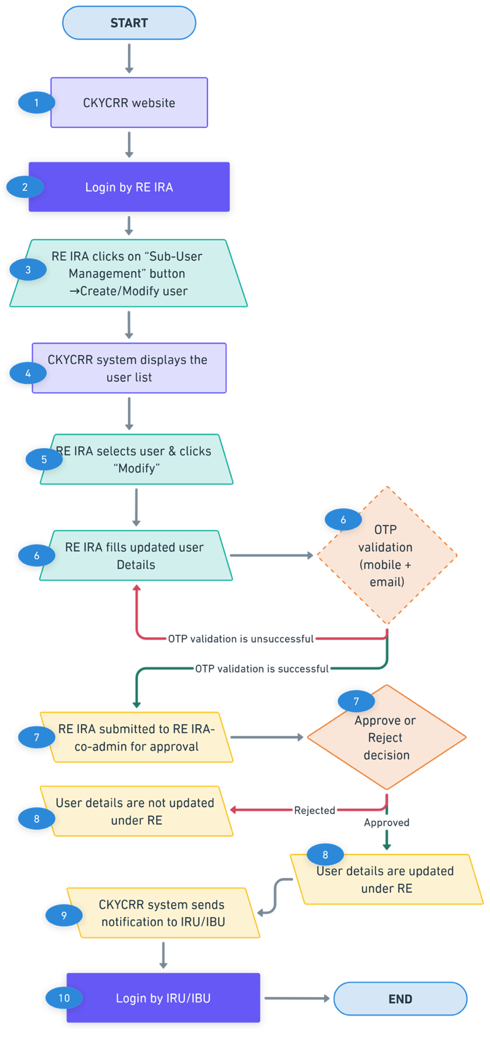

De-activation of User
The CKYCRR system provisions permanent de-activation of user by respective allowed admins.

Deactivation rights:
Type | Maker (de-activation by) | Approver | Impact
IRA /IU | Institutional admin user | Institutional co-admin user | Login rights to CKYCRR system forfeited.
IRU/ IBU | Institutional regional admin user | Institutional regional co-admin user | Login rights to CKYCRR system forfeited.
Below outlines the process of de-activating user:

Step 1: The IAU/IRA will access domain / URL “https://www.ckycindia.in” from their respective systems connected over internet.

Step 2: The IAU/IRA will login to the CKYCRR system using the user ID issued, password and DSC (as per login module).

Step 3: The IAU/IRA will click on “Sub-user management” button to navigate to “Create/ modify user” section.
Step 4: The CKYCRR system displays a list of already created users. The IAU/IRA can search any specific user by user name or user ID. Also, the CKYCRR system allows The IAU/IRA to sort the displayed records in ascending and descending order.
Step 5: The IAU/IRA can click “De-activate” button against an already approved users displayed.
Step 6: The CKYCRR system will prompt IAU/IRA to confirm the de-activation of user. Once the de-activation is confirmed by the IAU/IRA, the de-activation request will be submitted to IAU/IRA (approver) for approval.
Step 7: The CKYCRR system will display the de-activation request to IAU/IRA (approver) for further actions. The IAU/IRA (approver) will have the below actionable
- Approve: On successful approval by IAU/IRA (approver), the CKYCRR system will mark the user de-activated under RE.
- Reject: The CKYCRR system will send the notification to IAU/IRA and the user will not be de-activated.
Step 8: On successful approval, the CKYCRR system will mark the user as de-activated and user cannot login to the system.
Functional flow:
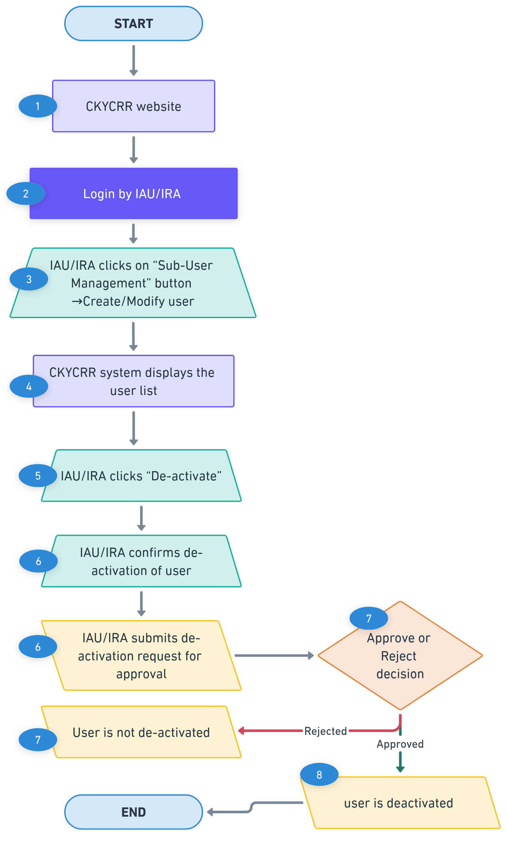

Suspension of User
The CKYCRR system provisions suspension of user by RE admin users which is for a temporary period.

Suspension rights:
Type | Maker (suspension by) | Approver | Impact
IRA /IU | Institutional admin user | Institutional co-admin user | Login rights to CKYCRR system forfeited.
IRU/ IBU | Institutional regional admin user | Institutional regional co-admin user | Login rights to CKYCRR system forfeited.
Below outlines the process of suspending user:

Step 1: The IAU/IRA will access domain / URL “https://www.ckycindia.in” from their respective systems connected over internet.

Step 2: The IAU/IRA will login to the CKYCRR system using the user ID issued, password and DSC (as per login module).

Step 3: The IAU/IRA will click on “Sub-user management” button to navigate to “Create/ modify user” section.
Step 4: The CKYCRR system displays a list of already created users. The IAU/IRA can search any specific user by user name or user ID. Also, the CKYCRR system allows the IAU/IRA to sort the displayed records in ascending and descending order.
Step 5: The IAU/IRA can click “Suspend” button against an already approved users displayed.
Step 6: The CKYCRR system will prompt IAU/IRA to provide suspension reason and suspension period and submit the suspension request to IAU/IRA (approver) for approval.
Step 7: The CKYCRR system will display the suspension request to IAU/IRA (approver) for further actions. The IAU/IRA (approver) will have the below actionable
- Approve: On successful approval by IAU/IRA (approver), the CKYCRR system will mark the user suspended under RE.
- Reject: The CKYCRR system will send the notification to IAU/IRA and the user will not be suspended.
Step 8: On successful approval, the CKYCRR system will mark the user as suspended and user cannot login to the system.
Functional flow:
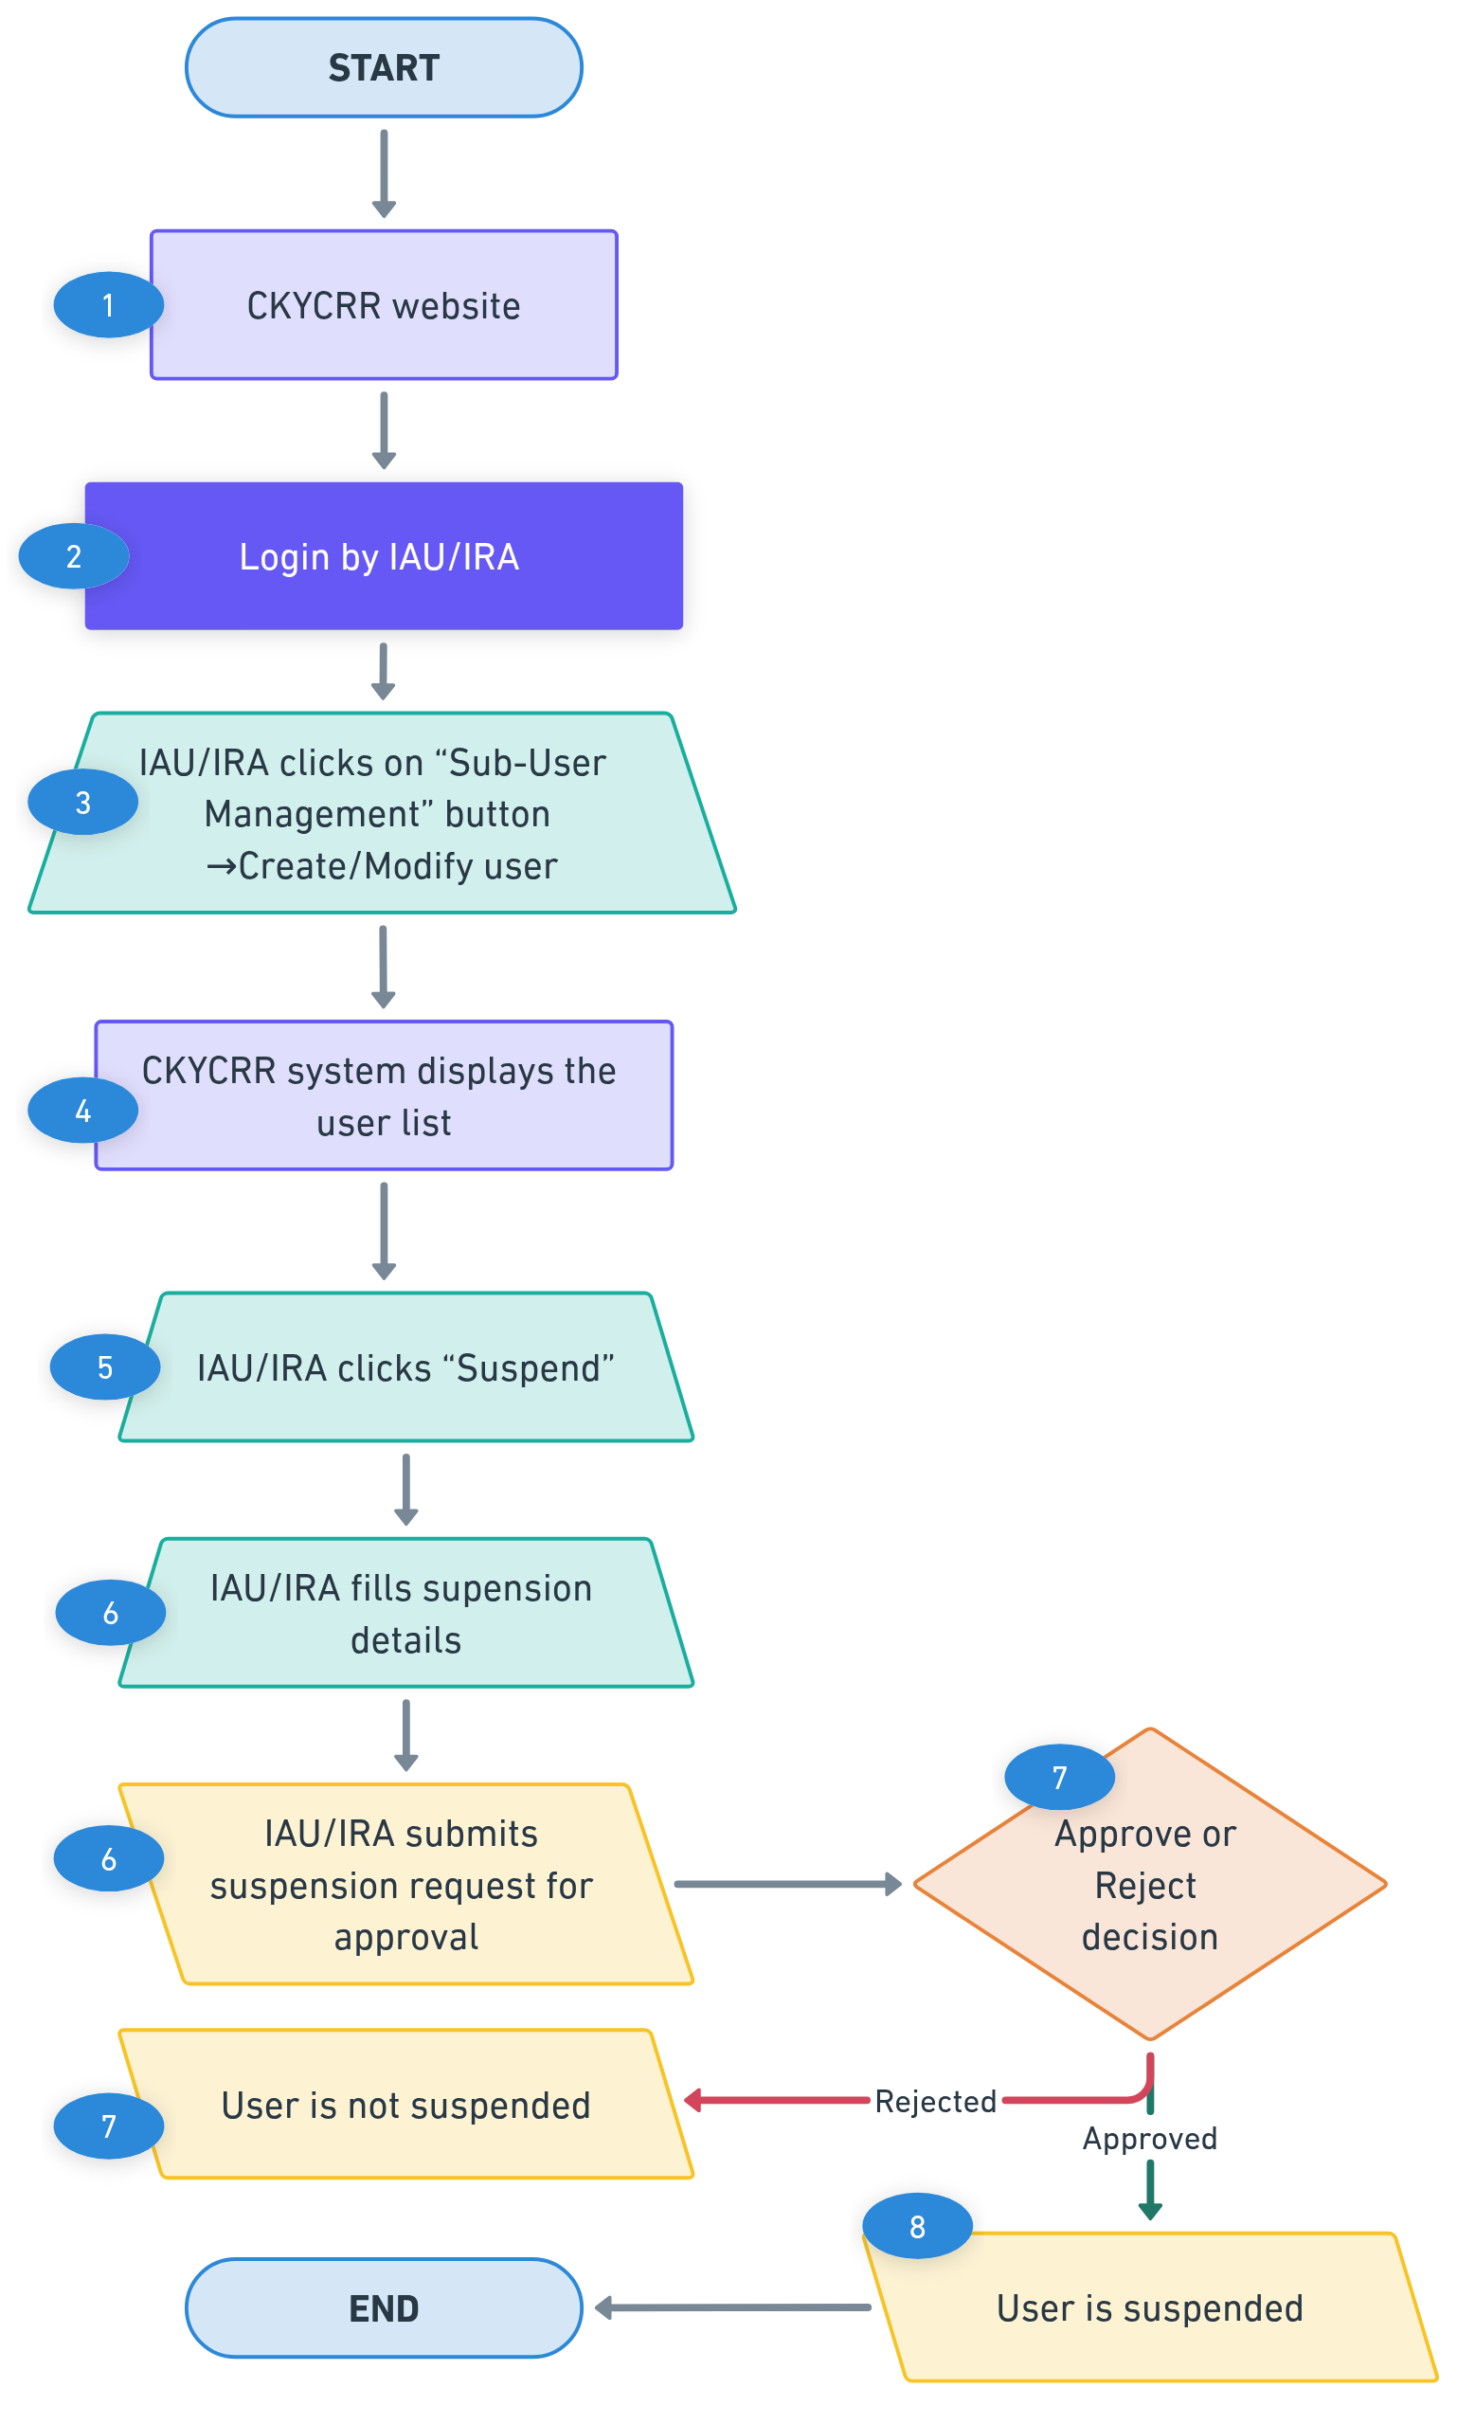

Revocation of Suspension of user
The CKYCRR system provisions revocation of suspension of user by admin users of the reporting entity

Revocation of Suspension rights:
Type | Maker (revocation by) | Approver | Impact
IRA /IU | Institutional admin user | Institutional co-admin user | Login rights to CKYCRR system forfeited.
IRU/ IBU | Institutional regional admin user | Institutional regional co-admin user | Login rights to CKYCRR system forfeited.
Below outlines the process of revoking suspension of user:

Step 1: The IAU/IRA will access domain / URL “https://www.ckycindia.in” from their respective systems connected over internet.

Step 2: The IAU/IRA will login to the CKYCRR system using the user ID issued, password and DSC (as per login module).

Step 3: The IAU/IRA will click on “Sub-user management” button to navigate to “Create/ modify user” section.
Step 4: The CKYCRR system displays a list of already created users. The IAU/IRA can search any specific user by user name or user ID. Also, the CKYCRR system allows the IAU/IRA to sort the displayed records in ascending and descending order.
Step 5: The IAU/IRA can search suspended user and then click “Revoke Suspension” button against an already suspended user displayed.
Step 6: The CKYCRR system will prompt IAU/IRA to provide revocation of suspension reason and submit the revocation of suspension request to IAU/IRA (approver) for approval.
Step 7: The CKYCRR system will display the suspension request to IAU/IRA (approver) for further actions. The RE co-admin user will have the below actionable
- Approve: On successful approval by IAU/IRA (approver) , the CKYCRR system will mark the user as active under RE.
- Reject: The CKYCRR system will send the notification to IAU/IRA and suspension will not be revoked.
Step 8: On successful approval, the CKYCRR system will mark the user as active.
Functional flow:
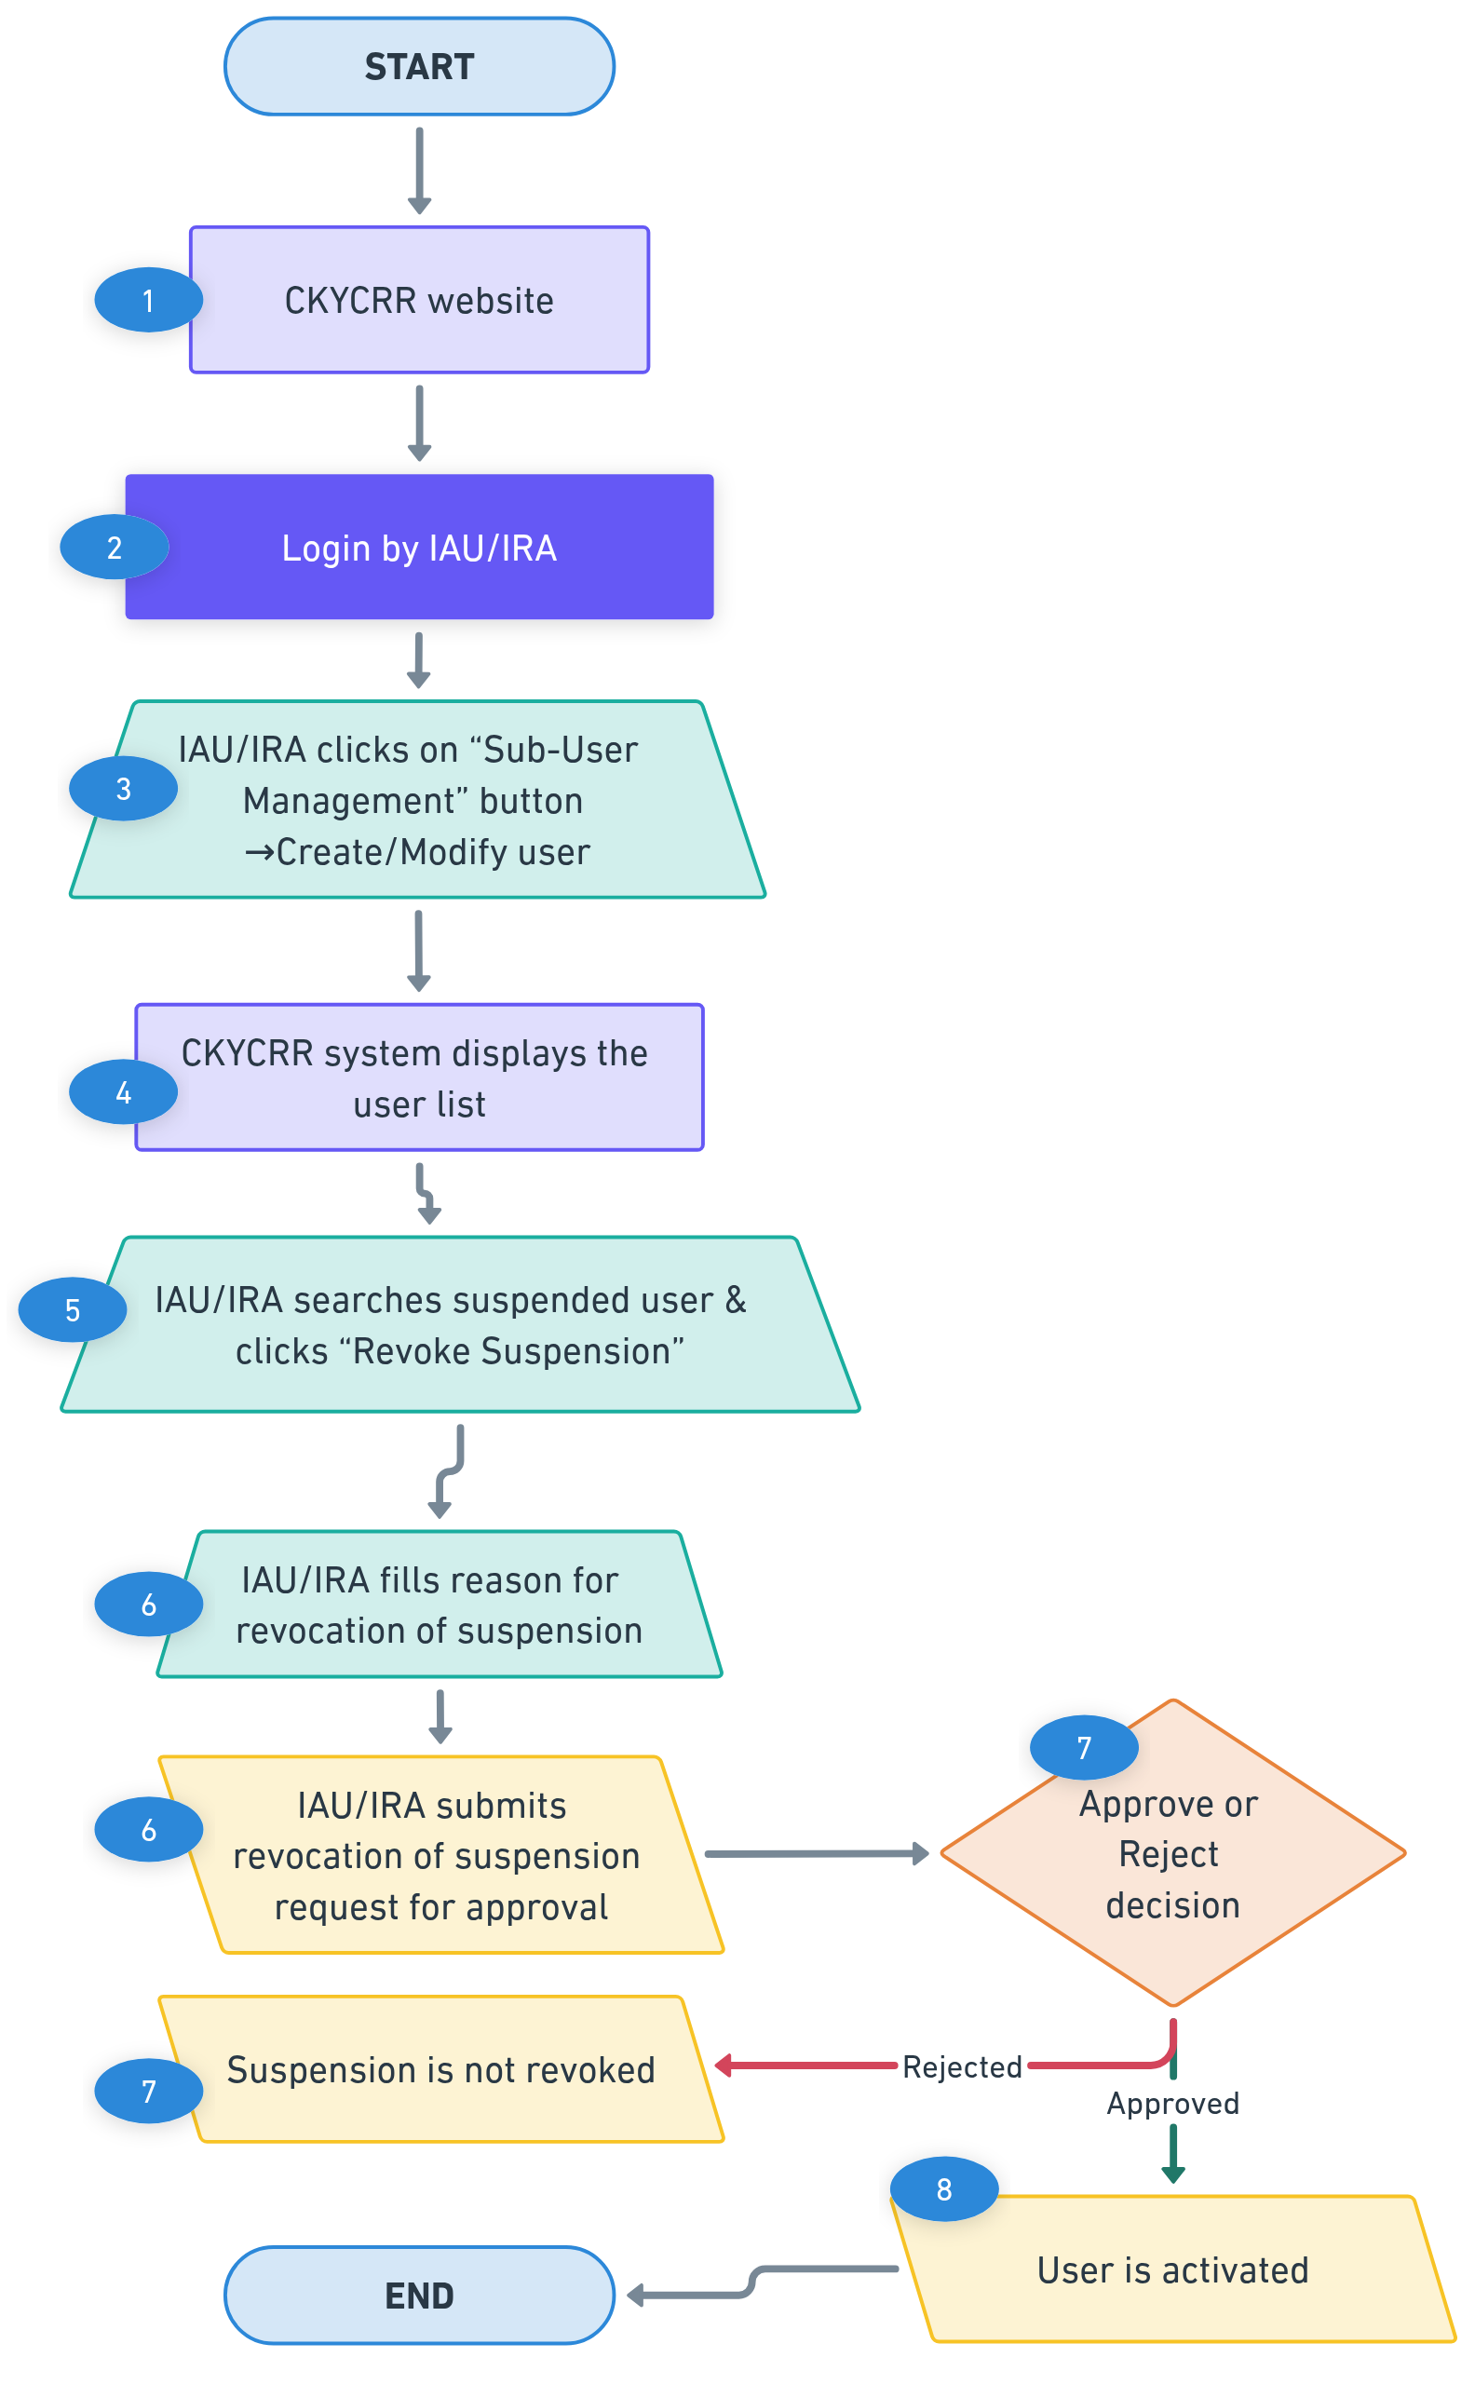

Points to remember:
- User Duplication Prevention: The CKYCRR system will prevent duplicate user creation within the reporting entity. Duplicity check is based on:
  - Email Address of the user
  - Mobile Number of the user
    - If the same email or mobile number is used for another user within the reporting entity, the system will display an error message and block the creation of new user.
- User Deactivation & Suspension Rules: IAU/IRA have the right to:
  - Deactivate Users (Permanent removal; the user cannot be reactivated but can be created again).
  - Suspend Users (Temporary restriction; suspension can be removed).
  - Deactivation & Suspension Effects: Deactivated / suspended users will lose access to the system immediately.
- User Transfer Between Regions/Branches: To transfer a user from one Region/Branch to another:
  - Step 1: First deactivate the user in the current Region/Branch.
  - Step 2: Create new user under the new Region/Branch.
- User Mapping Restrictions: A user cannot be mapped to multiple Regions or Branches simultaneously. Each user must have a unique association with a single Region and Branch.
- Number of users allowed at different levels
Level | Number of users
Institutional Admin user | 2
Institutional User | 3
Institutional Regional Admin user | 2
Institutional Regional User | 3
Institutional Branch User | 3

- The CKYCRR system will trigger notifications at the following key events
Key Event | User | Email | SMS | Post Login
Approval request of region creation/ modification/ de-activation/ merger | Institutional Admin User | Yes | No | Yes
Approval request of branch creation / modification/ de-activation/ merger | Institutional Regional Admin user / institutional admin user (for merger of branches in different regions) | Yes | No | Yes
Approval request for Branch Transfer from one Region to Another | Institutional Admin Users | Yes | No | Yes
Approval request of user creation / modification/ de-activation/ suspension/ revocation of suspension | Institutional Admin user, institutional regional Admin / concerned user | Yes | No | Yes
Password setup link | New User (IU/IRA/IRU/IBU) | Yes | No | No
Information on rejection of region creation/ modification/ de-activation/ merger | Institutional Admin | Yes | No | Yes
Information on rejection of branch creation/ modification/ de-activation/ merger | Institutional regional Admin | Yes | No | Yes
Rejection of Branch transfer request from one Region to Another | Institutional Admin User | Yes | No | Yes
Information on rejection of user creation/ modification/ de-activation/ suspension/ revocation of suspension | Institutional admin user, institutional regional admin | Yes | No | Yes

Update Profile
The Update Profile feature allows users of the reporting entity to modify and manage reporting entity profile details and user details. This ensures that reporting entity and user records remain accurate, up-to-date, and compliant with organizational or regulatory requirements.
Permitted Actions as per the roles defined
Action Permitted | Permitted Role
Reporting entity Profile Update | Nodal Officer, Institutional admin users of the reporting entity
New Nodal officer/ IAU | Nodal officer/ IAU of the reporting entity
User Profile Update for Nodal officer/ IAU/IRA/IRU/IBU/IU | Nodal officer/ IAU/IRA/IRU/IBU/IU of the reporting entity
Below outlines the process of reporting entity profile update:
Step 1: The nodal officer or institutional admin user of the reporting entity will access domain / URL “https://www.ckycindia.in” or testbed environment from their respective systems connected over internet.

Step 2: The nodal officer or institutional admin user of the reporting entity will login to the CKYCRR system using the user ID issued, password and DSC (as per login module).

Step 3: The nodal officer or institutional admin user of the reporting entity will click on “Profile” button to navigate to “entity profile” section. The CKYCRR system will display the latest information and documents of reporting entity.

Step 4: The nodal officer or institutional admin user can modify the details of the reporting entity under the following sections
- Entity profile and associated documents
  - The nodal officer can modify the existing information and upload documents.

Section | Field | Field Type | Field Size | M/O/CM | Validations | Editable
Entity Details | Name of Institution | Varchar | 99 | M | 1. Space in between words is allowed  2. A to Z, a to z, 0 to 9 are allowed  3. Following special characters are allowed  `~!@#$%^&*()_.+-= | Y
 | Regulator | Char | 2 | M | List of Regulators (dropdown selection)  1. RBI  2. PFRDA  3. SEBI  4. IRDAI  5. IFSCA  6. Government Agency | N
 | Institution Type | Char | 2 | CM | List of dropdown values  1.RBI  a. Foreign Exchange Business  b. Housing Finance Company  c. Full Fledged Money Changer  d.Non bank – PPI  e. Payment Bank  f. All India Financial Institutions  g. Payment System Operator  h. Non-Banking Financial Company  i. PSU Bank  j. Private Bank  k. Regional Rural Bank  l. Cooperative Bank  m. Foreign Bank  2.PFRDA  a. NPS Trust  b. POP  c. CRA  d. Custodian (Inactive)  e. Aggregators (Inactive)  3.SEBI  a. Depositary Participant  b. Portfolio Management Services  c. Trading Member  d. Investment Advisor  e. Mutual Fund  f. Venture Capital Funds  g. Alternative Investment Funds  h. Custodian  i. Clearing Member  j. Vault Manager (Inactive)  k. Real estate Investment trust (Inactive)  4.IRDA  a. Life Insurance  b. General Insurance  5.IFSCA  a. Payment Service Provider IFSCA_BKG  b. Finance Company IFSCA_BKG  c. IFSC Banking Units IFSCA_BKG  d. Bullion Trading/Clearing Members IFSCA_MCM  e. Fund Management Entity IFSCA_CMK  f. Investment Advisor IFSCA_CMK  g. Depositary Participant IFSCA_CMK  h. Clearing Member IFSCA_CMK  i. Broker Dealer IFSCA_CMK  j. Life Insurance IFSCA_INS  k. General Insurance IFSCA_INS  l. Custodian IFSC_CMK (inactive)  m. Vault manager IFSC_MCM (inactive)  6. Government Agency  a. Other  b. FIU-IND  List of dropdown values will be configurable | N
 | Constitution | Char | 2 | M | Dropdown with value:  A -Sole Proprietorship  B- Partnership Firm  C-HUF"  D- Private Limited Company  E - Public Limited Company  F - Society  G- Association of Persons (AOP) / Body of Individuals (BOI)  H- Trust  I- Liquidator  J - Limited Liability Partnership  K- Public Sector Banks  L-Central/State Government Department or Agency  M- Section 8 Companies (Companies Act, 2013)  N - Artificial Jurisdical Person  O- Others | Y
 | Proprietor Name | Varchar | 50 | CM | 1.Alphanumeric values allowed.  2. Mandatory only where constitution type selected is ‘Sole Proprietorship’ | N
 | Registration No. | Varchar | 50 | M | 1. As issued by regulator.  2.Alphanumeric values allowed  3.Special characters allowed | Y
 | PAN | Char | 10 | M | "Format: AAAAA9999A (5 alphabets, 4 digits, 1 alphabet).  Checksum Logic:  Validate the first 5 characters as alphabets (A-Z).  Validate the next 4 characters as digits (0-9).  Validate the last character as an alphabet (A-Z)."  4th character of the PAN will be validated as per constitution type selected by the nodal officer.  “P” stands for Individual.  “F” stands for Firm.  “C” stands for Company.  “G” stands for Government.  “H” stands for HUF.  “L” stands for Local Authority.  “J” stands for Artificial juridical person.  “A” stands for AOP.  “B” stands for Body of individuals(BOI)  “E” stands for LLP  “T” stands for TRUST  Online verification of PAN from PAN issuing authority. | N
 | CIN | Char | 21 | CM | "Format: 21 Alphanumeric characters.  Example: L12345MH2020PLC987654  Breakdown:  First character: Alphabet indicating listing status (e.g., L for Listed).  Next 5 digits: Industry code.  Next 2 characters: State code.  Next 4 digits: Year of incorporation.  Next 3 characters: Entity type code (e.g., PLC for Public Limited Company).  Last 6 digits: Serial number.  Checksum Logic:  Validate against the structure above.  "  Mandatory only where constitution type selected is ‘Private Limited Company’, Public limited company’, ‘section 8 company’ | N
 | LLPIN (Limited liability Partnership firm) | Varchar | 7 | CM | 7 digit alphanumeric.  Mandatory only where constitution type selected is “LLP”. | N
 | GSTIN | Char | 15 | CM | "Format: 15 Alphanumeric characters.  Example: 22ABCDE1234F1Z5  Breakdown:  First 2 digits: State code (numeric).  Next 10 characters: PAN of the taxpayer.  13th digit: Entity code (numeric).  14th digit: Default Z.  15th digit: Checksum character (alphanumeric).  Checksum Logic:  Validate the format structure.  "  Optional where regulator selected is IFSCA.  Online verification from document issuing authority. | Y
 | RE Website | Varchar | 100 | O | 1. Space not allowed. | Y
Documents | Regulator License/Certificate/Notification |  |  | CM | Default file format: PDF/Jpg/Jpeg ( File size < 500kb) -In case of change of name. | Y
 | PAN Card of the entity |  |  | CM | Default file format: PDF/Jpg/Jpeg ( File size < 500kb)- In case of change of name. | Y
 | Address proof |  |  | CM | Default file format: PDF/Jpg/Jpeg ( File size < 500kb)  Address proof to be provided where registered office address is different from the one mentioned in license registration certificate. | Y
 | Others |  |  | O | Default file format: PDF/Jpg/Jpeg ( File size < 500kb) | Y

  - In case of any modification made to the name of the reporting entity the CKYCRR system will run the de-duplication check process. The CKYCRR system checks for duplicate entries for REs based on the below parameters/ fields provided by the nodal officer or admin user:
    - For reporting entity registered as Sole Proprietorship– the CKYCRR system will check duplicates on PAN of the reporting entity, Name of the reporting Entity and regulator of reporting entity in the CKYCRR database.
    - For reporting Entity registered as others – the CKYCRR system will check duplicate on PAN of the reporting entity and regulator of reporting entity in the CKYCRR database.
Based on de-duplication check process, the CKYCRR system will follow the below steps based on duplication check result
    - Duplicate not found: The CKYCRR system will initiate online verification of updated key identifiers with issuing authority.
    - Duplicate found: The CKYCRR system will display error message “Duplicate PAN in the CKYCRR system”. The nodal officer or institutional admin must provide the correct PAN.
  - In case, of any modifications made to the GSTIN of the reporting entity, the CKYCRR system will do online verification of the identifiers with issuing authority.
Post de-duplication check of reporting entity record in the CKYCRR system, the system initiates online verification of the updated key identifiers listed below with the document issuing authority
    - GSTIN (Goods and Services Tax Identification Number)
Post successful verification of the updated identifier from the document issuing authority, the CKYCRR system will navigate the nodal officer or institutional admin user to “Address Details” section. If the verification of either one identifier fails, the CKYCRR system will display error message to provide the correct details. The nodal officer or institutional admin user must update the details of identifier to proceed further for correction in registration form details.
If there are no changes/ updation required in entity profile, the nodal officer or institutional admin user of the entity can skip the entire entity profile section and above mentioned de-duplication check and online verification will not be done by the CKYCRR system.
- Registered and correspondence addresses and associated documents
  - The nodal officer or institutional admin user can modify the existing information and upload documents.
Section | Field | Field Type | Field Size | M/O/CM | Validations | Editable
Registered Address | Line 1 | Varchar | 60 | M | 1. Alphanumeric value allowed  2. Space between words is allowed  3. Following Special Characters will be allowed  `~@#$%^&*()_+-= | Y
 | Line 2 | Varchar | 60 | O | 1. Alphanumeric value allowed  2. Space between words is allowed  3. Following Special Characters will be allowed  `~@#$%^&*()_+-= | Y
 | Line 3 | Varchar | 60 | O | 1. Alphanumeric value allowed  2. Space between words is allowed  3. Following Special Characters will be allowed  `~@#$%^&*()_+-= | Y
 | Country Code | Char | 4 | M | 1.Default value selected will be India (IN).  2. Dropdown values as per configurations in CMS. Draft values will be configured as per Annexure IV(ISO code). | Y
 | State / UT | Char | 2 | M | 1.Dropdown will be provided and value will be as per State Master.  2. State master values as per configurations in CMS. Draft values will be configured as per motor vehicle Act. | Y
 | District | Varchar | 4 | CM | 1.Value should be as per district Master  2. District master as per configurations in CMS. Draft values will be configured as per motor vehicle Act. | Y
 | City/Town | Char | 60 | M | Alphanumeric values allowed | Y
 | Pin Code | Char | 6 | CM | 1.Only numeric values allowed and should always be 6 digit.  2.Dropdown will be provided and Dropdown value will depend upon value selected in district field  3.Pincode will be configured as per India Post Master  4.Option to select “Others” will also be provided under Pincode field in case it is not there in the dropdown values. | Y
 | Pin code (in case of others) | Char | 6 | CM | 1.Only numeric values allowed and should always be 6 digit numeric.  2. System to verify that once “others” is selected and combination of state, district & pincode entered by RE user matches with combination of state, district & pincode configured in the system, other options will not be allowed. | Y
Correspondence  Address | Same as registered address | Char | 1 | M | Checkbox with possible values: Y/N | Y
 | Line 1 | Varchar | 60 | M | 1. Alphanumeric value allowed  2. Space between words is allowed  3. Following Special Characters will be allowed  `~@#$%^&*()_+-= | Y
 | Line 2 | Varchar | 60 | O | 1. Alphanumeric value allowed  2. Space between words is allowed  3. Following Special Characters will be allowed  `~@#$%^&*()_+-= | Y
 | Line 3 | Varchar | 60 | O | 1. Alphanumeric value allowed  2. Space between words is allowed  3. Following Special Characters will be allowed  `~@#$%^&*()_+-= | Y
 | Country Code | Char | 4 | M | 1.Default value selected will be India (IN).  2. Dropdown values as per configurations in CMS. Draft values will be configured as per Annexure IV (ISO code). | Y
 | State / UT | Varchar | 2 | M | 1.Dropdown will be provided and value will be as per State Master.  2. State master as per configurations in CMS. Draft values will be configured as per motor vehicle Act. | Y
 | District | Varchar | 4 | CM | 1.Value should be as per district Master  2. District master as per configurations in CMS. Draft values will be configured as per motor vehicle Act. | Y
 | City/Town | Char | 60 | M | Alphanumeric values allowed | Y
 | Pin Code | Char | 6 | CM | 1.Only numeric values allowed and should always be 6 digit.  2.Dropdown will be provided and Dropdown value will depend upon value selected in district field  3.Pincode will be configured as per India Post Master  4.Option to select “Others” will also be provided under Pincode field in case it is not there in the dropdown values. | Y
 | Pin code (in case of others) | Char | 6 | CM | 1.Only numeric values allowed and should always be 6 digit numeric.  2.  System to verify that once “others” is selected and combination of state, district & pincode entered by RE user matches with combination of state, district & pincode configured in the system, other options will not be allowed. | Y

  - If there are no changes/ updates required in address details, the nodal officer or institutional admin user of the reporting entity can skip the entire address details section.
- Head of institution details and associated documents
  - The nodal officer or institutional admin user can modify the existing information.
Section | Field | Field Type | Field Size | M/O/CM | Validations | Editable
Details | Citizenship | Char | 3 | M | Dropdown values as per configurations in CMS. Draft values will be configured. | Y
 | CKYC number | Char | 14 | CM | 14 digits numeric value allowed. CKYC number will be verified from CKYCRR registry.  Mandatory if citizenship selected is Indian | Y
 | Title | Char | 2 | M | Dropdown value  1. Mr.  2. Ms  3.Mrs. | Y
 | First Name | Varchar | 33 | M | 1. Space allowed  2. A to Z and a to z will be allowed  3. Single apostrophe will be allowed  4. Dot(.) is allowed  5. Auto-populated based on CKYC number provided if citizenship is Indian | Y
 | Middle name | Varchar | 33 | O | 1. Space allowed  2. A to Z and a to z will be allowed  3. Single apostrophe will be allowed.  4. Auto-populated based on CKYC number provided if citizenship is Indian | Y
 | Last name | Varchar | 33 | O | 1. Space not allowed  2. A to Z and a to z will be allowed.  3. Single apostrophe will be allowed  4. Auto-populated based on CKYC number provided if citizenship is Indian | Y
 | Designation | Varchar | 100 | M | 1. Alphanumeric value allowed  2. Following Special Characters will be allowed  `~@#$%^&*()_+-= | Y
 | email ID | Varchar | 255 | M | 1. Alphanumeric value allowed  2. Following Special Characters will be allowed  `~@#$%^&*.()_+-=  3.Atleast one @ should be present. | Y
 | Gender | Char | 2 | M | Dropdown will be displayed and dropdown values will be  1.Male  2.Female  3. Transgender  Auto-populated based on CKYC number provided if citizenship is Indian | Y
 | Country code | Char | 4 | M | 1.Default value selected will be India (+91).  2. Dropdown values as per Annexure IV (ISO code), will be configurable. | Y
 | Mobile No | Char | 15 | M | 1. Min 8 and maximum 15. In case of country code other than India, mobile number will accept numeric value of min 8 and maximum 15.  2.For India, 10 digit mobile number is allowed | Y
 | Landline number | Varchar | 15 | O | alphanumeric with special character (+) allowed | Y

  - In case of any modifications made to the email address and/or mobile number of the head of institution by the nodal officer or institutional admin user, the CKYCRR system will trigger OTPs to new email address and/or mobile number provided. The nodal officer or institutional admin user must enter the mobile OTP sent to provided mobile number of head of institution and/ or email OTP sent to provided email address of the head of institution and click “Submit” button. The CKYCRR system will validate the OTPs entered by the nodal officer or institutional admin user. Upon successful OTP validation, the CKYCRR system moves to the next section. If the OTP verification fails, the CKYCRR system will display error message “Incorrect email/ mobile OTP”. The nodal officer or institutional admin user will have to re-enter the OTPs sent to provided email address and/or mobile number of the head of institution.
  - If there are no changes/ updates required in head of institution details, the nodal officer or institutional admin user of the reporting entity can skip the entire head of institution details section and can directly proceed to the next section.
- Nodal officer details and associated documents
  - Institutional admin user will have option to add new nodal officer. Institutional admin user will click add new nodal officer button and the CKYCRR system will prompt the user to provide the below details:
Section | Field | Field Type | Field Size | M/O/CM | Validations
Details | Citizenship | Char | 3 | M | Dropdown values as per configurations in CMS. Draft values will be configured.
 | CKYC number | Char | 14 | CM | 14 digits numeric value allowed. CKYC number will be verified from CKYCRR registry.  Mandatory if citizenship selected is Indian
 | Title | Char | 2 | M | Dropdown value  1. Mr.  2. Ms  3.Mrs.  Auto-populated based on CKYC number provided if citizenship is Indian
 | First Name | Varchar | 33 | M | 1. Space allowed  2. A to Z and a to z will be allowed  3. Single apostrophe will be allowed  4. Dot (.) is allowed  5. Auto-populated based on CKYC number provided if citizenship is Indian
 | Middle name | Varchar | 33 | O | 1. Space allowed  2. A to Z and a to z will be allowed  3. Single apostrophe will be allowed  4. Auto-populated based on CKYC number provided if citizenship is Indian
 | Last name | Varchar | 33 | O | 1. Space not allowed  2. A to Z and a to z will be allowed  3. Single apostrophe will be allowed  4. Auto-populated based on CKYC number provided if citizenship is Indian
 | Designation | Varchar | 100 | M | 1. Alphanumeric value allowed  2. Following Special Characters will be allowed  `~@#$%^&*()_+-=
 | email ID | Varchar | 254 | M | 1. Alphanumeric value allowed  2. Following Special Characters will be allowed  `~@#$%^&*()._+-=  3.Atleast one @ should be present.
 | Country code | Char | 4 | M | 1.Default value selected will be India (+91).  2. Dropdown values as per Annexure III (ISO code), will be configurable.
 | Mobile No | Char | 15 | M | 1. Min 8 and maximum 15. In case of country code other than India, mobile number will accept numeric value of min 8 and maximum 15.  2.For India, 10 digit mobile number is allowed
 | Proof of Identity | Char | 2 | M | Dropdown values will be displayed. The Nodal officer needs to select any one option from the below options  1. Aadhaar  2. Voter ID  3. Passport  4. Driving License  5. PAN card
 | Proof of identity number | Char | 50 | M | Validation to be kept as per option type selected in PoI.  System will verify the ID with document issuing authority, where facility is available and citizenship is Indian.
 | Date of Birth | Calendar | 8 | M | Date should be as per DDMMYYYY format
 | Gender | Char | 2 | M | Dropdown will be displayed and dropdown values will be  1.Male  2.Female  3. Transgender  Auto-populated based on CKYC number provided if citizenship is Indian
 | Office Address (same as entity registered address) | Checkbox | 1 | CM | Nodal officer can also select either RE registered address or Correspondence address
 | Landline number | Varchar | 15 | O | alphanumeric with special character + allowed
 | Date of board resolution for appointment of nodal officer | Calendar | 8 | M | Date should be as per DDMMYYYY format
Document | Board resolution |  |  | M | Default file format: PDF/Jpg/Jpeg ( File size < 500kb)
 | Certified copy of Proof of Identity Document of nodal officer |  |  | M | Default file format: PDF/Jpg/Jpeg ( File size < 500kb)
 | Certified copy of photo identity card of nodal officer issued by the institution |  |  | M | Default file format: PDF/Jpg/Jpeg ( File size < 500kb)

  - Institutional admin user will click the validate button, the CKYCRR system will trigger OTPs to provided email address and/or mobile number. Institutional admin user must enter the mobile OTP sent to provided mobile number of nodal officer and email OTP sent to provided email address of the nodal officer and click “Submit” button. The CKYCRR system will validate the OTPs entered by the institutional admin user. Upon successful OTP validation, the CKYCRR system moves to the next section. If the OTP verification fails, the CKYCRR system will display error message “Incorrect email/ mobile OTP”. The institutional admin user will have to re-enter the OTPs sent to provided email address and/or mobile number of the nodal officer.
  - On successful validation of the mobile and email OTP, the CKYCRR system will initiate the online verification with the issuing authority of the provided proof of identity number. Post successful verification of the proof of identity number, the CKYCRR system will navigate the institutional admin user to the next section. If the online verification fails, the CKYCRR system will display an error message “Verification of POI/PAN not successful. Kindly check the POI/PAN details”.
  - If change in nodal officer is not required, the institutional admin user can proceed to the next section.
- Institutional admin user details and associated documents
  - The nodal officer or institutional admin user will have option to add new institutional admin user. The Nodal officer or Institutional admin user will click add new institutional admin user button and the CKYCRR system will prompt the user to provide the below details:
Section | Field | Field Type | Field Size | M/O/CM | Validations
Details | Citizenship | Char | 3 | M | Dropdown values as per configurations in CMS. Draft values will be configured.
 | CKYC number | Char | 14 | CM | 14 digits numeric value allowed. CKYC number will be verified from CKYCRR registry.  Mandatory if citizenship selected is Indian
 | Title | Char | 2 | M | Dropdown value  1. Mr.  2. Ms  3.Mrs.
 | First Name | Varchar | 33 | M | 1. Space allowed  2. A to Z and a to z will be allowed  3. Single apostrophe will be allowed  4. Dot (.) is allowed.  5. Auto-populated based on CKYC number provided if citizenship is Indian
 | Middle name | Varchar | 33 | O | 1. Space not allowed  2. A to Z and a to z will be allowed  3. Single apostrophe will be allowed  4. Auto-populated based on CKYC number provided if citizenship is Indian
 | Last name | Varchar | 33 | O | 1. Space not allowed  2. A to Z and a to z will be allowed  3. Single apostrophe will be allowed  4. Auto-populated based on CKYC number provided if citizenship is Indian
 | Designation | Varchar | 100 | M | 1. Alphanumeric value allowed  2. Following Special Characters will be allowed  `~@#$%^&*()_+-=
 | email ID | Varchar | 254 | M | 1. Alphanumeric value allowed  2. Following Special Characters will be allowed  `~@#$%^&*()._+-=  3.Atleast one @ should be present.
 | Country code | Char | 4 | M | 1.Default value selected will be India (+91).  2. Dropdown values as per Annexure III (ISO code), will be configurable
 | Mobile No | Varchar | 15 | M | 1. Min 8 and maximum 15. In case of country code other than India, mobile number will accept numeric value of min 8 and maximum 15.  2.For India, 10 digit mobile number is allowed
 | Proof of Identity | Char | 2 | M | Dropdown values will be displayed. User needs to select any one option. List of OVD  1. Aadhaar  2. Voter ID  3. Passport  4. Driving License  5. PAN card
 | Proof of identity number | Char | 50 | M | Validation to be kept as per ID type selected in PoI.  System will verify the ID with document issuing authority, where facility is available and citizenship is Indian.
 | Date of Birth | Calendar | 8 | M | Date should be as per DDMMYYYY format
 | Gender | Char | 2 | M | Dropdown will be displayed and dropdown values will be  1.Male  2.Female  3. Transgender  Auto-populated based on CKYC number provided if citizenship is Indian
 | Employee code | Varchar | 20 | M | alphanumeric with special character + allowed
 | Office Address (same as entity registered address) | Checkbox | 1 | CM | Nodal officer can also select either RE registered address or Correspondence address.
 | Landline number | Varchar | 15 | O | alphanumeric with special character + allowed
 | Authorization letter details | Varchar | 20 | M | alphanumeric with special character + allowed
 | Date of authorization | Calendar | 8 | M | Date should be as per DDMMYYYY format
Document | Authorization letter by Competent Authority for Admin users (should be signed by the authorized signatory/director, etc.) |  |  | M | Default file format: PDF/Jpg/Jpeg ( File size < 500kb)
 | Certified copy of the proof of the identity of the Admin users |  |  | M | Default file format: PDF/Jpg/Jpeg ( File size < 500kb)  Configurable via CMS
 | Certified copy of photo identity card of the Admin users issued by the institution (in case photo IDs are not issued by the institution to employees, a letter duly signed by the authorized signatory mentioning the same would be required along with the photographs of the admin users) |  |  | M | Default file format: PDF/Jpg/Jpeg ( File size < 500kb)

  - The nodal officer or Institutional admin user will click the validate button, the CKYCRR system will trigger OTPs to provided email address and mobile number. The nodal officer or institutional admin user must enter the mobile OTP sent to provided mobile number of institutional admin users and email OTP sent to provided email address of the institutional admin users and click “Submit” button. The CKYCRR system will validate the OTPs entered by the nodal officer or institutional admin user. Upon successful OTP validation, the CKYCRR system moves to the next section. If the OTP verification fails, the CKYCRR system will display error message “Incorrect email/ mobile OTP”. The nodal officer or institutional admin user will have to re-enter the OTPs sent to provided email address and/or mobile number of the institutional admin users.
  - On successful validation of the mobile and email OTP, the CKYCRR system will initiate the online verification with the issuing authority of the provided proof of identity number. Post successful verification of the proof of identity number, the CKYCRR system will navigate the nodal officer or institutional admin user to the next section. If the online verification fails, the CKYCRR system will display an error message “Verification of POI/PAN not successful. Kindly check the POI/PAN details.”.
  - If change in institutional admin user is not required, the nodal officer or institutional admin user can move to the next section.
Step 5: Form Preview: The nodal officer or institutional admin user is shown with a preview of the complete form filled by them, including thumbnails of the uploaded documents.
Nodal officer or institutional admin user has two options on preview page:
- Edit – If nodal officer or institutional admin user wishes to update any details provided by them, the nodal officer or institutional admin user can click the ‘Edit’ button to navigate to specific section / tab to modify the details.
- Save and Next – If nodal officer or institutional admin user feels all provided information and documents are valid then the nodal officer or institutional admin user can click on the “Save and Next” button to proceed further in entity profile update journey. Post clicking “Save and Next” button, the CKYCRR system will display a consolidated document of information provided and documents uploaded by the nodal officer or admin user of the reporting entity for preview and signing purposes. The document will only be available for viewing and download will not be allowed at this stage.
The CKYCRR system will display the below fields on the screen to the nodal officer or institutional admin user to complete the entity profile update journey
- Declaration:- “I hereby declare that the details furnished above are true and correct to the best of my knowledge and belief and I undertake to inform you of any changes therein immediately on their occurrence. In case any of the above information is found to be false or untrue or misleading or misrepresenting I am aware that I may be held liable for same and the consequences thereof.” : The nodal officer or institutional admin user of the reporting entity needs to provide the declaration before submitting the update request form for CERSAI’s approval.
- Place: The nodal officer or institutional admin user of the reporting entity needs to enter the place of declaration.
- Date: The CKYCRR system will auto-populate the current date and the nodal officer or institutional admin user will not be allowed to modify it.
Step 6: Post providing declaration and filling details of Place and Date (auto-populated by the CKYCRR system) by the nodal officer or institutional admin user of the reporting entity, the nodal officer or institutional admin user needs to click “eSign” button to digitally sign the consolidated document before submitting the update request to CERSAI for approval. The document shall be signed by the nodal officer where there is no change in Nodal Officer and any of the institutional admin users in case change in nodal officer is involved. In case the document is not signed by the nodal officer or institutional admin user, the CKYCRR system will not allow the submission of the update entity profile request form.
Step 7: The CKYCRR system will accept the entity profile update request of reporting entity submitted by the nodal officer or institutional admin user and the signed document will be available for download. The CKYCRR system will also send the notification to email addresses of the nodal officer, head of institution and the institutional admin users of the reporting entity.
Step 8: The CKYCRR system will display the reporting entity request in CERSAI approvers’ my task for approval. The CERSAI approvers can view the details information and documents submitted by the nodal officer or institutional admin user of the reporting entity. CERSAI approvers will have the following options
- Approve: The entity profile update request of the reporting entity is approved in the CKYCRR system and the CKYCRR system triggers the confirmation notification to the nodal officer, head of the institution and institutional admin users of the reporting entity. The CKYCRR system will save the updated information and documents.
- Reject: The entity profile update request is rejected in the CKYCRR system and the CKYCRR system will trigger an email notification to the nodal officer, the head of institution, and institutional admin users with rejection remarks. The CKYCRR system will keep the latest approved record.
Step 9: In case of approval of entity profile update request: The CKYCRR system saves the updated information and documents in CKYCRR system. Also, the CKYCRR system will send the password setup link along with environment link to registered email address of new nodal officer and/ or institutional admin user. The CKYCRR system will de-activate the existing nodal officer and/or institutional admin user IDs.
Step 10: In case of rejection: The nodal officer, head of institution, and institutional admin users of the reporting entity will receive the email notification along with rejection remarks. The CKYCRR system will keep the latest approved record in the registry.
Entity profile details can only by updated by the nodal officer of the reporting entity and further all updates/ modifications must be approved by the CERSAI approvers. However, if there is a need to change the nodal officer of the reporting entity, the entity profile update request can be initiated by the institutional admin user of the reporting entity. This modification request initiated by the institutional admin user (maker) must be approved by the institutional co-admin user (checker) of the reporting entity and final approval will be required from the CERSAI approvers. In case the update request is rejected by any of the approver (institutional admin user of the reporting entity or CERSAI approver), the entity profile update request will be terminated and the CKYCRR system will keep the latest approved record.
Approval mechanism of entity profile update request:
Scenarios | Modifications in Details | Reporting Entity |  | CERSAI
 |  | Maker | Checker | Maker | Checker
1 | Change in Nodal Officer | Institutional admin user 01 | Institutional admin user 02 | Y | Y
2 | Change in Nodal officer + one Institutional admin user | Institutional admin user – 2nd | NA | Y | Y
3 | No change in nodal officer | Nodal Officer | NA | Y | Y
4 | Change in nodal officer and both institutional admin users | NA | NA | Y | Y
5 | Change In both institutional admin users | Nodal Officer | NA | Y | Y

Functional Flow:

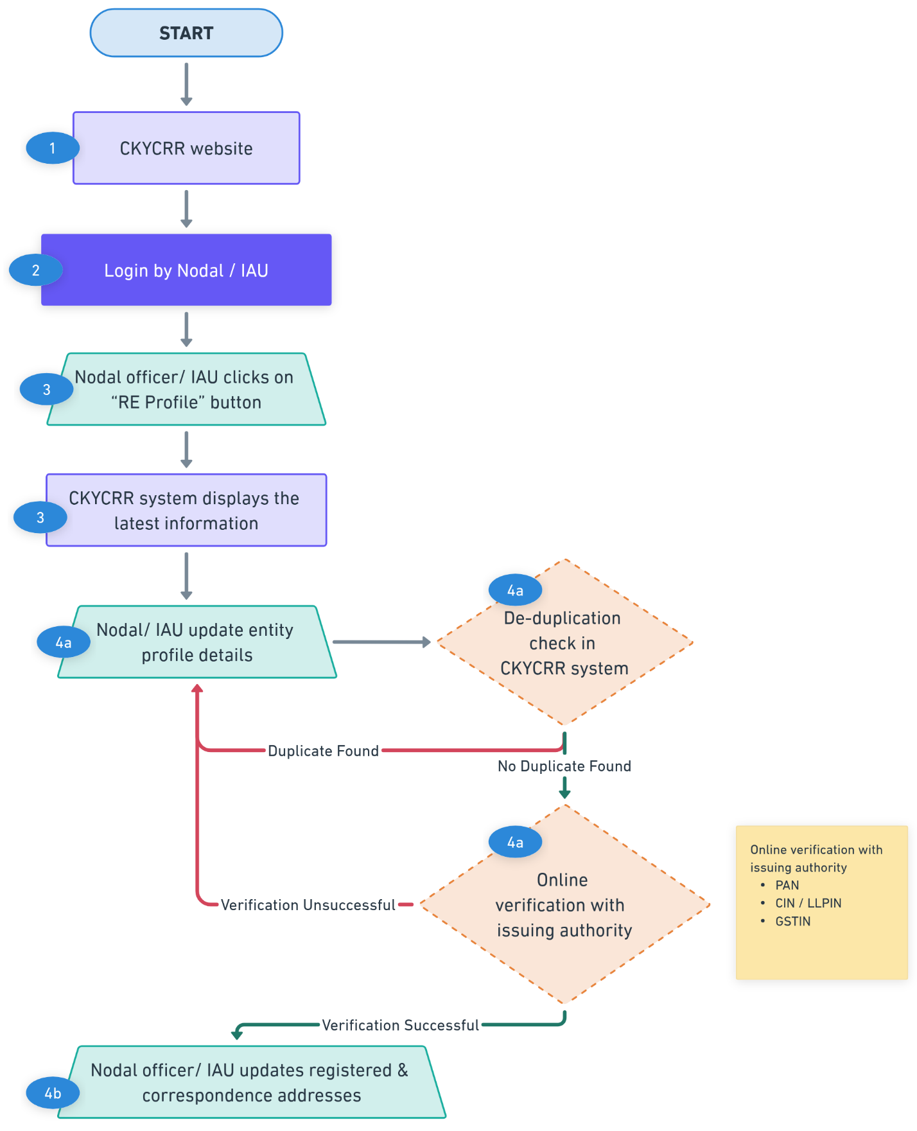
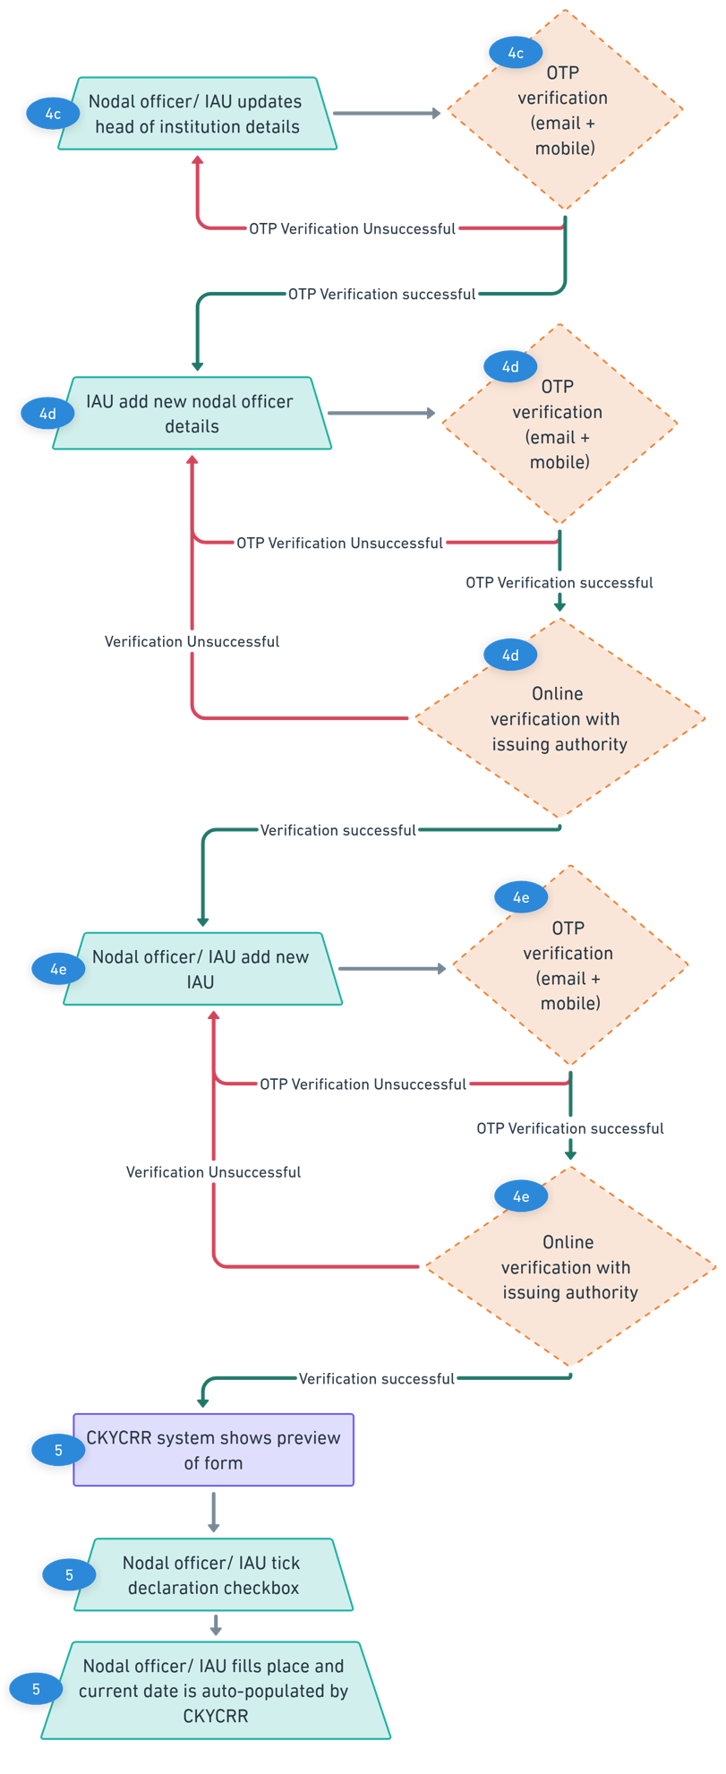
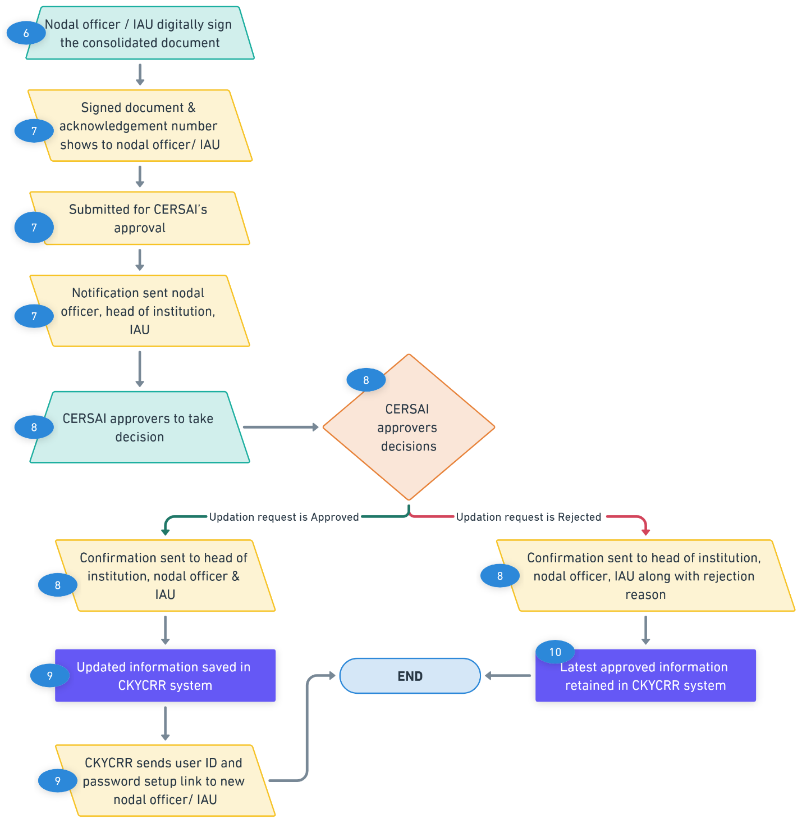
Below outlines the process of user details update:

User profile update is available for every user of the reporting entity. User profile update section allows users of the reporting entity to self-update few information and submit for approval.

Step 1: The RE user will access domain / URL “https://www.ckycindia.in” from their respective systems connected over internet.

Step 2: The RE user will login to the CKYCRR system using the user ID issued, password and DSC (as per login module).

Step 3: The RE user will click on “Profile” button to navigate to “user details” section. The CKYCRR system will display the latest information and documents of user.

Step 4: The RE user can update the following details by clicking the “Edit” button

Section | Field | Field Type | Field Size | M/O/CM | Validations | Editable
Details | Citizenship | Char | 3 | M | Dropdown values as per configurations in CMS. Draft values will be configured. | N
 | CKYC number | Char | 14 | CM | 14 digits numeric value allowed. CKYC number will be verified from CKYCRR registry.  Mandatory if citizenship selected is Indian | N
 | Title | Char | 2 | M | Dropdown value  1. Mr.  2. Ms  3.Mrs. | N
 | First Name | Varchar | 33 | M | 1. Space allowed  2. A to Z and a to z will be allowed  3. Single apostrophe will be allowed  4. Dot (.) is allowed. | N
 | Middle name | Varchar | 33 | O | 1. Space not allowed  2. A to Z and a to z will be allowed  3. Single apostrophe will be allowed | N
 | Last name | Varchar | 33 | O | 1. Space not allowed  2. A to Z and a to z will be allowed  3. Single apostrophe will be allowed | N
 | Designation | Varchar | 100 | M | 1. Alphanumeric value allowed  2. Following Special Characters will be allowed  `~@#$%^&*()_+-= | Y
 | email ID | Varchar | 254 | M | 1. Alphanumeric value allowed  2. Following Special Characters will be allowed  `~@#$%^&*()._+-=  3.Atleast one @ should be present. | Y
 | Country code | Char | 4 | M | 1.Default value selected will be India (+91).  2. Dropdown values as per Annexure III (ISO code), will be configurable | N
 | Mobile No | Varchar | 15 | M | 1. Min 8 and maximum 15. In case of country code other than India, mobile number will accept numeric value of min 8 and maximum 15.  2.For India, 10 digit mobile number is allowed | Y
 | Proof of Identity | Char | 2 | M | Dropdown values will be displayed. User needs to select any one option. List of document  1. Aadhaar  2. Voter ID  3. Passport  4. Driving License  5. PAN card | Y
 | Proof of identity number | Char | 50 | M | Validation to be kept as per ID type selected in PoI. | Y
 | Date of Birth | Calendar | 8 | M | Date should be as per DDMMYYYY format | Y
 | Gender | Char | 2 | M | Dropdown will be displayed and dropdown values will be  1.Male  2.Female  3. Transgender | N
 | Employee code | Varchar | 20 | M | alphanumeric with special character + allowed | Y
 | Office Address | Checkbox | 1 | CM | Either RE registered address or correspondence address for Nodal officer/IAU/IU. For IRA/IRU : Region address  IBU: Branch address | N
 | Landline number | Varchar | 15 | O | alphanumeric with special character + allowed | Y
 | Authorization letter details | Varchar | 20 | M | alphanumeric with special character + allowed | N
 | Date of authorization | Calendar | 8 | M | Date should be as per DDMMYYYY format | N
Document | Certified copy of the proof of the identity of the RE user (Only for Nodal officer and IAU) |  |  | CM | Default file format: PDF/Jpg/Jpeg ( File size < 500kb)  Configurable via CMS  Mandatory if POI is changed. | Y
 | Certified copy of photo identity card of the RE user (Only for Nodal officer and IAU) issued by the institution (in case photo IDs are not issued by the institution to employees, a letter duly signed by the authorized signatory mentioning the same would be required along with the photographs of the admin users) |  |  | CM | Default file format: PDF/Jpg/Jpeg ( File size < 500kb) | Y
 | DSC |  |  | M | DSC file | Y

Step 5: In case of any modifications made to the email address and/or mobile number by the user, the CKYCRR system will trigger OTPs to new email address and/or mobile number provided. The RE user must enter the mobile OTP sent to provided mobile number and/ or email OTP sent to provided email address and click “Submit” button. The CKYCRR system will validate the OTPs entered by the RE user. Upon successful OTP validation, the CKYCRR system moves to the next section. If the OTP verification fails, the CKYCRR system will display error message “Incorrect email/ mobile OTP”. The user will have to re-enter the OTPs sent to provided email address and/or mobile.

Step 6: In case the DSC is updated by the RE user of the reporting entity, the CKYCRR system will do the below validation
- The CKYCRR system will check the validity of the updated DSC to ensure that DSC is not expired or revoked. If the DSC is expired or revoked, the CKYCRR system will give error message “Invalid DSC, Please upload valid DSC”.
- The CKYCRR system will check if the updated DSC is class 3 compliant or not. If the DSC is not Class 3 compliant, the CKYCRR system will give error message “DSC is not class 3. Please upload class 3 DSC”.
- Upon successful validation, the CKYCRR system will match the name of the user with name mentioned in DSC. If the names do not match, the CKYCRR system will give error message “Invalid DSC. Please try again”. If the names match, the CKYCRR system will send the request to approver as per the below matrix.

Step 7: The modification request will be submitted to the approver as per the below matrix:

Approval matrix:
Type of User | Approver
Nodal officer | CERSAI (approver I & approver II)
Institutional Admin User | Nodal Officer
Institutional user | Institutional admin user
Institutional regional admin | Institutional admin user
Institutional regional user | Institutional regional admin user
Institutional branch user | Institutional regional admin
**Note: If only DSC is updated by the RE user, the CKYCRR system will not send the update request for approval.
Step 8: The CKYCRR system will display the modification request in approvers’ my task for approval. The approver can view the information and documents submitted by the reporting entity user. Approver will have the following options
- Approve: The user details modification request is approved in the CKYCRR system and the CKYCRR system triggers the confirmation notification to the RE user. The CKYCRR system will save the updated information and documents.
- Reject: The RE user details modification request is rejected in the CKYCRR system and the CKYCRR system will trigger an email notification user. The CKYCRR system will keep the latest approved record.
Step 9: In case of approval of user details modification request: The CKYCRR system saves the updated information and documents in registry.
Step 10: In case of rejection: User of the reporting entity will receive the notification along with rejection remarks. The CKYCRR system will keep the latest approved record in the registry.

Functional Flow:
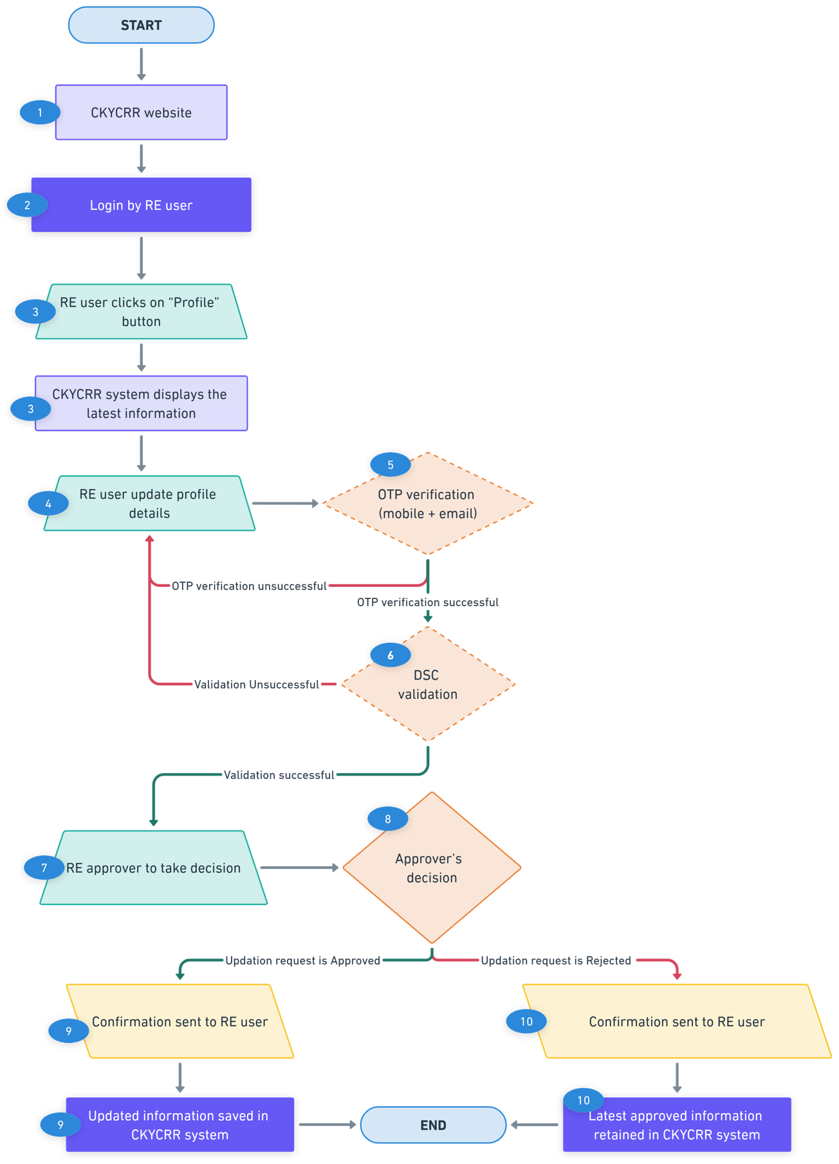

Points to remember:
- Permissions for updating user profiles will be managed through RBAC settings in the CKYCRR system.
- Once an update request is submitted for approval, user of the reporting entity cannot modify the details. The edit option will be re-enabled only after the required action has been taken by the approvers.
- The OTPs sent to the user of the reporting entity to their registered mobile number and email addresses is valid for 10 minutes. The user of the reporting entity can request a resend of OTP as per below time intervals:
- 30 seconds (1st attempt)
- 60 seconds (2nd attempt)
- 90 seconds (3rd attempt)
- Where there is change in name, RE shall upload revised license copy from the regulator with new name and updated PAN. For change in address, nodal officer, admin users, documents in support of the same, as required at the time of registration to be submitted by RE.
- In case change in nodal officer and both IAUs, RE shall physically submit the request to CERSAI in the designated format signed by the new nodal officer along with supporting documents.
- The form to be submitted separately for Nodal Officer and each Institutional Admin user along with a covering letter. The request should be submitted on the letterhead of the Reporting Entity.
- The CKYCRR system will trigger notifications at the following key events:-
Key Event | User | Email | SMS | Post Login
Nodal Officer – email/ mobile OTP Verification | Nodal Officer | Yes | Yes | No
Head of Institution– email/ mobile OTP Verification | Head of Institution | Yes | Yes | No
Institutional admin user– email/ mobile OTP Verification | Institutional admin user | Yes | Yes | No
Approval/ rejection of entity profile update notification | Nodal Officer/ Institutional admin user/ Head of institution/ CERSAI user | Yes | No | Yes
Acknowledgment of Submission for entity profile update Approval | Nodal Officer/ Head of Institution/ head of institution/ CERSAI user | Yes | No | Yes
IU/IRA/IRU/IBU email/mobile verification | IU/IRA/IRU/IBU | Yes | Yes | No
Password setup link for new user | Nodal officer/ institutional admin user | Yes | No | No
Approval/ rejection of user profile update | Nodal Officer/ IAU/IU/ IRA/ IRU/ IBU | Yes | No | Yes
Acknowledgment of Submission for user profile update Approval | Nodal Officer/ IAU/IU/ IRA/ IRU/ IBUCERSAI user | Yes | No | Yes

KYC Management
KYC Management allows Reporting Entities (RE) to search, download, create, and update KYC records of individuals and legal entities within the CKYCRR system. These functionalities will be accessible through CKYCRR website, API and SFTP. The section defines the detailed process of web based KYC management.

**Process of Search/ upload/ download / update through SFTP and API will be defined in SRS document.

Below outlines the process of accessing KYC management:
Step 1: The RE user will access domain / URL “https://www.ckycindia.in” from their respective systems connected over internet.

Step 2: The RE user will login to the CKYCRR system using the user ID issued, password and DSC (as per login module).

Step 3: The RE user will click on “KYC Management ” button to navigate to KYC management modules.
- Search – Locate existing KYC records in the registry.
- Download – Retrieve KYC records.
- Update – Modify existing KYC records.
- Create/Upload – Add new KYC records to the registry.
- De-activate existing KYC record
- Re-activate de-activated KYC record
- Suspend existing KYC record
- Revocation of Suspended KYC record
- Closure of relationship

Search KYC Record
Search functionality enables RE users to search existing KYC records in the CKYCRR registry.

Below outlines the process of searching single KYC record in the CKYCRR registry:
Step 1: The RE user will access domain / URL “https://www.ckycindia.in” from their respective systems connected over internet.

Step 2: The RE user will login to the CKYCRR system using the user ID issued, password and DSC (as per login module).

Step 3: The RE user will click on “KYC Management ” button to navigate to KYC management modules and select search option.

Step 4: The RE user will can search the single record of individual or legal entity by providing any one of the below parameters
Individual | Legal Entity
Option 01: OVD Number/ PAN/ CKYC number | Option 01: PAN / GSTIN/ CKYC number
Option 02: Combination of Name + Date of Birth + Gender | Option 02: Combination of Name + Date of Incorporation/ Formation
Option 03: Name + Photo
In case of Aadhaar OVD provided for individual, the RE user needs to provide last 4 digits of the Aadhaar number along with full Name, date of birth and gender as per the Aadhaar.

Step 5: Post selection of the option by the RE user, the RE user needs to provide the details mapped to option selected by the RE user.

Step 6: The RE user needs to click on the “Search” button.

Step 7: The CKYCRR system will generate the following response
Scenario01:Record Exists
If the record is found in the CKYC registry, the following details will be displayed to the RE user for a single record.
Individual | Legal Entity
Name | Name
Gender | Document Submitted (list)
Photo | Last Update Date
Document Submitted (list) | CKYC Reference Number
Last Update Date | Masked mobile number
CKYC Reference Number | Masked Email ID
Masked mobile number
Masked Email ID
** In case of multiple records found, the CKYCRR system will generate single reference number (system generated) for new KYC record creation. For download, the RE can use the CKYC reference number of the particular record.
Scenario 02: Record Does Not Exist
If the record is not found in the CKYCRR registry, the user will receive a upload reference key and the CKYCRR system will prompt RE user to create a new KYC record of the individual or legal entity.
Step 8: If record exists in the CKYCRR registry: The RE user can proceed to download KYC record process.
Step 9: if the record does not exist in the CKYCRR registry: The RE user can proceed to create KYC record process.
Functional Flow:
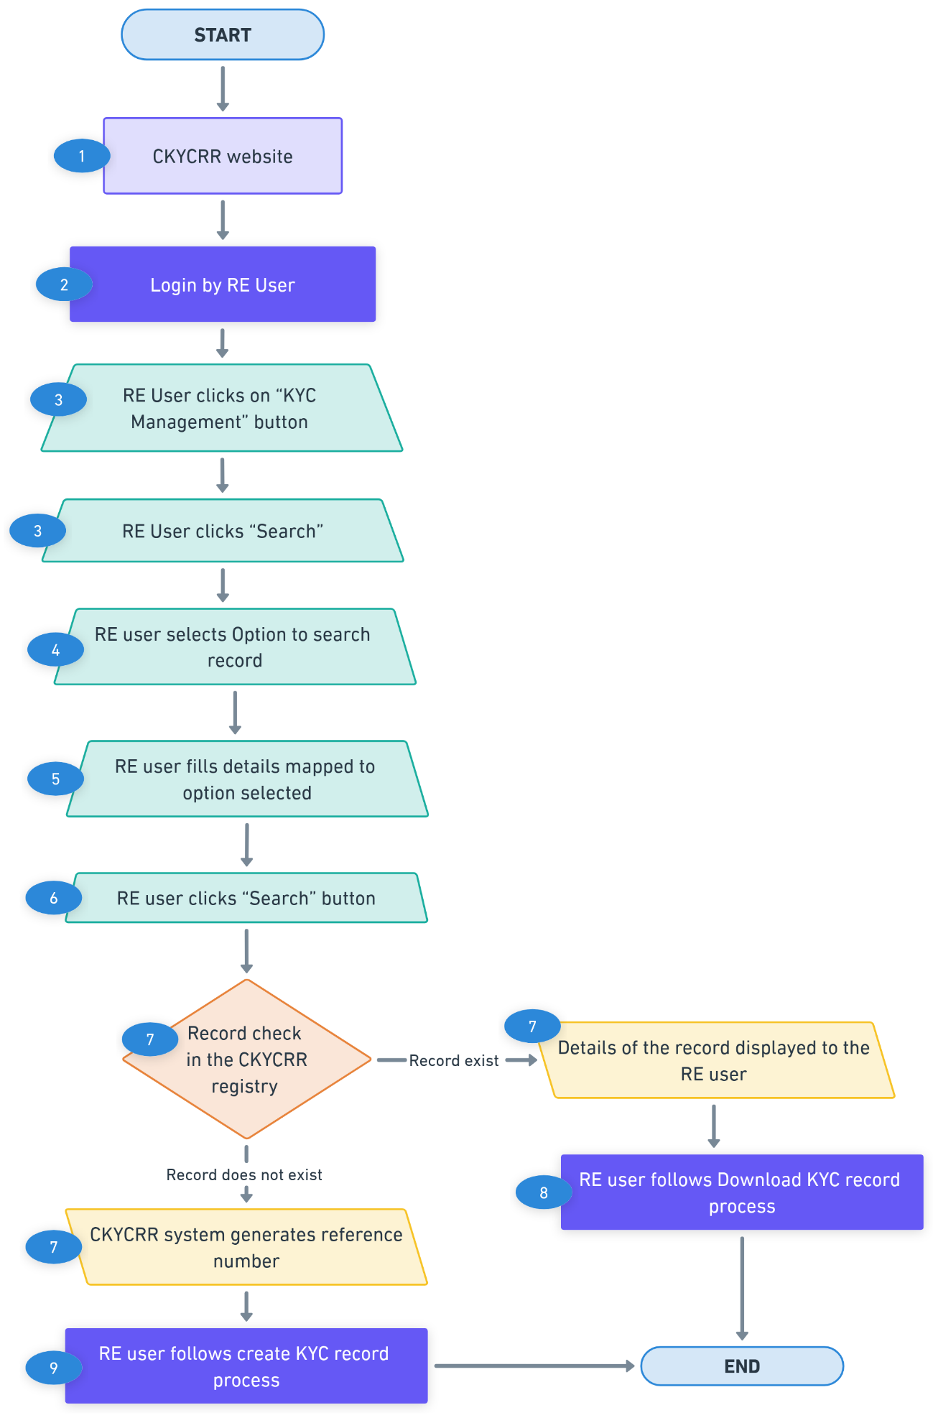

Points to remember:
- The CKYCRR system will automatically generate and assign a reference number for each record searched and not found in the CKYCRR registry.
- Search parameters will adhere to field-level validations, similar to those in the record creation process.
Below outlines the process of searching bulk KYC record:
Bulk search enables RE users to search multiple records simultaneously in the CKYCRR registry, optimizing time and effort.
Step 1: The RE user will access domain / URL “https://www.ckycindia.in” from their respective systems connected over internet.

Step 2: The RE user will login to the CKYCRR system using the user ID issued, password and DSC (as per login module).

Step 3: The RE user will click on “KYC Management ” button to navigate to KYC management modules and select search option.
Step 4: The RE user needs to fill the search parameters in the predefined excel sheet offline. The search criteria can be any of the following options
Individual | Legal Entity
Option 01: OVD Number/ PAN/ CKYC number | Option 01: PAN / GSTIN/ CKYC number
Option 02: Demographic - Name + Date of Birth + Gender | Option 02: Demographic - Name + Date of Incorporation/ Formation
Option 03: Name + Photo
In case of Aadhaar as OVD provided for individual, the RE user needs to provide last 4 digits of the Aadhaar number along with Name, date of birth and gender as per the Aadhaar.
Step 5: The RE user will validate the completed CSV sheet using the File Validation Utility (FVU). Once validated, the same file must be uploaded to the CKYCRR system.
Step 6: Upon submission by RE user (maker), the bulk file will be sent to checker (RE user) for approval. The RE user will have the below actionable:
- Approve: Upon approval, the CKYCRR system will start processing the search bulk file.
- Reject: The CKYCRR system will send the notification to RE user (maker) for required modifications and re-submission.
Step 7: Upon successful approval and processing by CKYCRR system, the CKYCRR system will generate a ZIP output file containing the CSV file mentioning status (record found/record not found) along with relevant details for records that exist in the database and photos of record found. The ZIP output file will be available under “KYC logs” for view and download.
Step 8: CSV file provided by the CKYCRR registry will provide the following information
Scenario 01: Record Exists
If the record is found in the CKYC registry, the following details will be provided to the RE for every record.
Individual | Legal Entity
Name | Name
Gender | Document Submitted (list)
Photo | Last Update Date
Document Submitted (list) | CKYC Reference Number
Last Update Date | Masked mobile number
CKYC Reference Number | Masked Email ID
Masked mobile number
Masked Email ID

Scenario 02: Record Does Not Exist
If the record is not found in the CKYCRR registry, the user will receive a upload reference number and the CKYCRR system will prompt RE user to create a new KYC record of the individual or legal entity.
Step 9: For records exist: The RE user can download the KYC record using bulk download process or single download process.
Step 10: For records do not exist: The RE user can create the KYC record using bulk upload process or single upload process.
Functional Flow:
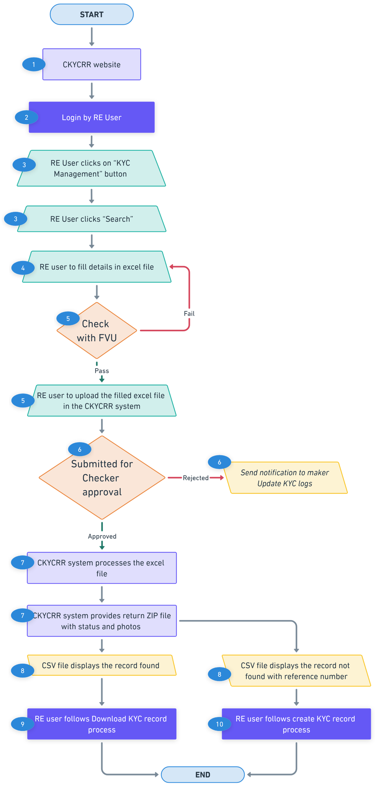
Points to remember:
- Name and Photograph-Based Search: This feature is exclusively available for individual records. It does not support search for legal entity KYC record.
- Bulk File Templates Access: Standardized bulk search templates will be provided in the Download section available on the CKCYRR website. RE users can access these templates for KYC search.
- For every record retrieved as part of a bulk search, a unique Photo ID reference number will be included in the CSV file provided by the CKYCRR system. This reference number will help RE users locate the corresponding photograph within the ZIP folder containing image files.
- For masked mobile number, the CKYCRR system will display the starting 2 digits and last 2 digits. For example: 79xxxxxx89
- For masked email address, the CKYCRR system will display the starting 2 characters and domain name. For example: raxxxxxxxxxxx@gmail.com.

Download KYC Record
The Download feature enables RE users to search and download the complete details of any existing KYC record within the CKYCRR system.
Below outlines the process of downloading single record:
Step 1: The RE user will access domain / URL “https://www.ckycindia.in” from their respective systems connected over internet.

Step 2: The RE user will login to the CKYCRR system using the user ID issued, password and DSC (as per login module).

Step 3: The RE user must follow the “Search KYC Record” process to get CKYC reference number of existing records.

Step 4: The RE user will click on “KYC Management ” button to navigate to KYC management modules and select download option.

Step 5: After successful search, RE user must enter the CKYC reference number and the RE user must provide anyone of the authentication factor to proceed with download of the KYC record

Option | For Individuals | For Legal Entities
1 | Mobile Number | Mobile Number
2 | Email ID | Email ID
3 | Date of Birth | Date of Incorporation/ Formation
4 | Year of Birth & PIN Code (Current Address) | Year of Incorporation/ Year of Formation & PIN Code (Registered Address)
5 | Father / mother/ spouse name | -

Step 6: The CKYCRR system validates the CKYC reference number and the provided authentication factor by the RE user. If the authentication factors are valid, the CKYCRR system will prompt RE user to capture the client consent as per the client consent mechanism defined in Annexure I.

Step 7: Upon successful capturing of client consent, the KYC record will be retrieved and displayed to the RE user. A download button is provided for saving/ downloading the file.

Step 8: The RE user can click download button to download the entire KYC record in the system in PDF/ZIP file.

Functional Flow:
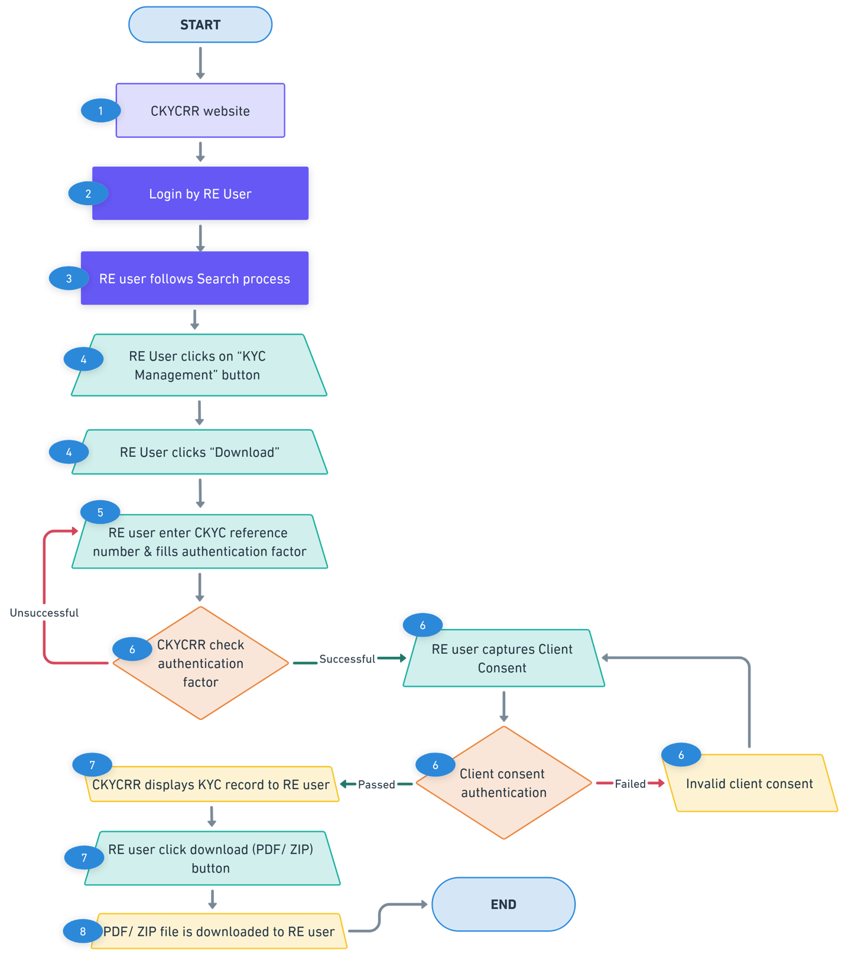
Points to remember:
- The RE user can provide any one of the available authentication factors.
- Consent mechanism to be followed as per consent mechanism defined in Annexure I.
- The CKYCRR system will display confidence level category and score to RE user upon downloading the KYC record.
- The de-activated / suspended CKYC record will not be downloaded but will be available for search.
- The downloaded PDF file will be watermarked. The template of PDF will be annexed in SRS.
- The KYC record will be displayed on the screen, along with a download (PDF/ ZIP file) button option to save the record for offline use.
Key Event | User | Email | SMS | Post login
Information to Client on download (where client consent is not captured through OTP mechanism) | Client | Yes | Yes | No
Information to client on download through mobile OTP | Client | Yes | No | No

Below outlines the process of downloading bulk KYC record:
Step 1: The RE user will access domain / URL “https://www.ckycindia.in” from their respective systems connected over internet.

Step 2: The RE user will login to the CKYCRR system using the user ID issued, password and DSC (as per login module).

Step 3: The RE user will click on “KYC Management ” button to navigate to KYC management modules and select download option.
Step 4: On successful search, the CKYCRR system will generate reference number and the same reference number to be used by RE user while filling the download excel file.
Step 5: For records that exist in the CKYCRR registry, provide anyone of the authentication factor against the CKYC Reference number using the defined template.
Option | For Individuals | For Legal Entities
1 | Mobile Number | Mobile Number
2 | Email ID | Email ID
3 | Date of Birth | Date of Incorporation/ Formation
4 | Year of Birth & PIN Code (Current Address) | Year of Incorporation/ Formation & PIN Code (Registered Address)
5 | Father / mother/ spouse name | -
Step 6: The RE user will validate the completed CSV sheet using the File Validation Utility (FVU). Once validated, the same file must be uploaded to the CKYCRR system.
Step 7: Upon submission by RE user (maker), the bulk file will be sent to checker (RE user) for approval. The RE user will have the below actionable:
- Approve: Upon approval, the CKYCRR system will start processing the download bulk file.
- Reject: The CKYCRR system will send the notification to RE user (maker) for required modifications and re-submission.
Step 8: Upon successful approval by RE user (checker), the CKYCRR system validates the CKYC reference number and the provided authentication factor by the RE user. If the authentication factors are valid, the CKYCRR system will authenticate client consent as per the client consent mechanism defined in Annexure I.

Step 9: On successful capture of client consent and completion of file processing, the CKYCRR system will revert with the ZIP file containing CSV file and associated documents of the records. CSV file will have detailed report on successful downloads and errors/ system responses for unsuccessful downloads.
Functional Flow:
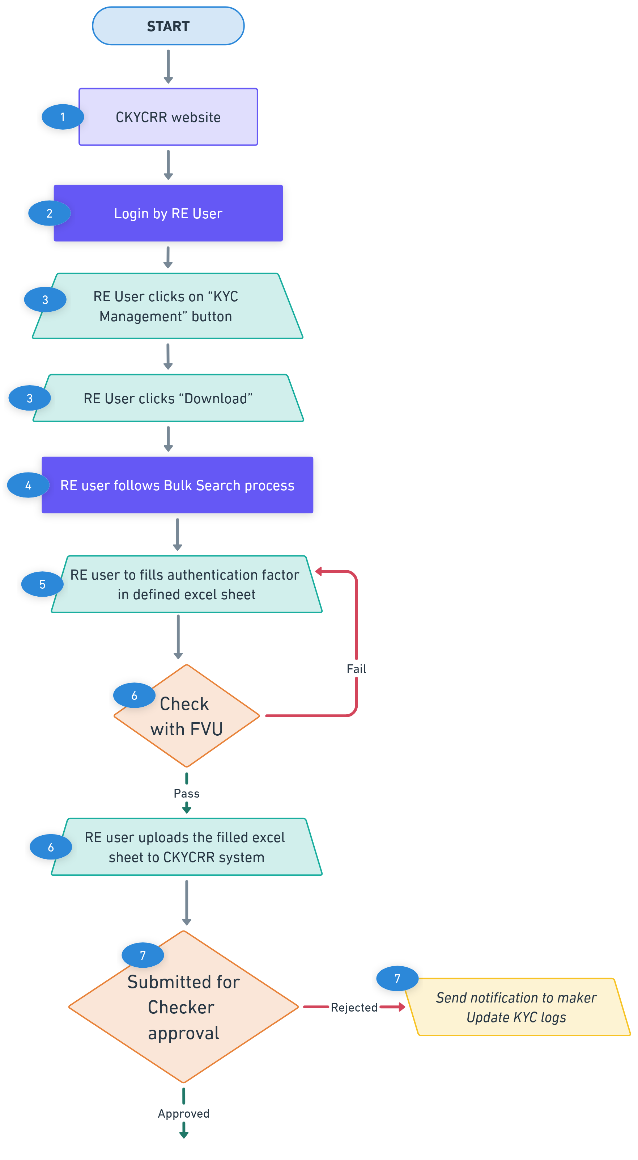
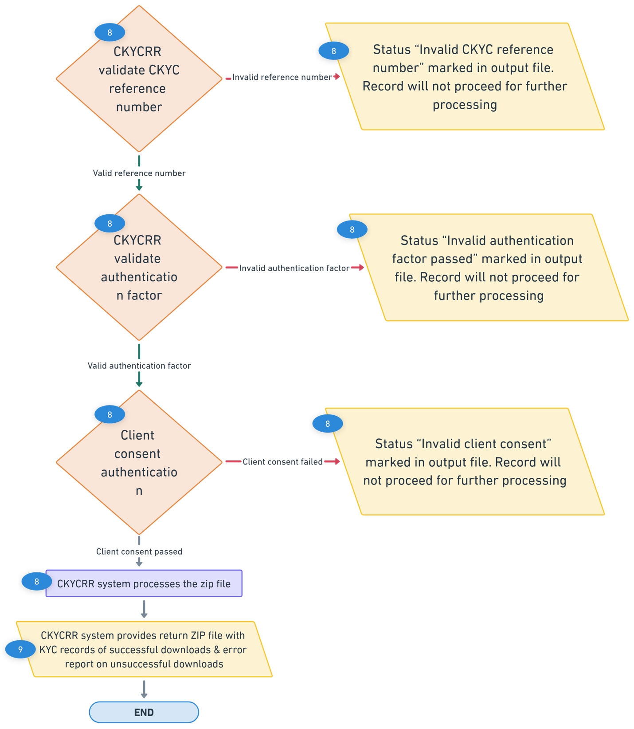
Points to remember:
- Download template to fill authentication factor will be available under download section of the CKYCRR website.
- If the file format is not uploaded in the defined templates, the CKYCRR system will reject the entire file.
- CKYCRR system will follow the client consent as per consent mechanism defined in annexure II.
- The de-activated / suspended CKYC record will not be downloaded.
- The CKYCRR system will display confidence level category and score to RE user upon downloading the KYC record.
- For the authentication factors and client consent, if the provided parameters do not match , the CKYCRR system will provide the error in response CSV file.
Key Event | User | Email | SMS | Post login
Information to Client on download (where client consent is not captured through OTP mechanism) | Client | Yes | Yes | No
Information to maker on bulk file rejection | RE user | Yes | No | Yes
Information to client on download through mobile OTP | Client | Yes | No | No

Create KYC Record – Individual
The create new KYC record feature enables RE users to register a new KYC record in the system. KYC records can be created for both individual and legal entity. Where on search, no record is found, RE shall proceed to upload the KYC documents of the client for creation of new KYC record. This section covers the KYC record creation of individual.
Below outlines the process of creating new single KYC record:
Step 1: The RE user will access domain / URL “https://www.ckycindia.in” from their respective systems connected over internet.

Step 2: The RE user will login to the CKYCRR system using the user ID issued, password and DSC (as per login module).

Step 3: The RE user will click on “KYC Management ” button to navigate to KYC management modules and select create KYC record option.
Step 4: The RE user will be prompted to enter the reference number generated by the CKYCRR system during search process. CKYCRR system will check the reference number. If the entered reference number is correct, the RE user will move to the next step. If the entered reference number is incorrect, the CKYCRR system will prompt RE user to enter the correct reference number.
Step 5: The RE user will select the type of CKYC account as per the below dropdown values:
  - Normal
  - Minor
  - Aadhaar OTP based eKYC (non-face to face mode)
Step 6: The RE user will provide the below demographic details of the individual
Section | Field | Field Type | Field Size | M/O/CM | Validations
Name | Title | Char | 2 | M | Dropdown value  1.Mr.  2.Ms  3. Mrs.
 | First Name | Varchar | 33 | M | 1. Space not allowed  2. A to Z and a to z will be allowed  3. Single apostrophe will be allowed  4. Dot(.) will be allowed
 | Middle Name | Varchar | 33 | O | 1. Space allowed  2. A to Z and a to z will be allowed  3. Single apostrophe will be allowed
 | Last Name | Varchar | 33 | O | 1. Space not allowed  2. A to Z and a to z will be allowed  3. Single apostrophe will be allowed
Maiden Name (if any) | First Name | Varchar | 33 | O | 1. Space not allowed  2. A to Z and a to z will be allowed  3. Single apostrophe will be allowed  4. Dot(.) will be allowed
 | Middle Name | Varchar | 33 | O | 1. Space allowed  2. A to Z and a to z will be allowed  3. Single apostrophe will be allowed
 | Last Name | Varchar | 33 | O | 1. Space not allowed  2. A to Z and a to z will be allowed  3. Single apostrophe will be allowed
Mother Name | First Name | Varchar | 33 | CM | 1. Space not allowed  2. A to Z and a to z will be allowed  3. Single apostrophe will be allowed  4. Dot(.) will be allowed  RE to provide atleast one from mother name/ father name / spouse name.  Other 2 will be optional.
 | Middle Name | Varchar | 33 | O | 1. Space allowed  2. A to Z and a to z will be allowed  3. Single apostrophe will be allowed
 | Last Name | Varchar | 33 | O | 1. Space not allowed  2. A to Z and a to z will be allowed  3. Single apostrophe will be allowed
Father Name | First Name | Varchar | 33 | CM | 1. Space not allowed  2. A to Z and a to z will be allowed  3. Single apostrophe will be allowed  4. Dot(.) will be allowed  RE to provide atleast one from mother name/ father name / spouse name  Other 2 will be optional.
 | Middle Name | Varchar | 33 | O | 1. Space not allowed  2. A to Z and a to z will be allowed  3. Single apostrophe will be allowed
 | Last Name | Varchar | 33 | O | 1. Space not allowed  2. A to Z and a to z will be allowed  3. Single apostrophe will be allowed
Spouse Name | First Name | Varchar | 33 | CM | 1. Space not allowed  2. A to Z and a to z will be allowed  3. Single apostrophe will be allowed  4. Dot(.) will be allowed.  RE to provide atleast one from mother name/ father name / spouse name  Other 2 will be optional.
 | Middle Name | Varchar | 33 | O | 1. Space not allowed  2. A to Z and a to z will be allowed  3. Single apostrophe will be allowed
 | Last Name | Varchar | 33 | O | 1. Space not allowed  2. A to Z and a to z will be allowed  3. Single apostrophe will be allowed
Date of Birth |  | Calendar | 8 | M | Date should be as per DDMMYYYY format
Minor |  | Char | 1 | M | Checkbox with possible values: Y/N  Auto-populated by the CKYCRR
DOB matching with OVD |  | Char | 1 | M | Checkbox with possible values: Y/N
Name matching with OVD |  | Char | 1 | M | Checkbox with possible values: Y/N
Photo matching with OVD |  | Char | 1 | M | Checkbox with possible values: Y/N
Gender |  | Char | 1 | M | Dropdown with value:  male  female  transgender
Gender matching with OVD |  | Char | 1 | M | Checkbox with possible values: Y/N
PAN |  | Varchar | 10 | CM | "Format: AAAAA9999A (5 alphabets, 4 digits, 1 alphabet).  Checksum Logic:  Validate the first 5 characters as alphabets (A-Z).  Validate the next 4 characters as digits (0-9).  Validate the last character as an alphabet (A-Z)."  4th character should be “P”.  Any one from PAN, Form 60, Form 61 is required
Form 60 |  | Char | 1 | CM | Checkbox with possible values: Y/N
Form 61 |  | Char | 1 | CM | Checkbox with possible values: Y/N
PAN verified |  | Char | 1 | CM | Checkbox with possible values: Y/N  Where PAN is provided
Residential Status |  | Char | 1 | M | Dropdown with value:  Resident  NRI  PIO  Foreign National
Residential Status supported by the document |  | Char | 1 | M | Checkbox with possible values: Y/N
Nationality |  | Varchar | 33 | O | Alphabets allowed. Default Indian to be selected
Nationality  Supported by document |  | Char | 1 | CM | Checkbox with possible values: Y/N  Where Nationality is provided
Differently Abled status |  | Char | 1 | M | Checkbox with possible values: Y/N
Differently Abled Type |  | Char | 2 | CM | Dropdown values:  1) Blindness.  2) Low Vision.  3) Hearing Impairment.  4) Locomotor Disability.  5) Leprosy Cured.  6) Cerebral Palsy.  7) Intellectual Disability.  8) Mental Illness.  9) Muscular Dystrophy.  10) Parkinson's Disease.  11) Acid Attack Victim.  12) Sickle Cell Disease.  13) Hemophilia.  14) Thalassemia.  15) Speech and Language Disability.  16) Multiple Sclerosis.  17) Specific Learning Disabilities.  18) Chronic Neurological Conditions.  19) Autism Spectrum Disorder.  20) Dwarfism.  Mandatory when Differently Abled type is “Yes”.
UDID No |  | Varchar | 18 | CM | Alphanumeric value allowed  First 2 alphabets, remaining 16 numbers.
Differently Abled percentage |  | Varchar | 3 | CM | Numeric value allowed.  Minimum value: 01  Maximum value: 100
Differently Abled status  Supported by document |  | Char | 1 | CM | Checkbox with possible values: Y/N
Documents | PAN |  |  | CM | PDF/Jpg/Jpeg (file size < 500kb)  If PAN is selected
 | Photo of Individual |  |  | M | PDF/Jpg/Jpeg (file size < 500kb)
 | Differently Abled certificate |  |  | CM | PDF/Jpg/Jpeg (file size < 500kb)  Where Differently Abled status is supported by document
 | Form 60/61 |  |  | CM | PDF/Jpg/Jpeg (file size < 500kb)  If PAN is not provided

Step 7: The RE user will click on “Save & Next” and the CKYCRR system will generate an Acknowledgment Number, which the RE user can use to resume the KYC record creation process if needed. Draft records, including the Acknowledgment Number and saved data, will be retained in the CKYCRR system under KYC logs for 30 days from the last update. After 30 days, the CKYCRR system will automatically delete incomplete/draft records.
Step 8: The RE user shall then proceed to the Proof of Identity/ proof of address details along with the associated documents. The following OVD (Officially Valid Document) details must be provided.
Section | Field | Field Type | Field Size | M/O/CM | Validations
OVD Details | OVD Type | Char | 1 | M | Dropdown with value:  a. Passport  b. Voter ID card  c. Driving license  d. NREGA job card  e. National Population Register Letter  f. Proof of possession of Aadhar  g. eKYC authentication  h. Offline verification of Aadhar
 | Passport expiry date | Calendar | 8 | CM | Date should be as per DDMMYYYY format.  Required in case of “passport” selected as OVD
 | Driving license expiry date | Calendar | 8 | CM | Date should be as per DDMMYYYY format  Required in case of “Driving License” selected as OVD
 | ID Number | Varchar | 100 | M | Depends upon value selected in POI
 | Certified copy verified with original OVD | Char | 1 | CM | Checkbox with possible values: Y/N  Atleast one mandatory between certified with physical copy of OVD, equivalent e-doc, or document verified from digilocker.
 | Equivalent e-doc | Char | 1 | CM | Checkbox with possible values: Y/N  Atleast one mandatory between certified with physical copy of OVD, equivalent e-doc, or document verified from digilocker.
 | Document verified from digilocker | Char | 1 | CM | Checkbox with possible values: Y/N  Atleast one mandatory between certified with physical copy of OVD, equivalent e-doc, or document verified from digilocker.
 | Presence of Passport in MEA repository | Char | 1 | CM | Checkbox with possible values: Y/N  Applicable for passport OVD
 | Presence of Voter ID in ECI repository | Char | 1 | CM | Checkbox with possible values: Y/N  Applicable for Voter ID OVD
 | Presence of Driving License in RTO repository | Char | 1 | CM | Checkbox with possible values: Y/N  Applicable for driving license OVD
 | Presence of NREGA in respective repository | Char | 1 | CM | Checkbox with possible values: Y/N  Applicable for NREGA OVD
 | Presence of NPR in census records/ respective repository | Char | 1 | CM | Checkbox with possible values: Y/N  Applicable for NPR OVD
 | Offline verification of Aadhaar | Char | 1 | CM | Checkbox with possible values: Y/N  Applicable for Aadhaar OVD
 | Data received from offline verification | Char | 1 | CM | Checkbox with possible values: Y/N  Applicable for Aadhaar OVD where offline verification is done
 | E-KYC authentication | Char | 1 | CM | Checkbox with possible values: Y/N  Applicable for Aadhaar OVD
 | E-KYC data received from UIDAI | Char | 1 | CM | Checkbox with possible values: Y/N  Applicable for Aadhaar OVD where e-KYC authentication is selected
 | E-KYC authentication biometric / face authentication carried out | Char | 1 | CM | Checkbox with possible values: Y/N  Applicable for Aadhaar OVD  Any one of the e-KYC authentication methods where e-KYC authentication is selected—biometric/face authentication or OTP authentication—was carried out.
 | E-KYC OTP authentication carried out | Char | 1 | CM | Checkbox with possible values: Y/N  Applicable for Aadhaar OVD  Any one of the e-KYC authentication methods where e-KYC authentication is selected —biometric/face authentication or OTP authentication—was carried out.
Documents | Copy of OVD/POI |  |  | M | PDF/Jpg/Jpeg (file size < 500kb)  Depends upon value selected in POI

Step 9: The CKYCRR system will initiate the OCR (Optical Character Recognition) process for the uploaded OVD (Officially Valid Document), PAN and photo to extract relevant details from the OVD, PAN and photo. The CKYCRR system will compare the extracted details from OVD, PAN and photo with the manually entered details by the RE user. The CKYCRR system will match photo uploaded by the RE with the photo in OVD. If the details match, the CKYCRR system will proceed with the next step. If the details do not match, the CKYCRR system will display: “Details do not match with documents provided. Please enter the correct details”
Step 10: Address details: The RE user will enter the permanent address and the current address. Permanent address is the address as mentioned in the OVD submitted by the client. The user will have the option to mark the current address (for individuals) as the same as the permanent address. If the addresses are different, the RE user must enter the current address separately. Additionally, required documents must be attached as proof of the current address and its validity for foreign nationals. For other than foreign nationals, proof of current address is not mandatory to upload. RE user may use self declaration check box where Aadhaar authentication has been carried out successfully for an individual and individual wants to provide current address different from the information available/ received from Aadhaar/ UIDAI.
Section | Field | Field Type | Field Size | M/O/CM | Validations
Permanent Address | Flat no/house no | Varchar | 60 | O | 1. Alphanumeric value allowed  2. Space between words is allowed  3. Following Special Characters will be allowed  `~@#$%^&*()_+-=
 | Plot no/ apartment name | Varchar | 60 | O | 1. Alphanumeric value allowed  2. Space between words is allowed  3. Following Special Characters will be allowed  `~@#$%^&*()_+-=
 | locality/ street | Varchar | 60 | M | 1. Alphanumeric value allowed  2. Space between words is allowed  3. Following Special Characters will be allowed  `~@#$%^&*()_+-=
 | city/town/village | Varchar | 60 | M | 1. Alphanumeric value allowed  2. Space between words is allowed  3. Following Special Characters will be allowed  `~@#$%^&*()_+-=
 | State | Char | 2 | M | Value should be as per State Master. Master will be configurable.
 | District | Char | 2 | CM | Value should be as per district Master  Dropdown value depends upon value selected in state field. Master will be configurable.
 | Pin Code | Char | 6 | CM | 1.Only numeric values allowed and should always be 6 digit.  2.Dropdown will be provided and Dropdown value will depend upon value selected in district field  3.Pincode will be configured as per India Post Master  4.Option to select “Others” will also be provided under Pincode field in case it is not there in the dropdown values.
 | Pin code (in case of others) | Char | 6 | CM | 1. Only numeric values allowed and should always be 6 digit numeric. 2.System to verify that once others is selected and combination of state, district, and Pin code entered by RE user matches with combination of state, district, and Pin code configured in the system, others option should not be allowed
 | ISO 3166 country code | Char | 3 | M | Dropdown value as per annexure IV (ISO code). Default “India” will be selected
 | Address (supported with document) | Char | 1 | M | Checkbox with possible values: Y/N
 | Address match with OVD | Char | 2 | M | Dropdown values:  a. Exactly match with OVD  b. Partial match with OVD  c. Does not match with OVD
Current Address | Same as permanent address | Char | 1 | M | Checkbox with possible values: Y/N
 | Flat no/house no | Varchar | 60 | O | 1. Alphanumeric value allowed  2. Space between words is allowed  3. Following Special Characters will be allowed  `~@#$%^&*()_+-=
 | Plot no/ apartment name | Varchar | 60 | O | 1. Alphanumeric value allowed  2. Space between words is allowed  3. Following Special Characters will be allowed  `~@#$%^&*()_+-=
 | locality/ street | Varchar | 60 | M | 1. Alphanumeric value allowed  2. Space between words is allowed  3. Following Special Characters will be allowed  `~@#$%^&*()_+-=
 | city/town/village | Varchar | 60 | M | 1. Alphanumeric value allowed  2. Space between words is allowed  3. Following Special Characters will be allowed  `~@#$%^&*()_+-=
 | State | Char | 2 | M | Value should be as be State Master
 | District | Char | 2 | CM | Value should be as per District Master  Dropdown value depends upon value selected in state field
 | Pin Code | Char | 6 | CM | 1.Only numeric values allowed and should always be 6 digit.  2.Dropdown will be provided and Dropdown value will depend upon value selected in district field  3.Pincode will be configured as per India Post Master  4.Option to select “Others” will also be provided under Pincode field in case it is not there in the dropdown values.
 | Pin code (in case of others) | Char | 6 | CM | 1. Only numeric values allowed and should always be 6 digit numeric. 2.System to verify that once others is selected and combination of state, district, and Pin code entered by RE user matches with combination of state, district, and Pin code configured in the system, others option should not be allowed
 | ISO 3166 country code | Char | 3 | M | Dropdown value as per Annexure IV (ISO code)  Default “India” will be selected
 | Deemed PoA | Char | 1 | CM | Dropdown value (Yes/No)  Mandatory where current address is different from permanent address
 | Deemed proof of address type | Char | 2 | CM | Dropdown value refer table below
 | Deemed PoA Verified | Char | 1 | CM | Checkbox with possible values: Y/N
 | Declared address | Char | 1 | M | Checkbox with possible values: Y/N
 | Geo Tagged | Char | 1 | M | Checkbox with possible values: Y/N
 | Address exactly match with Deemed PoA | Char | 1 | M | Checkbox with possible values: Y/N
 | Positive verification of current address | Char | 1 | M | Checkbox with possible values: Y/N
 | Physical verification by third party | Char | 1 | M | Checkbox with possible values: Y/N
 | Physical verification by RE official | Char | 1 | M | Checkbox with possible values: Y/N
 | Any other documents issued by the Government departments of foreign jurisdictions and letter issued by the Foreign Embassy or Mission in India. |  |  | CM | Where nationality is other than Indian or residential status is foreign national.
Documents | Options to upload multiple documents |  |  | CM | PDF/Jpg/Jpeg (file size < 500kb)  Depends upon value selected in POA
Step 11: RE user will provide the below contact details of the individual.
Section | Field | Field Type | Field Size | M/O/CM | Validations
Contact Details | Email Address | Varchar | 254 | O | 1. Alphanumeric value allowed  2. Following Special Characters will be allowed  `~@#$%^&*()_+-=  3.Atleast one @ should be present.
 | Country code | Char | 4 | CM | 1.Default value selected will be India (+91).  2. Dropdown values as per Annexure IV (ISO code), will be configurable.  3. Mandatory where mobile number is provided
 | Mobile number | Varchar | 15 | O | 1. Min 8 and maximum 15. In case of country code other than India, mobile number will accept numeric value of min 8 and maximum 15.  2.For India, 10 digit mobile number is allowed
 | Mobile number Verified through OTP | Char | 1 | CM | Checkbox with possible values: Y/N  If mobile number is entered
 | Email verified through OTP | Char | 1 | CM | Checkbox with possible values: Y/N  If mobile number is entered
 | Mobile number verified through 3rd party | Char | 1 | CM | Checkbox with possible values: Y/N  If mobile number is entered

Step 12: Related party details: RE user will have to enter related party details and select the relation status with the individual. The RE user will provide the CKYC number of related persons and select relation from pre-defined dropdown values. The CKYCRR system will automatically populate the required fields based on the CKYC number, eliminating the need for manual entry. If the CKYC number of a related person is not available, the RE user will have to first create a new record for that person to generate CKYC number and then add his CKYC number in the related person details. For individual KYC records, adding related persons is optional.
Dropdown values for related person:
  - Guardian of minor (In case of minor, guardian details will be mandatory.)
  - Assignee
  - Authorized representative
Step 13: Other Details and Attestation. The RE user will provide any additional details (if applicable). The RE user will also enter the attestation details, confirming the accuracy and validity of the information provided.
- Other details
Section | Field | Field Type | Field Size | M/O/CM | Validations
Remarks |  | Varchar | 200 | O | Alphanumeric valued allowed
- Mode of KYC
The RE user can select anyone of the below options
Section | Field | Field Type | Field Size | M/O/CM | Validations
Mode of KYC | Video based KYC without official | Char | 1 | M | Checkbox with possible values: Y/N  User to select anyone mode of KYC
 | Digital KYC process | Char | 1 | M | Checkbox with possible values: Y/N  User to select anyone mode of KYC
 | Face to face/ video KYC with official | Char | 1 | M | Checkbox with possible values: Y/N  User to select anyone mode of KYC
 | Non face to face customer onboarding by RE official | Char | 1 | M | Checkbox with possible values: Y/N  User to select anyone mode of KYC
 | Face to face customer onboarding by non-official such as business correspondent | Char | 1 | M | Checkbox with possible values: Y/N  User to select anyone mode of KYC

- Attestation Details
Section | Field |  | Field Type | Field Size | M/O/CM | Validations
KYC verification carried out by | Date | Calendar |  | 8 | M | Date should be as per DDMMYYYY format
 | Emp - name | Varchar |  | 99 | M | 1. A to Z and a to z will be allowed  2. Single apostrophe will be allowed.  3. Space Allowed
 | Emp code | Varchar |  | 50 | M | Alphanumeric value allowed
 | Emp designation | Varchar |  | 50 | M | Alphanumeric value allowed
 | Emp branch | Varchar |  | 50 | M | Alphanumeric value allowed
 | Emp CKYC Id | Char |  | 14 | M | Numeric value allowed
Institutional details | Name | Varchar  Auto populate & non-editable |  | 99 | M | 1. A to Z and a to z will be allowed  2. Single apostrophe will be allowed
 | Code | Varchar  Auto populate & non-editable |  | 50 | M | Alphanumeric value allowed

Step 14: The CKYCRR System will check the quality of the uploaded documents by the RE user using OCR. If the minimum quality parameters defined by CERSAI are not met, the RE user will be prompted to re-upload the documents.
Step 15: The RE user will be able to preview the entire form and the images uploaded by RE before submission. Each section will have an “Edit” button, allowing the RE user to navigate to a specific section and modify the details. A Submit button will be available to mark the completion of form filling by the RE user.
Step 16: Upon submission of a KYC record by the maker (RE user), the CKYCRR system will route the entry to the assigned checker (RE user) for approval.
- If the checker (RE user) approves the record, the CKYCRR system will automatically proceed with the next set of validation or processing steps as defined in the workflow.
- If the checker (RE user) rejects the record, it will be logged under the KYC Logs section, where the initiating user can view the remarks, make necessary modifications, and re-submit the record for approval.
Step 17: The CKYCRR system will perform a de-duplication check by scanning the database for existing records with the same PAN or Officially Valid Document (OVD) details.
- If a duplicate PAN or OVD is detected, the record creation process will be halted. This record will be considered as confirmed match and the CKYCRR system will provide CKYC reference number. The RE user will be notified of the duplication along with CKYC reference number and the entry will be logged under the KYC Logs.
- If no matching record is found, the CKYCRR system will proceed to the next step.
Step 18: The CKYCRR system will perform a demographic and face matching de-duplication check based on de-duplication process defined separately.
Below are the possible outcome based on de-duplication check;
Duplication Status | System Response
No Match | CKYCRR System generates a new CKYC number in the CKYCRR registry and displays the CKYC number.
Confirmed Match | CKYCRR system displays the CKYC reference number and prompts RE user to download the record to get complete information
Probable Match | System sends the record for RE reconciliation under KYC logs

Step 19: For No match record: The CKYCRR system will generate a new CKYC number and display the newly generated CKYC number to the RE user and the CKYCR number will be sent to the email address and/or mobile number of the client. The record will also available under KYC logs along with CKYC number, confidence level, and confidence score.
Step 20: For confirmed match: The CKYCRR system will display the existing CKYC reference number and the RE user can download the CKYC record using the CKYC reference number.
Step 21: For Probable match: The CKYCRR system will display the individual record creation request under KYC logs for RE reconciliation. Under RE reconciliation, the RE user can either mark record as “Confirmed match” or “No Match”. Based on RE user decision, the CKYCRR system will follow the Confirmed match and No match flow. RE user will have 10 days for probable match reconciliation.
Step 22: The CKYCRR system will initiate verification of the OVD and PAN details with their respective issuing authorities through integrated online services or any other available mode.
- The verification status (e.g., Verified, Failed, Pending) will be stored within the CKYCRR system for audit and reference purposes.
- These statuses are intended solely for record maintenance and will not influence the progression of the KYC workflow.
Step 23: The CKCYRR system will check the individual’s status with external agencies for name screening. The statuses provided by the external agencies (screening agency) will be flagged in the CKYCR registry.
Step 24: The CKYCRR system will run the CCL framework process, assigning grades based on various parameters. Detailed CCL framework calculation is defined in Annexure II
Step 25: The CKYCRR system will save the final individual KYC record and the CKYCRR system will send notification to the RE (KYC logs) and email and/or SMS notification to the client.
Functional Flow:
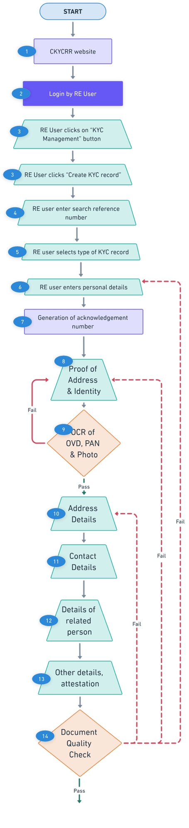
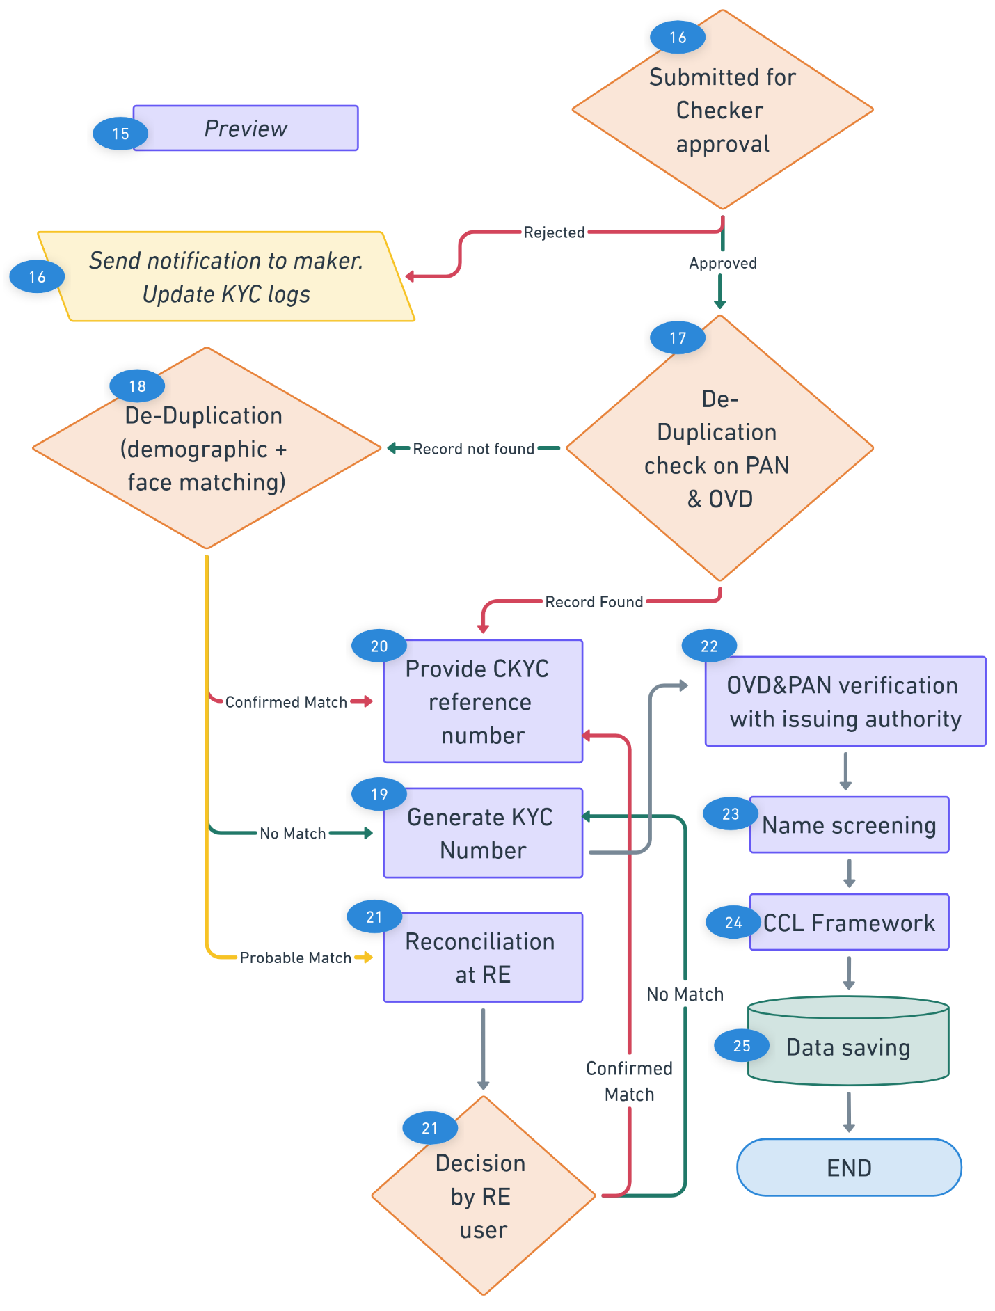
Points to remember:
- The CKYCRR System will not check for mobile and email verification through OTP for KYC record creation.
- The Billing Management Module will be interlinked with the KYC record upload/creation process. The CKYCRR system will deduct/ charge fees for each download done by RE and receive incentive amount on each upload and update KYC transactions done by RE. Charges will be configurable from CMS.
- Client (individual) will receive notifications upon the successful creation of a CKYC number.
- CCL Framework mechanism will run as defined under “CCL Framework” section.
- Probable match cases will reflect for RE Reconciliation section under KYC logs for further decision by RE user.
- For foreign national with overseas address, district/ state/UT/Pincode will not be mandatory fields and can be entered manually.
- Information (except photo) used for the searching KYC record will be auto-populated and non-editable.
- The CKYCRR system will keep checking the size of the documents being uploaded, once the total size exceed 25MB the system will alert the user via notification(pop-up) that “The total size of all documents being uploaded should be less than or equal to 500KB.”
- The CKYCRR system will trigger notifications at the following key events
Key Event | User | Email | SMS | Post login
Approval request to RE on KYC record creation | RE users | No | No | Yes
Information to Client on successful creation | Client | Yes | Yes | No
Information to maker on rejection by checker | Maker | No | No | Yes
Information to RE and FIU-Ind if record flagged in name screening | RE user, FIU-IND | Yes | No | Yes

Below outlines the process of creating bulk KYC record:
Step 1: The RE user will access domain / URL “https://www.ckycindia.in” from their respective systems connected over internet.

Step 2: The RE user will login to the CKYCRR system using the user ID issued, password and DSC (as per login module).

Step 3: The RE user will go to KYC management and select search option to follow the bulk search process to determine if a record already exists in the CKYCRR system. If the record exists, the record creation journey ends here. If the record does not exist, the system will:
- Generate a reference number.
- Return the file with status and reference number.
Step 4: The RE user will click on “KYC Management” button to navigate to KYC management modules and select create KYC record option.

Step 5: The RE user will fill in the required details for individual in defined templates against the CKYCRR system generated reference number. Associated documents will be mapped against each record and documents to be kept in ZIP folder named as per photo ID reference number mentioned in the excel file.
Step 6: The RE user will validate the completed CSV sheet using the File Validation Utility (FVU). Once validated, the same file must be uploaded to the CKYCRR system.
Step 7: Upon submission of a bulk ZIP file by the RE user, the CKYCRR system will route the file to the checker (RE user) for approval.
- If the checker (RE user) rejects the submission, a notification will be sent to the maker (RE user) specifying the reason for rejection. The maker (RE user) can then make the necessary modifications and re-submit the file.
- If the submission is approved, the CKYCRR system will automatically proceed with the subsequent processing steps, including data validation, duplication checks, and further workflow as defined.
Step 8: The CKYCRR System will unzip the File and retrieve CSV file and documents uploaded by the RE user.
Step 9: The CKYCRR system will initiate the OCR (Optical Character Recognition) process for the uploaded OVD (Officially Valid Document), PAN and photo to extract relevant details from the OVD, PAN, and Photo. The CKYCRR system will compare the extracted details from OVD PAN, and photo with the manually entered details by the RE user. If the details match, the CKYCRR system will proceed with the next step. If the details do not match, the CKYCRR system will not proceed further for failed record and error message will be provided in output file.
Step 10: The CKYCRR System will check the quality of the uploaded documents by the RE user using OCR. If the minimum quality parameters defined by CERSAI are not met, the CKYCRR system will not proceed further for failed record and error message will be provided in output file.
Step 11: The CKYCRR system will perform a de-duplication check by scanning the database for existing records with the same PAN or Officially Valid Document (OVD) details.
- If a duplicate PAN or OVD is detected, the record creation process will be halted. This record will be considered as confirmed match and the CKYCRR system will provide CKYCRR reference number in output file.
- If no matching record is found, the CKYCRR system will proceed to the next step.
Step 12: The CKYCRR system will perform demographic and face matching de-duplication check based on de-duplication process defined separately.
Below are the possible outcome based on de-duplication check;
Duplication Status | System Response
No Match | CKYCRR System generates a new CKYC number in the CKYCRR registry and save the CKYC number in output file
Confirmed Match | CKYCRR system shares the CKYC reference number to the RE for download
Probable Match | System sends the record for RE reconciliation under KYC logs
Step 13: For No match record: The CKYCRR system will generate a new CKYC number and saves the newly generated CKYC number in the output file and the CKYCR number will be sent to the email address and/or mobile number of the client. The record will also available under KYC logs along with CKYC number, confidence level, and confidence score.
Step 14: For confirmed match: The CKYCRR system will save the existing CKYC reference number and the RE user can download the CKYC record using the CKYC reference number.
Step 15: For Probable match: The CKYCRR system will save status as probable match in output file and display the individual record creation request under KYC logs for RE reconciliation. Under RE reconciliation, the RE user can either mark record as “Confirmed match” or “No Match”. Based on RE user decision, the CKYCRR system will follow the Confirmed match and No match flow. RE user will have 10 days for probable match reconciliation.
Step 16: The CKYCRR system will initiate verification of the OVD and PAN details with their respective issuing authorities through integrated online services or any other available services.
- The verification status (e.g., Verified, Failed, Pending) will be stored within the CKYCRR system for audit and reference purposes.
- These statuses are intended solely for record maintenance and will not influence the progression of the KYC record creation.
Step 17: The CKCYRR system will check the individual’s status with external agencies for name screening. The statuses provided by the external agencies (screening agency) will be flagged in the CKYCRR registry.
Step 18: The CKYCRR system will run the CCL framework process, assigning grades based on various parameters. Detailed CCL framework calculation is defined in Annexure II
Step 19: The CKYCRR system will save the final individual KYC record and the CKYCRR system will send notification to the RE and email and SMS notification to the individual.
Step 20: The CKYCRR system will return the output file to RE users under KYC logs.
Functional Flow:
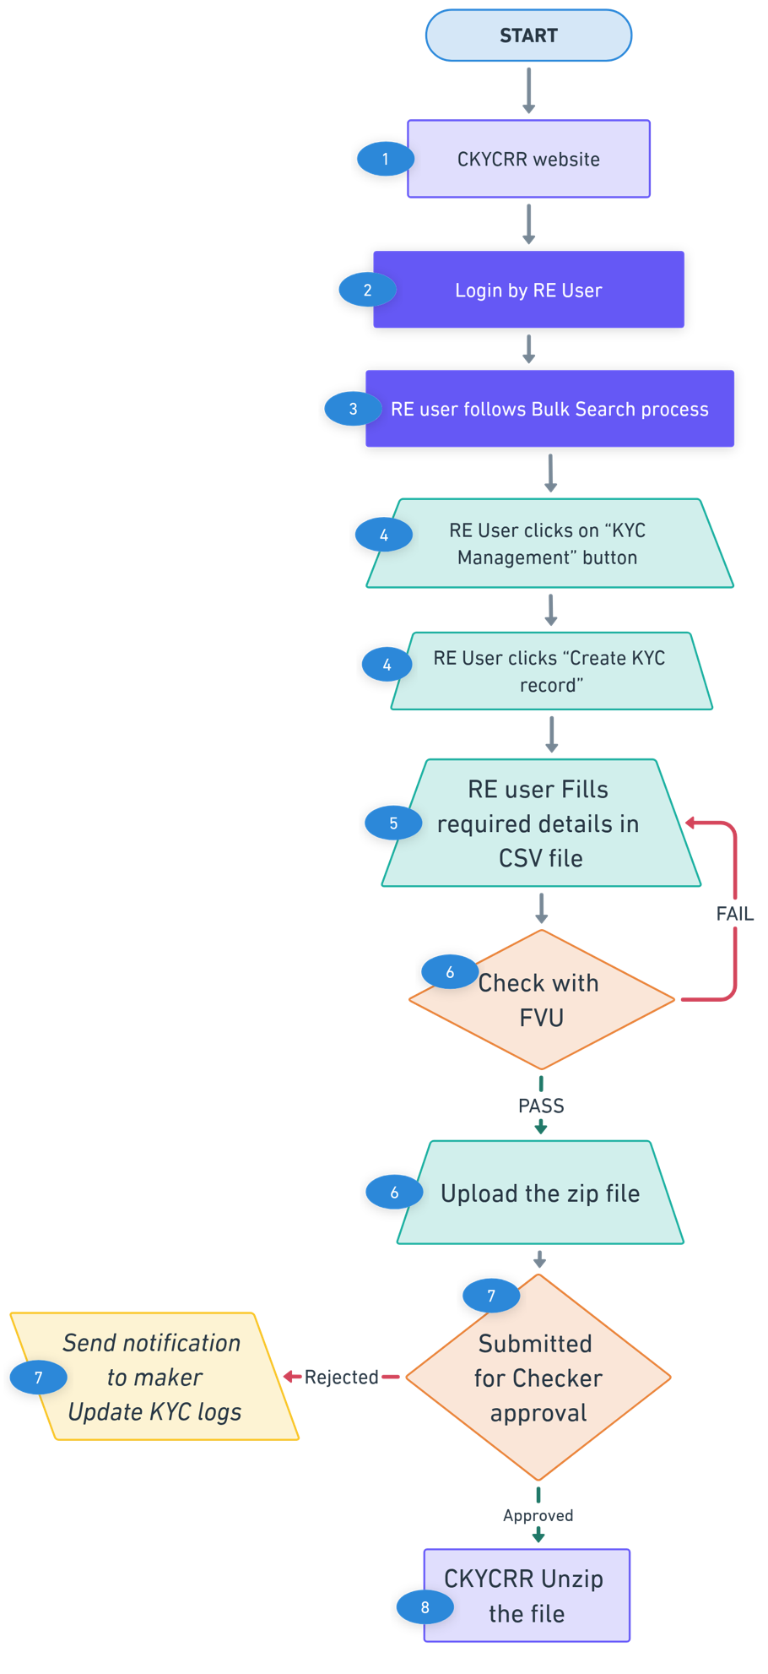
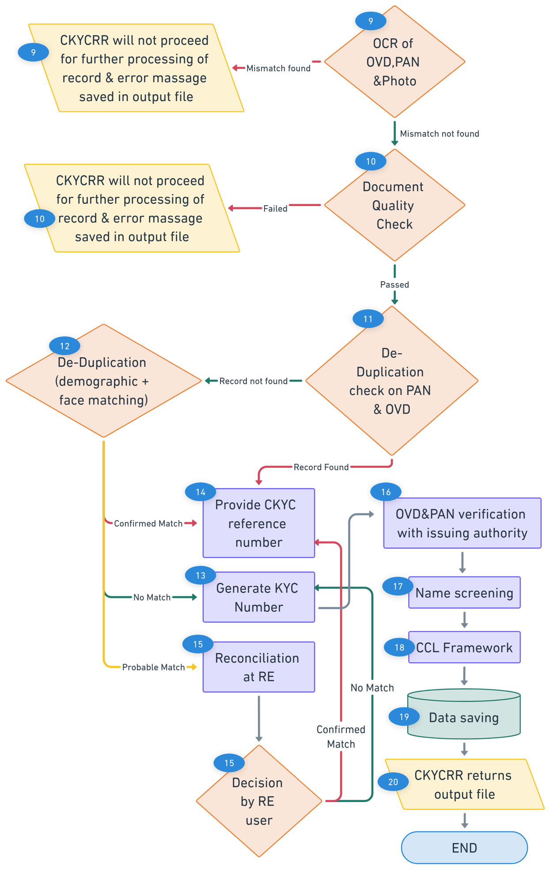
Points to remember:
- A template for bulk upload of KYC records would be available under Download Section of the CKYCRR website. The File Validation Utility (FVU) will also be available in the Download Section of the CKYCRR website. If the file is not uploaded in the defined template, the CKYCRR system will reject the entire file and display an error message.
- The uploaded file must pass through the FVU before submission. If the file has not been validated by the FVU, the CKCYRR system will not accept the file and will display an error message to the RE user.
- In cases where the CKYCRR system identifies a probable match during the de-duplication check, such records will be flagged and stored under the KYC Logs section of the reporting entity. These entries will remain available for further review and manual action by RE users.
- The Billing Management Module will be interlinked with the KYC record upload/creation process.
- Clients (individual) will receive notifications upon the successful creation of a CKYC number.
- CCL Framework mechanism will run as defined under “CCL Framework” section.
- The CKYCRR system will keep checking the size of the documents being uploaded, once the total size exceed 25MB the system will alert the user via notification(pop-up) that “The total size of all documents being uploaded should be less than or equal to 500KB.”
- The CKYCRR system will trigger notifications at the following key events
Key Event | User | Email | SMS | Post Login
Approval request to RE | RE users | No | No | Yes
Information to Client on successful creation | Client | Yes | Yes | No
Information to maker on rejection by checker | Maker | Yes | No | Yes
Information to RE and FIU-Ind if record flagged in name screening | User | Yes | No | Yes

Create KYC Record – Legal Entity
The create new KYC record feature enables RE users to register a new KYC record in the system. KYC records can be created for both individual and legal entity. This section covers the KYC record creation of legal entity.
Below outlines the process of creating new single KYC record:
Step 1: The RE user will access domain / URL “https://www.ckycindia.in” from their respective systems connected over internet.

Step 2: The RE user will login to the CKYCRR system using the user ID issued, password and DSC (as per login module).

Step 3: The RE user will click on “KYC Management ” button to navigate to KYC management modules and select create KYC record option.
Step 4: The RE user will be prompted to enter the reference number generated by the CKYCRR system during search process. CKYCRR system will check the reference number. If the entered reference number is correct, the RE user will move to the next step. If the entered reference number is incorrect, the CKYCRR system will prompt RE user to enter the correct reference number.
Step 5: The RE user will provide the below details for legal entity KYC record
Section | Field | Field Type | Field Size | M/O/CM | Validations
Entity Details | Name | Varchar | 99 | M | a. A to Z and a to z will be allowed  b. Single apostrophe will be allowed  c. Alphanumeric value allowed  d. Special characters allowed
 | Entity Constitution type | Char | 2 | M | Dropdown with value:  A -Sole Proprietorship  B- Partnership Firm  C-HUF"  D- Private Limited Company  E - Public Limited Company  F - Society  G- Association of Persons (AOP) / Body of Individuals (BOI)  H- Trust  I- Liquidator  J - Limited Liability Partnership  K- Artificial Liability Partnership (only for old records)  L- Public Sector Banks  M-Central/State Government Department or Agency  N- Section 8 Companies (Companies Act, 2013)  O - Artificial Jurisdical Person  P- International Organisation or Agency /Foreign Embassy or Consular Office etc.  Q- Foreign Portfolio Investors  R- Others
 | Company is Listed | Char | 1 | CM | Yes/ No  Only for Public Limited Companies
 | Firm is Registered | Char | 1 | CM | Yes/ No  For Partnership Firm
 | Trust is Registered | Char | 1 | CM | Yes/ No  For Trust
 | Date of incorporation/ formation | Calendar | 8 | M | Date should be as per DDMMYYYY format
 | Date of commencement of business | Calendar | 8 | CM | Date should be as per DDMMYYYY format  Only for public limited companies
 | Place of incorporation/ formation | Varchar | 50 | M | a. A to Z and a to z will be allowed
 | Country of incorporation / formation | Char | 2 | M | Dropdown with value:  As per country master. Default value to be India
 | TIN or equivalent issuing country | Char | 2 | O | Dropdown with value:  As per country master
 | PAN | Varchar | 10 | CM | "Format: AAAAA9999A (5 alphabets, 4 digits, 1 alphabet).  Checksum Logic:  Validate the first 5 characters as alphabets (A-Z).  Validate the next 4 characters as digits (0-9).  Validate the last character as an alphabet (A-Z)."  4th character should be other than P except for sole-proprietorship firm.  PAN mandatory for partnership firm, LLP and companies.
 | Form 60 |  |  | CM | PDF/Jpg/Jpeg (file size < 500kb)  Where PAN is not provided.
 | TIN/GST registration number | Char | 15 | O | GST:  "Format: 15 Alphanumeric characters.  Example: 22ABCDE1234F1Z5  Breakdown:  First 2 digits: State code (numeric).  Next 10 characters: PAN of the taxpayer.  13th digit: Entity code (numeric).  14th digit: Default Z.  15th digit: Checksum character (alphanumeric).  Checksum Logic:  Validate the format structure.  "  Online verification of GST, TIN
Step 6: The RE user will click on “Save & Next” and the CKYCRR system will generate an Acknowledgment Number, which the RE user can use to resume the KYC record creation process if needed. Draft records, including the Acknowledgment Number and saved data, will be retained in the CKYCRR system under KYC logs for 30 days from the last update. After 30 days, the CKYCRR system will automatically delete incomplete/draft records.
Step 7: The RE user shall the proceed to the Proof of Identity details along with the associated documents. The following must be provided.
Section | Field | Field Type | Field Size | M/O/CM | Validations
POI Details (for company) | Certificate of incorporation |  |  | M | PDF/Jpg/Jpeg (file size < 25MB)
 | CIN | Char | 21 | M | "Format: 21 Alphanumeric characters.  Example: L12345MH2020PLC987654  Breakdown:  First character: Alphabet indicating listing status (e.g., L for Listed).  Next 5 digits: Industry code.  Next 2 characters: State code.  Next 4 digits: Year of incorporation.  Next 3 characters: Entity type code (e.g., PLC for Public Limited Company).  Last 6 digits: Serial number.  Checksum Logic:  Validate against the structure above.  "  Mandatory only where constitution type selected is ‘Private Limited Company’, Public limited company’, ‘section 8 company’
 | Memorandum and articles of association |  |  | M | PDF/Jpg/Jpeg (file size < 25MB )
 | Resolution from Board of Directors and Power of Attorney granted to its manager, officer or employees to transact on its behalf |  |  | M | PDF/Jpg/Jpeg (file size < 25MB )
 | Names of persons holding senior management positions* (List to be enclosed) |  |  | M | PDF/Jpg/Jpeg (file size < 25MB )
 | Certificate of Commencement of Business for Public Limited Companies |  |  | CM | PDF/Jpg/Jpeg (file size < 25MB)  For Public Limited Companies
 | Others |  |  | O | PDF/Jpg/Jpeg (file size < 25MB)
Partnership Firm/ LLPIN | Registration certificate |  |  | CM | PDF/Jpg/Jpeg (file size < 25MB)  For Registered Partnership Firm.
 | Registration number | Varchar | 50 | CM | 1. As per certificate.  2.Alphanumeric values allowed  3.Special characters allowed  For Registered Partnership Firm
 | Certificate of incorporation |  |  | CM | PDF/Jpg/Jpeg (file size < 25MB). Mandatory where constitution type selected is LLP.
 | LLPIN | Varchar | 7 | CM | 1. 7 digit alphanumeric.  Mandatory only where constitution type selected is “LLP”.
 | Partnership Deed |  |  | M | PDF/Jpg/Jpeg (file size < 25MB)
 | Names of all partners (list to be enclosed) |  |  | M | PDF/Jpg/Jpeg (file size < 25MB)
 | Others |  |  | O | PDF/Jpg/Jpeg (file size < 25MB)
Trust | Registration certificate |  |  | CM | PDF/Jpg/Jpeg (file size < 25MB)  Mandatory For Registered Trust
 | Registration number | Varchar | 50 | CM | 1. As per certificate.  2.Alphanumeric values allowed  3.Special characters allowed  4. Mandatory for Registered Trust.
 | Trust Deed |  |  | M | PDF/Jpg/Jpeg (file size < 25MB)
 | Names of all beneficiaries, Trustees, Settlor (Protector, if any) and authors of the Trust (list to be enclosed) |  |  | M | PDF/Jpg/Jpeg (file size < 25MB)
 | Others |  |  | O | PDF/Jpg/Jpeg (file size < 25MB)
Unincorporated Association or Body of Individual | Resolution of Managing Body or Body of Individual of such association |  |  | M | PDF/Jpg/Jpeg (file size < 25MB)
 | Power of Attorney granted to transact on its behalf |  |  | M | PDF/Jpg/Jpeg (file size < 25MB)
 | Others |  |  | O | PDF/Jpg/Jpeg (file size < 25MB)
Constitution Type other than above | Supporting Documents for PoI |  |  | M | PDF/Jpg/Jpeg (file size < 25MB)
 | Registration Certificate |  |  | O | PDF/Jpg/Jpeg (file size < 25MB)
 | Power of attorney granted to its manager, officers or employees to transact on its behalf |  |  | O | PDF/Jpg/Jpeg (file size < 25MB)
 | Others |  |  | O | PDF/Jpg/Jpeg (file size < 25MB)
Step 8: The CKYCRR system will initiate the OCR (Optical Character Recognition) process for the uploaded PAN (if PAN is provided)/ Certificate of incorporation/ LLPIN certificate to extract relevant details from the documents. The CKYCRR system will compare the extracted details with the details entered by the RE user. If the details match, the CKYCRR system will proceed with the next step. If the details do not match, the CKYCRR system will display: “Details do not match with documents provided. Please enter the correct details” If the PAN)/ Certificate of incorporation/ LLPIN certificate is not provided by the RE, the CKYCRR system will skip this step.
Step 9: Address details: The RE user will enter the registered address and principal place of its business.
- In case of Company and Partnership Firm, Registered office (RO) and Principal Place of Business, if different from Registered office are mandatory
- In case of Others, Registered Office is mandatory, and Principal Place of Business is Optional.
Section | Field | Field Type | Field Size | M/O/CM | Validations
Registered office address | Line 1 | Varchar | 60 | M | 1. Alphanumeric value allowed  2. Space between words is allowed  3. Following Special Characters will be allowed  `~@#$%^&*()_+-=
 | Line 2 | Varchar | 60 | O | 1. Alphanumeric value allowed  2. Space between words is allowed  3. Following Special Characters will be allowed  `~@#$%^&*()_+-=
 | Line 3 | Varchar | 60 | O | 1. Alphanumeric value allowed  2. Space between words is allowed  3. Following Special Characters will be allowed  `~@#$%^&*()_+-=
 | City/town/village | Varchar | 60 | M | 1. Alphanumeric value allowed  2. Space between words is allowed  3. Following Special Characters will be allowed  `~@#$%^&*()_+-=
 | State | Char | 2 | M | Value should be as per State Master
 | District | Char | 2 | CM | Value should be as per district Master  Dropdown value depends upon value selected in state field
 | Pin Code | Char | 6 | CM | 1.Only numeric values allowed and should always be 6 digit.  2.Dropdown will be provided and Dropdown value will depend upon value selected in district field  3.Pincode will be configured as per India Post Master  4.Option to select “Others” will also be provided under Pincode field in case it is not there in the dropdown values.
 | Pin code (in case of others) | Char | 6 | CM | 1. Only numeric values allowed and should always be 6 digit numeric. 2.System to verify that once others is selected and combination of state, district, and Pin code entered by RE user matches with combination of state, district, and Pin code configured in the system, others option should not be allowed
 | ISO 3166 country code | Char | 3 | M | Dropdown value as per annexure IV (ISO code)
 | Proof of address | Char | 1 | M | Dropdown values  a. Certificate of incorporation / formation  b. Registration certificate  c. Other document
 | Other document name | Varchar | 50 | CM | Alphanumeric value allowed.  To provided in case of other document selected in proof of address.
Principal place of business | Same as registered address | Char | 1 | M | Checkbox with possible values: Y/N
 | Line 1 | Varchar | 60 | M | 1. Alphanumeric value allowed  2. Space between words is allowed  3. Following Special Characters will be allowed  `~@#$%^&*()_+-=
 | Line 2 | Varchar | 60 | O | 1. Alphanumeric value allowed  2. Space between words is allowed  3. Following Special Characters will be allowed  `~@#$%^&*()_+-=
 | Line 3 | Varchar | 60 | O | 1. Alphanumeric value allowed  2. Space between words is allowed  3. Following Special Characters will be allowed  `~@#$%^&*()_+-=
 | city/town/village | Varchar | 60 | M | 1. Alphanumeric value allowed  2. Space between words is allowed  3. Following Special Characters will be allowed  `~@#$%^&*()_+-=
 | State | Char | 2 | M | Value should be as per State Master
 | District | Char | 2 | CM | Value should be as per district Master  Dropdown value depends upon value selected in state field
 | Pin Code | Char | 6 | CM | 1.Only numeric values allowed and should always be 6 digit.  2.Dropdown will be provided and Dropdown value will depend upon value selected in district field  3.Pincode will be configured as per India Post Master  4.Option to select “Others” will also be provided under Pincode field in case it is not there in the dropdown values.
 | Pin code (in case of others) | Char | 6 | CM | 1. Only numeric values allowed and should always be 6 digit numeric. 2.System to verify that once others is selected and combination of state, district, and Pin code entered by RE user matches with combination of state, district, and Pin code configured in the system, others option should not be allowed
 | ISO 3166 country code | Char | 3 | M | Dropdown value as per annexure IV (ISO code)
 | Proof of address | Char | 1 | M | Dropdown values  a. Certificate of incorporation / formation  b. Registration certificate  c. Other document
 | Other document name | Varchar | 50 | CM | Alphanumeric value allowed.  To provide in case of other document selected in proof of address.
Document | Document for registered address |  |  |  | PDF/Jpg/Jpeg (file size < 500kb)  Depends upon value selected in POI
 | Document for principal place of business address |  |  |  | PDF/Jpg/Jpeg (file size < 500kb)  Depends upon value selected in POI
Step 10: RE user will enter the below contact details of the legal entity
Section | Field | Field Type | Field Size | M/O/CM | Validations
Contact Details | Country code | Char | 4 | M | 1.Default value selected will be India (+91).  2. Dropdown values as per Annexure IV (ISO code), will be configurable.
 | Mobile number (01) | Varchar | 15 | M | 1. Min 8 and maximum 15. In case of country code other than India, mobile number will accept numeric value of min 8 and maximum 15.  2.For India, 10 digit mobile number is allowed
 | Country code | Char | 4 | O | 1.Default value selected will be India (+91).  2. Dropdown values as per Annexure IV (ISO code), will be configurable.
 | Mobile number (02) | Varchar | 15 | O | 1. Min 8 and maximum 15. In case of country code other than India, mobile number will accept numeric value of min 8 and maximum 15.  2.For India, 10 digit mobile number is allowed
 | Email ID (01) | Char | 254 | M | 1. Alphanumeric value allowed  2. Following Special Characters will be allowed  `~@#$%^&*()_+-=  3.Atleast one @ should be present.
 | Email ID (02) | Char | 254 | O | 1. Alphanumeric value allowed  2. Following Special Characters will be allowed  `~@#$%^&*()_+-=  3.Atleast one @ should be present.
 | Telephone (official) | Varchar | 12 | O | 1. Numeric value allowed  2. ‘-‘ allowed
 | FAX | Varchar | 12 | O | 1. Numeric value allowed  2. ‘-‘ allowed

Step 11: Related party details: RE user will have to enter related party details and select the relation status with the legal entity. The RE user will provide the CKYC number of related persons and select relation from pre-defined dropdown values. The CKYCRR system will automatically populate the required fields based on the CKYC number, eliminating the need for manual entry. If the CKYC number of a related person is not available, the RE user will have to first create a new record for that person to generate CKYC number and then add his CKYC number in the related person details.
The RE user will enter the number of related persons.
Multiselect Dropdown values for related person:
  - Director
  - Promoter
  - Karta
  - Trustee
  - Partner
  - Court Appointment Official
  - Proprietor
  - Beneficiary
  - Authorised signatory
  - Beneficial Owner
  - Power of attorney holder
  - Others
(i) RE need to mandatorily select beneficial owner in case of companies (excluding listed companies), partnership firm (including LLPs), Trust & unincorporated association or body of individuals and any one of the other given options.
In case of Beneficial owner selected, percentage of ownership/ exercise control through other means to be provided by the RE for legal entity record.
In case of director selected by the RE user, the RE user needs to provide director identification number. Similarly, if others selected, the RE user needs to specify the relationship with the person.

The details of Beneficial Owners will be maintained in Beneficial Owner Registry.
Step 12: Other Details and Attestation. The RE user will provide any additional details (if applicable). The RE user will also enter the attestation details, confirming the accuracy and validity of the information provided.
Other details
Section | Field | Field Type | Field Size | M/O/CM | Validations
Remarks |  | Varchar | 200 | O | Alphanumeric valued allowed
Attestation
Section | Field | Field Type | Field Size | M/O/CM | Validations
Documents Received | Certified copies | Char | 1 | M | Checkbox with possible values: Y/N
 | Equivalent e-document | Char | 1 | M | Checkbox with possible values: Y/N
KYC verification carried out by | Date | Calendar | 8 | M | Date should be as per DDMMYYYY format
 | Emp - name | Varchar | 99 | M | 1. A to Z and a to z will be allowed  2. Single apostrophe will be allowed
 | Emp code | Varchar | 50 | M | Alphanumeric value allowed
 | Emp designation | Varchar | 50 | M | Alphanumeric value allowed
 | Emp branch | Varchar | 50 | M | Alphanumeric value allowed
 | Emp CKYC Id | Char | 14 | M | Numeric value allowed
Institutional details | Name | Varchar  Auto-populated & non-editable | 99 | M | 1. A to Z and a to z will be allowed  2. Single apostrophe will be allowed
 | Code | Varchar  Auto-populated & non-editable | 50 | M | Alphanumeric value allowed
Step 13: The CKYCRR System will check the quality of the uploaded documents by the RE user. If the minimum quality parameters defined by CERSAI are not met, the RE user will be prompted to re-upload the documents.
Step 14: The RE user will be able to preview the entire form along with the uploaded documents before submission. Each section will have an “Edit” button, allowing the RE user to navigate to a specific section and modify the details. A Submit button will be available to mark the completion of form filling by the RE user.
Step 15: Upon submission of a KYC record by the maker (RE user), the CKYCRR system will route the KYC entry to the assigned checker (RE user) for approval.
- If the checker (RE user) approves the record, the CKYCRR system will automatically proceed with the next set of validation or processing steps as defined in the workflow.
- If the checker (RE user) rejects the record, it will be logged under the KYC Logs section, where the initiating user can view the remarks, make necessary modifications, and re-submit the record for approval.
Step 16: The CKYCRR system will perform a de-duplication check by scanning the CKYCRR registry for existing record as per the de-duplication logic defined separately.
Below are the possible outcomes of de-dupe process:
Duplication Status | System Response
No Match | CKYCRR System generates a new CKYC number in the CKYCRR registry and displays the CKYC number.
Confirmed Match | CKYCRR system displays the CKYC reference number and prompts RE user to download the record to get complete information
Probable Match | System sends the record for RE reconciliation under KYC logs

Step 17: For No match record: The CKYCRR system will display the newly generated CKYCR number to the RE user.
Step 18: For confirmed match: The CKYCRR system will display the existing CKYC reference number and the RE user has to download the CKYC record using the CKYC reference number.
Step 19: For Probable match: The CKYCRR system will display the legal entity record creation request under KYC logs for RE reconciliation. Under RE reconciliation, the RE user can either mark record as “Confirmed match” or “No Match”. Based on RE user decision, the CKYCRR system will follow the Confirmed match and No match flow. Probable match reconciliation has to be carried out within 10 days.
Step 20: The CKYCRR system will initiate verification of the PAN and other documents (GST/TIN/ CIN/LLPIN) details with their respective issuing authorities through integrated online services or any other available mode.
- The verification status (e.g., Verified, Failed, Pending) will be stored within the CKYCRR system for audit and reference purposes.
- These statuses are intended solely for record maintenance and will not influence the progression of the KYC workflow.
Step 21: The CKCYRR system will check the legal entity’s status with external agencies for name screening. In case any match is found, it will be flagged in the CKYCRR registry and notified to RE and FIU-IND.
Step 22: The CKYCRR system will save the final legal entity KYC record and the CKYCRR registry will notify the RE as well as the client.
Functional Flow:
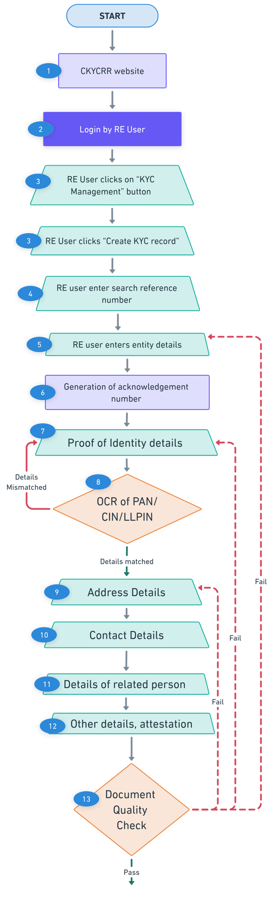
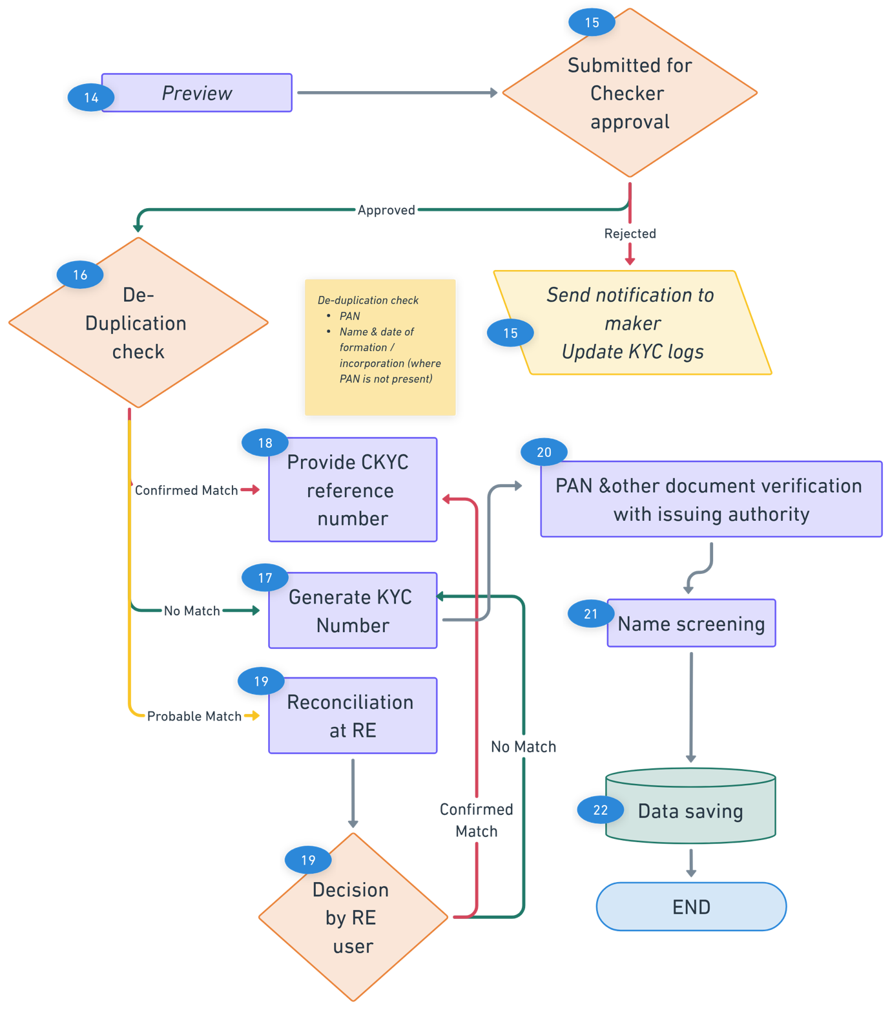
Points to remember:
- The CKYCRR System will not check for mobile and email verification through OTP for KYC record creation.
- The Billing Management Module will be interlinked with the KYC record upload/creation process.
- Probable match cases will reflect for RE Reconciliation section under KYC logs for further decision by RE user.
- The CKYCRR system will keep checking the size of the documents being uploaded, once the total size exceed 25MB the system will alert the user via notification(pop-up) that “The total size of all documents being uploaded should be less than or equal to 25MB.”

- The CKYCRR system will trigger notifications at the following key events
Key Event | User | Email | SMS | Post login
Approval request to RE | RE users | No | No | Yes
Information to Client on successful creation | Client | Yes | Yes | No
Information to maker on rejection by checker | Maker | No | No | Yes
Information to RE and FIU-Ind if record flagged in name screening | RE user, FIU-Ind | Yes | No | Yes

Below outlines the process of creating bulk KYC record:
Step 1: The RE user will access domain / URL “https://www.ckycindia.in” from their respective systems connected over internet.

Step 2: The RE user will login to the CKYCRR system using the user ID issued, password and DSC (as per login module).
Step 3: The RE user will follow the bulk search process to determine if a record already exists in the CKYCRR system. If the record exists, the record creation journey ends here. If the record does not exist, the system will:
- Generate a reference number.
- Return the file with status and reference number.
Step 4: The RE user will click on “KYC Management ” button to navigate to KYC management modules and select create KYC record option.
Step 5: The RE user will fill in the required details of legal entity in defined templates against the CKYCRR system generated reference number. Associated documents will be mapped against each record and documents to be kept in ZIP folder named as per photo ID/ document reference number mentioned in the excel file.
Step 6: The RE user will validate the completed CSV sheet using the File Validation Utility (FVU). Once validated, the same file must be uploaded to the CKYCRR system.
Step 7: Upon submission of a bulk ZIP file by the RE user, the CKYCRR system will route the file to the checker (RE user) for approval.
- If the checker (RE user) rejects the submission, a notification will be sent to the maker (RE user) specifying the reason for rejection. The maker (RE user) can then make the necessary modifications and re-submit the file.
- If the submission is approved, the CKYCRR system will automatically proceed with the subsequent processing steps, including data validation, duplication checks, and further workflow as defined.
Step 8: The CKYCRR System will unzip the File and retrieve CSV file and documents uploaded by the RE user.
Step 9: The CKYCRR system will initiate the OCR (Optical Character Recognition) process for the uploaded PAN/ CIN/ LLPIN (if provided) to extract relevant details. The CKYCRR system will compare the extracted details with the details entered by the RE user. If the details match, the CKYCRR system will proceed with the next step. If the details do not match, the CKYCRR system will save the error message in return/ output file. If the PAN/CIN/LLPIN is not provided by the RE, the CKYCRR system will skip this step.
Step 10: The CKYCRR System will check the quality of the uploaded documents by the RE user using OCR. If the minimum quality parameters defined by CERSAI are not met, the CKYCRR system will not proceed further for failed record and error message will be provided in output file.
Step 11: The CKYCRR system will perform a de-duplication check by scanning the CKYCRR registry for existing records as per the de-duplication logic defined separately.
- Based on the de-duplication Check, below are the possible outcomes:
Duplication Status | System Response
No Match | CKYCRR System generates a new CKYC number in the CKYCRR registry and save the CKYC number in output file
Confirmed Match | CKYCRR system shares the CKYC reference number to the RE for download
Probable Match | System sends the record for RE reconciliation under KYC logs
Step 12: For No match record: The CKYCRR system will return the newly generated CKYCR number in output file.
Step 13: For confirmed match: The CKYCRR system will return the existing CKYC reference number and the RE user has to download the CKYC record using the CKYC reference number by following download process.
Step 14: For Probable match: The CKYCRR system will display the legal entity record creation request under KYC logs for RE reconciliation. Under RE reconciliation, the RE user can either mark record as “Confirmed match” or “No Match”. Based on RE user decision, the CKYCRR system will follow the Confirmed match and No match flow. Probable match reconciliation has to be carried out within 10 days.
Step 15: The CKYCRR system will initiate verification of the PAN and other document (GST/TIN/ CIN/LLPIN) details with their respective issuing authorities through integrated online services or any other available mode.
- The verification status (e.g., Verified, Failed, Pending) will be stored within the CKYCRR system for audit and reference purposes.
- These statuses are intended solely for record maintenance and will not influence the progression of the KYC workflow.
Step 16: The CKCYRR system will check the legal entity’s status with external agencies for name screening. In case any match is found, it will be flagged in the CKYCRR registry and notified to RE and FIU-IND.
Step 17: The CKYCRR system will save the final legal entity KYC record and will notify the RE as well as the client.
Step 18: The CKYCRR system will return the output file under KYC logs.
Functional Flow:
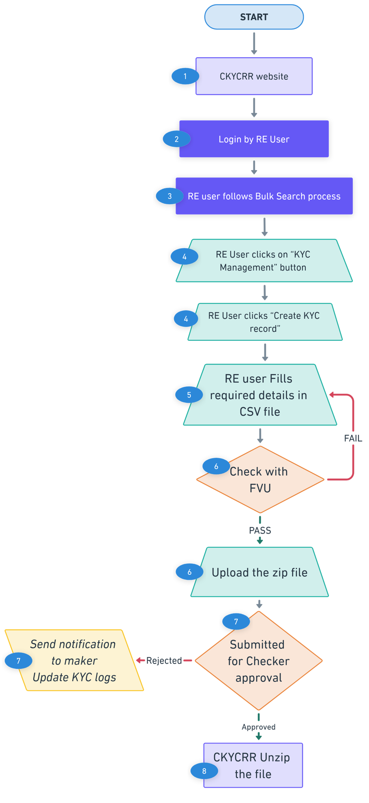
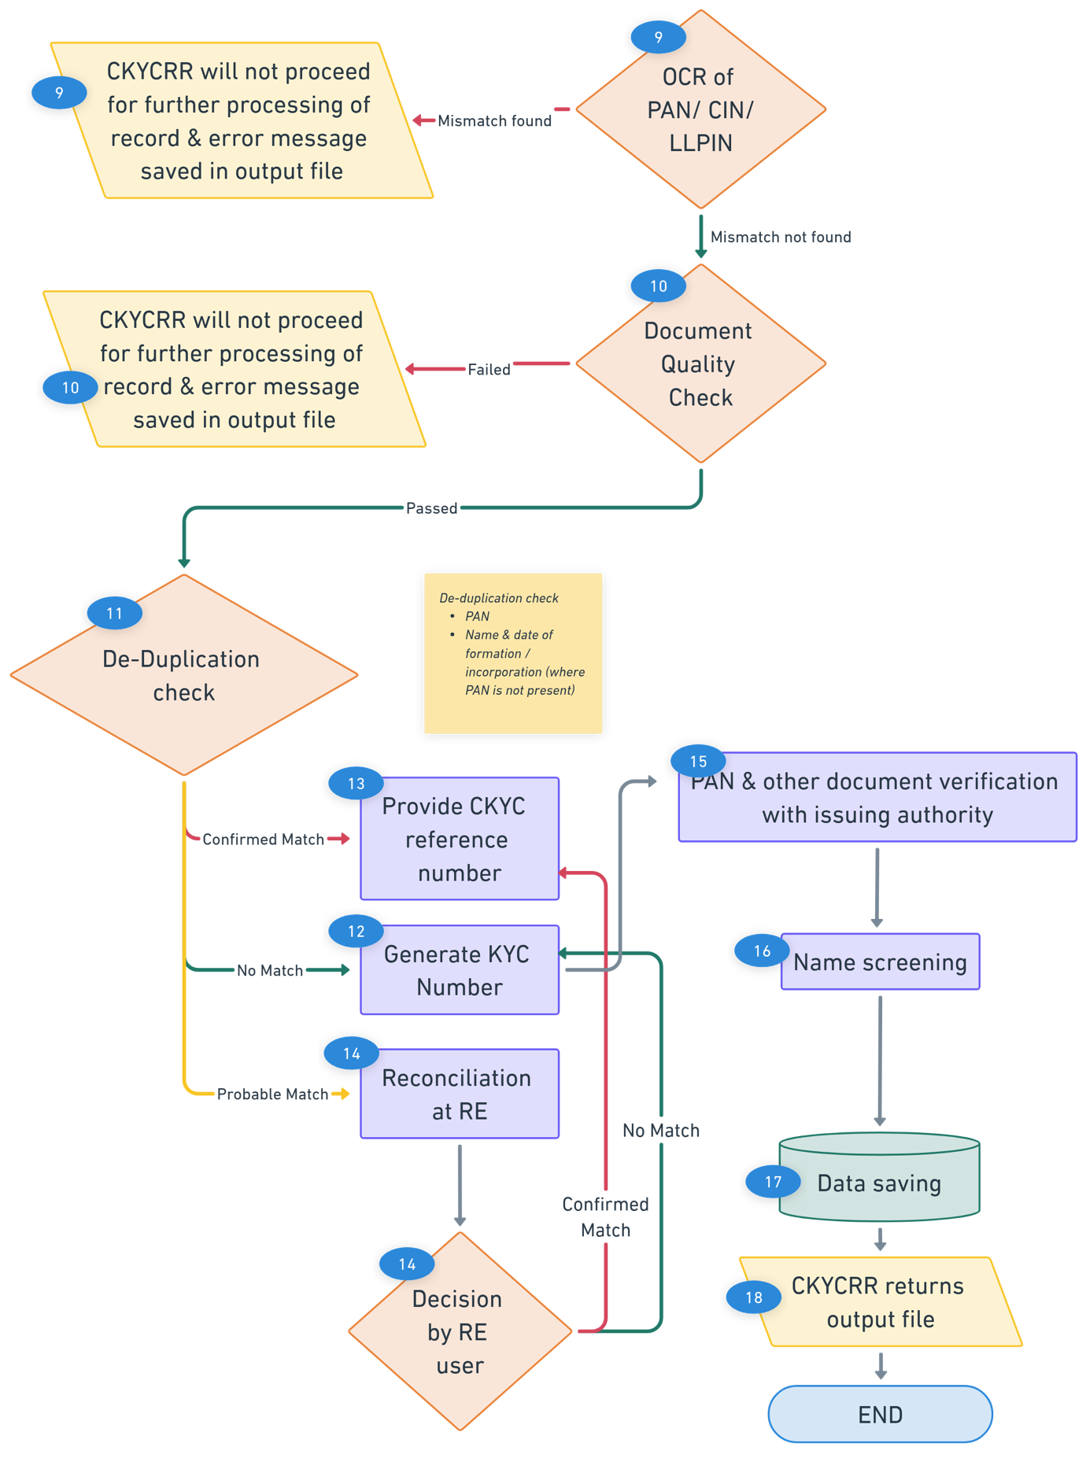
Points to remember:
- A template for entering the reference number (for non-existing KYC records) and entire KYC details will be available under Download Section of the CKYCRR website. The File Validation Utility (FVU) will also be available in the Download Section of the CKYCRR website. If the file is not uploaded in the defined template, the CKYCRR system will reject the entire file and display an error message.
- The uploaded file must pass through the FVU before submission. If the file has not been validated by the FVU, the CKCYRR system will not accept the file and will display an error message to the RE user.
- In cases where the CKYCRR system identifies a probable match during the de-duplication check, such records will be flagged and stored under the KYC Logs section of the reporting entity. These entries will remain available for further review and manual action by RE users.
- The Billing Management Module will be interlinked with the KYC record upload/creation process.
- The CKYCRR system will keep checking the size of the documents being uploaded, once the total size exceed 25MB the system will alert the user via notification(pop-up) that “The total size of all documents being uploaded should be less than or equal to 25MB.”
- The CKYCRR system will trigger notifications at the following key events

Key Event | User | Email | SMS | Post Login
Approval request to RE | RE users | No | No | Yes
Information to Client on successful creation | Client | Yes | Yes | No
Information to maker on rejection by checker | Maker | Yes | No | Yes
Information to RE and FIU-Ind if record flagged in name screening | RE user, FIU-Ind | Yes | No | Yes

Update KYC Record - Individual
The Update KYC Record functionality allows the RE user to:
- Update existing KYC details of the individual
- De-activate a KYC record
- Re-activate a KYC record
- Suspend a KYC record
- Revoke suspension of KYC record

Below outlines the process of updating an individual KYC record:
Step 1: The RE user will access domain / URL “https://www.ckycindia.in” from his/her respective systems connected over internet.

Step 2: The RE user will login to the CKYCRR system using the user ID issued, password and DSC (as per login module).

Step 3: The RE user will click on “KYC Management ” button to navigate to KYC management modules and select update KYC record option.
Step 4: The RE user will search for the KYC record in the CKYCRR registry. The CKCYRR registry will automatically check for the following conditions:
  - Record created by RE
  - Record downloaded by RE
If either of these conditions is met, the CKYCRR system moves to next step. If neither of the conditions is met, the CKYCRR system will prompt the RE user to download the KYC record first before proceeding for update.
Step 5: The CKYCRR system will display existing KYC record of the individual to the RE user.
Step 6: The RE user can update any or all of the following sections individual
  - Personal details
  - Proof of Identity & Address
  - Address details
  - Contact details
  - Details of related persons (modify existing details/ delete related person/ add new)
  - Other details & attestation
Step 7: The CKYCRR system will initiate the OCR (Optical Character Recognition) process for the uploaded OVD (Officially Valid Document)/ PAN/ photo to extract relevant details from the OVD/ PAN/photo. The CKYCRR system will compare the extracted details from OVD/PAN/photo with the details entered by the RE user. The CKYCRR system will match photo uploaded by the RE with the photo in OVD. If the details match, the CKYCRR system will proceed with the next step. If the details do not match, the CKYCRR system will display: “Details do not match with documents provided. Please enter the correct details”
The CKYCRR system will initiate OCR for OVD/PAN/Photo in case of any change in the OVD/ PAN data or upload of new documents for OVD/PAN/ Photo.
Step 8: The CKYCRR system will check the quality of the documents uploaded by the RE user. If the document quality does not match the threshold defined, the CKCYRR system will give the error message to update document. If the document quality matches with the threshold, the RE user can see the preview and submit the request for checker approval.
Step 9: Post submission of updated details, the CKYCRR system will send the updated KYC record to checker (RE user) for approval. Below are the possible outcomes of the approval request:
- If approved, the CKYCRR system will proceed with the subsequent steps in the update KYC record workflow.
- If rejected, the update KYC record will be redirected to the KYC Logs section, where it will be available for necessary modifications and re-submission by the maker (RE user).
Step 10: In case of approval by the checker (RE user), the CKYCRR system will perform a de-duplication check if any of the following conditions are met:
- PAN is modified
- OVD details are modified
- New OVD detail is added
- If any demographic parameters are changed in case of Aadhaar
Based on de-duplication check, the CKYCRR system will have the below outcomes
- Duplicate found : In case a matching record is found, the update request of the KYC record will not be processed further and will be rejected. Reasons will be conveyed to the RE under KYC logs.
- Duplicate not found: the CKYCRR system will proceed with next step.
Step 11: In case no matching record is found, the CKYCRR system will update the KYC details against the existing CKYC number of the KYC record.
Step 12: The CKYCRR system will initiate verification with the respective issuing authorities whenever any modifications are made to PAN or OVD details. The response/status returned by the issuing authority will be captured and recorded in the CKCYRR registry for flagging and CCL framework.
Step 13: The CKYCRR system will check the updated details with external agencies for name screening and update the status (flag) of the KYC record in the CKYCRR registry. If any match is found, notification will be sent to the linked REs and FIU-IND.
Step 14: The CCL Framework Process will run to determine the new score based on the updated details of the KYC record. In case of change in confidence level, the notification will be sent to the linked REs.
Step 15: The CKYCRR system will send the notification to individual for the record updated by the reporting entity along with all the REs linked to the KYC record. Linked REs are those which have either uploaded the record (creator of CKYC ID) or downloaded the record in the past.
Functional Flow:
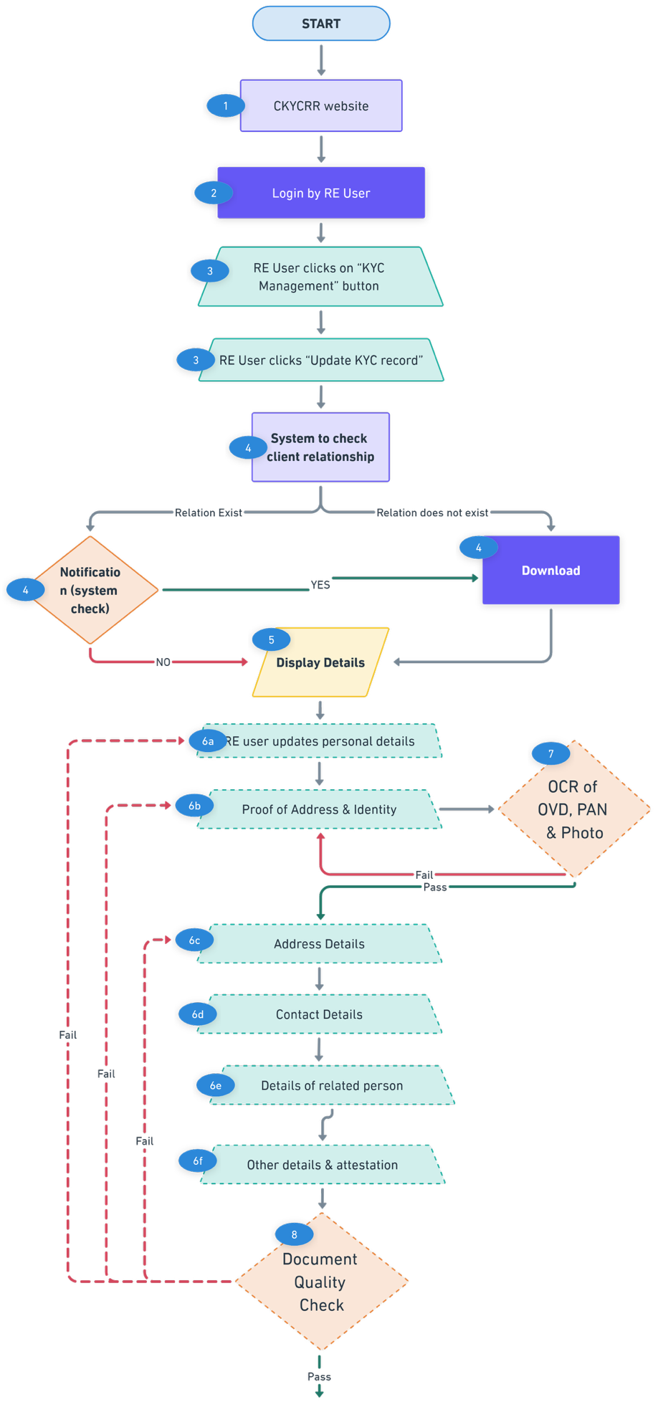
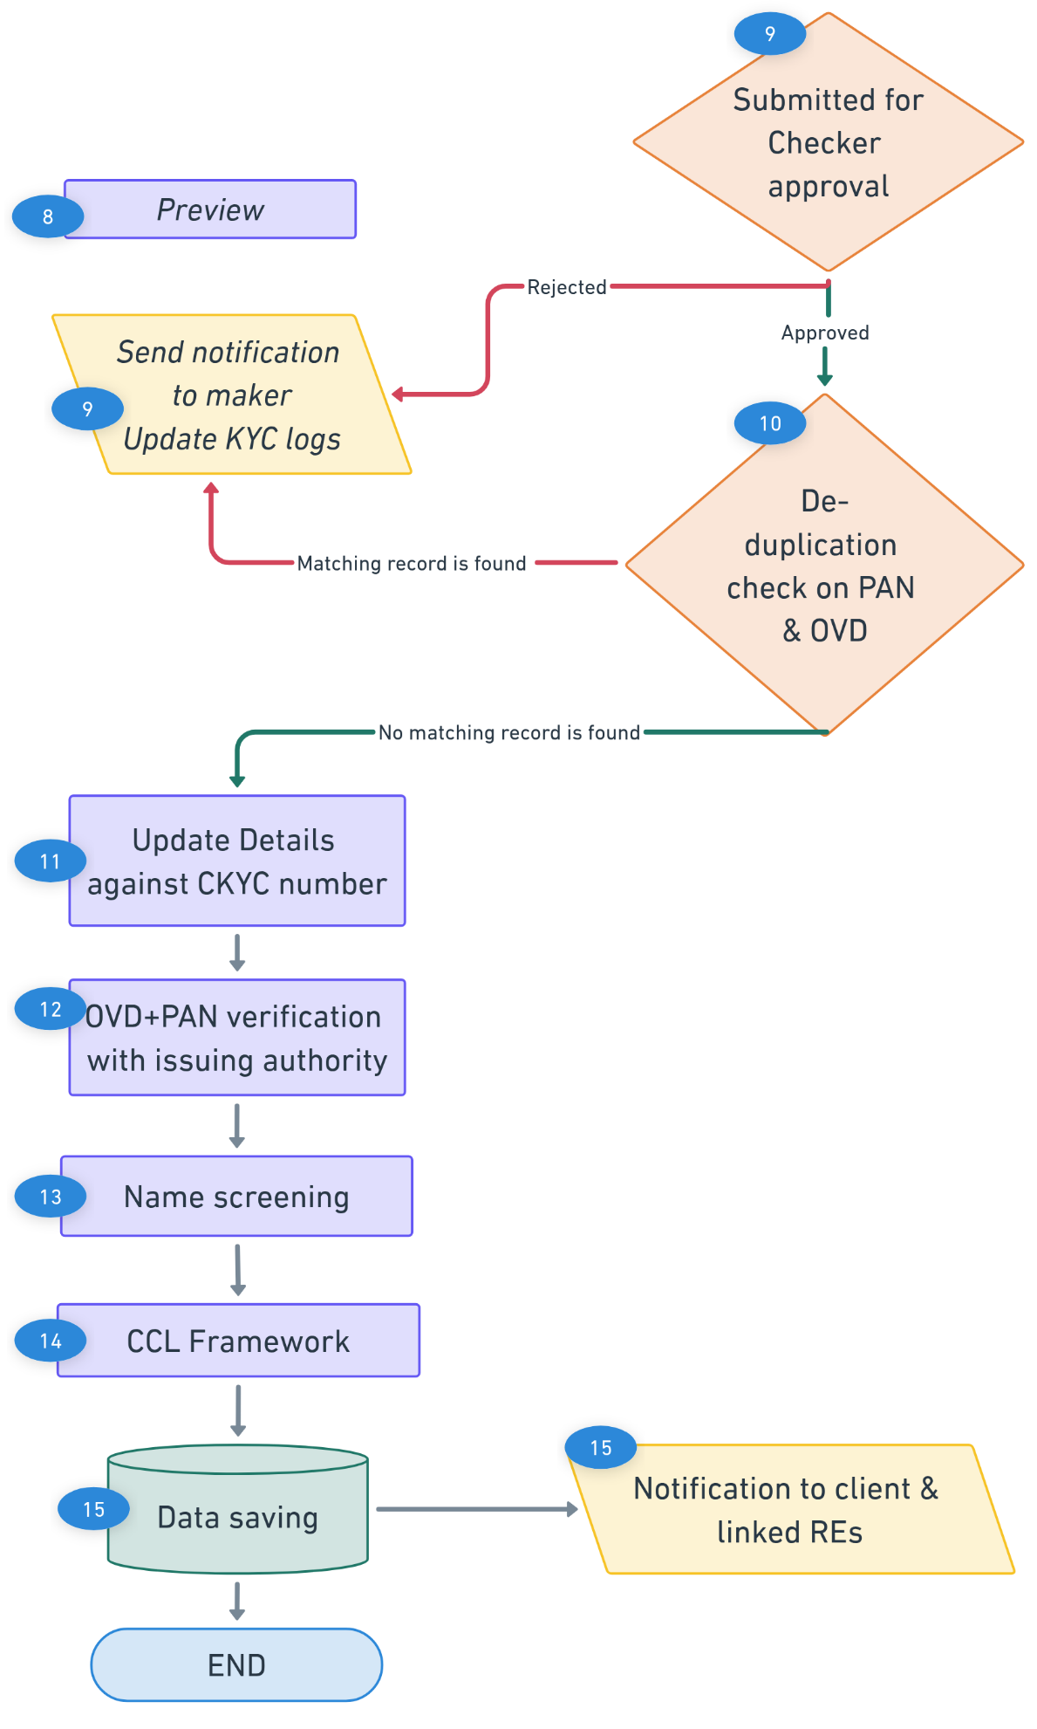
Below outlines the process of bulk updating individual KYC record:
Step 1: The RE user will access domain / URL “https://www.ckycindia.in” from their respective systems connected over internet.

Step 2: The RE user will login to the CKYCRR system using the user ID issued, password and DSC (as per login module).

Step 3: The RE user will click on “KYC Management ” button to navigate to KYC management modules and select update KYC record option.
Step 4: The RE user will fill in the required details for record updation in defined templates against the CKYC number of the KYC record. Associated documents will be kept in ZIP file and reference number of the documents to be noted against each record.
Step 5: The RE user will upload the CSV file and validate it using the File Validation Utility (FVU). Once validated by the FVU, the same file must be uploaded to the system. In case of the rejection by the FVU, the CSV file will not be accepted by the CKYCRR system.
Step 6: Upon submission of a bulk ZIP file by the maker (RE user), the CKCYRR system will route the update KYC record to the checker (RE user) for approval. Checker (RE user) can download the ZIP file to view the details of the bulk file.
- If the checker (RE) rejects the update request, a notification will be sent to the maker (RE user) specifying the reason for rejection. The maker (RE user) can then make the necessary modifications and re-submit the file.
- If the update request is approved, the CKYCRR system will automatically proceed with the subsequent processing steps, including data validation, duplication checks, and further workflow as defined.
Step 7: Upon successful approval of the bulk update request: the CKYCRR system will unzip the File and retrieve CSV file and documents uploaded by the RE user.
Step 8: The CKYCRR System will check the client relationship with RE by checking the below
- Record created by RE
- Record downloaded by RE
If either of these conditions is met, the CKYCRR system will proceed for processing of update request. In case the conditions are not met, those records will not be updated and the reason for rejection will be conveyed to the RE through return/ output file.
Step 9: The CKYCRR system will initiate the OCR (Optical Character Recognition) process for the uploaded OVD (Officially Valid Document)/ PAN/ photo to extract relevant details from the OVD/ PAN/photo. The CKYCRR system will compare the extracted details from OVD/PAN/photo with the details entered by the RE user. The CKYCRR system will match photo uploaded by the RE with the photo in OVD. If the details match, the CKYCRR system will proceed with the next step. If the details do not match, the CKYCRR system will not proceed further for failed record and rejection reason will be conveyed in return/ output file.
Step 10: The CKYCRR system will check the quality of the documents uploaded by the RE user. If the document quality does not match the threshold defined, the CKCYRR system will give the error message in return/ output file. If the document quality matches with the threshold, the CKYCRR system will move to the next step.
Step 11: The CKYCRR system will perform a de-duplication check if any of the following conditions are met:
- PAN is modified
- OVD details are modified
- New OVD detail is added
- If any demographic parameters are changed in case of Aadhaar
Based on de-duplication check, the CKYCRR system will have the below outcomes
- Duplicate found : In case a matching record is found, the update request of the KYC record will not be processed further and will be rejected. Reasons will be conveyed to the RE through return/ output file.
- Duplicate not found: the CKYCRR system will proceed with next step.
Step 12: In case of no matching record is found, the CKYCRR system will update the updated details of the KYC record against the existing CKYC number.
Step 13: The CKYCRR system will initiate verification with the respective issuing authorities whenever any modifications are made to PAN or OVD details. The response/status returned by the issuing authority will be captured and recorded in the CKCYRR registry for flagging and CCL framework.
Step 14: The CKYCRR system will check the online status with external agencies for name screening. The statuses provided by the external agencies will be flagged in CKYCRR registry. If any match is found, notification will be sent to the linked REs and FIU-IND.
Step 15: The system will run a CCL framework process, assigning grades based on various parameters as per CCL framework defined in Annexure II. In case of change in confidence level, the notification will be sent to the linked REs.
Step 16: The CKYCRR system will return status file to RE user alongwith details of successful and unsuccessful updates.
Step 17: The CKYCRR system will send notification to the client as well as linked REs.
Functional Flow:
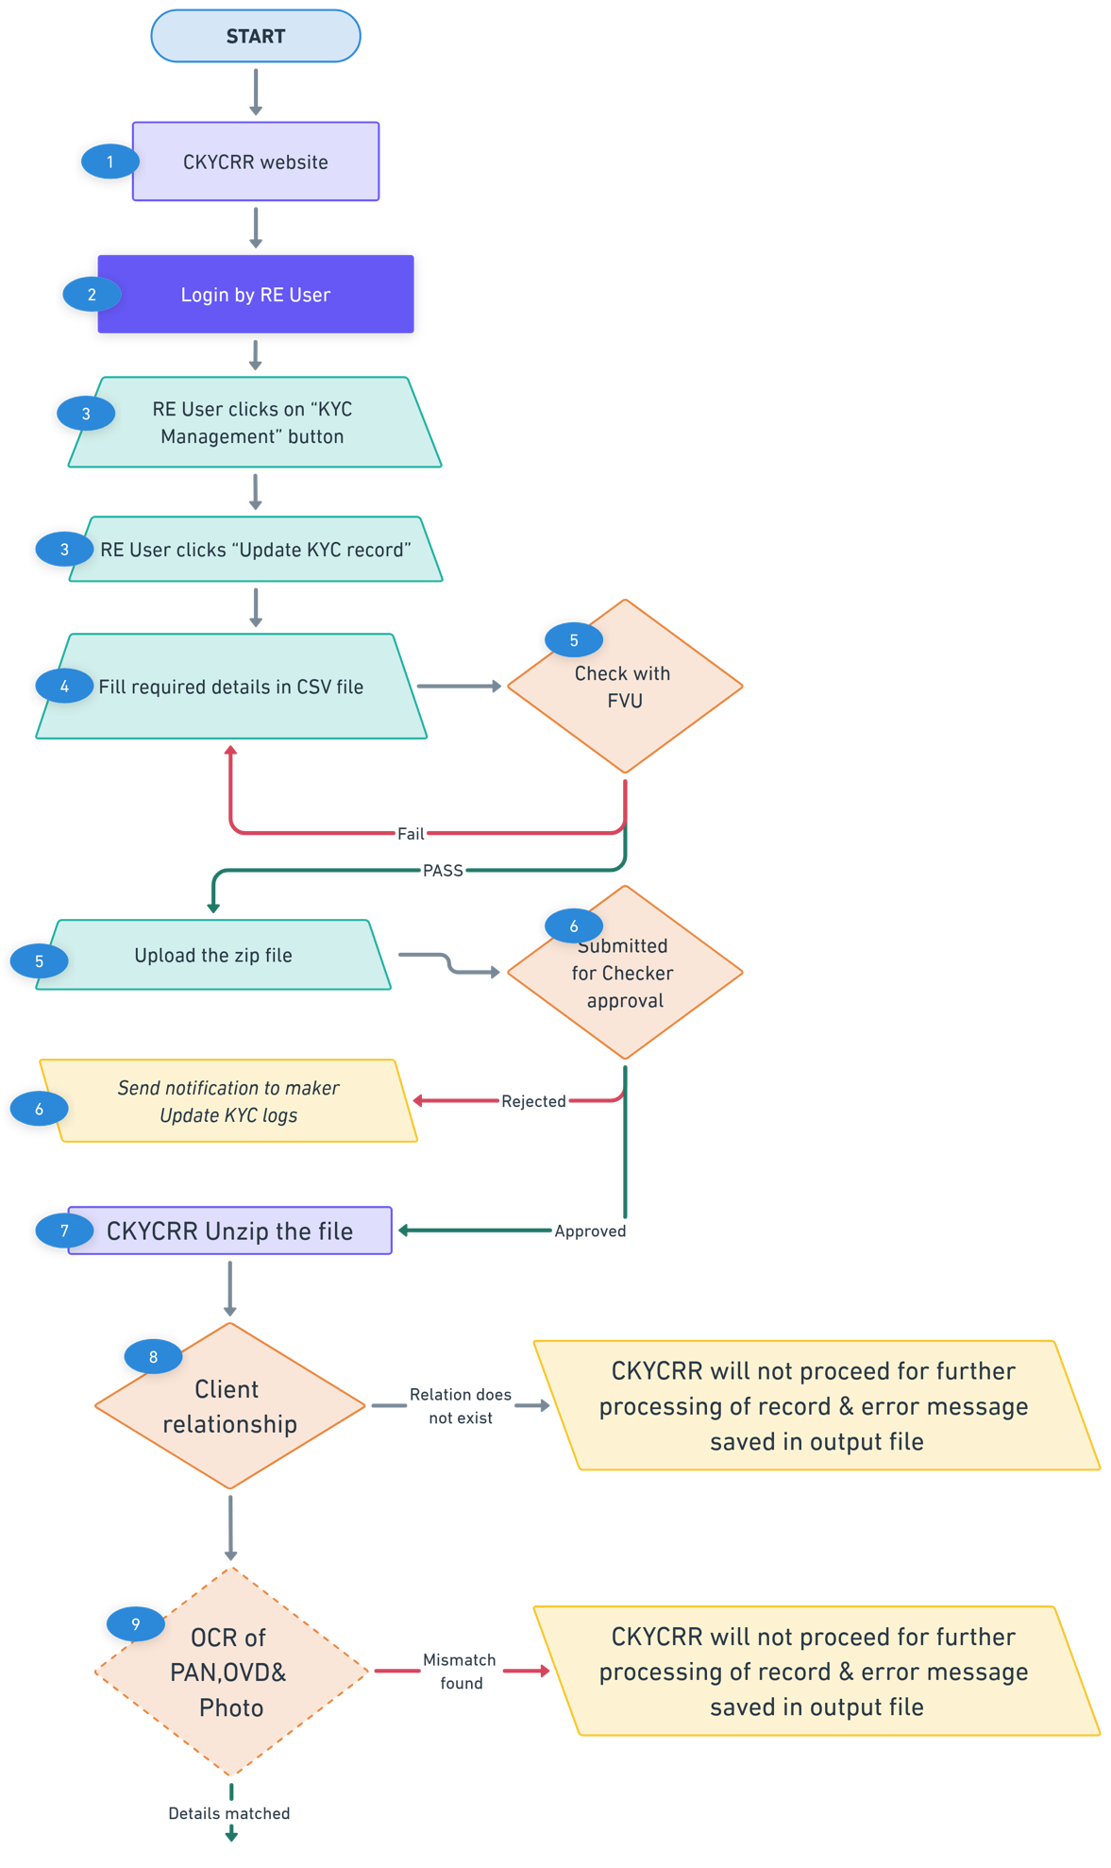
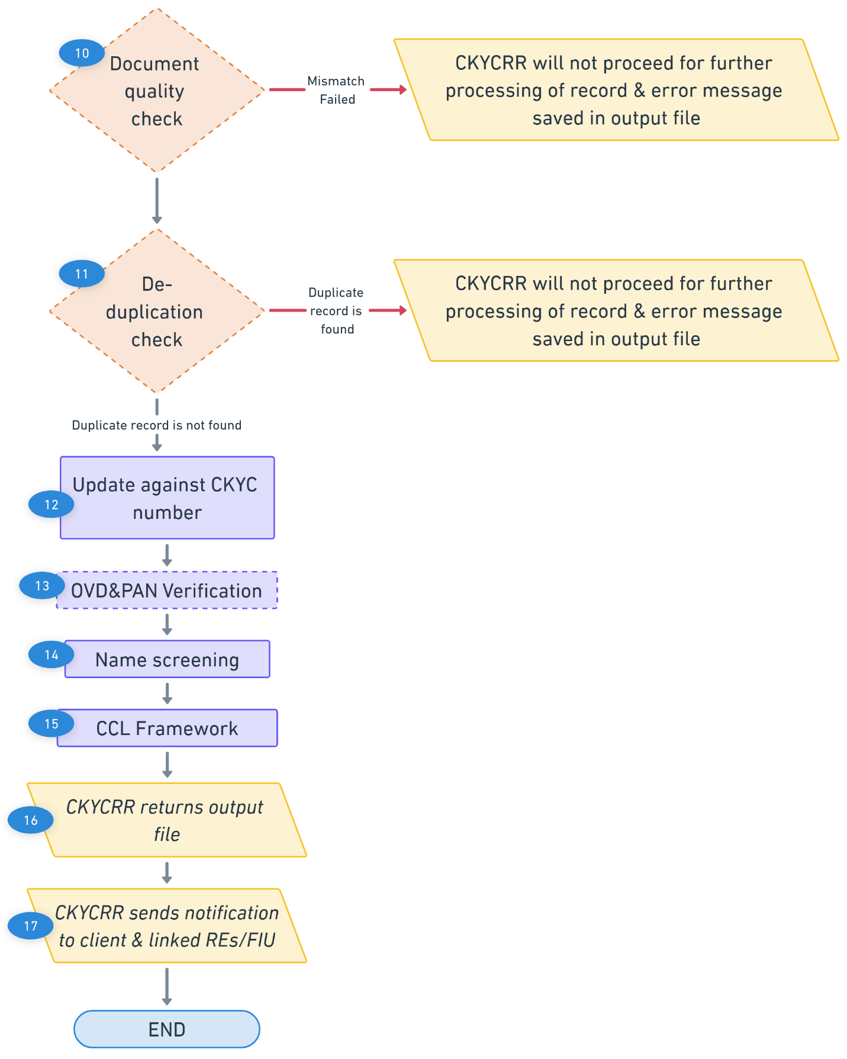

Points to Remember:
- OVD Validation and Verification will be triggered only when there are modifications/ change made to the OVD and/or PAN.
- De-duplication check will be initiated whenever there is an addition or modification to OVD or PAN details and demographic parameters in case of Aadhaar, ensuring uniqueness across the database.
- The CCL Framework will run as defined under CCL framework in Annexure II.
- The CKYCRR system will keep checking the size of the documents being uploaded including documents already available in the system, once the total size exceed 25MB the system will alert the user via notification(pop-up) that “The total size of all documents being uploaded should be less than or equal to 500KB.”
- Notifications will be triggered at the following key events.
Key Event | User | Email | SMS | Post Login
Approval request to checker | RE user (checker) | No | No | Yes
Information to Client on successful updation- SMS would be sent only where e-mail is not available. | Client | Yes | Yes | No
Information to maker on rejection by checker | RE user (maker) | No | No | Yes
Information to linked REs on updation | RE users | No | No | Yes
Information to RE and FIU-Ind if record flagged in name screening process | RE users, FIU-Ind | Yes | No | Yes

Update KYC Record – Legal Entity
The Update KYC Record functionality allows the RE user to:
- Update existing KYC details of the legal entity
- De-activate a KYC record
- Re-activate a KYC record
- Suspend a KYC record
- Revoke suspension of KYC record

Below outlines the process of updating a KYC record:
Step 1: The RE user will access domain / URL “https://www.ckycindia.in” from their respective systems connected over internet.

Step 2: The RE user will login to the CKYCRR system using the user ID issued, password and DSC (as per login module).

Step 3: The RE user will click on “KYC Management ” button to navigate to KYC management modules and select update KYC record option.
Step 4: The RE user will search for the KYC record in the CKYCRR registry. The CKCYRR registry will automatically check for the following conditions:
  - Record created by RE
  - Record downloaded by RE
If either of these conditions is met, the CKYCRR system moves to next. If neither of the conditions is met, the CKYCRR system will prompt the RE user to download the KYC record just before proceeding for update.
Step 5: The CKYCRR system will display existing KYC record of the legal entity to the RE user.
Step 6: The RE user can update any or all of the following sections based on type of the KYC record.
  - Entity details
  - Proof of Identity
  - Registered address and principal place of business address details
  - Contact details
  - Details of related persons
  - Other details & attestation
Step 7: The CKYCRR system will initiate the OCR (Optical Character Recognition) process for the uploaded PAN (if PAN is provided)/ CIN/LLPIN certificate to extract relevant details from the documents. The CKYCRR system will compare the extracted details from the documents with the details entered by the RE user. If the details match, the CKYCRR system will proceed with the next step. If the details do not match, the CKYCRR system will not proceed further for failed record.
- Existing PAN detail is updated and document is uploaded
- Existing PAN document is updated
- Existing CIN/LLPIN certificate document is updated
Step 8: The CKYCRR system will check the quality of the documents uploaded by the RE user. If the document quality does not match the threshold defined, the CKCYRR system will give the error message to update document. If the document quality matches with the threshold, the RE user can see the preview and submit the request for checker approval.
Step 9: Post submission of updated details, the CKYCRR system will send the update KYC record to checker (RE user) for approval. Below are the possible outcomes of the approval request:
- If approved, the CKYCRR system will proceed with the subsequent steps in the update KYC record workflow.
- If rejected, the update KYC record will be redirected to the KYC Logs section, where it will be available for necessary modifications and re-submission by the maker (RE user).
Step 10: On approval by checker (RE user), the CKYCRR system will perform a de-duplication check by scanning the CKYCRR registry for existing records as per the de-duplication logic defined separately.
The CKYCRR system will perform a de-duplication check if any of the following conditions are met:
- PAN is modified
- Name of the legal entity is modified (where PAN is not present)
- Date of formation / incorporation is modified (where PAN is not present)
- Modifications made to any other parameter used in de-duplication check
Based on de-duplication check, the CKYCRR system will have the below outcomes
- Duplicate found: In case a matching record is found, the update request of the KYC record will not be processed further and will be rejected. Reasons will be conveyed to the RE.
- Duplicate not found: the CKYCRR system will proceed with next step.
Step 11: In case no matching record is found, the CKYCRR system will update the KYC details against the existing CKYC number of the KYC record.
Step 12: The CKYCRR system will initiate verification with the respective issuing authorities whenever any modifications are made to PAN and other document (GST/TIN/CIN/LLPIN) details. The response/status returned by the issuing authority will be captured and recorded in the CKCYRR registry for flagging.
Step 13: The CKYCRR system will check the updated details with external agencies for name screening and update the status of the KYC record in the CKYCRR registry. If any match in found, the notification will be sent to linked REs and FIU-IND.
Step 14: The CKYCRR system will send the notification to legal entity and all the linked REs for the record updated by the reporting entity.
Functional Flow:
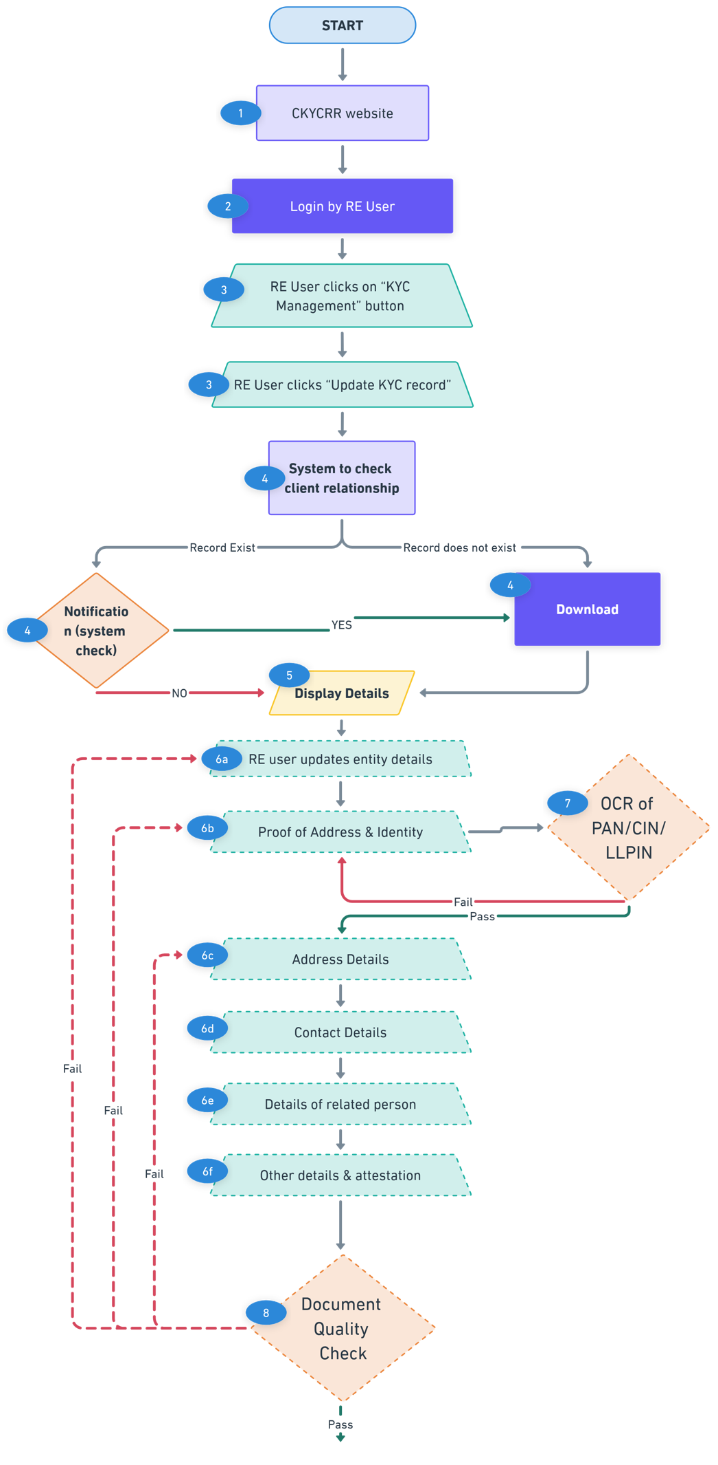
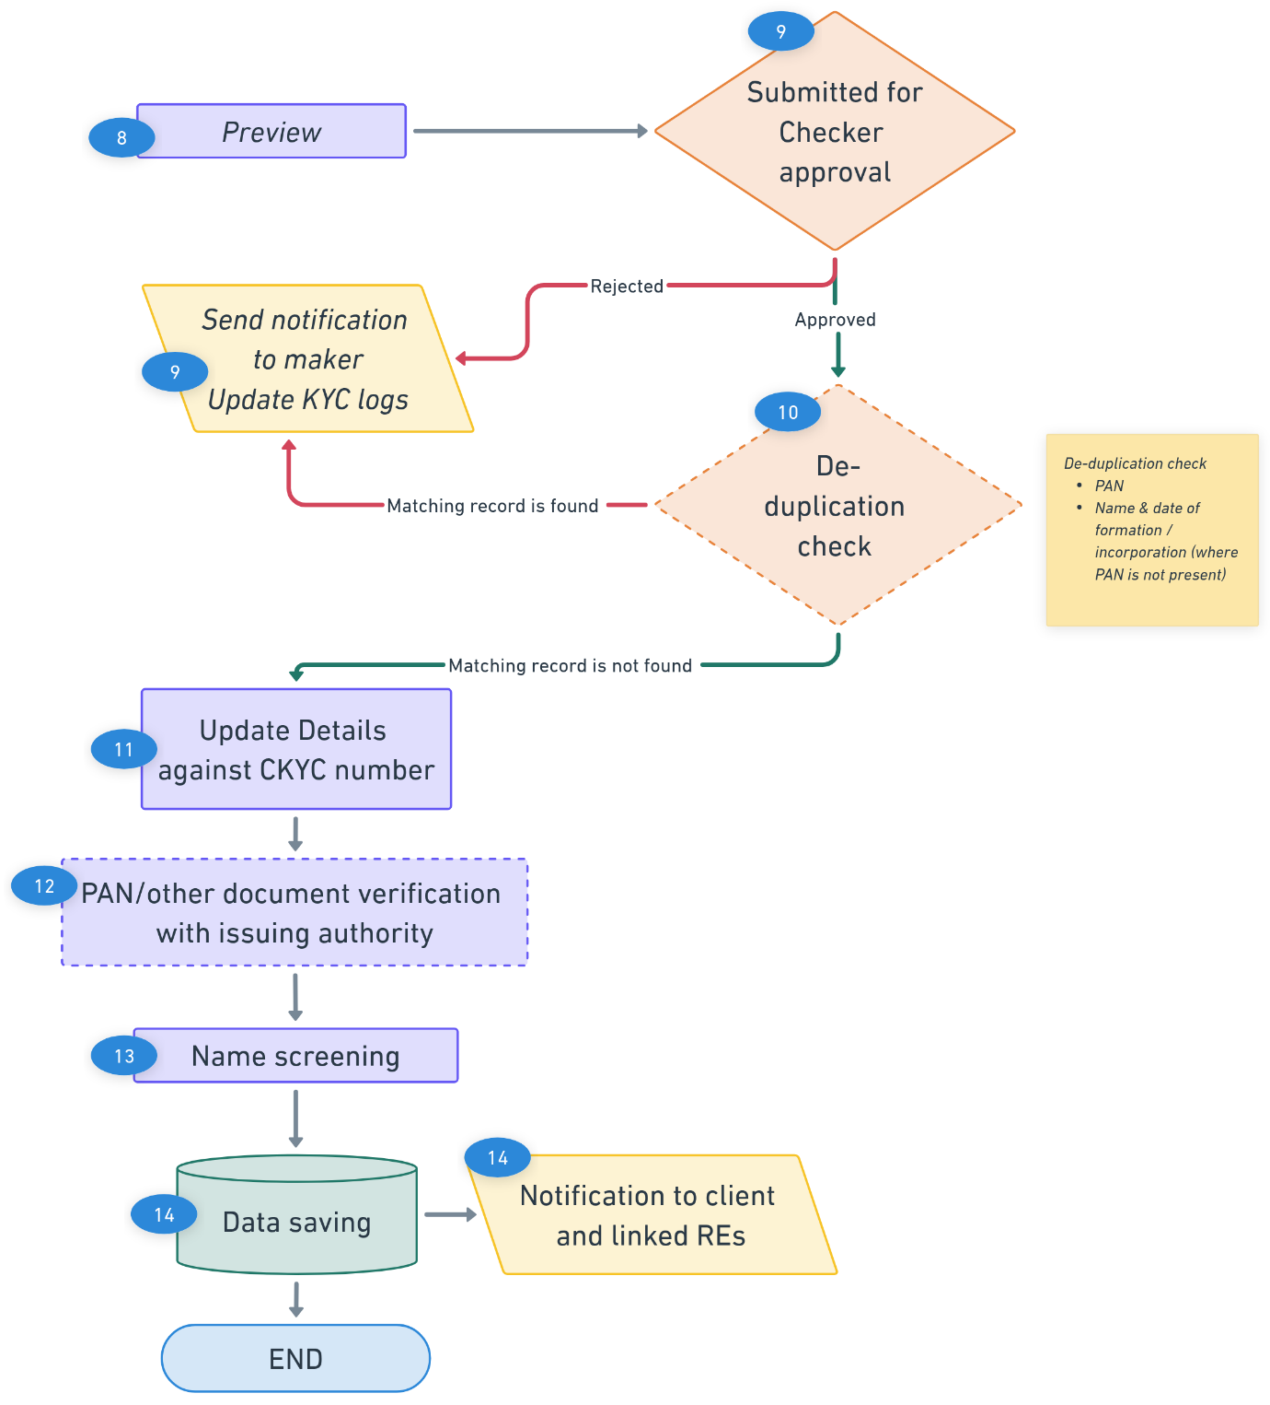
Points to Remember:
- PAN and/or POI Validation and Verification will be triggered only when there are modifications made to the PAN and/or proof of identity details.
- De-duplication check will be initiated whenever there is an addition or modification to PAN details, name of entity, date of incorporation/ date of formation (where PAN is not present) or any other parameter on which de-duplication logic is based.
- The CKYCRR system will keep checking the size of the documents being uploaded including documents already available in the system, once the total size exceed 25MB the system will alert the user via notification(pop-up) that “The total size of all documents being uploaded should be less than or equal to 25MB.”

- The CKYCRR system will trigger notifications at the following key events
Key Event | User | Email | SMS | Post Login
Approval request to checker | Co-admin (RE user) | No | No | Yes
Information to Client on successful updation | Client | Yes | No | No
Information to maker on rejection by checker | Maker (RE user) | No | No | Yes
Information to linked REs | RE users | No | No | Yes
Information to RE and FIU-Ind if record flagged in name screening | RE users, FIU-Ind | Yes | No | Yes
Below outlines the process of bulk updating legal entity KYC record:
Step 1: The RE user will access domain / URL “https://www.ckycindia.in” from their respective systems connected over internet.

Step 2: The RE user will login to the CKYCRR system using the user ID issued, password and DSC (as per login module).

Step 3: The RE user will click on “KYC Management ” button to navigate to KYC management modules and select update KYC record option.
Step 4: The RE user will fill in the required details for record updation in defined templates against the CKYC number of the KYC record. Associated documents will be kept in ZIP file and reference number of the documents to be noted against each record.
Step 5: The RE user will upload the CSV file and validate the completed CSV sheet using the File Validation Utility (FVU). Once validated by the FVU, the same file must be uploaded to the system. In case of the rejection by the FVU, the CSV file will not be accepted by the CKYCRR system.
Step 6: Upon submission of a bulk ZIP file by the maker (RE user), the CKCYRR system will route the update KYC record to the checker (RE user) for approval. Checker (RE user) can download the ZIP file to view the details of the bulk file.
- If the checker (RE) rejects the update request, a notification will be sent to the maker (RE user) specifying the reason for rejection. The maker (RE user) can then make the necessary modifications and re-submit the file.
- If the update request is approved, the CKYCRR system will automatically proceed with the subsequent processing steps, including data validation, duplication checks, and further workflow as defined.
Step 7: Upon successful approval of the bulk update request: the CKYCRR system will unzip the File and retrieve CSV file and documents uploaded by the RE user.
Step 8: The CKYCRR System will check the client relationship with RE by checking the below
- Record created by RE
- Record downloaded by RE
If either of these conditions is met, the CKYCRR system moves to next. If neither of the conditions is met, the CKYCRR system will prompt the RE user to download the KYC record just before proceeding for update.
Step 9: The CKYCRR system will initiate the OCR (Optical Character Recognition) process for the uploaded PAN (if PAN is provided)/ CIN/ LLPIN certificate to extract relevant details from the PAN documents. The CKYCRR system will compare the extracted details from documents with the details entered by the RE user. If the details match, the CKYCRR system will proceed with the next step. If the details do not match, the CKYCRR system will not proceed further.
- Existing PAN detail is updated and document is uploaded
- Existing PAN document is updated
- Existing CIN/ LLPIN certificate is document is updated.
Step 10: The CKYCRR system will check the quality of the documents uploaded by the RE user. If the document quality does not match the threshold defined, the CKCYRR system will give the error message in return/ output file. If the document quality matches with the threshold, the CKYCRR system will move to the next step.
Step 11: The CKYCRR system will perform a de-duplication check if any of the following conditions are met:
- PAN is modified
- Name of the legal entity is modified (where PAN is not present)
- Date of formation / incorporation is modified (where PAN is not present)
- Modifications made to any other parameter used in de-duplication check
Based on de-duplication check, the CKYCRR system will have the below outcomes
- Duplicate found : In case a matching record is found, the update request of the KYC record will not be processed further and will be rejected. Reasons will be conveyed to the RE.
- Duplicate not found: the CKYCRR system will proceed with next step.
Step 12: In case of no matching record is found, The CKYCRR system will update the KYC details against the existing CKYC number of the KYC record.
Step 13: The CKYCRR system will initiate verification with the respective issuing authorities whenever any modifications are made to PAN and other documents (GST/TIN/CIN/LLPIN) details. The response/status returned by the issuing authority will be captured and recorded in the CKCYRR registry for flagging.
Step 14: The CKYCRR system will check the online status with external agencies for name screening. The statuses provided by the external agencies will be flagged in CKYCRR registry. If any match in found, the notification will be sent to linked REs and FIU-IND.
Step 15: The CKYCRR system will return status file to RE user along with details of successful updates and unsuccessful updates
Step 16: The CKYCRR system will send notification to the client and linked REs regarding updation of record.
Functional Flow:
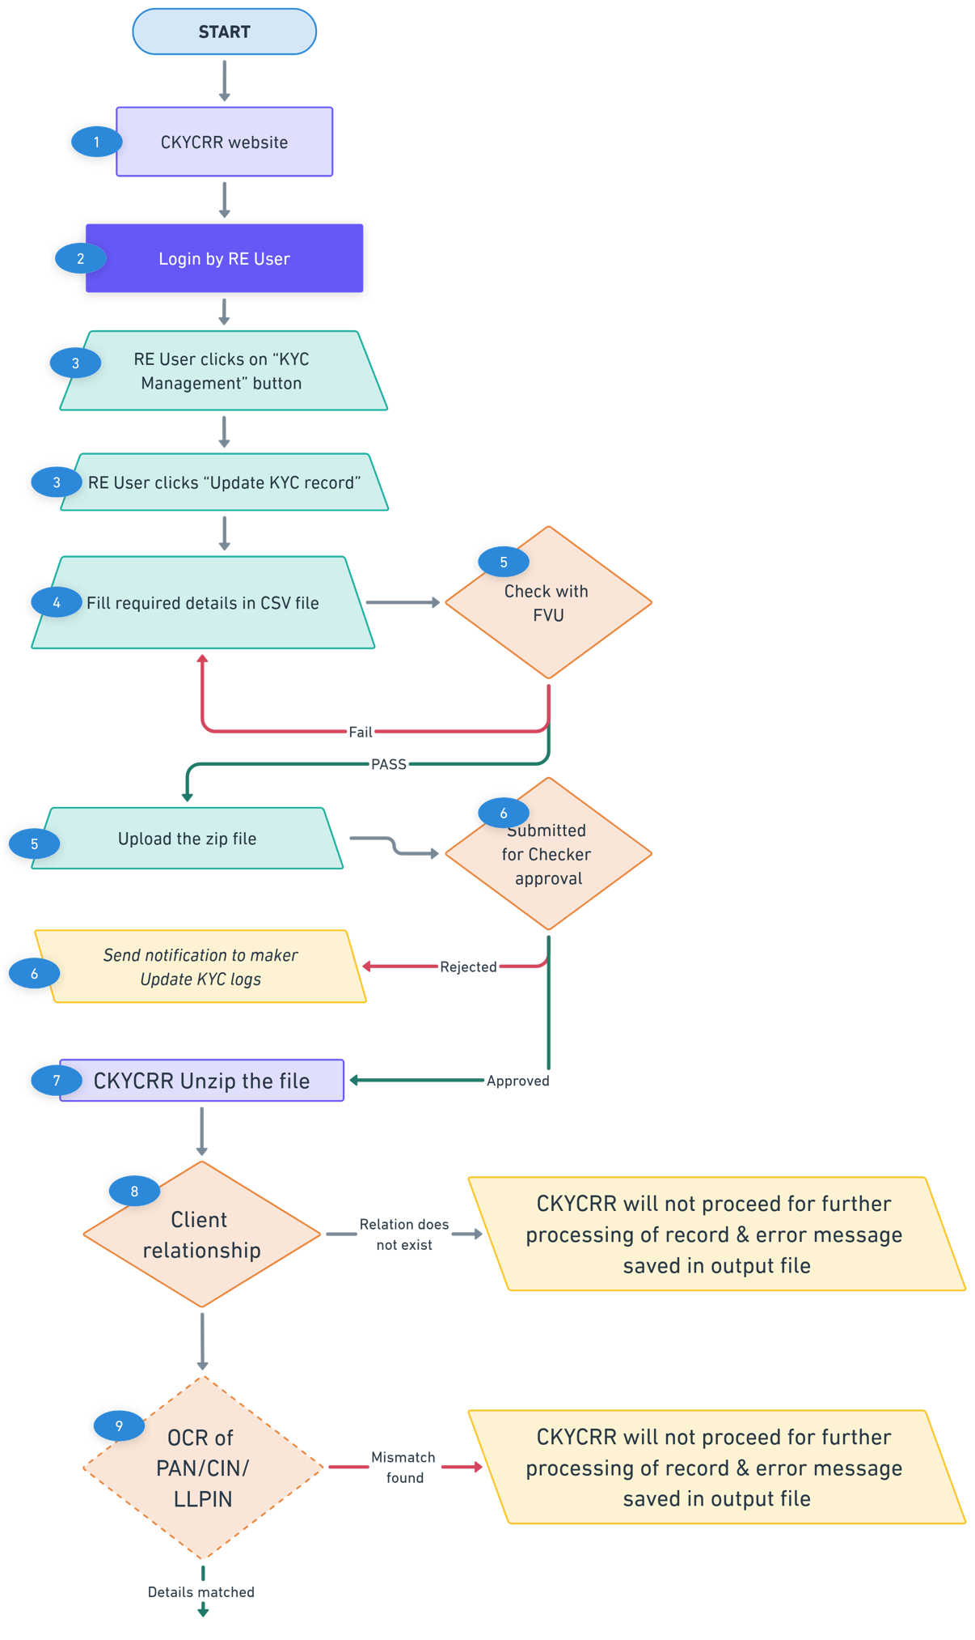
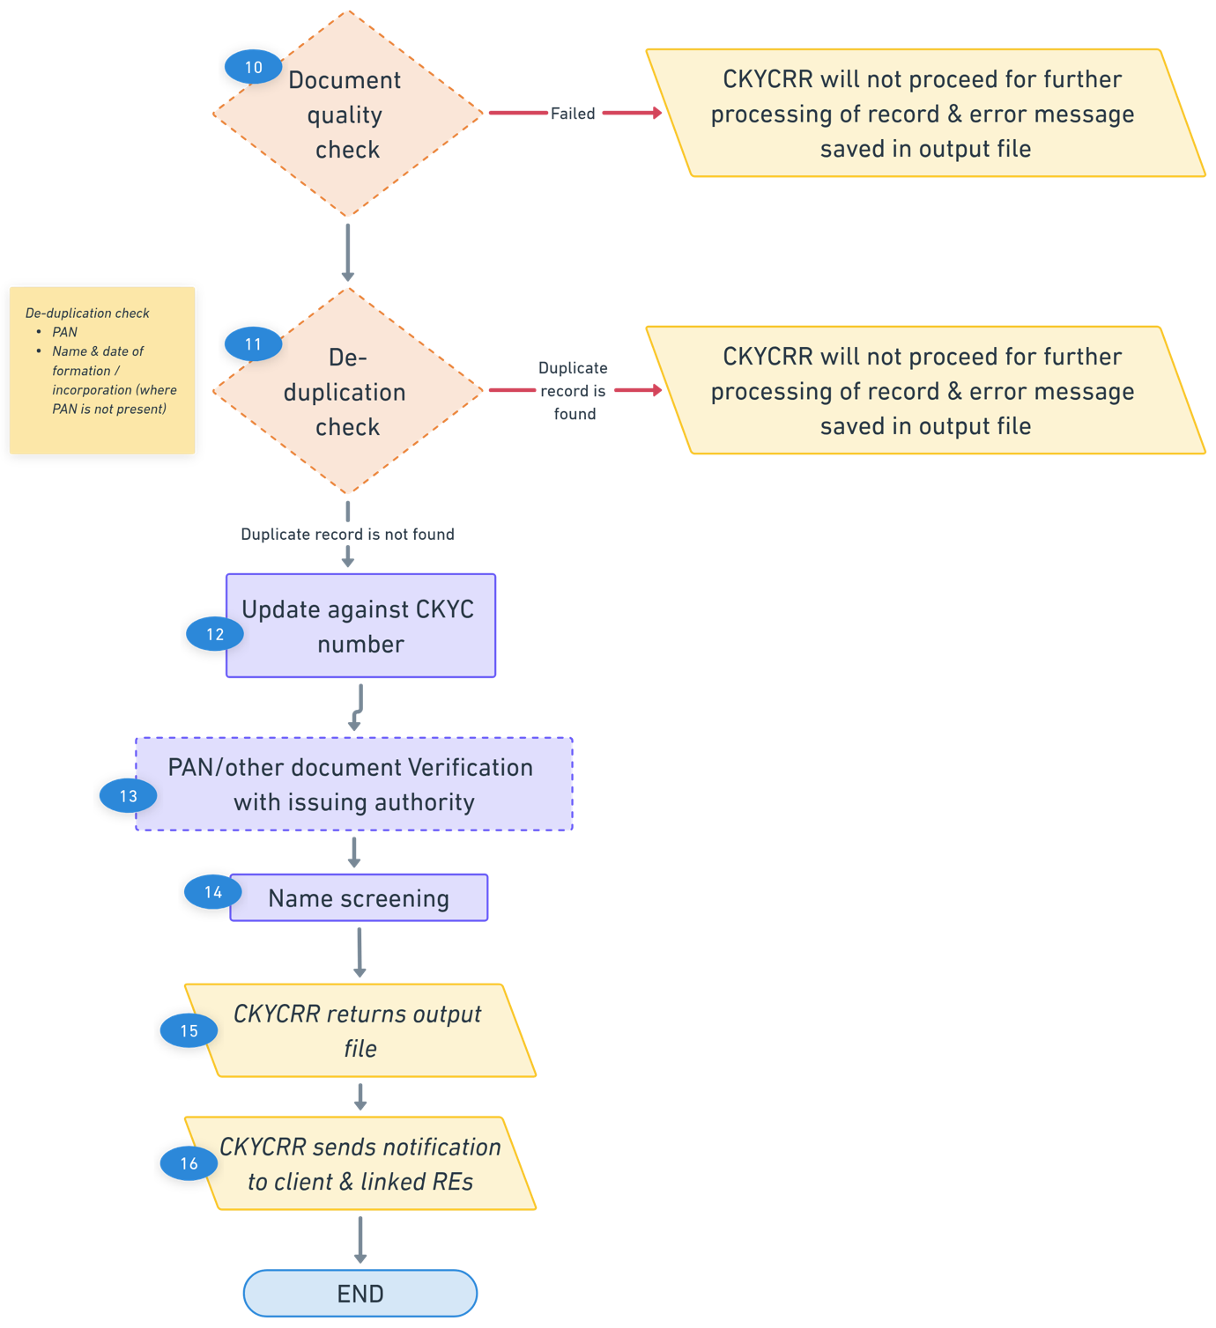
Points to Remember:
- PAN/POI Validation and Verification will be triggered only when there are modifications made to the Proof of Identity and/or PAN.
- De-duplication Check will be initiated whenever there is an addition or modification to PAN details, name of entity, date of incorporation/ date of formation (where PAN is not present) or any other parameter on which de-duplication logic is based.
- The CKYCRR system will keep checking the size of the documents being uploaded including documents already available in the system, once the total size exceed 25MB the system will alert the user via notification(pop-up) that “The total size of all documents being uploaded should be less than or equal to 25MB.”
- The CKYCRR system will trigger notifications at the following key events
Key Event | User | Email | SMS | Post Login
Approval request to RE | RE users | No | No | Yes
Information to Client on successful updation | Client | Yes | No | No
Information to maker on rejection by checker | Maker (RE user) | Yes | No | Yes
Information to linked REs | RE users | No | No | Yes
Information to RE and FIU-Ind if record flagged in name screening | RE users, FIU-Ind | Yes | No | Yes

De-activate KYC record
Deactivation of KYC Record enables the Reporting Entity (RE) user to initiate deactivation of any KYC record by providing valid details, including the reason for deactivation and supporting remarks/documents. The de-activation request will follow the maker-checker workflow and, upon approval, the KYC record will be de-activated in the CKYCR registry.

Below outlines the process of de-activating Single KYC record:
Step 1: The RE user will access domain / URL “https://www.ckycindia.in” from their respective systems connected over internet.

Step 2: The RE user will login to the CKYCRR system using the user ID issued, password and DSC (as per login module).
Step 3: The RE user will click on “KYC Management ” button to navigate to KYC management modules and select de-activate KYC record option.
Step 4: The RE user will select the type of deactivation from the following options:
- Duplicate Record
- Deceased
- Court order
- Others
Step 5: Based on selection by the RE user, the CKYCRR system will prompt user to provide the below details
- If Duplicate Record is selected:
  - The RE user must provide at least two CKYC numbers.
  - Based on the CKYC numbers entered by the RE, the CKYCRR system fetches and displays the details of each KYC record.
  - The RE user will select the record to be retained and record to be de-activated.
  - The RE user can update the retained record. In case of retained record does not have PAN and records selected for de-activation have PAN, then system will auto-populate PAN in retained record.
  - RE user will upload the client consent as per the prescribed format and enter remarks and submit the request.
- If other than duplicate option is selected by the RE user:
  - The RE user selects the KYC record to be de-activated and selects a reason from a predefined dropdown values and provides necessary remarks along with document upload (if any).
  - Upon submission, the request is directly routed to the checker (RE user) for approval.
Step 6: Once the request is submitted by RE user (maker), it will go to the RE checker for approval.
Step 7: The checker (RE user) reviews the request with options to Approve or Reject:
- On Approval: The selected KYC record will be marked as Deactivated in the CKYCRR registry.
- On Rejection: The de-activation request is returned to the maker (RE user) with feedback for modification and resubmission.
Step 8: Once the record is deactivated, a notification will be sent to all the linked REs regarding the deactivated record and the retained record with a request to download the retained record. All the REs linked to the de-activated KYC record will be automatically linked to the retained record. Name of the RE which de-activated KYC record will be shared along with the reason of de-activation with linked REs.
Step 9: The de-activated record will be available on search with appropriate remarks. However, the record will not be downloadable.
Functional Flow:
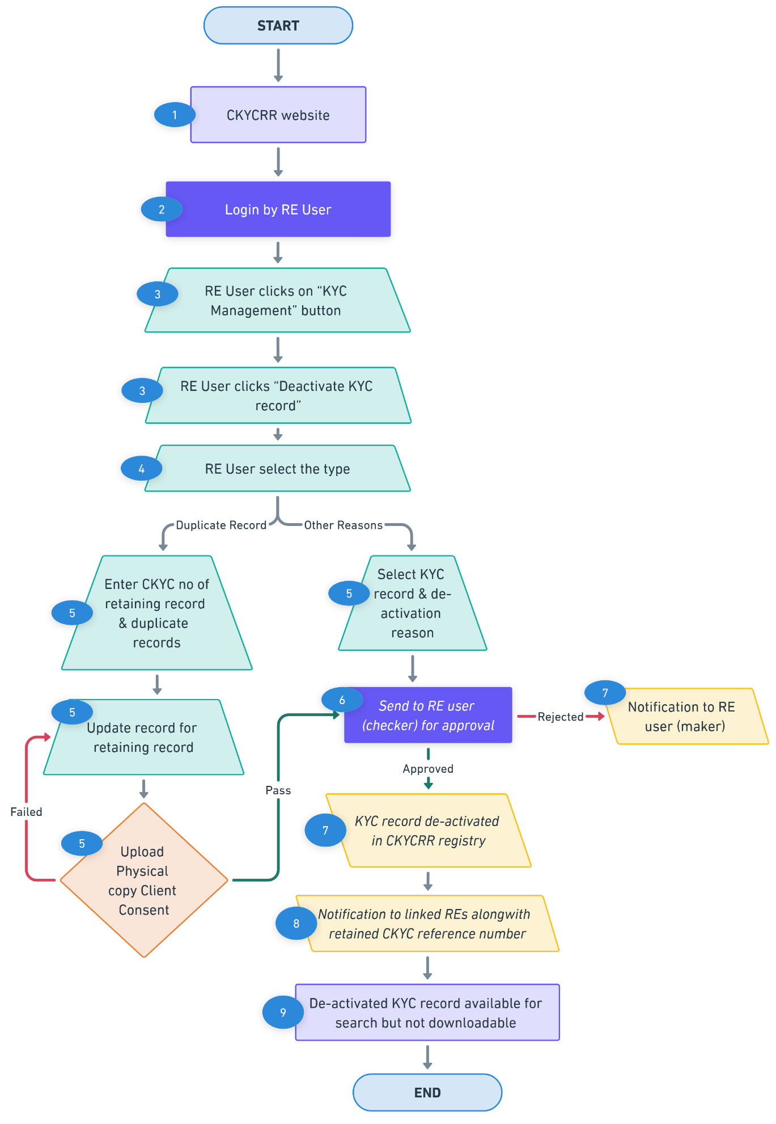

Below outlines the process of de-activating Bulk KYC record:
CKYCRR system provisions bulk de-activation of duplicate KYC record.

Below outlines the process of bulk de-activating duplicate record:
Step 1: The RE user will access domain / URL “https://www.ckycindia.in” from their respective systems connected over internet.

Step 2: The RE user will login to the CKYCRR system using the user ID issued, password and DSC (as per login module).
Step 3: The RE user will click on “KYC Management ” button to navigate to KYC management modules and select de-activate KYC record option.
Step 4: The RE user will fill in the required details for record de-activation in defined templates.
Step 5: The RE user will validate the completed CSV sheet using the File Validation Utility (FVU). Once validated, the same file must be uploaded to the CKYCRR system for approval to RE user (checker).
Step 6: Upon submission of a bulk CSV file by the maker (RE user), the CKCYRR system will route the de-activate KYC record to the checker (RE user) for approval. Checker (RE user) can download the CSV file to view the details of the bulk file.
- If the checker (RE) rejects the de-activation request, a notification will be sent to the maker (RE user) specifying the reason for rejection. The maker (RE user) can then make the necessary modifications and re-submit the file.
- If the de-activation request is approved, the CKYCRR system will automatically proceed with the next steps.
Step 7: Upon successful approval of the bulk de-activation request: the CKYCRR system will process CSV file uploaded by the RE user.
Step 8: The CKYCRR System will authenticate the client consent as per the consent mechanism defined separately. For authenticated client consent, the CKYCRR system will de-activate the duplicate record and map the duplicate record to retained record. If the client consent is not authenticated, the CKYCRR system will record the status in output file.
Step 9: Once the record is deactivated, a notification will be sent to all the linked REs regarding the deactivated record and the retained record with a request to download the retained record. All the REs linked to the de-activated KYC record will be automatically linked to the retained record. Name of the RE which de-activated KYC record will be shared along with the reason of de-activation with linked REs.
Step 10: The de-activated record will be available on search with appropriate remarks. However, the record will not be downloadable.
Step 11: The CKYCRR system will provide the return output file with status under KYC logs.
Functional Flow:
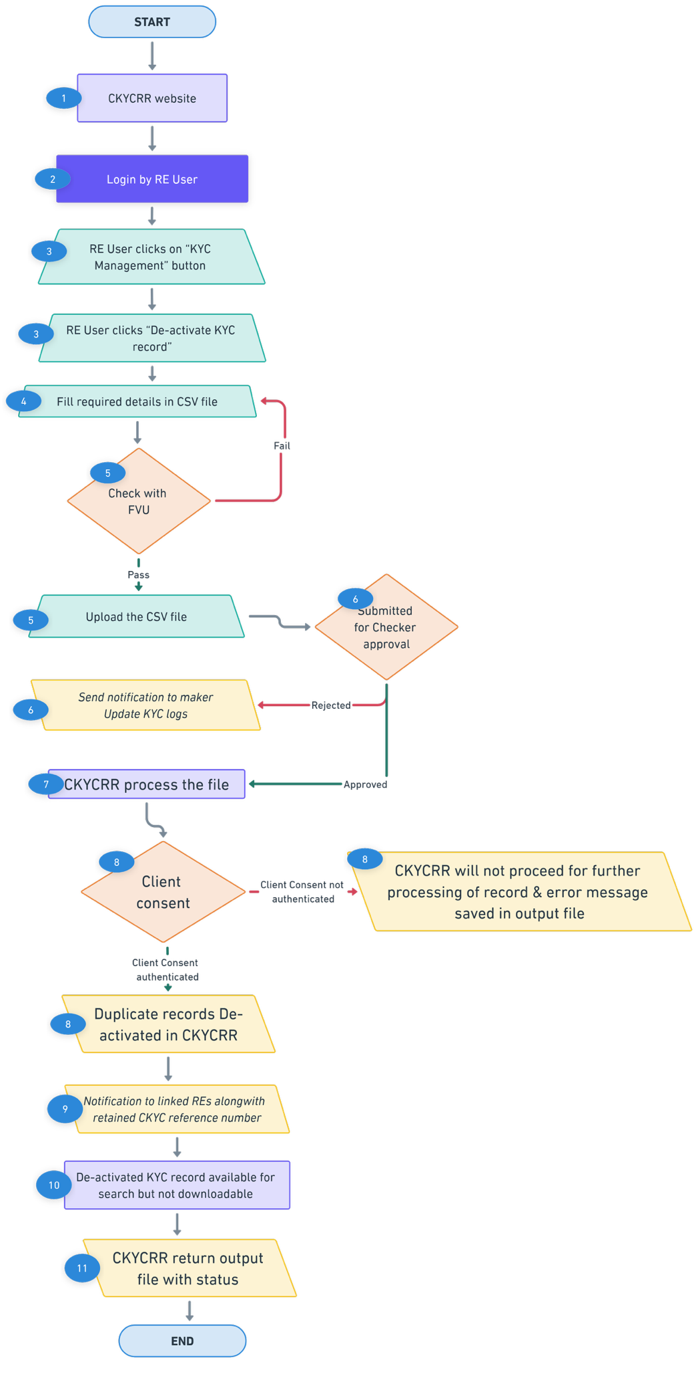

Points to Remember:
- De-activated KYC records will be considered for de-duplication check.
- CKYCRR system will restrict the download of de-activated KYC record.
- The CKYCRR system will trigger notifications at the following key events
Key Event | User | Email | SMS | Post Login
Information to checker for approval | Checker | No | No | Yes
Information to maker on rejection by checker | Maker | No | No | Yes
Information to linked REs | RE users | No | No | Yes
Information to client (duplicate record) | Client | Yes | Yes | No

Re-activate KYC record
The Re-activation of KYC Record functionality enables a Reporting Entity (RE) user to re-activate previously deactivated KYC record. This can be initiated only under permitted circumstances and requires appropriate justification and approval.
Below outlines the process of re-activating KYC record:
Step 1: The RE user will access domain / URL “https://www.ckycindia.in” from their respective systems connected over internet.

Step 2: The RE user will login to the CKYCRR system using the user ID issued, password and DSC (as per login module).
Step 3: The RE user will click on “KYC Management ” button to navigate to KYC management modules and select re-activate KYC record option.
Step 4: The CKYCRR system displays a list of all de-activated KYC records associated with the RE. The RE user selects the desired record by clicking “View Details” next to the KYC record. The RE user can also search the record by entering CKYC number.
Step 5: The CKYCRR system will navigate RE user to the details screen, the RE user selects a re-activation reason from a predefined dropdown list and enters the required remarks to support the re-activation request. Upon submitting the re-activation request, the re-activation request is automatically routed to the checker (RE user) for approval.
Dropdown reasons:
- Inadvertently
- Incorrect information
- Others
Step 6: The checker (RE user) reviews the submitted re-activation request and has two actionable options:
- Approve: The KYC re-activation request is forwarded to the CERSAI user for final approval.
- Reject: The re-activation request is returned to the maker (RE user) with appropriate feedback for correction and resubmission.
Step 7: CERSAI users (maker -checker) reviews the submitted re-activation request and has two actionable options:
- Approve: The KYC re-activation request is approved and KYC record is re-activated in the CKYCRR registry.
- Reject: The re-activation request is returned to the maker (RE user) with appropriate feedback for correction and resubmission.
Step 8: The CKYCRR registry will notify all the linked REs about the re-activation of the record as well as the client.
Functional Flow:
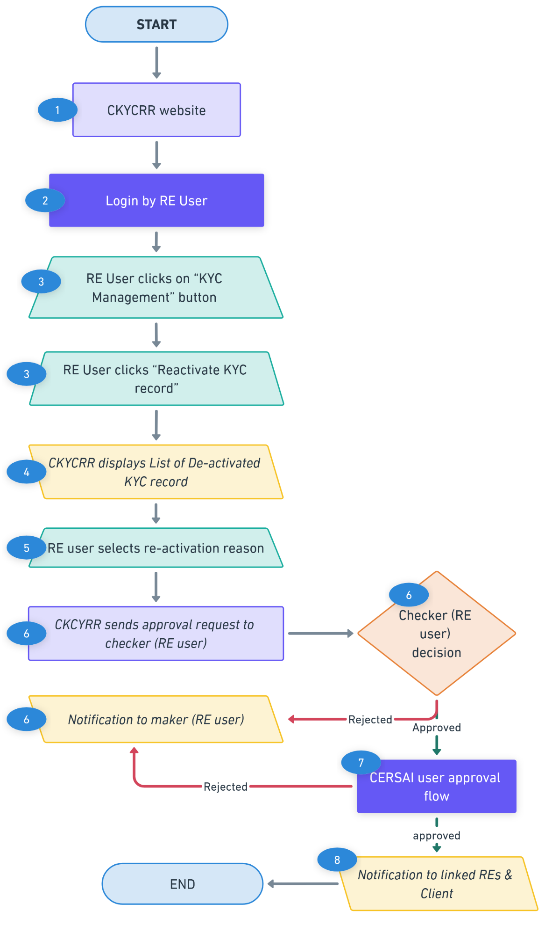
Points to Remember:
- The re-activation of a KYC record will undergo a two-level approval process by designated CERSAI users (Maker–Checker workflow) (as per CERSAI approval flow).
- A KYC record can only be re-activated by the same Reporting Entity (RE) that originally deactivated the KYC record.
- The CKYCRR system will trigger notifications at the following key events
Key Event | User | Email | SMS | Post Login
Information to client on re-activation | Client | Yes | Yes | No
Information to checker for approval | Checker | Yes | No | Yes
Information to maker on rejection by checker | Maker | Yes | No | Yes
Information to linked REs | RE users | Yes | No | Yes

Suspend KYC record
The suspension feature allows a Reporting Entity user to temporarily disable any active KYC record for a pre-defined duration, based on valid business requirements or compliance triggers. The RE user must specify the suspension reason, effective start date, suspension period, and any supporting remarks or documentation as part of the request.

Below outlines the process of suspending KYC record:
Step 1: The RE user will access domain / URL “https://www.ckycindia.in” from their respective systems connected over internet.

Step 2: The RE user will login to the CKYCRR system using the user ID issued, password and DSC (as per login module).
Step 3: The RE user will click on “KYC Management ” button to navigate to KYC management modules and select suspend KYC record option.
Step 4: The RE user inputs the relevant CKYC number, selects a suspension reason from a predefined dropdown list, and provides the required remarks and documents (if any) to support the suspension request.
Suspension reason dropdown values:
- Fake/fraud documents
- Court order
- Inadvertent errors
- Others
Step 5: The RE user specifies the suspension time period by selecting the “From Date” and “To Date” and submit the request for checker (RE user) approval.
- From Date must be the current date or a future date.
- To Date must be greater than the From Date.
Step 6: The checker (RE user) reviews the submitted suspension request and has two actionable options:
- Approve: The KYC suspension request is approved and KYC record is marked suspended in the CKYCRR registry.
- Reject: The suspension request is returned to the maker (RE user) with appropriate feedback for correction and resubmission.
Step 7: The CKYCRR system will notify all the linked REs and client. Name of the RE which suspended and suspension reason will also be shared.
Functional Flow:
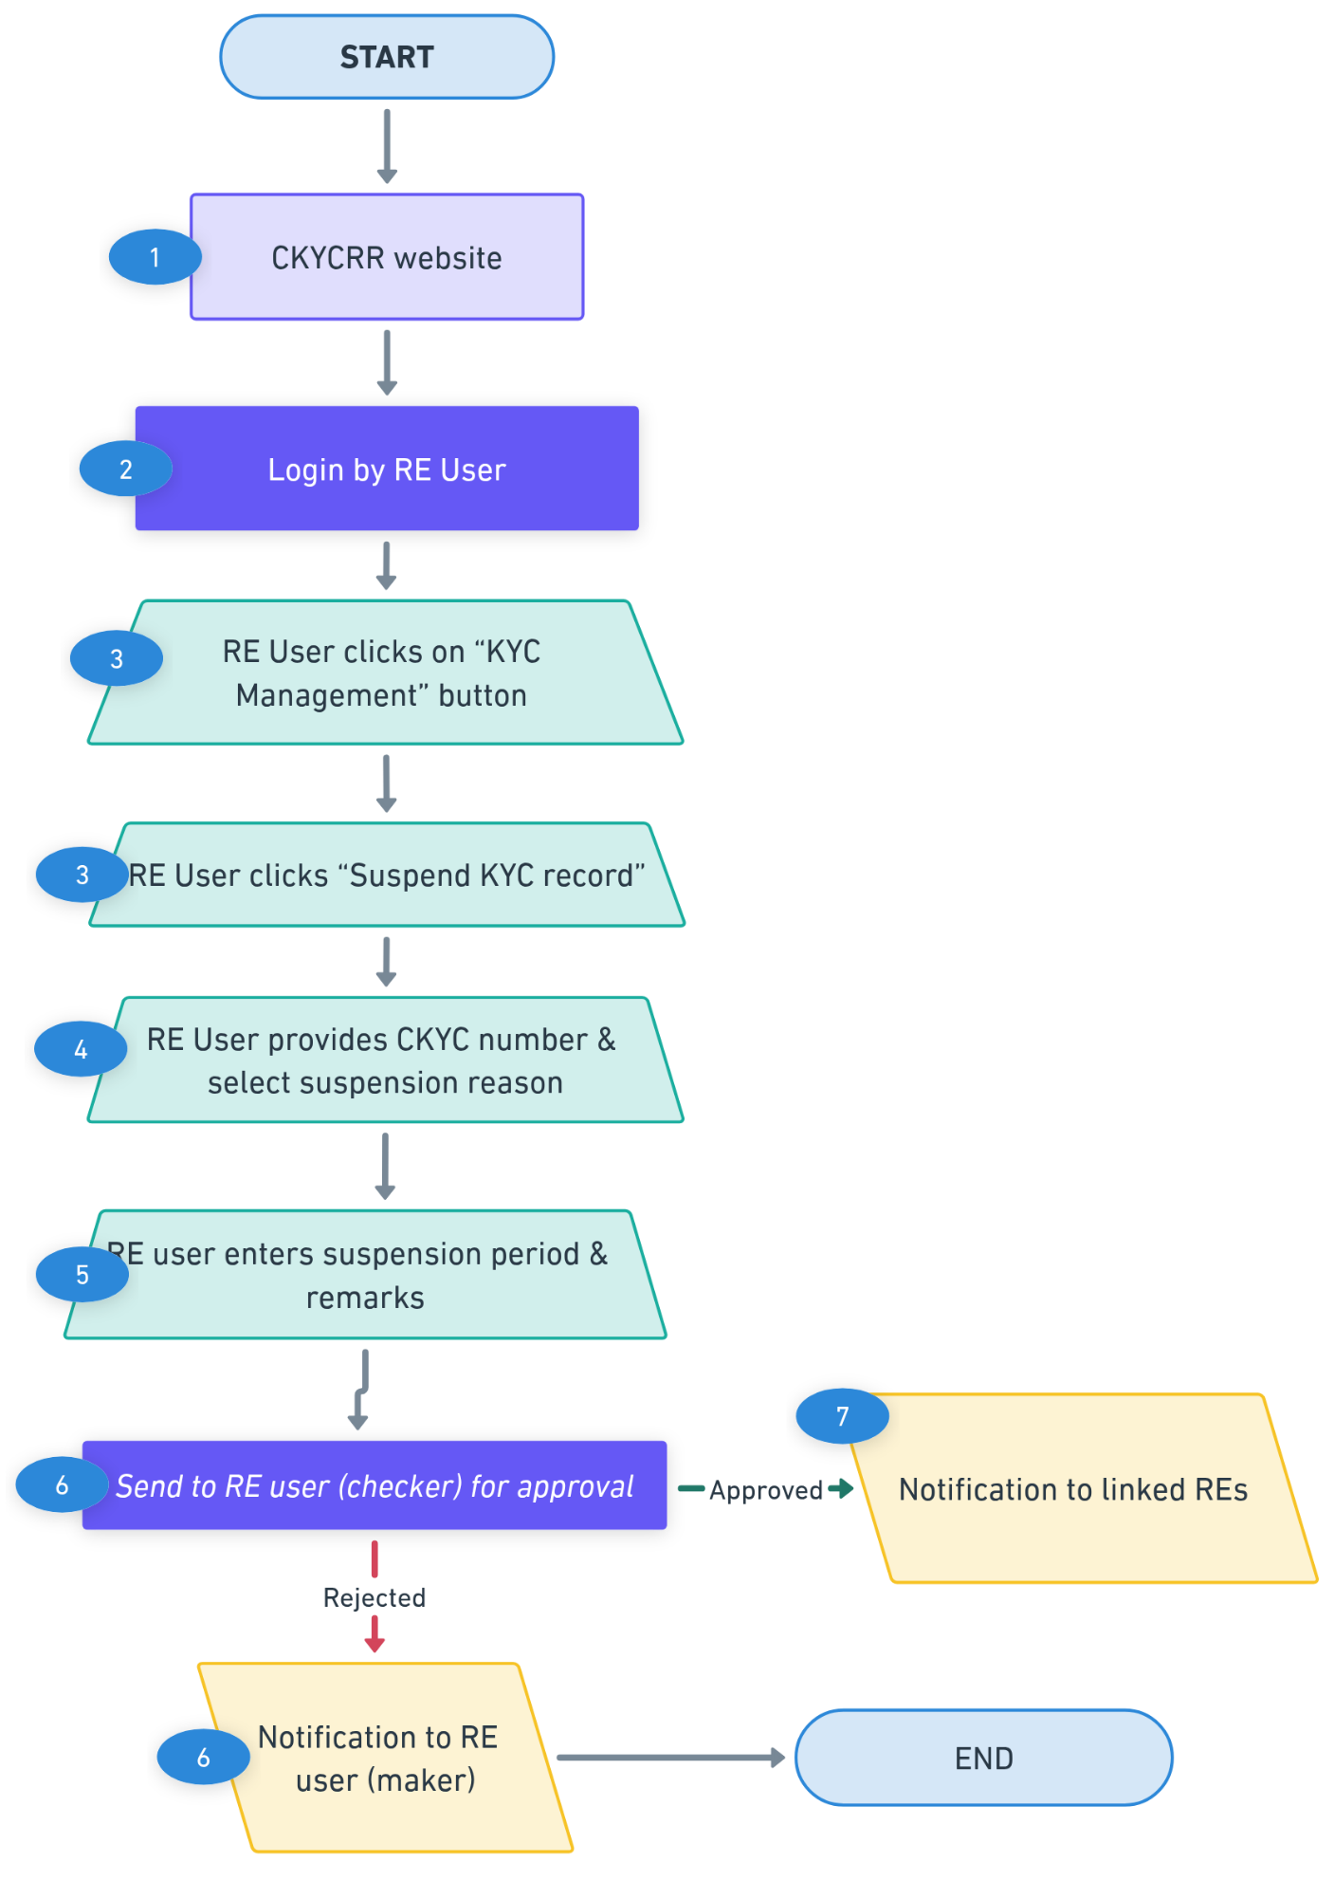
Points to Remember:
- Suspension will be automatically revoked in the CKYCRR registry on completion of time period defined by RE.
- The CKYCRR system will trigger notifications at the following key events
Key Event | User | Email | SMS | Post Login
Information to RE for approval | RE users | No | No | Yes
Information to maker on rejection by checker | RE user (Maker ) | No | No | Yes
Information to linked REs | RE users | Yes | No | Yes
Information to client (except fake/ fraud document) | Client | Yes | Yes | No
Information to RE user on completion of suspension period of KYC ID (notification to be sent on suspension date (S)  [S-0 day,S-3 days,S-6 days] | RE user | Yes | No | Yes

Revocation of Suspension
The revocation of a suspended KYC record enables a Reporting Entity to revoke the suspension on a KYC record prior to the originally defined suspension end date, if deemed necessary. This action can be initiated by the same RE that imposed the suspension.

Below outlines the process of suspending KYC record:
Step 1: The RE user (maker) will access domain / URL “https://www.ckycindia.in” from his/her respective systems connected over internet.

Step 2: The RE user will login to the CKYCRR system using the user ID issued, password and DSC (as per login module).
Step 3: The RE user will click on “KYC Management ” button to navigate to KYC management modules and select revoke suspension KYC record option.
Step 4: A list of all suspended KYC records is displayed to the RE user. The RE user selects a KYC record and clicks "View Details" to open the revoke suspension form.
Step 5: The CKYCRR system will navigate the RE user to the details screen, the RE user clicks on revoke suspension, enters the remarks and upload documents (if any) and submits the request.
Step 6: The CKYCRR system will send the revocation of suspension request to the checker (RE user) and RE user will have two actionable options:
- Approve: Revocation of suspension request is approved and KYC record is marked active in the CKYCRR registry.
- Reject: The revocation of suspension request is returned to the maker (RE user) with appropriate feedback for correction and resubmission.
Step 7: The CKYCRR system will notify all the linked REs and the client.

Functional Flow:
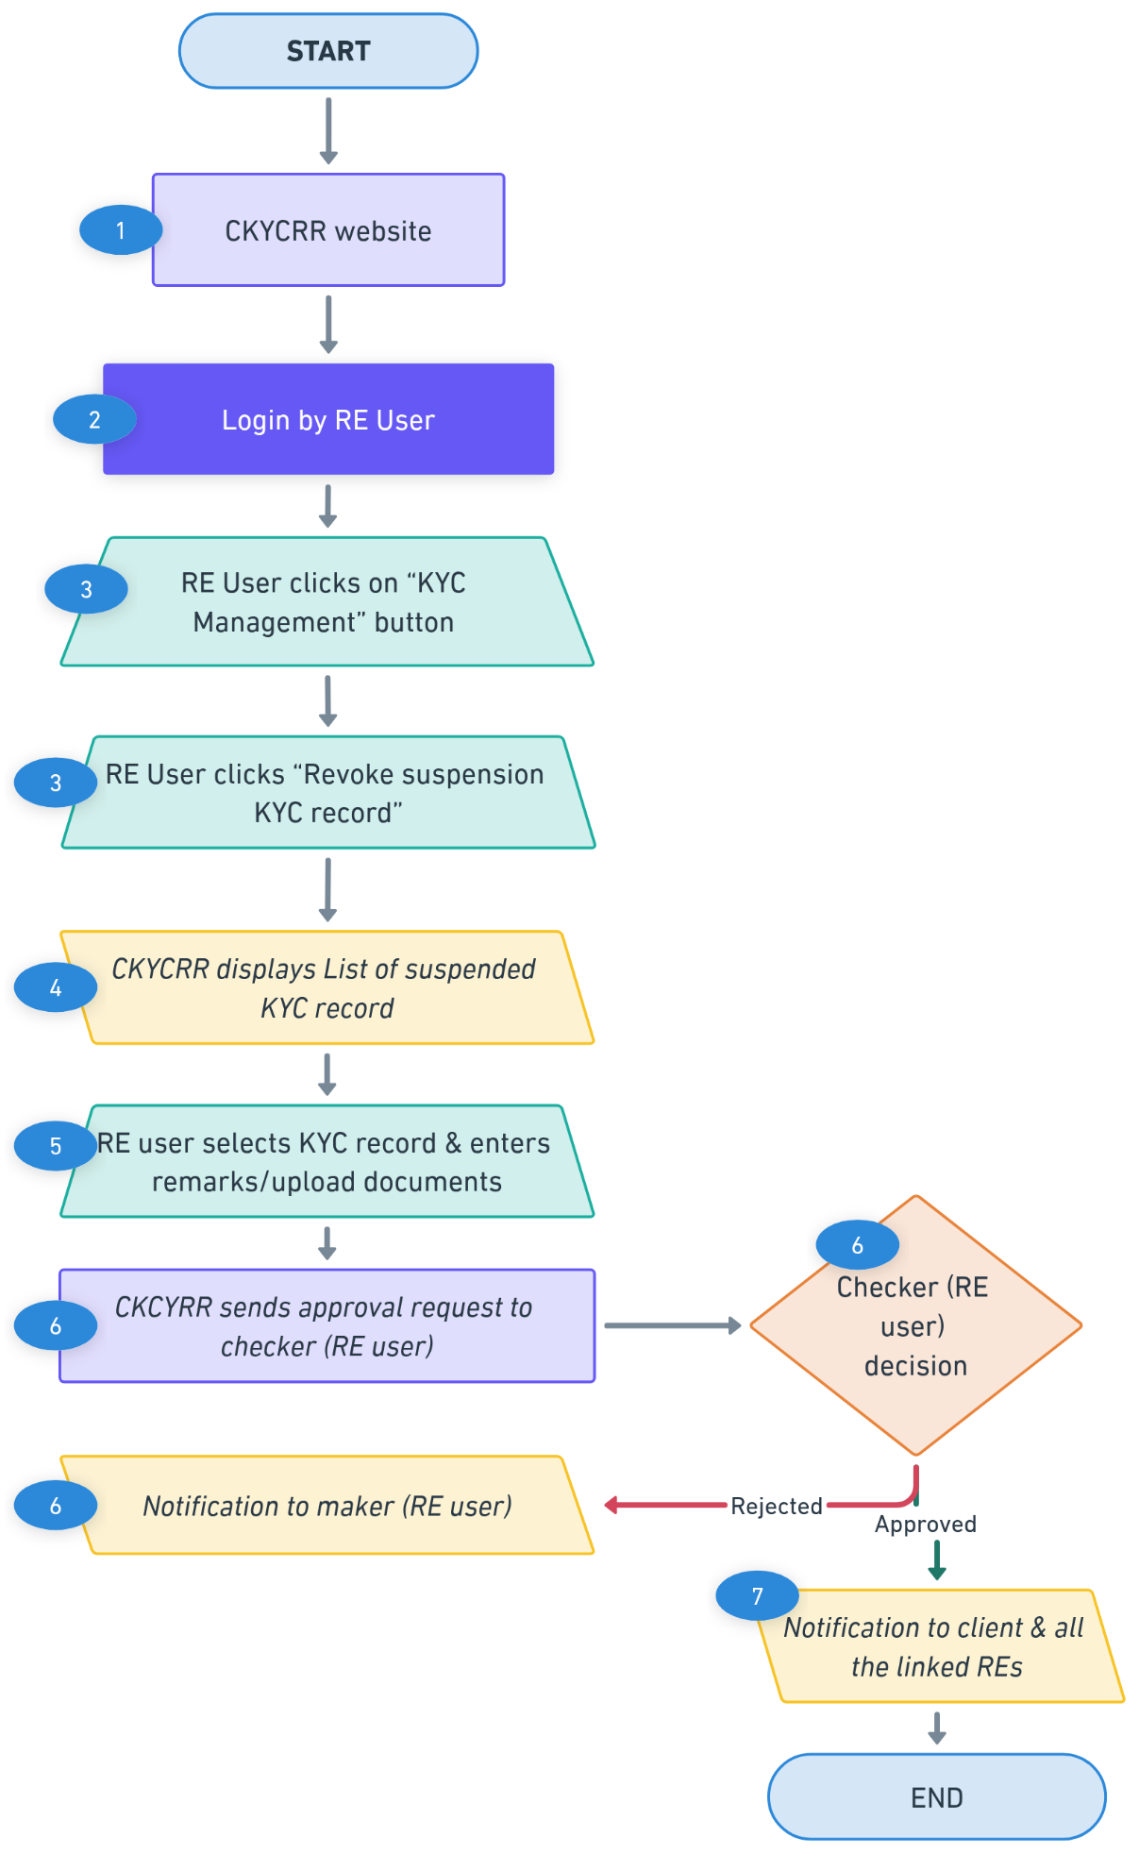

Points to Remember:
- Revocation of suspension can only be requested by the same Reporting Entity (RE) that initiated the suspension of the KYC record.
- The CKYCRR system will trigger notifications at the following key events
Key Event | User | Email | SMS | Post Login
Information to RE for approval | RE users | Yes | No | Yes
Information to maker on rejection by checker | RE user (Maker) | Yes | No | Yes
Information to client | Client | Yes | Yes | No
Information to all the linked REs | RE users | Yes | No | Yes

KYC logs
The KYC Logs module enables the reporting entity users to access a comprehensive summary of all KYC-related transactions. This module serves as a centralized tracking point for reviewing the status, history, and actions taken on each KYC record. It facilitates operational efficiency and ensures compliance through the following key functionalities:
Below outlines the process of accessing KYC logs:
Step 1: The RE user will access domain / URL “https://www.ckycindia.in” from his/her respective systems connected over internet.

Step 2: The RE user will login to the CKYCRR system using the user ID issued, password and DSC (as per login module).
Step 3: The RE user will click on “KYC Management ” button to navigate to KYC management modules and select KYC logs option.
Step 4: The RE user will have the below options:
- Reconciliation of Probable Match Cases: During the KYC record creation process, if the CKCYRR system identifies a probable matches, the KYC record is flagged for RE reconciliation. RE users can review the flagged records, compare data, and take necessary action to resolve duplicates or confirm uniqueness.
  - The RE user can click on the view details of the KYC record.
    - The following details will be displayed for probable match records
      - Match Percentage
      - Name (as per KYC record)
      - CKYC reference number
      - DOB (for individual)/ Date of Incorporation/ formation (for legal entity)
      - Gender (for individual)
      - PAN No (for individual & legal entity if available)
      - Photo
  - The CKYCRR system will display the probable matches KYC records for RE user reference. The RE user can compare the details of the new KYC record and probable match KYC record.
  - The CKYCRR system will display the percentage match against each probable match KYC record to reporting entity. The criteria for percentage match will be configured based on dedupe and data cleansing POC.
  - Based on the details displayed, the RE user can mark the new KYC record as “No Match” and “Confirmed Match”.
  - For No match, the CKYCRR system will generate the new CKYC number and the client will be notified.
  - For confirmed match, the CKYCRR system will display the CKYC reference number of the existing KYC record. The RE user can download the KYC record.
- Modifications Post-Rejection: In case any KYC related request is rejected by the checker during the approval process, the rejected record becomes available in the KYC logs. RE users can access these entries, make required modifications based on feedback, and re-submit the request for approval.
- Client-Initiated Update Requests: The KYC logs also track any update requests submitted by the client. RE users are notified and can take appropriate action, such as reviewing the changes, validating supporting documents, and processing the request through the maker-checker workflow.
- Summary of KYC transactions: The CKYCRR system will show summary of KYC transactions in the form of MIS reports.
- Status of Bulk files: The CKYCRR system will display bulk files (search, download, upload, update) uploaded by the RE user for approval or system processing. The CKYCRR system will display the status of each bulk file along with return file (processed by CKYCRR system) available for download.
- Notifications sent to RE: The CKYCRR system will display all the notifications sent to RE related KYC management like update of KYC record, de-activation of KYC record, etc.

Client relationship
The CKYCRR system maintains the audit of client relationship with reporting entities. Client relationship is established based on below KYC transactions
- CKYC record is created by the reporting entity
- CKYC record is downloaded by the reporting entity
- CKYC record is updated by the reporting entity

The CKYCRR system will manage the list of all clients relationship with the reporting entity. The RE user can mark closure of relationship with client.

Below outlines the process of closing client relationship:
Step 1: The RE user will access domain / URL “https://www.ckycindia.in” from his/her respective systems connected over internet.

Step 2: The RE user will login to the CKYCRR system using the user ID issued, password and DSC (as per login module).
Step 3: The RE user will click on “KYC Management ” button to navigate to KYC management modules and select client relationship option.
Step 4: The CKYCRR system will prompt user to enter the CKYC number of the client.
Step 5: The CKYCRR system will display the CKYC record of the client to the RE user. The RE user can tick the checkbox “Relationship Closed”, provide remarks to close the client relationship and date of closure of client relationship and submit the request for approval.
Step 6: The CKYCRR system will send the approval request to checker (RE user). The RE user will have the below actionable
- Approve: Upon successful approval, the CKYCRR system will mark the client relationship status as Closed.
- Reject: The CKYCRR system will send email to RE user (maker)
Step 7: On successful approval, the CKYCRR system will mark client relationship status as closed and the CKYCRR system will not send further notification to closed relationship RE for particular CKYC record.
Functional Flow: 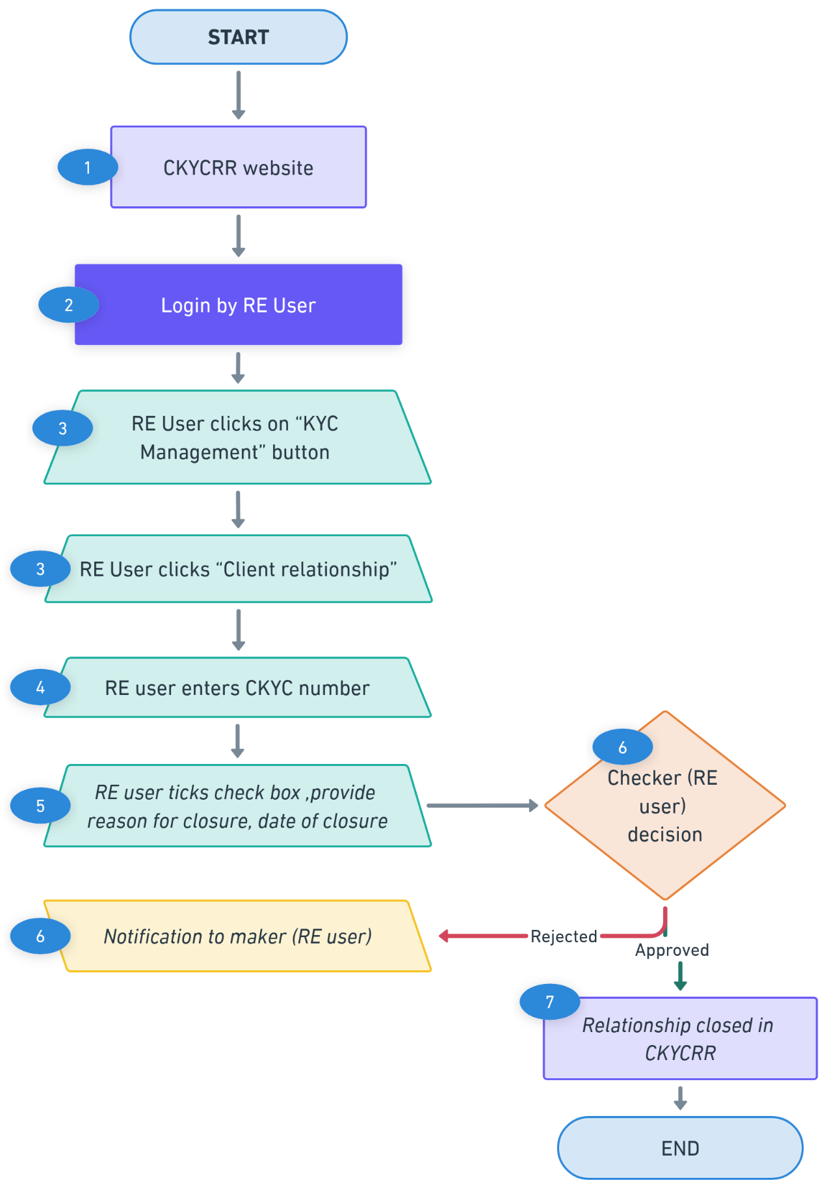
Points to Remember:
- The CKYCRR system will trigger notifications at the following key events
Key Event | User | Email | SMS | Post Login
Information to checker for approval | RE user (Checker) | Yes | No | Yes
Information to maker on rejection by checker | RE user (Maker) | Yes | No | Yes
Information to client | Client | Yes | Yes | No

Below outlines the process of re-establishment of relationship with CKYC record:

In case RE wishes to establish relationship/ linkage with a CKYC record, RE will have to first download the record (using Download KYC record process) after which linkage would be established again. It would be considered as fresh download for charging fees.
The complete metadata and audit trail would continue to be available including the dates of upload/ download/ update by the RE before marking the closure/ end of relationship , date of marking closure, etc. Further, in case of re-establishment of relationship and its subsequent linkage with CKYCRR, the system will again capture all these events in the audit trail/ logs.

